Pin modification:

P0.8 -> P0.6

P0.9 -> P0.7

Output (UART #2 ) explanation

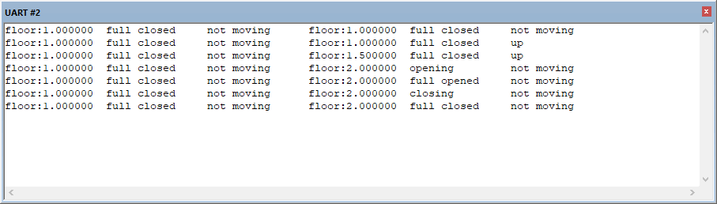

Left Elevator Right Elevator

The screen will output only when state is changing(or fire)

The reason for that is to save print time

Unfix bugs

No, everything is fixed(I hope)

Including the previous part1 of the homework(So please also check that)