1. 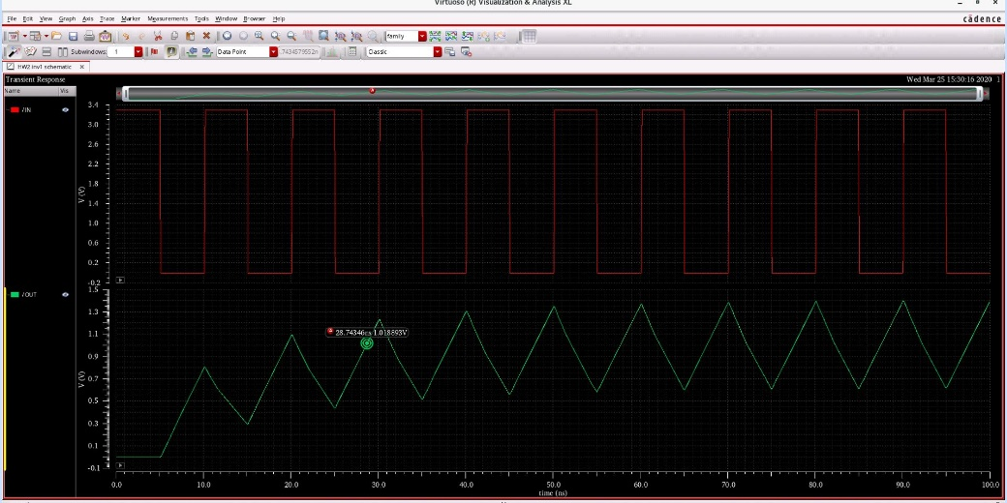**inverters with different width and length**
   * 1. PU:PD = (2/1 : 1/1)
     2. 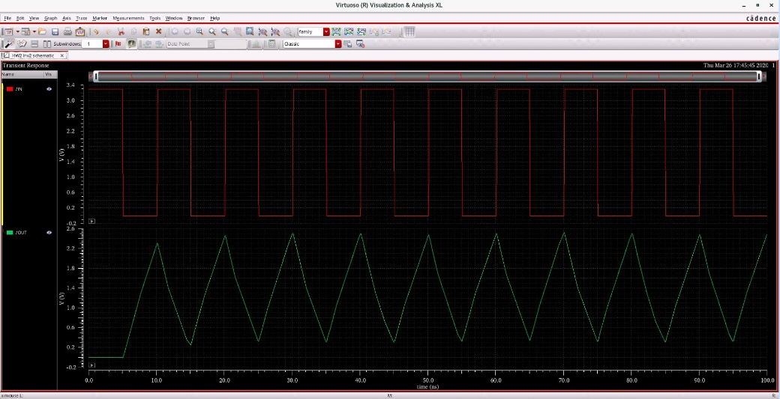PU:PD = (6/1 : 3/1)
     3. 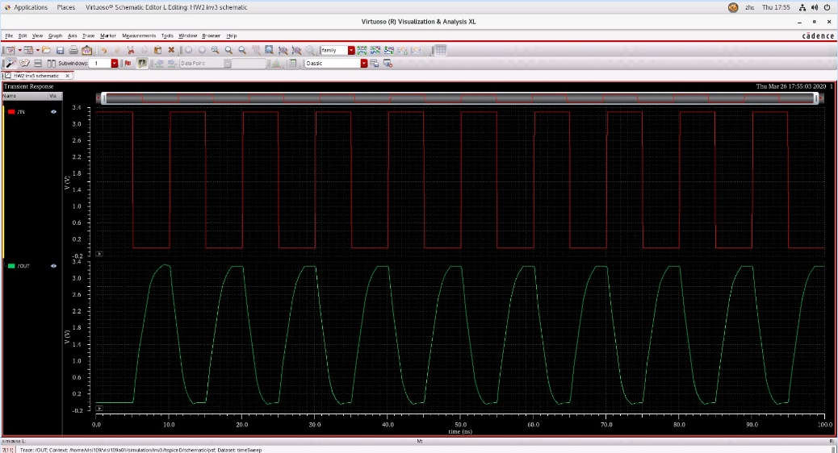PU:PD = (18/1 : 9/1)
     4. 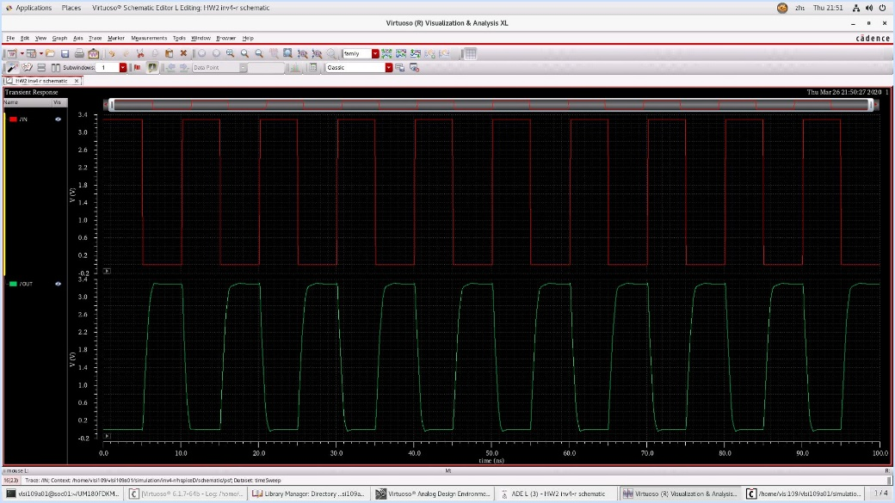PU:PD = (48/1 : 24/1)
     5. 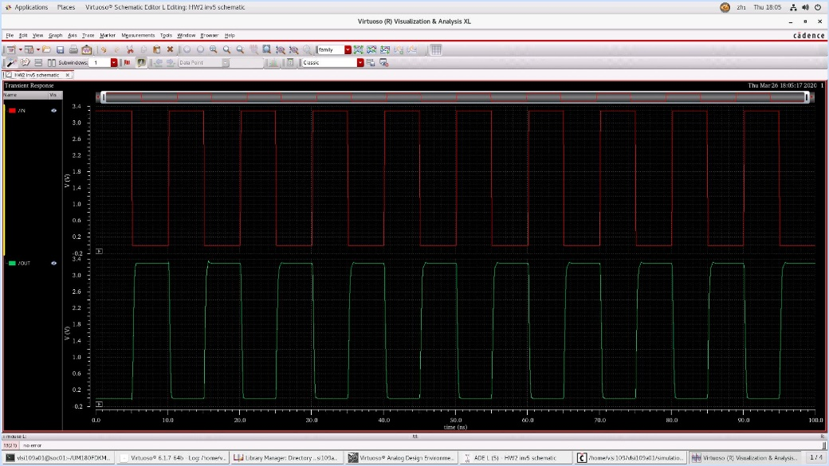PU:PD = (144/1 : 72/1)
2. 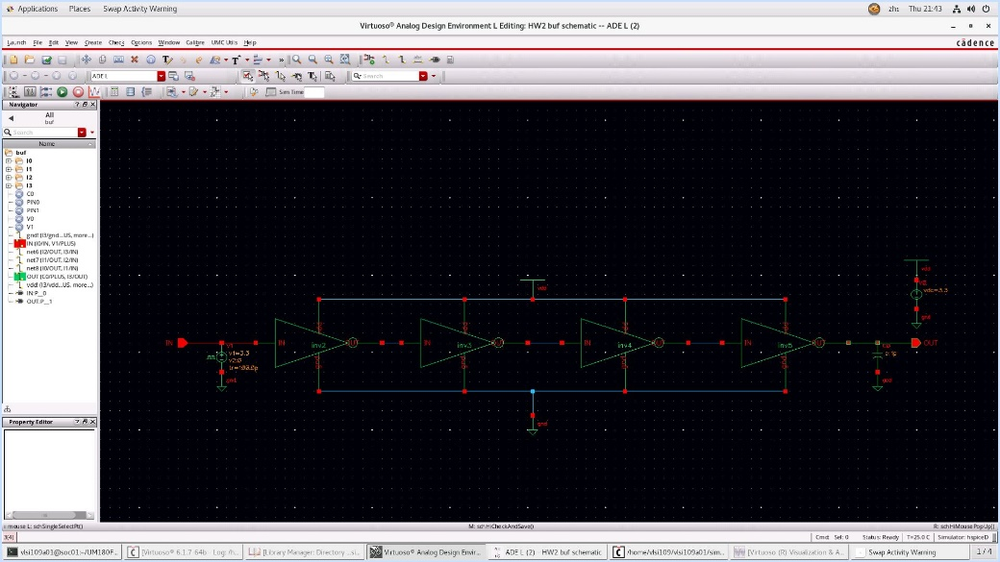**buffer schematic**
3. 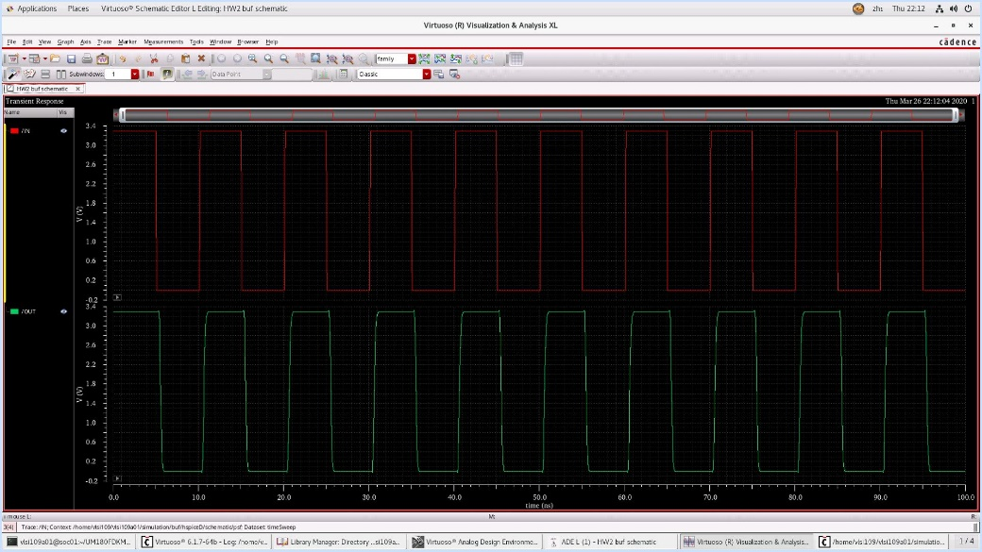**buffer analysis**

Timer:717.1053ps

Timef:643.4771ps

delaypL->H:935.3662ps

delaypH->L:852.1278ps