￭PART1 XOR

1. Schematic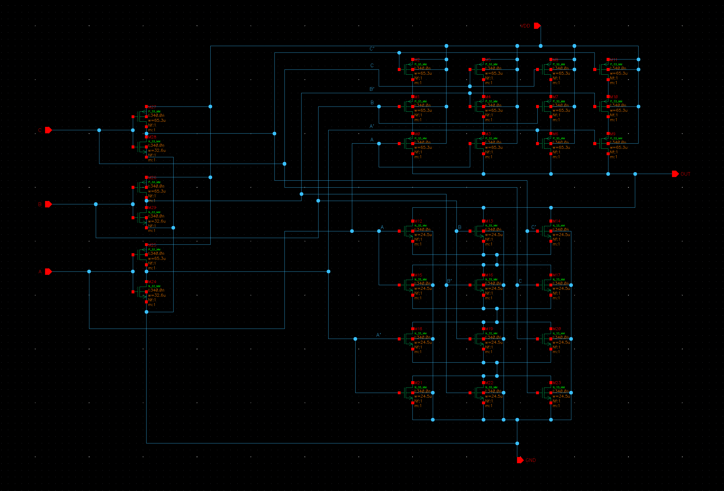

|  |  |  |  |
| --- | --- | --- | --- |
| m0 | p_33_mm | w=65.28e-6 | l=340e-9 |
| m1 | p_33_mm | w=65.28e-6 | l=340e-9 |
| m2 | p_33_mm | w=65.28e-6 | l=340e-9 |
| m3 | p_33_mm | w=65.28e-6 | l=340e-9 |
| m4 | p_33_mm | w=65.28e-6 | l=340e-9 |
| m5 | p_33_mm | w=65.28e-6 | l=340e-9 |
| m6 | p_33_mm | w=65.28e-6 | l=340e-9 |
| m7 | p_33_mm | w=65.28e-6 | l=340e-9 |
| m8 | p_33_mm | w=65.28e-6 | l=340e-9 |
| m9 | p_33_mm | w=65.28e-6 | l=340e-9 |
| m10 | p_33_mm | w=65.28e-6 | l=340e-9 |
| m11 | p_33_mm | w=65.28e-6 | l=340e-9 |
| m12 | n_33_mm | w=24.5e-6 | l=340e-9 |
| m13 | n_33_mm | w=24.5e-6 | l=340e-9 |
| m14 | n_33_mm | w=24.5e-6 | l=340e-9 |
| m15 | n_33_mm | w=24.5e-6 | l=340e-9 |
| m16 | n_33_mm | w=24.5e-6 | l=340e-9 |
| m17 | n_33_mm | w=24.5e-6 | l=340e-9 |
| m18 | n_33_mm | w=24.5e-6 | l=340e-9 |
| m19 | n_33_mm | w=24.5e-6 | l=340e-9 |
| m20 | n_33_mm | w=24.5e-6 | l=340e-9 |
| m21 | n_33_mm | w=24.5e-6 | l=340e-9 |
| m22 | n_33_mm | w=24.5e-6 | l=340e-9 |
| m23 | n_33_mm | w=24.5e-6 | l=340e-9 |
| m24 | n_33_mm | w=32.64e-6 | l=340e-9 |
| m25 | p_33_mm | w=65.28e-6 | l=340e-9 |
| m26 | p_33_mm | w=65.28e-6 | l=340e-9 |
| m27 | p_33_mm | w=65.28e-6 | l=340e-9 |
| m28 | n_33_mm | w=32.64e-6 | l=340e-9 |
| m29 | n_33_mm | w=32.64e-6 | l=340e-9 |

1. Waveform

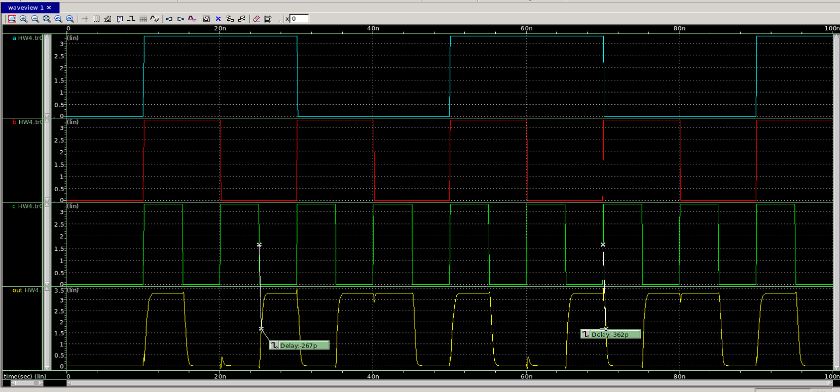

1. 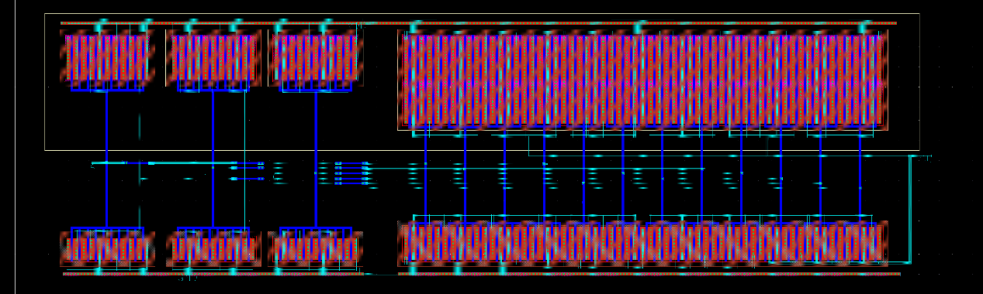layout
2. DRC & ERC & LVS
   1. 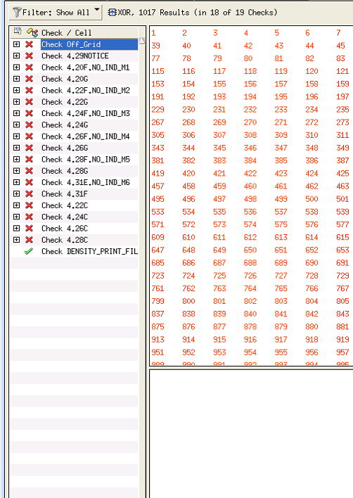DRC
   2. 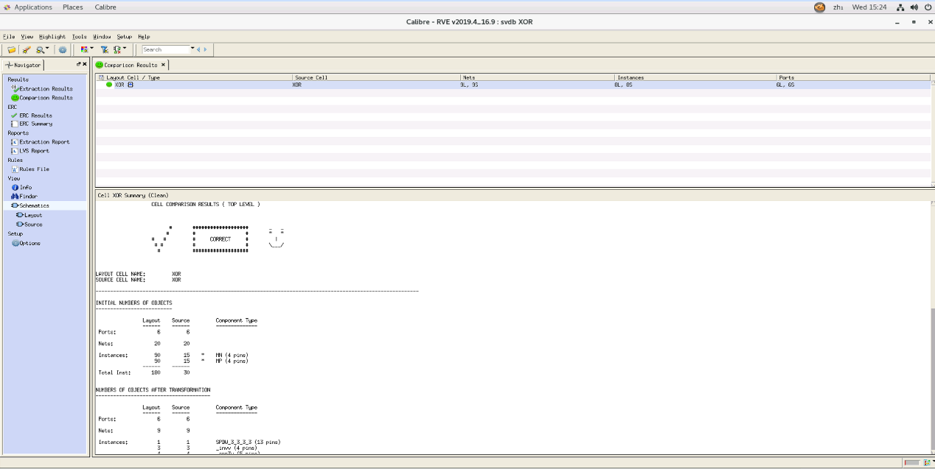LVS&ERC
3. 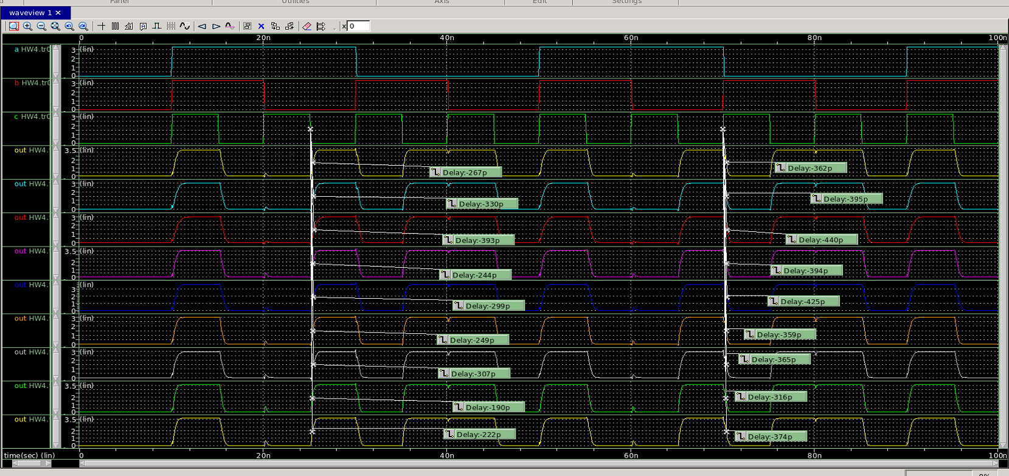8 corners waveform



￭PART2 XNOR

1. 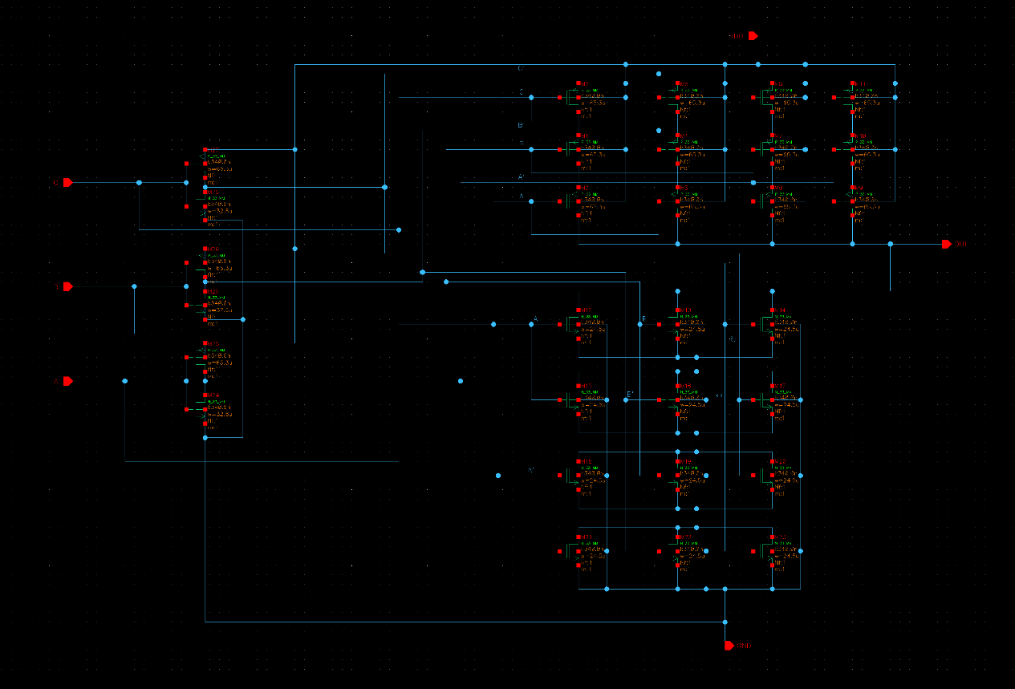Schematic

|  |  |  |  |
| --- | --- | --- | --- |
| m0 | p_33_mm | w=65.28e-6 | l=340e-9 |
| m1 | p_33_mm | w=65.28e-6 | l=340e-9 |
| m2 | p_33_mm | w=65.28e-6 | l=340e-9 |
| m3 | p_33_mm | w=65.28e-6 | l=340e-9 |
| m4 | p_33_mm | w=65.28e-6 | l=340e-9 |
| m5 | p_33_mm | w=65.28e-6 | l=340e-9 |
| m6 | p_33_mm | w=65.28e-6 | l=340e-9 |
| m7 | p_33_mm | w=65.28e-6 | l=340e-9 |
| m8 | p_33_mm | w=65.28e-6 | l=340e-9 |
| m9 | p_33_mm | w=65.28e-6 | l=340e-9 |
| m10 | p_33_mm | w=65.28e-6 | l=340e-9 |
| m11 | p_33_mm | w=65.28e-6 | l=340e-9 |
| m12 | n_33_mm | w=24.5e-6 | l=340e-9 |
| m13 | n_33_mm | w=24.5e-6 | l=340e-9 |
| m14 | n_33_mm | w=24.5e-6 | l=340e-9 |
| m15 | n_33_mm | w=24.5e-6 | l=340e-9 |
| m16 | n_33_mm | w=24.5e-6 | l=340e-9 |
| m17 | n_33_mm | w=24.5e-6 | l=340e-9 |
| m18 | n_33_mm | w=24.5e-6 | l=340e-9 |
| m19 | n_33_mm | w=24.5e-6 | l=340e-9 |
| m20 | n_33_mm | w=24.5e-6 | l=340e-9 |
| m21 | n_33_mm | w=24.5e-6 | l=340e-9 |
| m22 | n_33_mm | w=24.5e-6 | l=340e-9 |
| m23 | n_33_mm | w=24.5e-6 | l=340e-9 |
| m24 | n_33_mm | w=32.64e-6 | l=340e-9 |
| m25 | p_33_mm | w=65.28e-6 | l=340e-9 |
| m26 | p_33_mm | w=65.28e-6 | l=340e-9 |
| m27 | p_33_mm | w=65.28e-6 | l=340e-9 |
| m28 | n_33_mm | w=32.64e-6 | l=340e-9 |
| m29 | n_33_mm | w=32.64e-6 | l=340e-9 |

1. 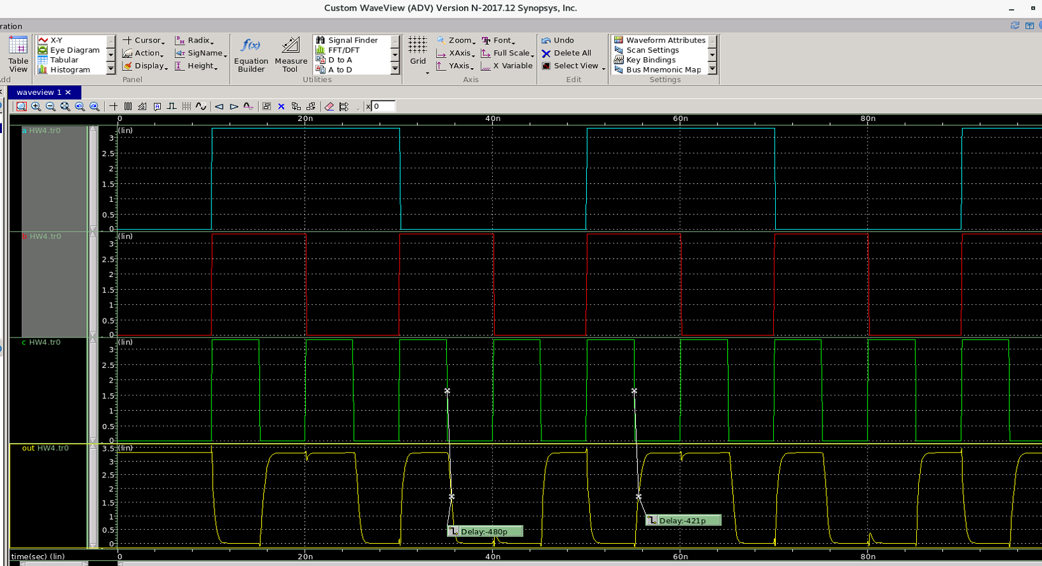waveform
2. 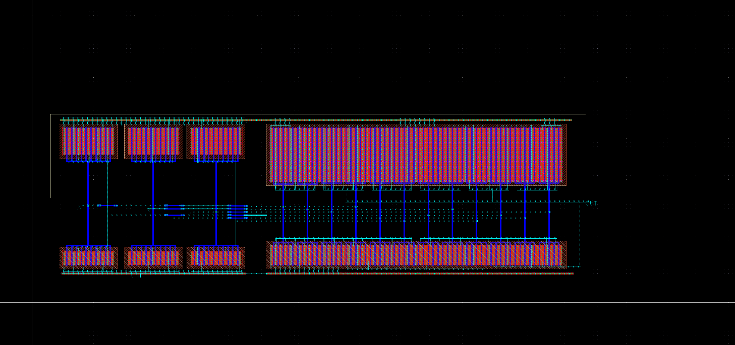Layout
3. DRC & ERC & LVS
   1. DRC

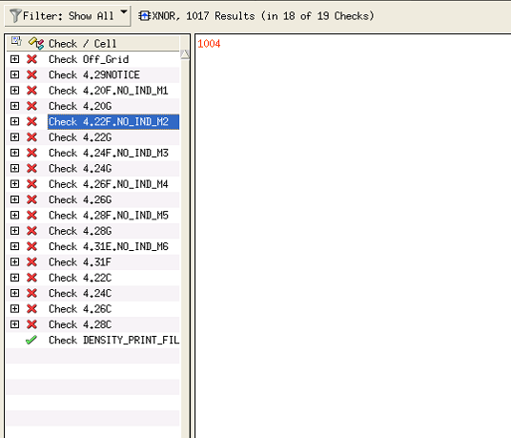

* 1. 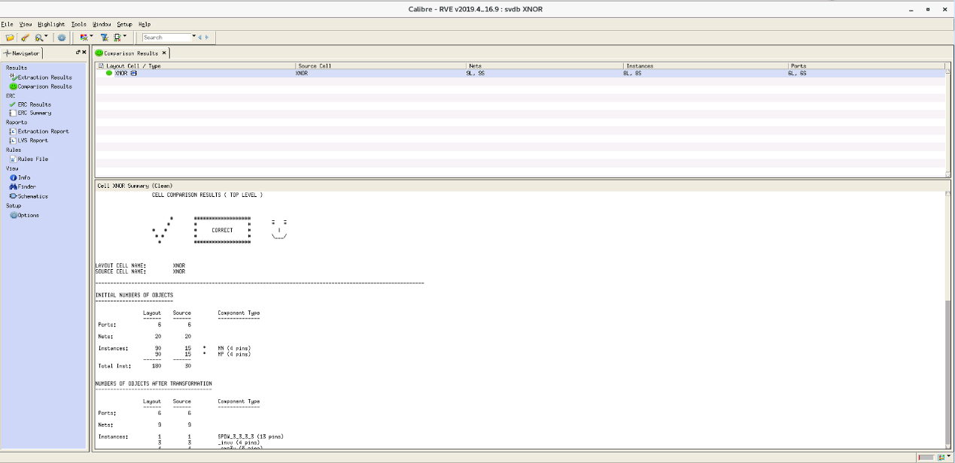LVS & ERC

1. 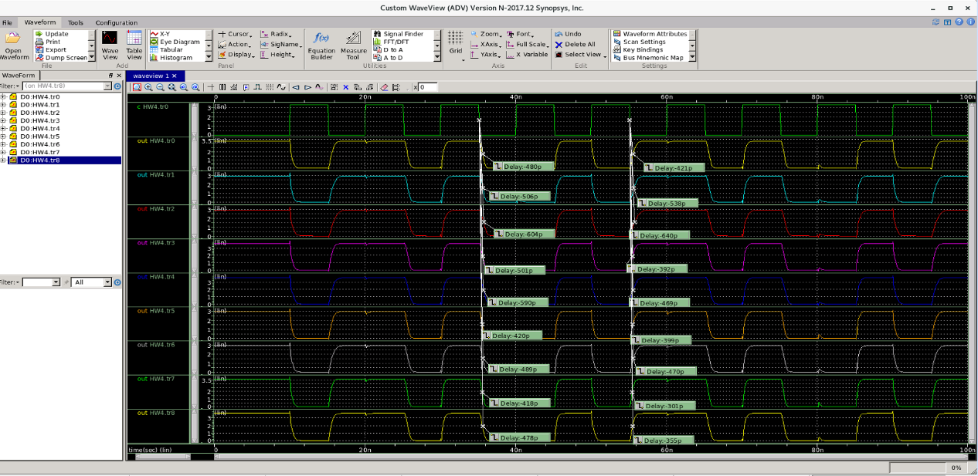8 corners waveform

