Project: To-Do Application Test Plan – Module 4.2 | Tested by Max Jankowski
Course: CSD 380 - DevOps
Description: A functional test plan that validates the BU To-Do application against the approved business requirements document.
Date: 6/25/2026
To complete the test case plan, fill out the information for Project, Course, Description and Date in the header below.
.
TABLE OF CONTENTS
Create a New To-Do Task Item 2
Edit an Existing To-Do Task item 2
Delete a To-Do Task Item 3
Validate Empty To-Do Tasks 4
Site Access using URL 5

For each test, the developer should: provide a test description, a test objective, the developer name and date tested. For each step, fill out the actions to be taken and describe the expected results, and indicate yes or no for each step depending upon the result. The peer tester should provide their name, date tested, indicate yes or no for each step depending upon the result, and a screenshot (thumbnail) of the result.

Test 1 | Create a New To-Do Task Item
 | Test Objective: Verify that a user can successfully create a new To-Do task item, appears in list view | Developer: Brayan Cova  Date tested: 6/25/2026 | Peer tester: Max Jankowski  Date tested: <2026/06/27>
Step | Action | Expected results: | Developer pass/fail | Tester pass/fail  + Screenshot
1 | Navigate to https://buwebdev.github.io/todo and locate the new task input field | The todo list page loads and an input field for entering a new task is visible | <yes/no> | Yes  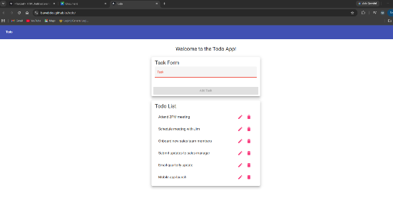
2 | Enter a valid task description (“buy ice cream”) into the new task input field | The text is accepted into the input field without error | <yes/no> | Yes  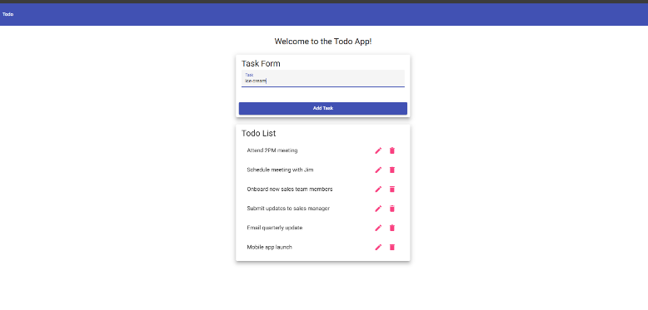
3 | Submit the new task | The new task item is created and added to the list view | <yes/no> | Yes  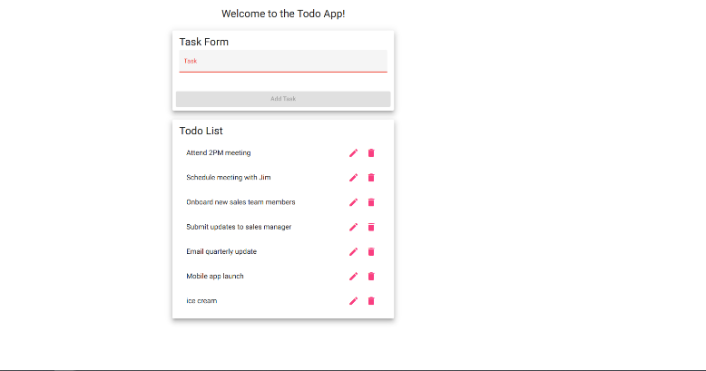
4 | Confirm the new task item appears in the list view | The task created is visible in the list, exactly as typed | <yes/no> | Yes  See above
5 | Repeat the process by adding a second, different task item | The second task is also added, both items are visible at the same time | <yes/no> | Yes  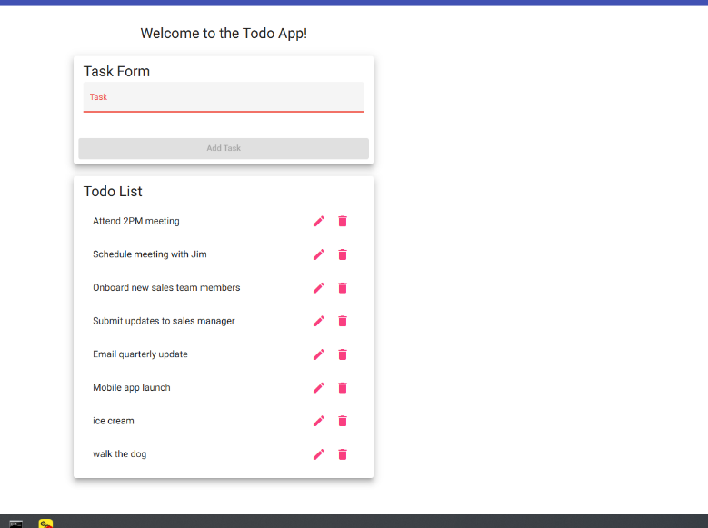
Comments | This test validates a high priority requirement, creating a new todo item. The steps confirm that both the create action succeeds and the new item persists visibly in the list. Testing with two items sequentially also confirms the list correctly appends rather than overwrites.

Test 2 | Edit an existing To-Do Task Item
 | Test Objective: Verifies that a user can edit an existing todo item and that the updated text is saved and displayed properly | Developer: Brayan Covarrubias  Date tested: 6/25/2026 | Peer tester: Max Jankowski  Date tested: <2026/06/27>
Step | Action | Expected results: | Developer pass/fail | Tester pass/fail
1 | Navigate to the site and create a task titled “Do laundry” if one doesn’t already exist | The task item appears in the list view | <yes/no> | Yes  See prior test
2 | Select the edit option for the task item | An editable field opens, pre-populated with the original task text | <yes/no> | Yes  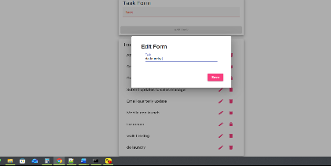
3 | Clear the existing text and enter “Do laundry at 10am” | The edit field accepts the updated text without error | <yes/no> | Yes  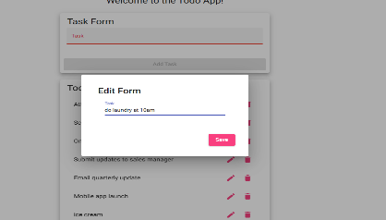
4 | Save and confirm the edit | The edit is saved and the edit view closes, returning to the list view | <yes/no> | Yes
5 | Confirm the todo list now displayed the updated task item | The item now reads “Do laundry at 10am”, replacing the original | <yes/no> | Yes  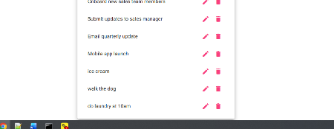
Comments | This test confirms that users can modify an existing task without needing to delete or recreate it. It also confirms the edit form correctly pre-populates the edit form correctly with the current task.

Test 3 | Delete a To-Do Task item
 | Test Objective: Verifies that a user can delete a todo item and the item is removed from the list | Developer: Brayan Cova  Date tested: 6/25/202 | Peer tester: Max Jankowski  Date tested: <2026/06/27>
Step | Action | Expected results: | Developer pass/fail | Tester pass/fail
1 | Navigate to the site and create a task titled “Temporary test” if one doesn’t already exist | The task item appears in the todo list | <yes/no> | Yes  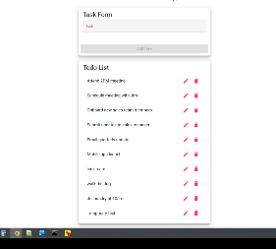
2 | Note down the total number of task items currently on the list view | The current task count is recorded | <yes/no> | Yes 10
3 | Select the delete option for the targeted task item | The item is removed from the list immediately after confirmation | <yes/no> | yes
4 | Confirm the task item no longer appears in the todo list | The task is no longer visible on the list view | <yes/no> | Yes  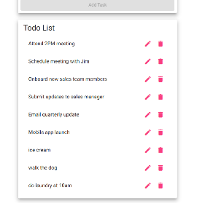
5 | Refresh the page and confirm the deleted item does not reappear | After refreshing, the task count is one less than the original, the item stays gone | <yes/no> | Yes, but it clears all info
Comments | Tis test confirms deletion is immediate and persistent after a page refresh, checking off a potential bug that deleted items could reappear if changes aren’t properly saved. Comparing task count before and affer provides a pass or fail signal.

Test 4 | Validate Empty To-Do Tasks
 | Test Objective: Verifies that the app prevents users from submitting or updating with empty string tasks in the input field | Developer: Brayan Cova  Date tested: 6/25/2026 | Peer tester: Max Jankowski  Date tested: <2026/06/27>
Step | Action | Expected results: | Developer pass/fail | Tester pass/fail
1 | Navigate to the site and locate the new task input field | The new task input field is visible and empty | <yes/no> | yes
2 | Leave the new input field empty and attempt to submit | The app prevents submission, no blank task is added, validation message appears | <yes/no> | Yes, does not accept entry  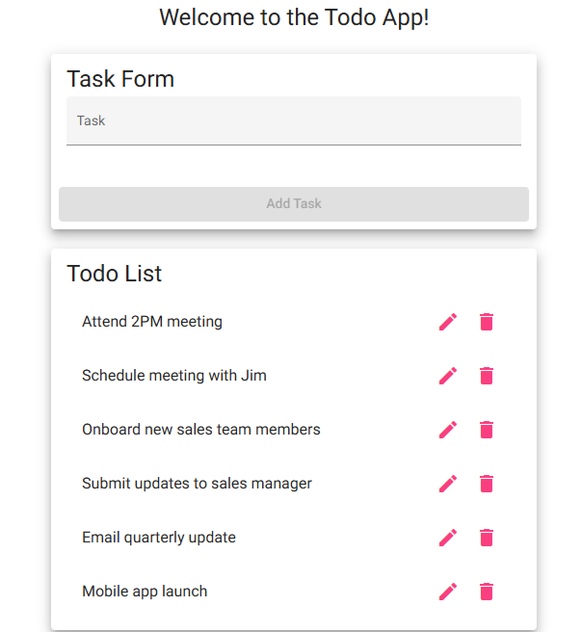
3 | Select an existing item and press the edit option to open the edit form | The edit view opens, pre-populated with the task’s existing text | <yes/no> | yes
4 | Clear all text from the edit field, leaving it empty, attempt to save | The app prevents savings, original text is preserved | <yes/no> | No, erased text from task  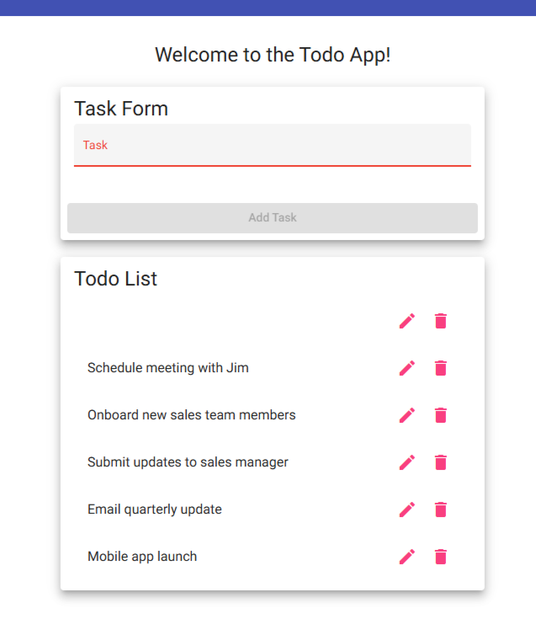
5 | Confirm todo list still shows original, unmodified task list with no blank entries | No empty or blank tasks exist or appear on the task list view, tasks still showing original text | <yes/no> | No, see above
Comments | This test targets two validation requirements by blocking empty submissions on both new tasks or editing existing tasks. They both fit under the save test case since they both test the same validation rule, just in two different locations and CRUD actions. If either fails, it means the validation logic is not consistent across the app.

Test 5 | Site Access using URL
 | Test Objective: Verifies that users can access the To-Do app through the standard URL, page loads and reloads without errors | Developer: Brayan Cova  Date tested: 6/25/2026 | Peer tester: Max Jankowski  Date tested: <2026/06/27>
Step | Action | Expected results: | Developer pass/fail | Tester pass/fail
1 | Visit https://buwebdev.github.io/todo in a web browser | The To-Do app home page loads successfully with no errors and list view is displayed | <yes/no> | yes
2 | Confirm the page is loaded without errors -- check for broken UI layout, console errors, missing content, | Page renders compeltely with all expected elements | <yes/no> | Yes  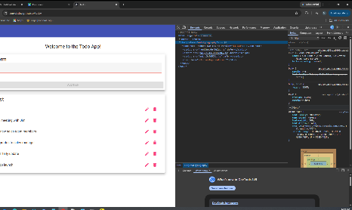
3 | Refresh the browser window | The page reloads and displays the same app list view without errors | <yes/no> | Yes same as above
4 | Confirm the page reloaded correctly | App layout and state are consistent with initial load, no broken elements or UI | <yes/no> | yes
5 | Close and reopen browser, then navigate to URL again | The app loads again successfully through same URL | <yes/no> | yes
Comments | This test confirms the app is reachable through the proper URL. It also confirms that the page is stable with reloads, no broken UI elements. This test is considered crucial.

