Project: | Todo Application Test Plan
Course: | CSD380 Rashai Robertson/ tested my Max Jankowski
Description: | Functional test case plan based on the Todo Business Requirements document.
Date: | 2026/06/25
To complete the test case plan, fill out the information for Project, Course, Description and Date in the header below.
.
TABLE OF CONTENTS
Verify Website 2
Create Task Item 2
Edit Task Item 3
Delete Task Item 3
404 Error 4

For each test, the developer should: provide a test description, a test objective, the developer name and date tested. For each step, fill out the actions to be taken and describe the expected results, and indicate yes or no for each step depending upon the result. The peer tester should provide their name, date tested, indicate yes or no for each step depending upon the result, and a screenshot (thumbnail) of the result.
Test 1 | Verify Website
 | Test Objective: Allow users to visit the website through https://buwebdev.github.io/todo/ | Developer: Rashai R.  Date tested: 2026/06/25 | Peer tester: Max Jankowski  Date tested: <2026/06/27>
Step | Action | Expected results: | Developer pass/fail | Tester pass/fail  + Screenshot
1 | Visit https://buwebdev.github.io/todo/. | Website loads | Pass | yes
2 | Confirm the page loads. | No 404 error | Pass | Yes
3 | Confirm the Todo application is visible. | TODO is visible | Pass | Yes  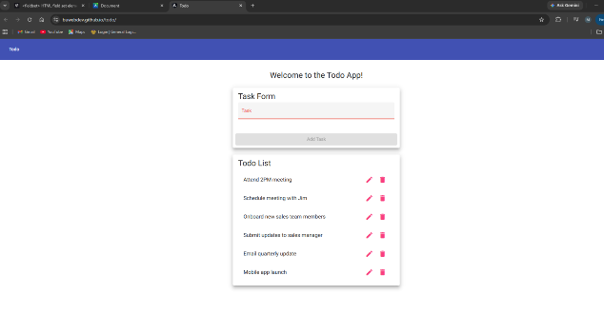
4 | Refresh the browser window. | Website loads | Pass | yes
5 | Confirm the page reloads correctly. | Website loads | Pass | Yes  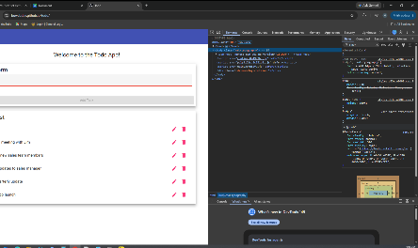
Comments | The website was deployed successfully and displayed the TODO application. Refreshing the page did not cause any errors.

Test 2 | Create Task Item
 | Test Objective: Verify users can create a new todo task. | Developer: Rashai R.  Date tested: 2026/06/25 | Peer tester: Max Jankowski  Date tested: <2026/06/27>
Step | Action | Expected results: | Developer pass/fail | Tester pass/fail
1 | Open the Todo application. | Application loads successfully. | Pass | Yes
2 | Click inside the task field. | Cursor appears in the text box. | Pass | Yes  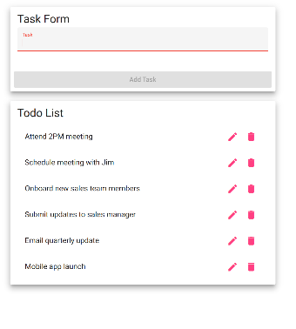
3 | Enter "Finish homework." | The text is accepted. | Pass | Yes  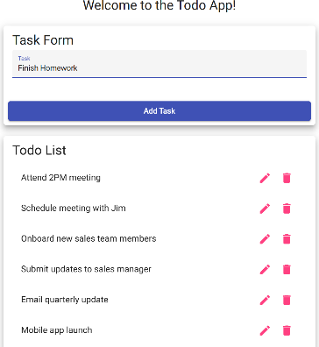
4 | Click Add Task. | The task is created successfully. | Pass | yes
5 | Verify the task appears in the list. | The new task is displayed. | Pass | Yes  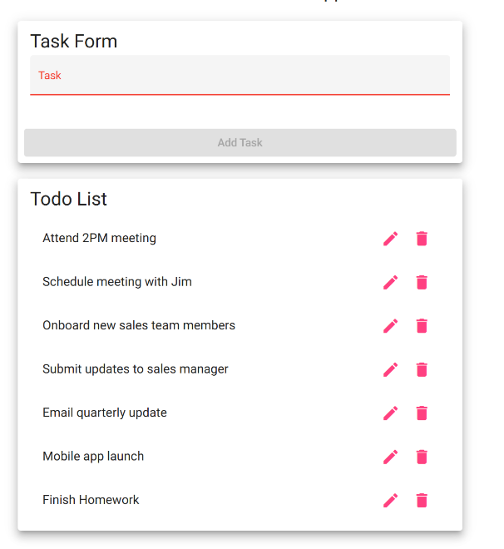
Comments | The application successfully created a new task and immediately displayed it in the todo list. No errors occurred during task creation.

Test 3 | Edit Task Item
 | Test Objective: Verify users can edit an existing todo task. | Developer: Rashai R.  Date tested: 2026/06/25 | Peer tester: Max Jankowski  Date tested: <2026/06/27>
Step | Action | Expected results: | Developer pass/fail | Tester pass/fail
1 | Open the Todo application. | Application loads successfully. | Pass | Yes
2 | Select an existing task. | The task enters edit mode. | Pass | Yes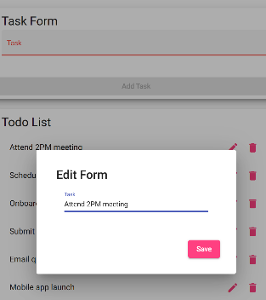
3 | Modify the task description. | The edited text is accepted. | Pass | Yes  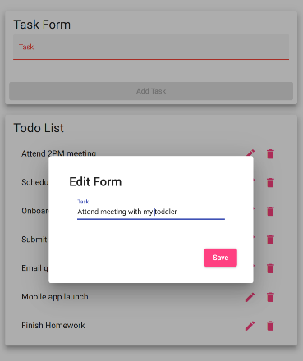
4 | Save the changes. | The changes are saved successfully. | Pass | Yes
5 | Verify the updated task appears. | The edited task displays the new text. | Pass | Yes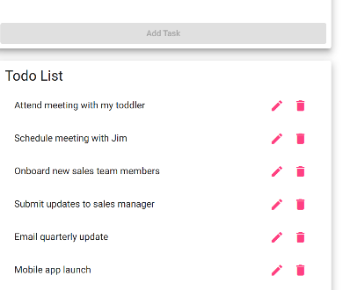
Comments | The application successfully updated the selected task. The changes were saved and displayed correctly without affecting other tasks.

Test 4 | Delete Task Item
 | Test Objective: Verify users can delete an existing todo task. | Developer: Rashai R.  Date tested: 2026/06/25 | Peer tester: Max Jankowski  Date tested: <2026/06/27>
Step | Action | Expected results: | Developer pass/fail | Tester pass/fail
1 | Open the Todo application. | Application loads successfully. | Pass | Pass
2 | Locate an existing task. | The task is displayed. | Pass | Pass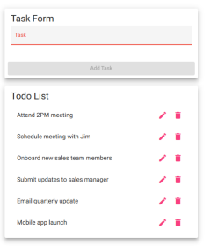
3 | Click the Delete button. | The selected task is removed. | Pass | Pass
4 | Verify the task no longer appears. | The deleted task is absent from the list. | Pass | Pass  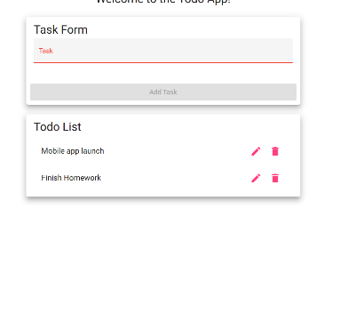
5 | Refresh the page. | The deleted task does not reappear. | Fail | Failed all edits and deletions are reset
Comments | The application successfully deleted the selected task. The changes were not saved, and the task reappears when refreshing page

Test 5 | 404 Error
 | Test Objective: Verify the application displays a custom 404 page when an invalid URL is entered. | Developer: Rashai R.  Date tested: 2026/06/25 | Peer tester: Max Jankowski  Date tested: <2026/06/27>
Step | Action | Expected results: | Developer pass/fail | Tester pass/fail
1 | Navigate to https://buwebdev.github.io/todo/invalidpage | Application loads successfully. | Pass | Pass
2 | Wait for the page to finish loading. | A custom 404 page appears. | Pass | Pass “not found works” appears
3 | Verify the page displays a "Page Not Found" message. | The custom error message is visible. | Pass | Pass  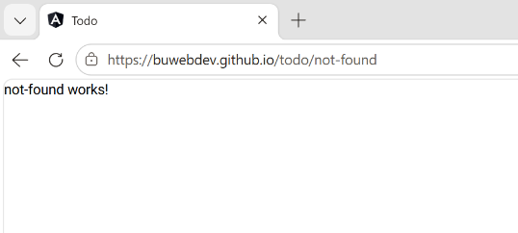
4 | Return to the Todo home page. | The application loads normally. | Pass | Pass
5 | Verify the application functions correctly. | The Todo application operates normally. | Pass | Pass
Comments | The application handled an invalid URL by displaying a custom 404 page instead of a generic browser error. Shows “not-found works!” but no return home button.

