**2022 ERAU REU: Ensemble Deep Learning**



Embry-Riddle Aeronautical University Rachel Swan

Dr. Berezovski

Nevada National Security Site Jesse Adams, PhD

Margaret Lund, PhD

Nevada National Security Site (NNSS)

Nuclear Weapons Science Nuclear Emergency Response

National security programs Environmental Protection

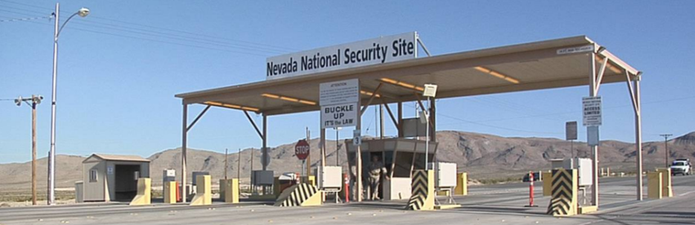

Problem Introduction 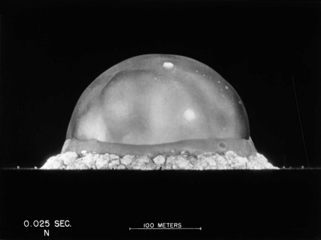

Radiographic image analysis using convolutional neural networks

Aids in nuclear tests analysis National security 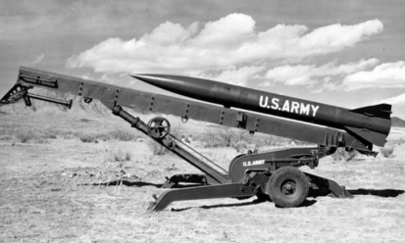

Nuclear weapons safety

Project Scope

Develop a network using Python and train it using image data Probability model and uncertainty quantification

