!Broke | An overview
  - Jordan Mosselson, ST10270629 | Max van der Walt, ST10354483 | Nail Arslan, ST10342009| Nicolas Christofides, ST10339570 | Tyrus Fernandes, ST10365737
  - PROG7313 Portfolio of Evidence
  - Part 1

Table Of Contents
Research Introduction 3
Monefy 4
Vault22 8
YNAB(You Need a Budget): 11
App Comparison 15
Conclusion 15
References 16
Planning & Design 17
Introduction 17
Overview 18
Requirements list 19
UI 22
Navigation Draw up 30
Project Plan 31
Conclusion 32
References 33

Research Introduction
In this world of technology, understanding how to manage one’s finances has become crucial for many people. There is significant demand for mobile applications that facilitate budgeting and expense tracking. Financial management applications, however, are often perceived as too sophisticated or too dull for regular use. The primary objective of this project is to develop an engaging personal budget tracking application that helps users keep track of their spending and savings as well as make budgeting more enjoyable by integrating gaming features.

Monefy
Monefy is a popular expense tracking app known for its minimalist design and ease of use. Its main features include:
- Dashboard View: A clear summary of daily, weekly, or monthly spending. (Reflective Technologies, 2018)
- Expense Entry Screen: A straightforward interface where users can add new expenses by selecting categories, entering amounts, and optionally attaching photos (e.g., receipts). (Reflective Technologies, 2018)
- Category Management: Allows users to create and manage categories such as “Groceries,” “Transport,” and “Entertainment.” (Reflective Technologies, 2018)
- Visual Charts: Basic charts and graphs display spending trends over a selected period. (Reflective Technologies, 2018)

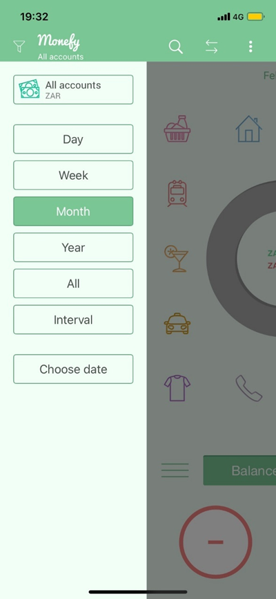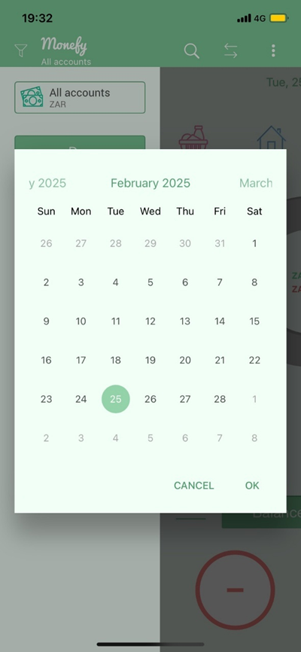
Screenshot Description:
Budget period can be divided into quarters with each quarter further split into months. Their spending habits are tracked visually, allowing users to effectively manage and control their budget. (Reflective Technologies, 2018)
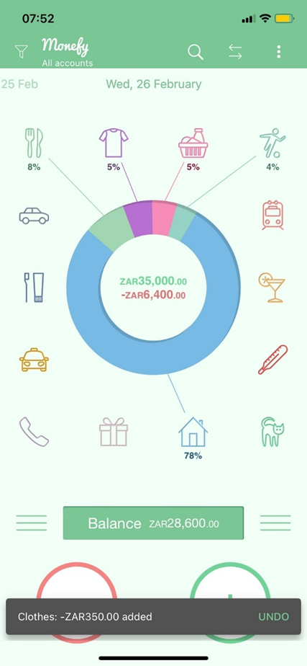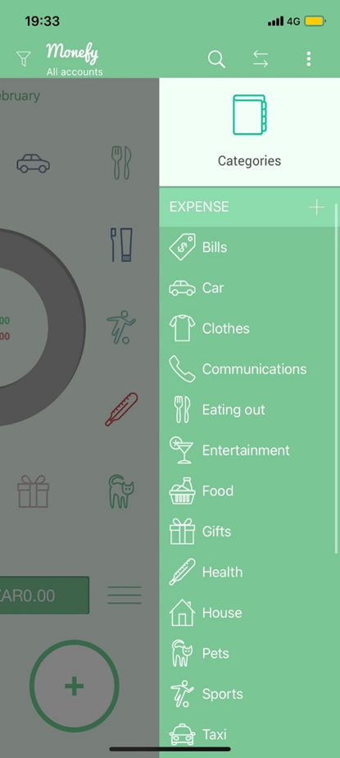
Screenshot Description:
This image illustrates the ability to see expenditures and income in a visual, pie chart form. Different segments, such as Groceries, Entertainment, or Transport. It helps boost financial understanding by allowing users to analyze spending in a quick and fun way. (Reflective Technologies, 2018)

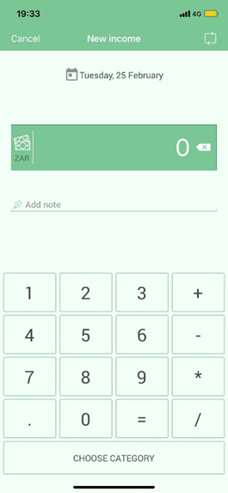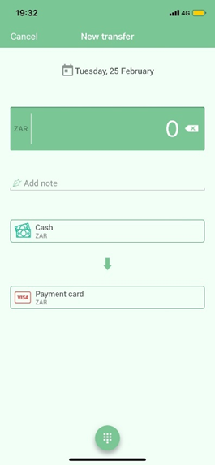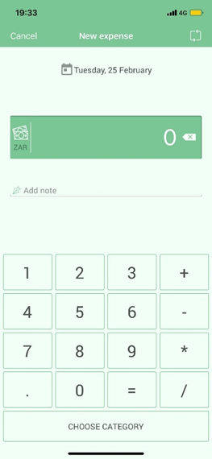
Screenshot Description:
The screenshot displays the area where users can input financial data, such as receiving payment, spending money, and moving funds between accounts. The design is optimized for efficient input and uses clear symbols to depict each type of transaction. This function is essential for keeping proper financial records. (Reflective Technologies, 2018)

Strengths and Weaknesses
Strengths:
- User-Friendly Interface: Monefy’s minimalistic design makes it accessible even for users who are not tech-savvy. (Reflective Technologies, 2018)
- Intuitive Navigation: The app’s structure – from the dashboard to the expense entry screen – is streamlined, allowing users to quickly understand and navigate the app. (Reflective Technologies, 2018)
- Quick Data Entry: With large buttons and a clear layout, adding an expense is fast and straightforward. (Reflective Technologies, 2018)
- Visual Feedback: Basic graphs provide users with immediate insights into their spending patterns. (Reflective Technologies, 2018)

Weaknesses:
- Limited Customization: Simplicity comes at the cost of flexibility. Users may find it challenging to adjust settings or customize categories beyond the default options. (Reflective Technologies, 2018)
- Advanced Features are Limited: While great for basic tracking, Monefy does not offer advanced analytics or deeper financial insights. (Reflective Technologies, 2018)
- Premium Lockout: Some features, such as enhanced reporting or additional themes, are only available through in-app purchases. (Reflective Technologies, 2018)
- Lack of Gamification: There are no reward mechanisms or badges, which might limit long-term engagement for users who thrive on gamified experiences. (Reflective Technologies, 2018)

Innovative Features
While Monefy’s design prioritizes simplicity, it also offers several innovative aspects:
- Effortless Expense Logging: The streamlined interface minimizes friction, making it easier for users to record their expenditures in real time. (Reflective Technologies, 2018)
- Visual Spending Overview: The integration of visual charts helps users quickly grasp their spending habits, enabling faster financial decisions. (Reflective Technologies, 2018)
- User-Centric Design: The clean and intuitive interface reduces the cognitive load, which is essential for an app intended for everyday use. (Reflective Technologies, 2018)

Vault22
Vailt22 is a highly integrated South African personal finance management app. Its simple design allows users to easily and very intuitively navigate their way around the app. It automatically aggregates your financial accounts into a single unified view. This provides users with a holistic oversight of their spending habits, income and financial health. The app represents the user’s score through a financial fitness level.
The higher the user scores in each category, the higher the fitness level
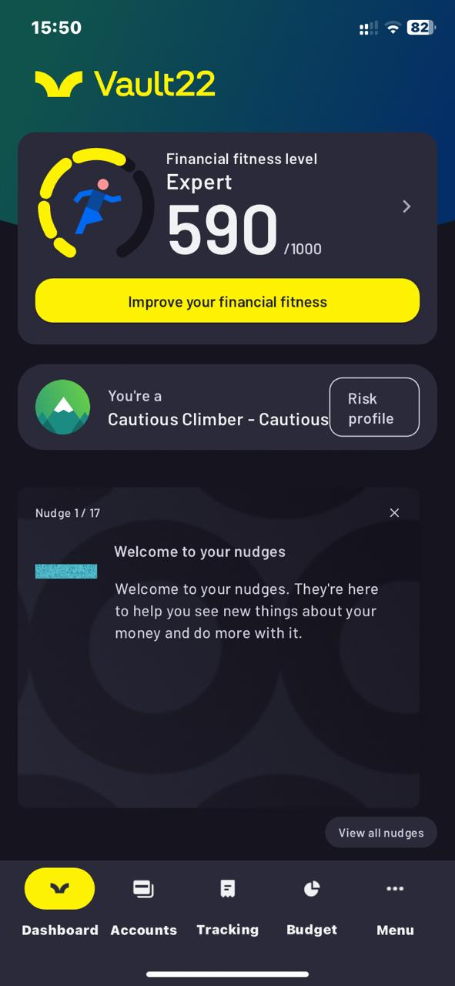
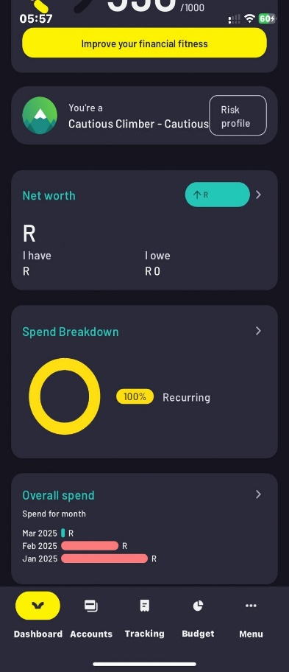
The dashboard is the first screen the user will see after the create and log in with a profile. The app allows you to select and choose which widgets can be displayed here. Along with viewing your financial fitness score.

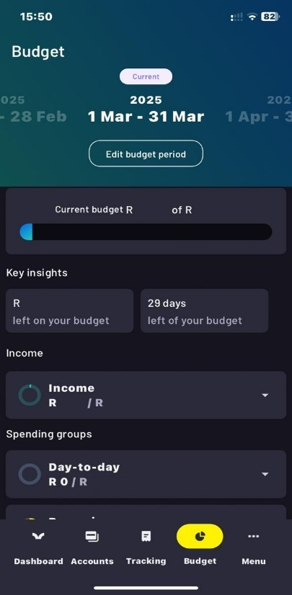
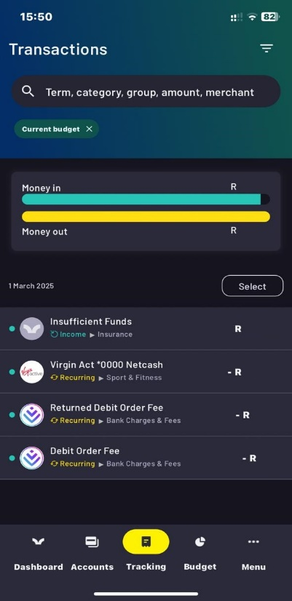
Users can track their all transactions based on category, and select which transactions during a specified period

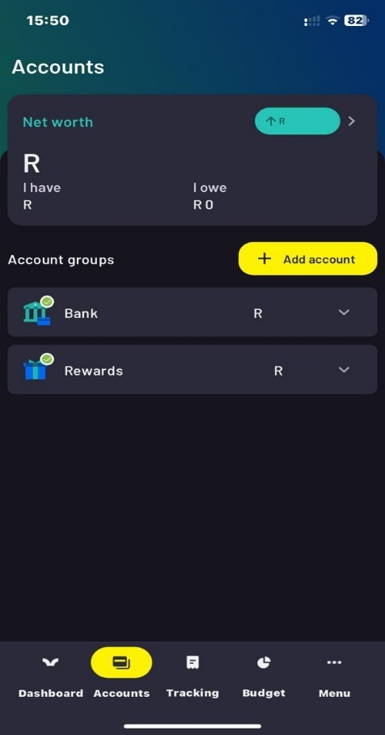
On the accounts screen users can view all their financial accounts. Additionally, users can also add additional financial accounts on this screen.
Strengths:
- Automated aggregation and categorization of transactions.
- Seamless, read-only, and encrypted integration with South African banks which are held to high standards.
- Significant time and effort savings for users.
- User-friendly UI and app structure.
- Comprehensive, unified view of a user’s financial life (eliminating the need for multiple apps). (Vault22, 2025)

Weaknesses:
- Data accuracy is dependent on the financial institution’s integration.
- Lack of customization options for advanced users.
- Potential user discomfort with a third-party app accessing financial accounts. (Vault22, 2025)

Innovative Features:
- Automatic Transaction Categorisation
- Customised Budgeting Tools
- Net Worth Tracking
- Investment Tracking
- Debt Tracking
- Reports and Insights
- Security
- Seamless Integration with South African Banks (Vault22, 2025)

YNAB(You Need a Budget):
When creating an account for YNAB you are asked to complete a questionnaire to learn about your expenses and debt, then organizes the expenses into Monthly expense, needs, and Wants (Ynab.com, 2024). 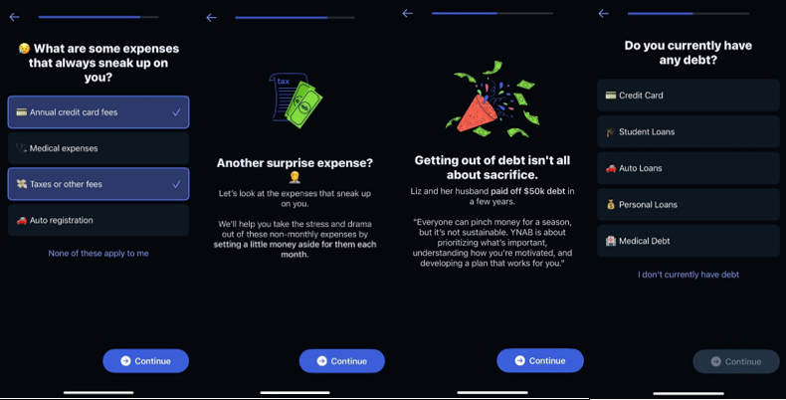from this page you set targets for your expenses and can select when these payments are due and control if they're constant payments (weekly or monthly) on this page, you can also edit the amount associated with each expense (Ynab.com, 2024). 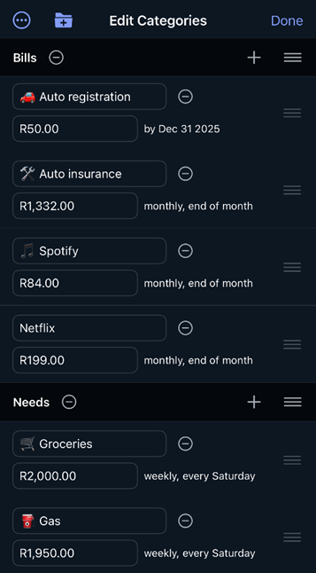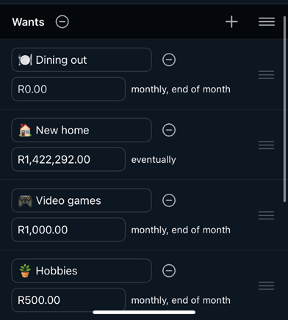
now it will shows how much money you have put towards each expense category as well as a bar showing you progress to the target, you can also link you bank account or create your own separate account with a balance you can edit both allow manual entering of expenses, once you have an account you can start to choose where to assign your money too or use their auto-assign feature to do it for you, once that money is assigned it will fill with a second grey bar showing the amount of funds used (Ynab.com, 2024).
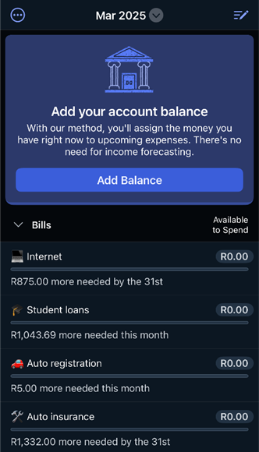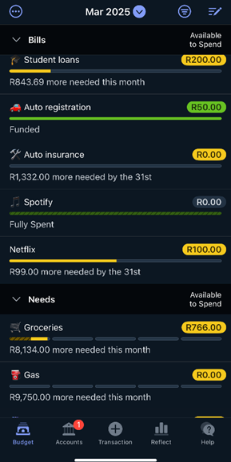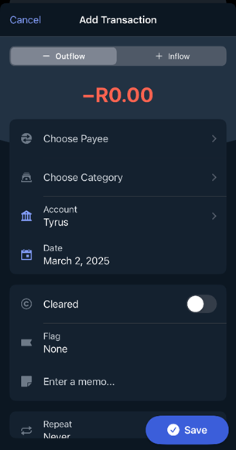
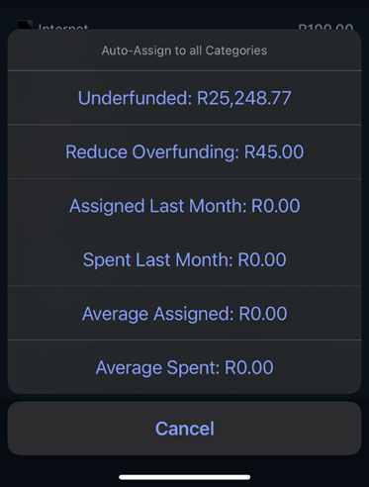
Innovative features
The reflect tab that gives a breakdown of all your spending and monthly spending as well as calculates your Net Worth , the reflect tab also has a feature called age of money which will help to gauge time between earning and spending which will prevent you from sitting on money and helps you better plan how that money can instead be used on further future payments (Ynab.com, 2024).
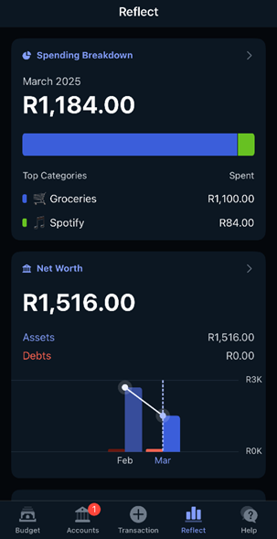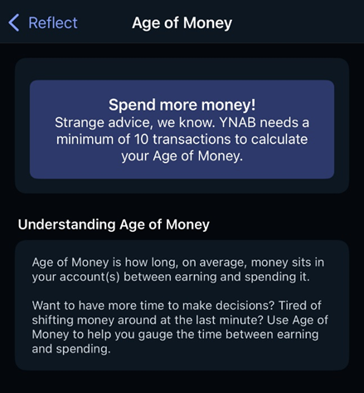

The help tab that that provides resources to the users that will help them understand how to better use the YNAB app and also helps them to better understand their banking and finances which results in better money management skills , the help tab also offers a YNAB AI support bot to better assist you with any problems you run into but if you prefer human support they also offer their human support team (Ynab.com, 2024).
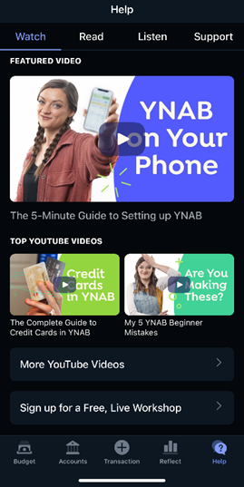
Strengths
- The YNAB app has great visuals making use of graphs and other similar info graphics making it easy for a user to understand how and where their money is spent within a month.
- The app offers lots of resources to help the user understand both finance and how to efficiently use the app. (Tommy & Neidel, 2024)
- Offers useful features like spending breakdowns, net worth calculations and an old money feature to help show you how to efficiently spend money you are not using (Tommy & Neidel, 2024)
Weaknesses
- The interface design can be confusing at first, but you will eventually understand how to use it thanks to their guides.
- The money management process of the app is a lot more hands on instead of automatic making difficult for some users to use if they don’t understand finances. (Tommy & Neidel, 2024)
- YNAB does not offer a free version of their app, and it is quite pricey whether you choose their monthly or yearly subscription fees. (Tommy & Neidel, 2024)

App Comparison
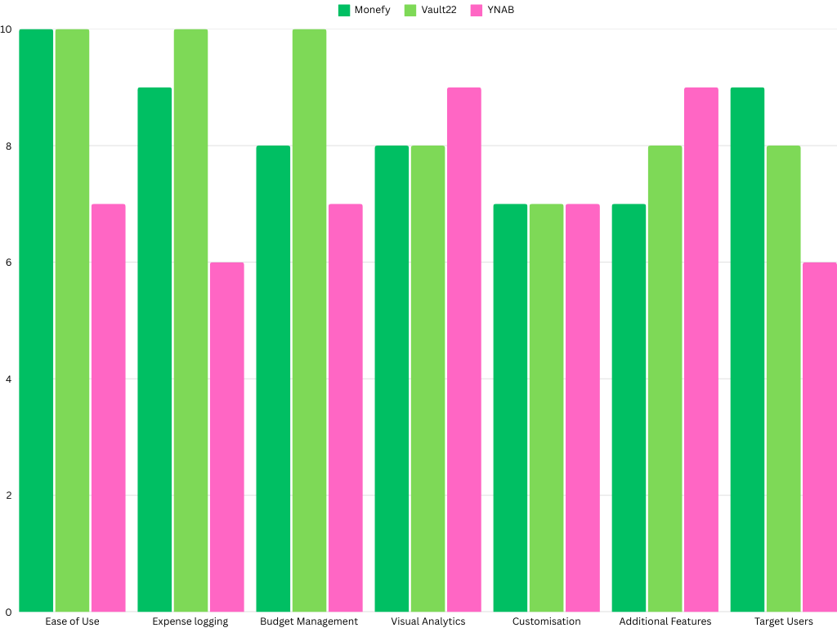

Conclusion
The research phase provided us with an understanding of the core functions and features of the top budgeting apps. By combining the strengths of these apps, our final product will no longer be only an expense tracking app, it will be an engaging, and a customizable financial companion. User experience will be a primary focus of our app by providing a seamless user experience through a calm and a visually dynamic interface. The logging of expenses will be fast, stress-free and intuitive. Furthermore, with innovative features like seasonal progression rewards, cross device synchronization, automatic aggregation of logged expenses, allows the user to focus on building regular engagement with the app and will be making informed financial decisions.

References
Reflective Technologies. 2018. Monefy | Handy personal finance management tool for iOS and Android. [online] Monefy.com. Available at: https://monefy.com/ [Accessed 25 Feb. 2025].

Ynab.com. 2024. YNAB. [online] Available at: https://www.ynab.com/ [Accessed 18 Mar. 2025].
Tommy, T. & Neidel, C., 2024. Review: We Tested the YNAB App. [Online]
Available at: https://www.nerdwallet.com/article/finance/ynab-app-review
[Accessed 31 February 2024].

Vault22, 2025. Vault22 formely 22Seven. [Online]
Available at: https://www.vault22.io/za
[Accessed 2 March 2025].

‌

Planning & Design

Introduction
In times where financial responsibility is more crucial than ever. They ways in which you can spend your money has increases rapidly over the past century. This is why budgeting applications play a significant role in helping individuals manage their expenses effectively. Our applications name is !Broke which stands for not broke which is what we strive for nowadays isn’t it? So, worry not !Broke is designed not just as a traditional budgeting tool but as an engaging and gamified experience that encourages users to take control of their finances in an intuitive and rewarding way. Unlike conventional budgeting apps, which often feel restrictive or tedious, !Broke incorporates a seasonal progression system, debt repayment planning, real-time net worth tracking, and automatic expense aggregation, making financial management both effortless and engaging.

This research explores three existing personal budgeting apps that we have made to analyse their features, strengths, and areas for improvement. By understanding what makes a budgeting application effective, we aim to implement the most innovative, user-friendly, and functional features in !Broke, ensuring that users receive a comprehensive financial planning tool that is both practical and motivating. The research also has an analysis through comparison, which is by identifying key features that contribute to a better user experience and a better financial discipline.

Through this analysis, !Broke will take inspiration from the best features we can come up with while ensuring that users not only track their spending but also enjoy the process of financial growth.

Overview
App Name:
!Broke
(The exclamation mark implies “not” from programming syntax, symbolizing that while you may be “broke” in name, you are anything but financially irresponsible.)
Tagline:
"Not Broke. Only Smart."
Concept:
!Broke is a contemporary application which is centred around its users, combines budgeting with gaming, and is able to track both expenses as well as help its users adhere to their budget. By combining unique elements along with expense tracking, such as an automated categorization tool, seasonal progression system, as well as an all-inclusive debt repayment planner, !Broke strives to give users in need of financial management tools assist in a captivating, straightforward, and enjoyable way!

Initial Icon Design:
- Visual Concept: A modern logo that fuses an exclamation mark and a piggy bank.
- Colour Palette: Choose reliable colours like deep green because green represents growth and wealth.
- Style: The most simple and flat illustration that uses sharp edges and blends. The logo must be easily identified on a mobile device while suggesting alertness and empowerment financially.

Innovative Features:
- Seasonal Progression & Gamification: Users can earn badges and rewards while staying in budget as they progress through seasonal challenges.
- Debt Repayment Planner: Using motivational badges, users can set for milestones where progress bars and visual timelines show where their debts will be paid off.
- Automatic Expense Aggregation: Employ smart algorithms to auto-sort expenses (either through imported data or receipt scanning) to make expense tracking easier.
- Real-Time Net Worth Calculator: Calculate net worth instantly with expense, asset, liability integration alongside graphical displays of trends over time.
- Custom Alerts & Notifications: Set alerts to notify when reaching or going over budget and when milestones are reached for further customization.

Requirements list
A. User Authentication and Profile Management
- Registration & Login:
  - Functionality: Users must register using a unique username and secure password.
  - Security: Implement email verification, password encryption, and optional two-factor authentication.
  - Account Recovery: Include options for password reset and “remember me” functionality.
- Local User Profile Storage:
  - Data: Store user preferences, default categories, budget settings, and profile details (e.g., display name, profile picture, currency).
  - Offline Capability: Ensure profile data is stored locally for fast access and offline functionality, with periodic synchronization.

B. Expense Management
- Expense Entry Creation:
  - Data Fields: An expense entry includes a required amount, date, description, and category.
  - Additional Inputs: Give the option for tags, notes, and checkboxes for recurring expenses.
- Photo Attachment for Receipts:
  - Integration: Users can add receipts by taking a new photo or selecting one from their device’s gallery.
  - Accessibility: The images must be stored with the expense entry for both list and detailed views.
- Expense List and Detailed View:
  - Filtering: Detailed view, with filtering user-selectable periods (daily, weekly, monthly, or custom ranges).
  - Receipt Access: Enable thumbnail images showing the linked receipt to be clicked within the details view so the photo can be seen in full screen.
  - Sorting: Enable sorting and searching by date, category, or amount.

C. Expense Category Management
- Custom Categories:
  - Functionality: Users should be able to add, edit, and delete any question category expense (i.e. “Groceries,” “Entertainment,” “Transport”)
  - Customization: Each category should allow an icon, colour, and order priority to be set for display in summaries and graphs Customization of each category should be allowed.
- Predefined Categories:
  - Set some basic categories that users can change or add

D. Budget Goals and Limits
- Monthly Budget Goal:
  - Global Setting: Allow users to set an overall monthly spending limit.
  - Visual Indicators: Provide real-time visual feedback (e.g., progress bars) to show remaining budget.
- Category-Specific Limits:
  - Customization: Enable users to set spending limits for individual categories.
  - Alerts: Display visual and/or notification-based alerts when spending nears or exceeds these limits.

E. Analytics and Visualization
- Spending Graphs:
  - Trends: Provide daily spending patterns for individual users through interactive graphs (line or bar) over user-selectable durations.
  - Breakdown: Display differentiations for graphs by categories with capabilities of tapping data points for more detailed breakdown.
- Category Spending Overview:
  - Summary: Display total spending in each category selected over periods through visual summaries (pie).
  - Interactivity: Enable users to access detailed expense entries within each category.
- Progress Dashboard:
  - Overview: Design a central dashboard with clear metrics visually tracking the user's progress towards monthly budget goals.
  - Alerts: Warn users of overspending categories with distinct colours or warning icons.
- Net Worth Calculator:
  - Integration: Permit users to input cash, investments, properties, debts, and loans to arrives at their total net worth.
  - Trend Analysis: Provide interactive graphs which display changes in net worth over time.

F. Gamification and Advanced Features
- Seasonal Progression System:
  - Rewards: Create a system that rewards staying within budget for set periods with badges, points, or similar incentives (e.g., compete through monthly or quarterly challenges)
  - Challenges: Develop challenges that are shareable with friends or members of the community.
- Debt Repayment Planner:
  - Data Inputs: Allow users to specify debt details (total amount, interest rate, repayment schedule).
  - Visualization: Include a timeline or progress bar to track the debt payoff schedule.
  - Milestones: Award milestones badges as users progress through key repayment milestones.
- Automatic Expense Aggregation:
  - Functionality: Employ set parameters or machine learning to expense data for previously defined logically fetched data such as bank statements or scanned receipts
  - User Control: Enable users to adjust and review auto-categorized entries and set preferences for the categorization rule.
- User Alerts and Notifications:
  - Customization: Let users set custom thresholds that will trigger alerts for spending, upcoming bills, or earned rewards.
  - Delivery: Ensure real-time alerts via push notifications, emails, or in-app notifications.

G. Cloud Synchronization
- Data Syncing:
  - Cross-Device Access: User information must be kept in an online database for it to be accessed from different devices with minimum hassle.
  - Conflict Resolution: A procedure for resolving data conflicts resulting from simultaneous edits made on various devices should be established.
- Security:
  - Put in place appropriate measures to ensure that information sent and saved is secured with encryption and complies with the relevant privacy laws.

UI
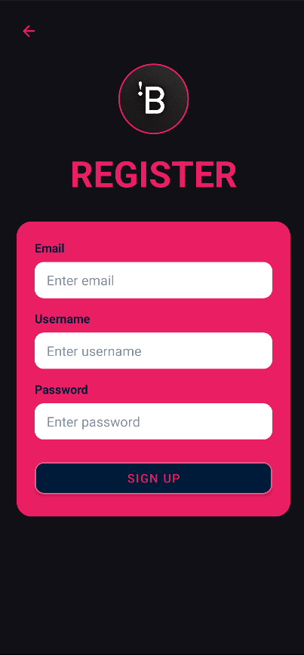
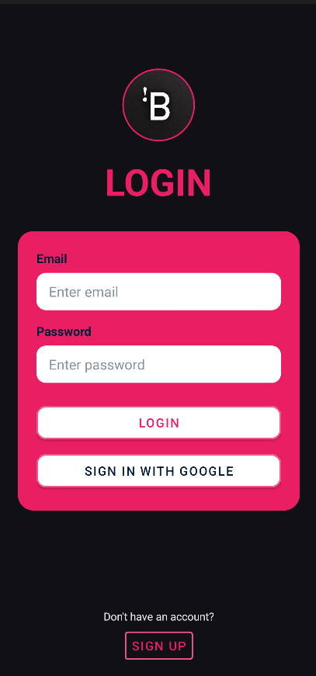
Users who are not signed into or who do not have an account must either sign into their account or create a new account by signing up.
Once the user presses sign up, they will be taken to the register screen, where they will be asked to create an account.
LOGIN | REgister

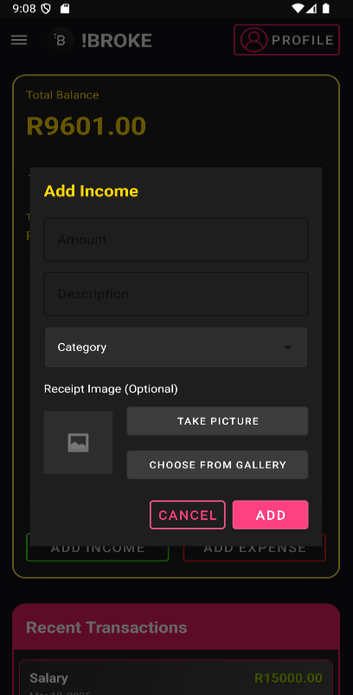
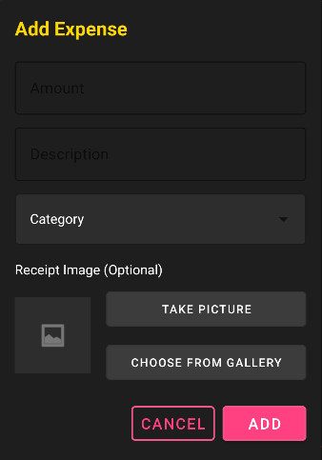
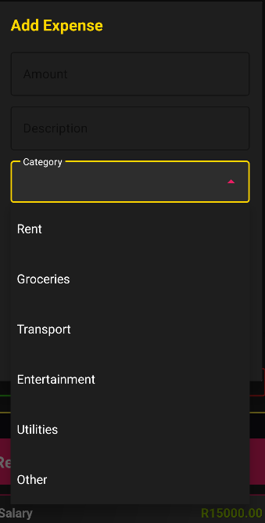
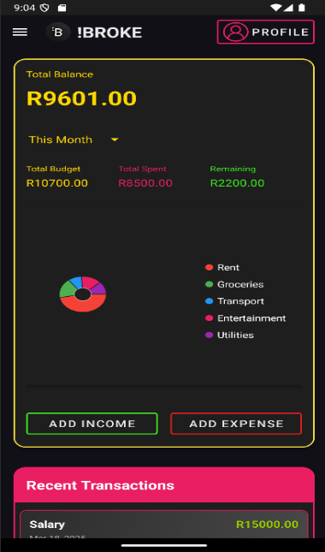
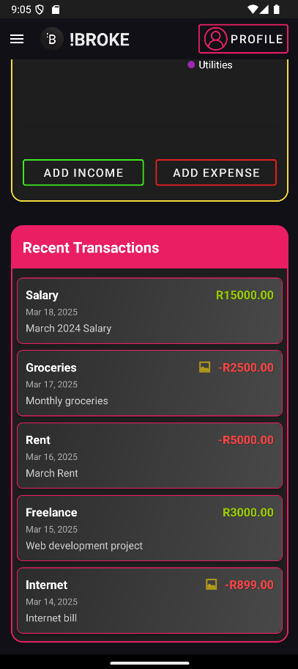
When users click on Add Income / Add Expense the appropriate pop up appears ready to capture the transactions details, with an option to upload a receipt as an image.
Users who are signed into an account will see this as their home screen. This is the dashboard; users can quickly glance at a spend breakdown detailing where their expenses have gone.
Users can also see their recent transactions.
Users are also able to add expenses or income.
Dashboard
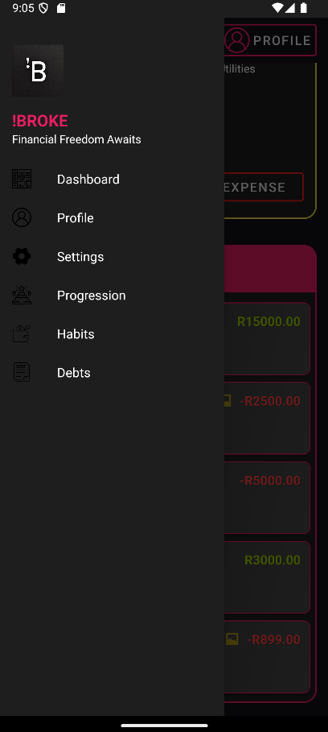
Users will navigate !Broke through the side navigation menu that will open when they press the hamburger in the top left of the toolbar.
Side navigatiom menu
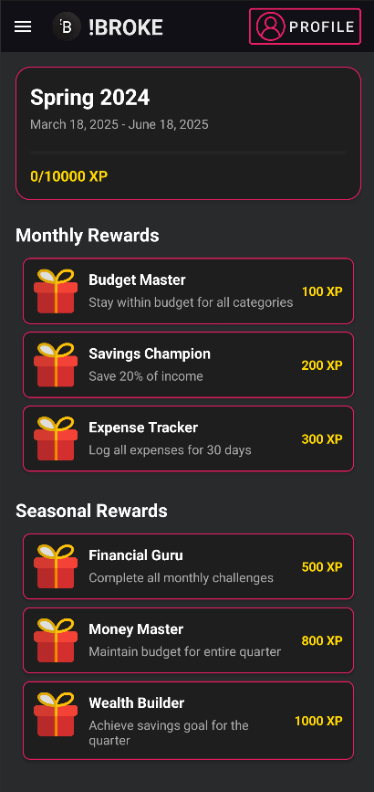
Users can claim their completed tasks here to earn experience, or other rewards.
Seasonal progression
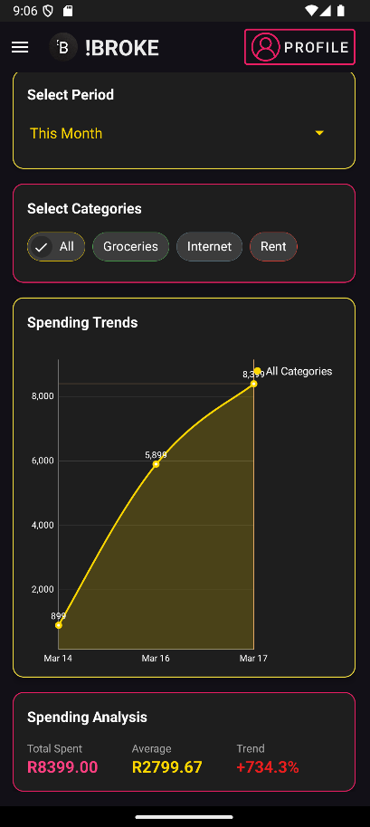
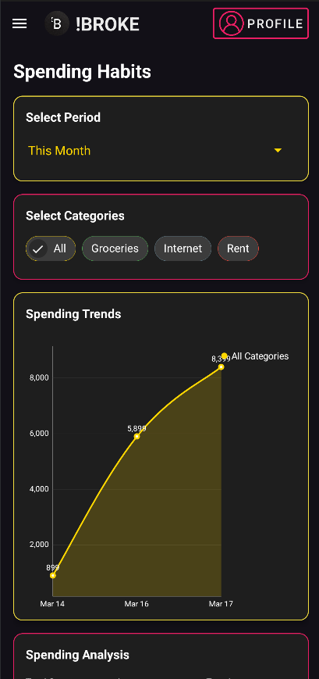
Users can see a more detailed spend breakdown of their funds. Users can specify which categories they would like to analyze. Additionally, users can choose a period to analyse.
Habits

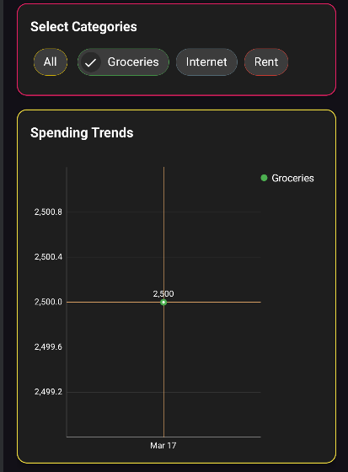
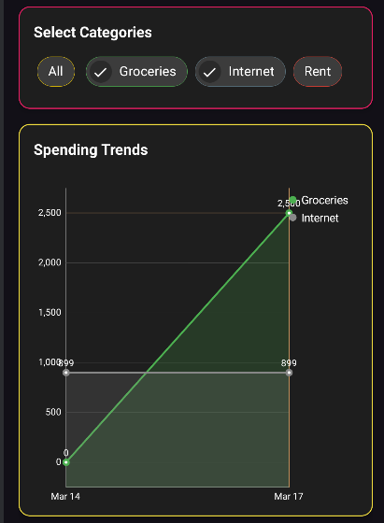
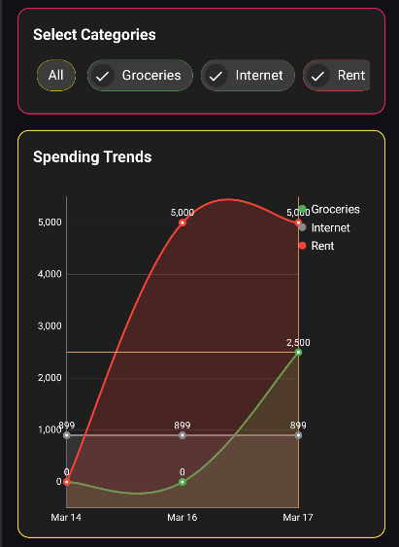

Users can customise the information the graph displays.
Users can choose which categories to display in addition to the period they would like to analyse.
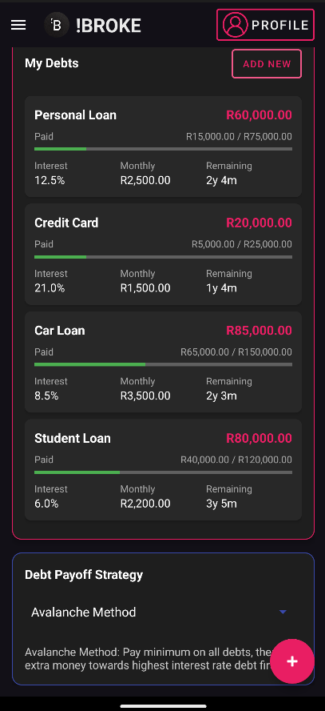
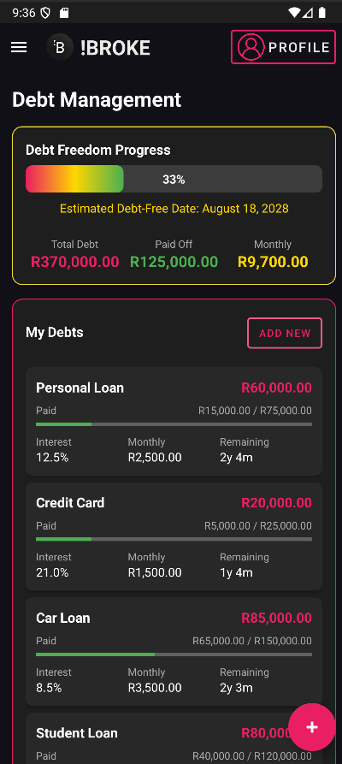
Users are able to manage and track their debt repayments. Users can visually see when they will be debt free, with a progress bar. Users can add payments or new debts from this screen. Additionally, users can choose their debt payoff strategy.
Debt management

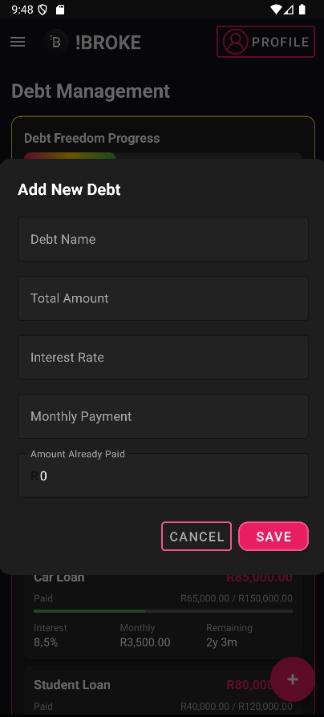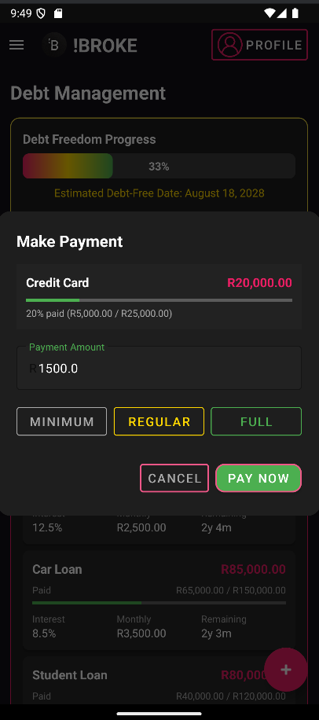
Popups that will appear when the user wants to add a new debt or the user can log a payment to a debt by clicking on debt.

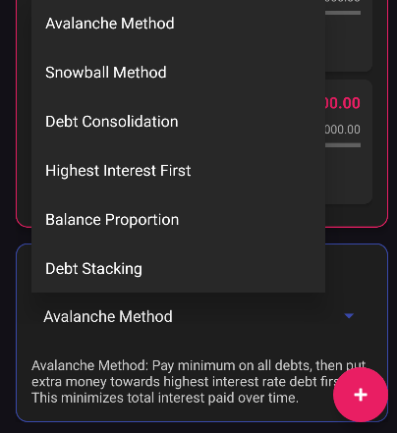
User can choose between different payoff strategies

Navigation Draw up
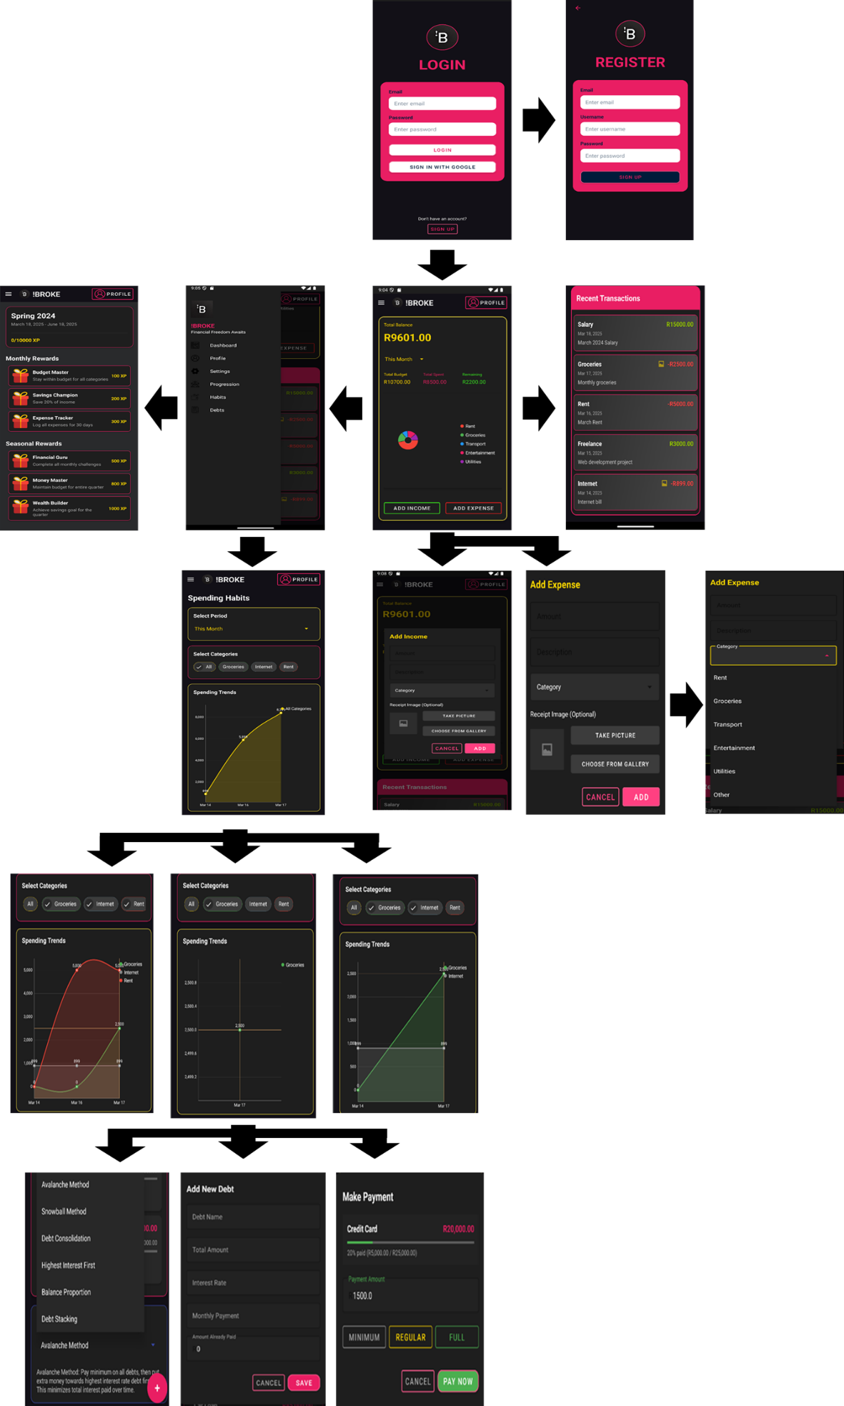

Project Plan
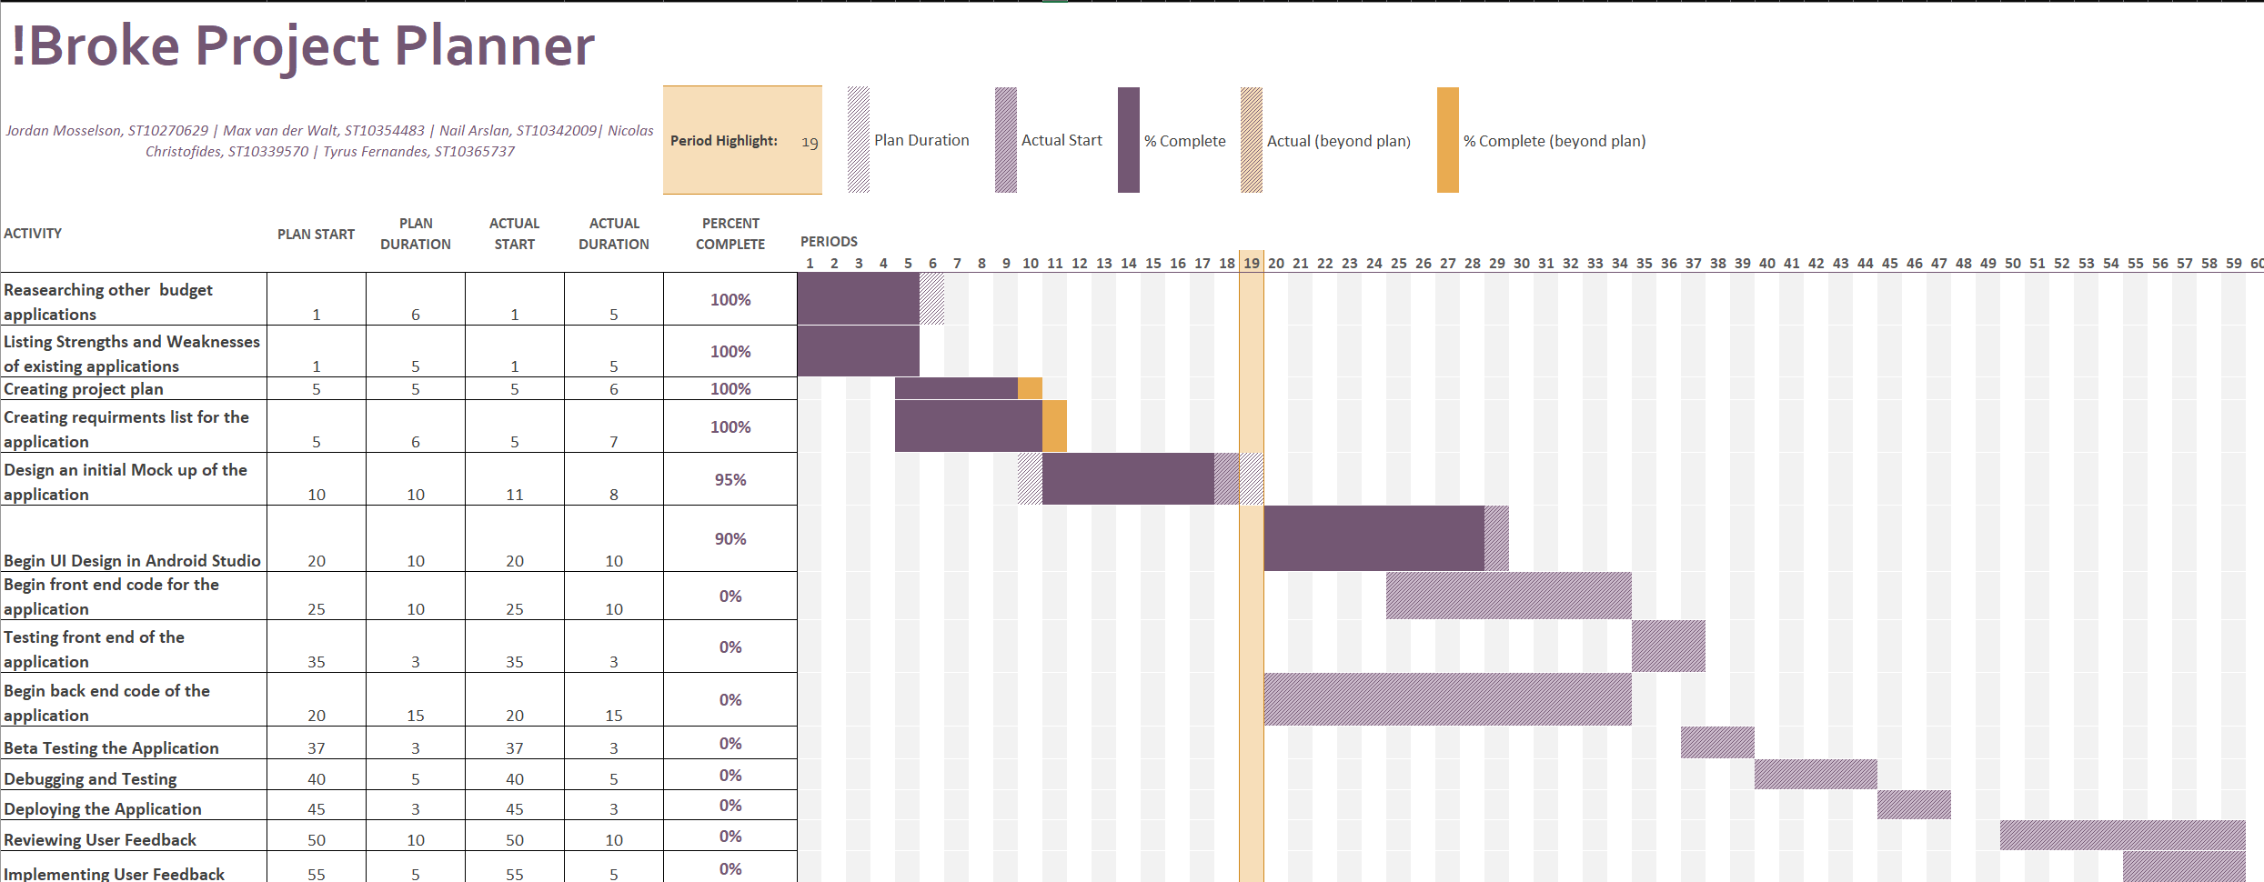

Conclusion
Effective budgeting is not just about tracking expenses, it’s about creating sustainable financial habits. If we don’t change our bad habits that lead to overspending, we cannot achieve long term financial stability. Which is why our app “!Broke” helps in that regard empowering individuals to change bad habits and achieve a long-term financial stability. Through the research that we created using our budgeting apps, we have found important features and innovations that help achieve a more engaging and efficient financial management experience.

From the things we learned, !Broke is designed to be more than just a budgeting app; it is a comprehensive financial companion that makes use of gamification, automation, and smart ways to provide users with real-time insights and motivation. The inclusion of a seasonal progression system, debt repayment planner, and automatic expense aggregation makes it different from traditional budgeting applications, making financial planning a rewarding experience rather than a chore.

By adding the most effective features from existing apps and innovative elements, !Broke strives to redefine personal finance management. With its intuitive design, engaging rewards system, and powerful analytics, this app will allow user to have more control over their finances, make informed decisions, and help achieve their financial goals with ease.

References
FlatIcon, n.d. Dashboard. [Online]
Available at: https://www.flaticon.com/free-icon/dashboard_4335416?related_id=4335416
[Accessed 15 March 2025].
FlatIcon, n.d. Debt. [Online]
Available at: https://www.flaticon.com/free-icon/debt_4334495?term=debt&page=1&position=29&origin=search&related_id=4334495
[Accessed 15 March 2025].
FlatIcon, n.d. Progress. [Online]
Available at: https://www.flaticon.com/free-icon/success_14913466?related_id=14913466
[Accessed 15 March 2025].
FlatIcon, n.d. Settings. [Online]
Available at: https://www.flaticon.com/free-icon/setting_3019014?term=settings&page=1&position=6&origin=search&related_id=3019014
[Accessed 15 March 2025].
FlatIcons, n.d. Habits. [Online]
Available at: https://www.flaticon.com/free-icon/spending_10758854?term=spending&page=1&position=1&origin=search&related_id=10758854
[Accessed 15 March 2025].
FlatIcons, n.d. Rewards. [Online]
Available at: https://www.flaticon.com/free-icon/gift_3179668?term=reward&page=1&position=6&origin=search&related_id=3179668
[Accessed 15 March 2025].
https://www.flaticon.com/free-icon/user_1144760?term=account&page=1&position=3&origin=search&related_id=1144760, n.d. Flaticon. [Online]
Available at: https://www.flaticon.com/free-icon/user_1144760?term=account&page=1&position=3&origin=search&related_id=1144760
[Accessed 15 March 2025].

