1.download nebula-windows-amd64.zip from github

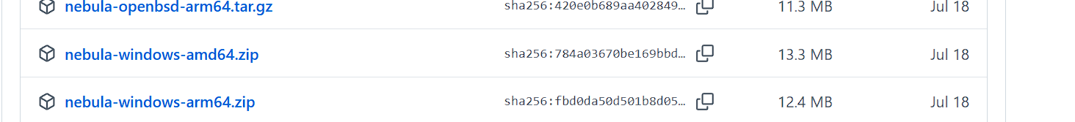

Extract the downloaded compressed file to D:\nebula. After extraction, get

nebula.exe and nebula-cert.exe

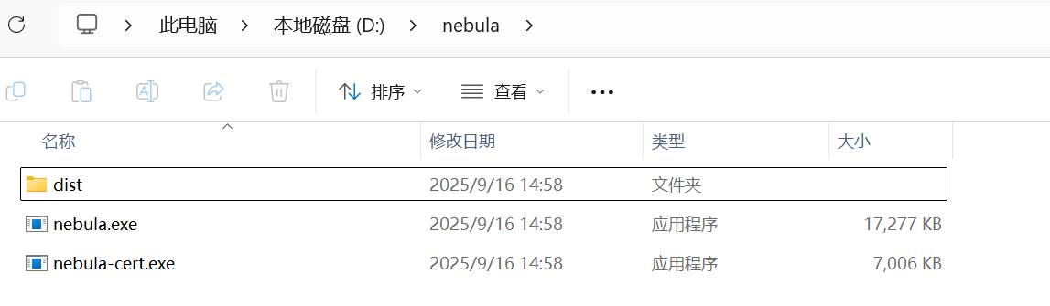

2.Obtain three files from the instructor: your name.crt, your name.key, and ca.crt. Copy these three files to the D:\nebula working directory.

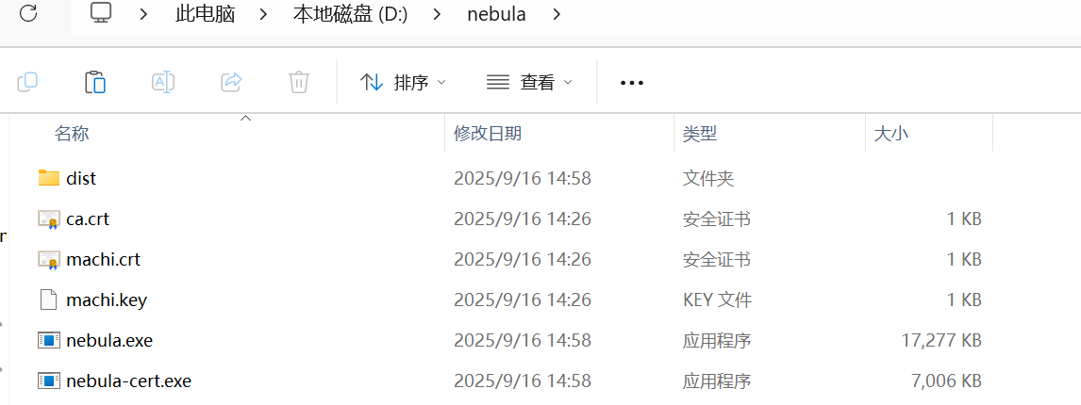

3.config and save the config.yaml

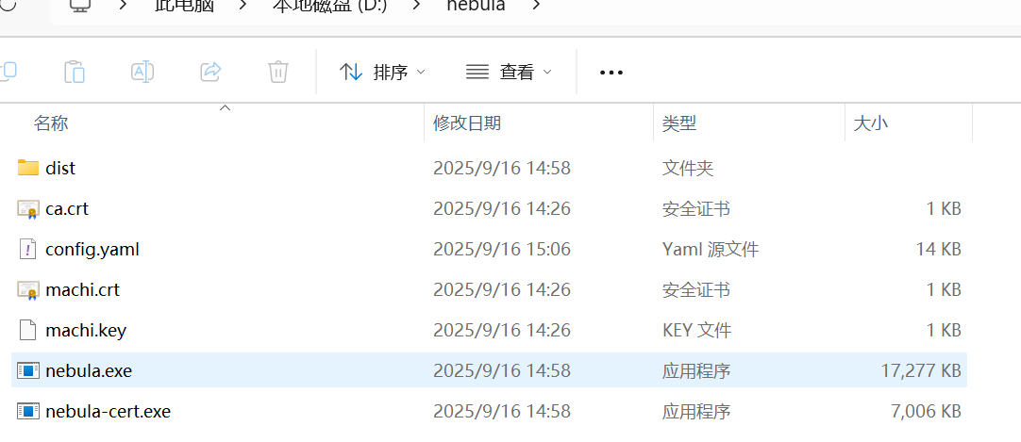

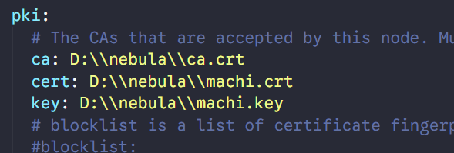

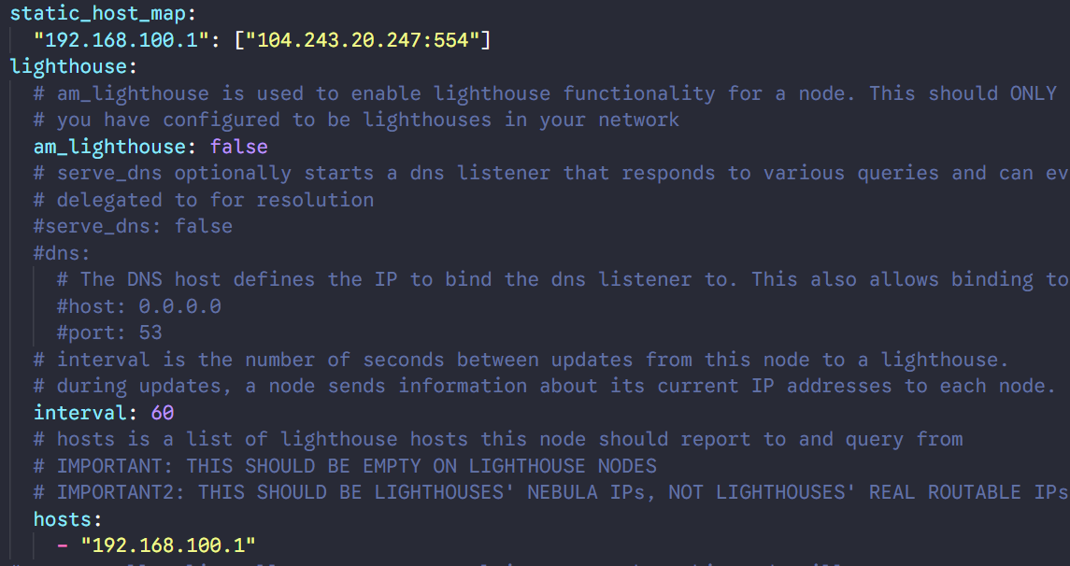

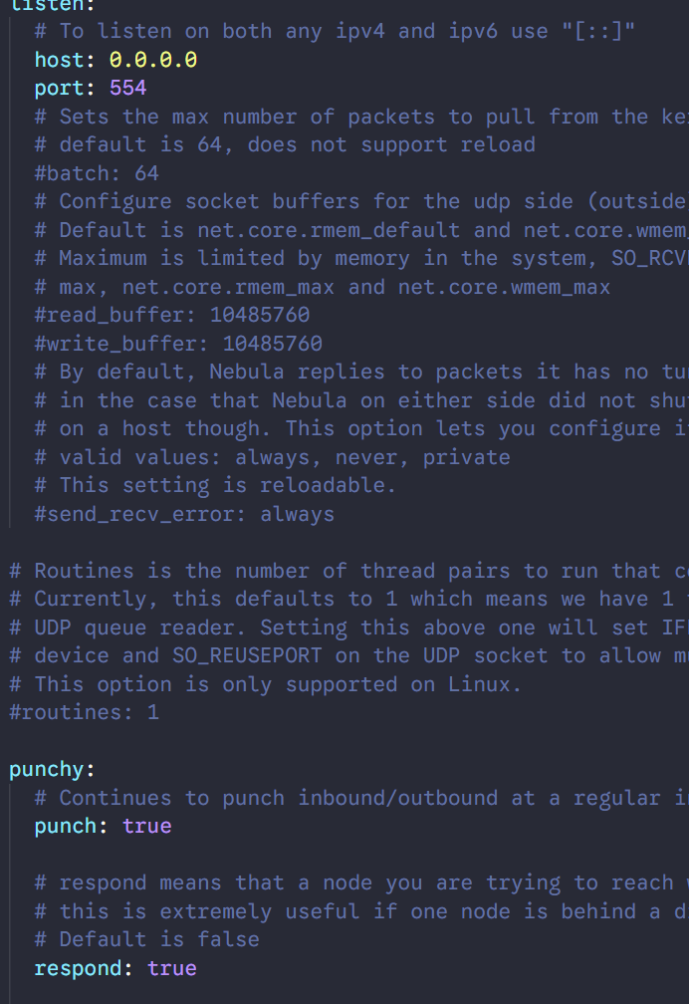

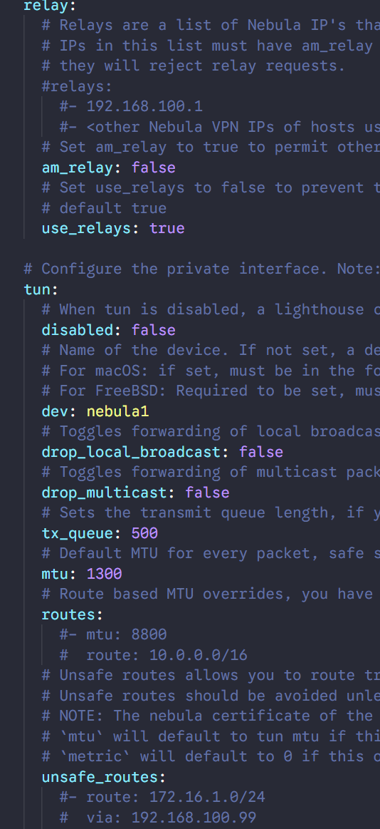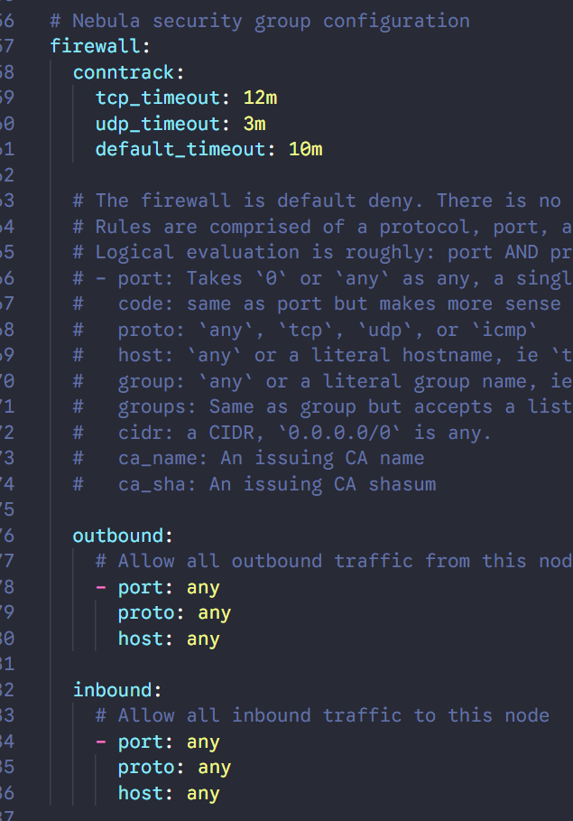

1. Run cmd as administrator,

cd d:\nebula

nebula.exe -config D:\nebula\config.yaml

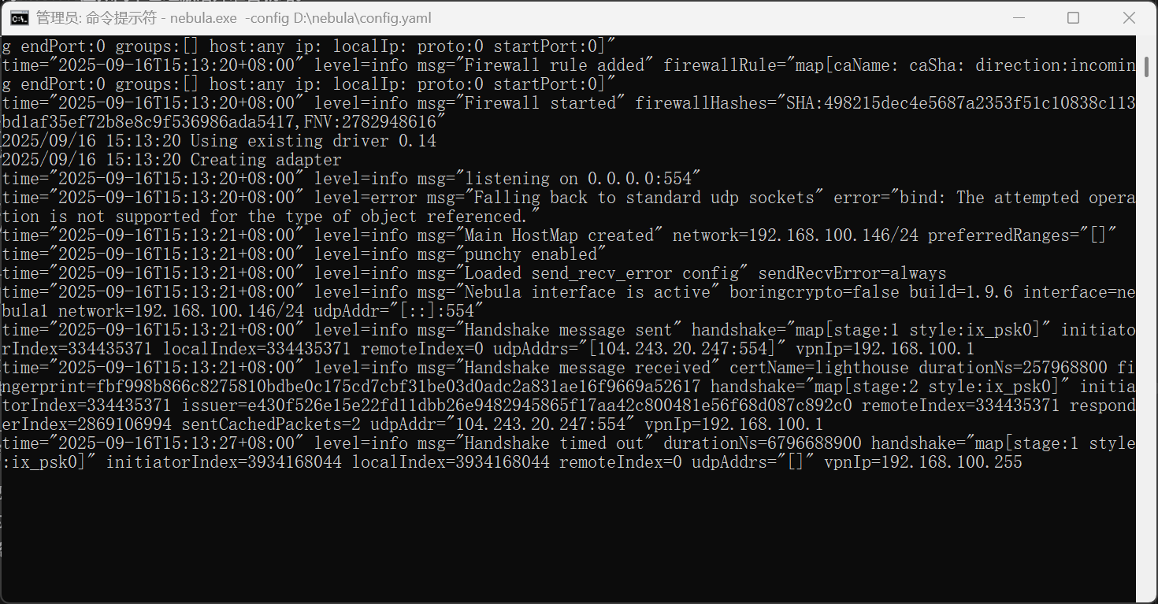

Keep the previous CMD window running and open a new administrator CMD window.

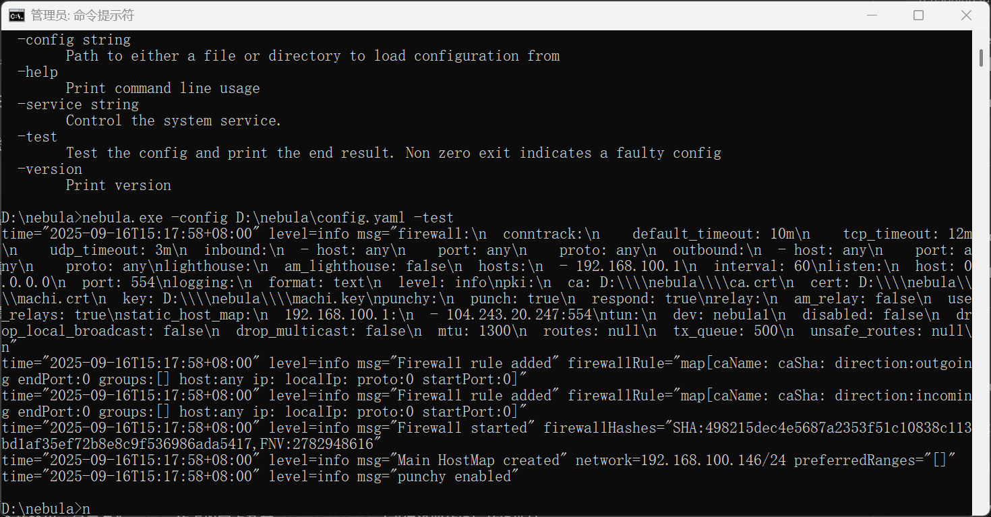

ping 192.168.100.1

图片包含 文本

AI 生成的内容可能不正确。

Try connecting to the remote server at IP address 192.168.100.1 as user nuist  
enter yes and input the password

