1. Install Docker Desktop
   1. Install WSL (as my OS is Windows11)
      1. Open cmd (Run as Administrator)
      2. Run wsl --install

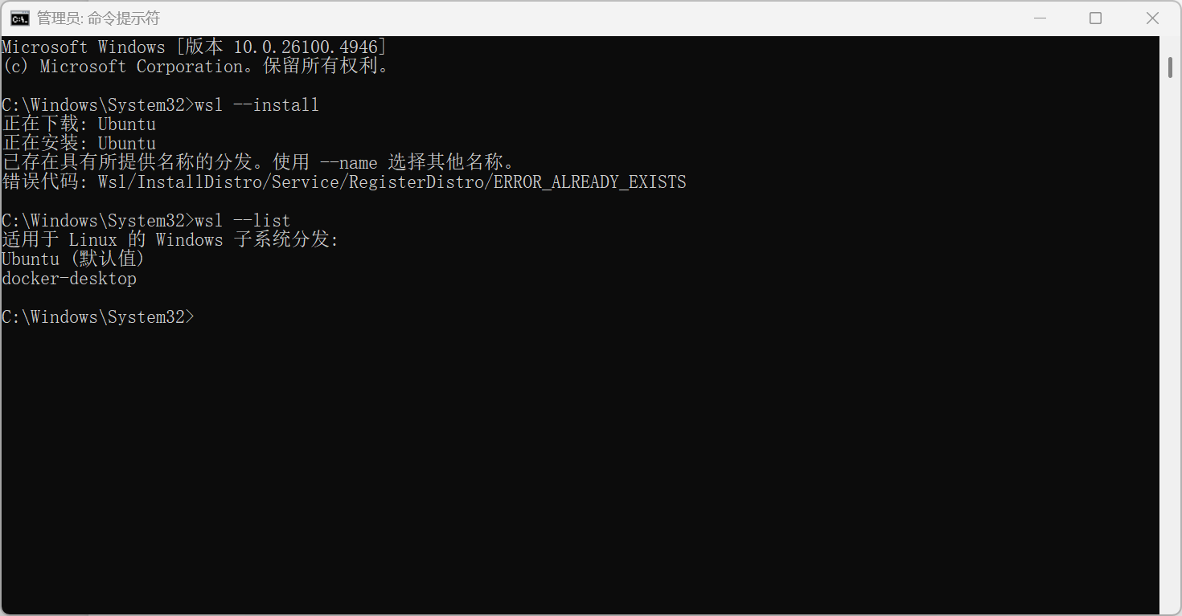

Restart the computer

* 1. download and install Docker Desktop
     1. Visit the official Docker website to download the Docker Desktop installation package: <https://www.docker.com/products/docker-desktop/.>

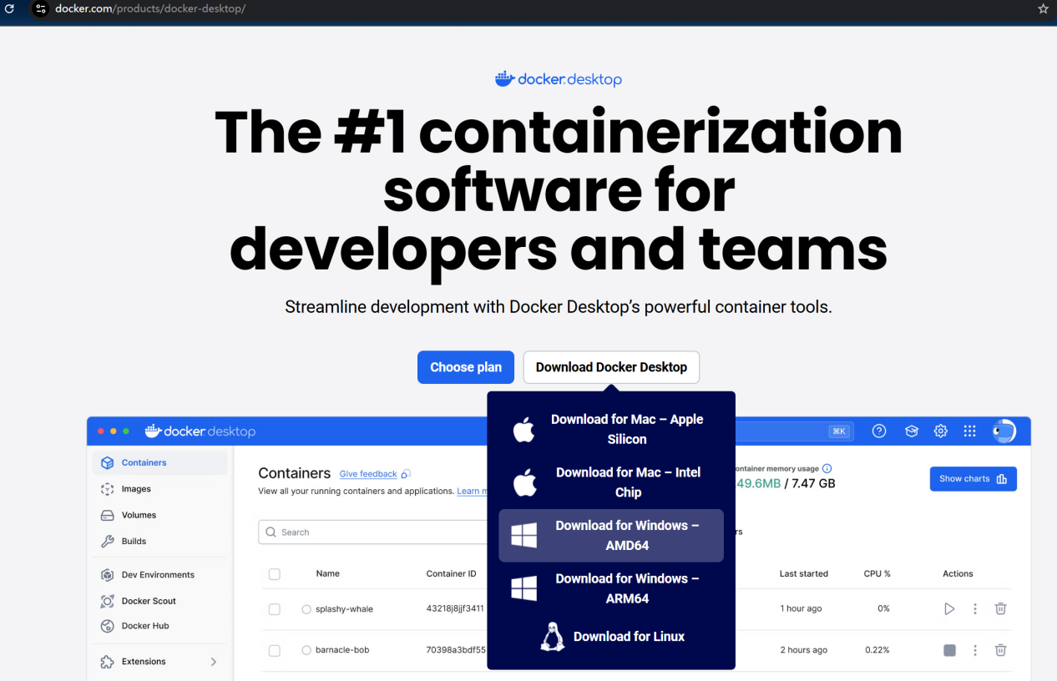

* + 1. Install Docker Desktop

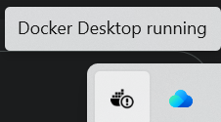

Register a Docker ID and log in

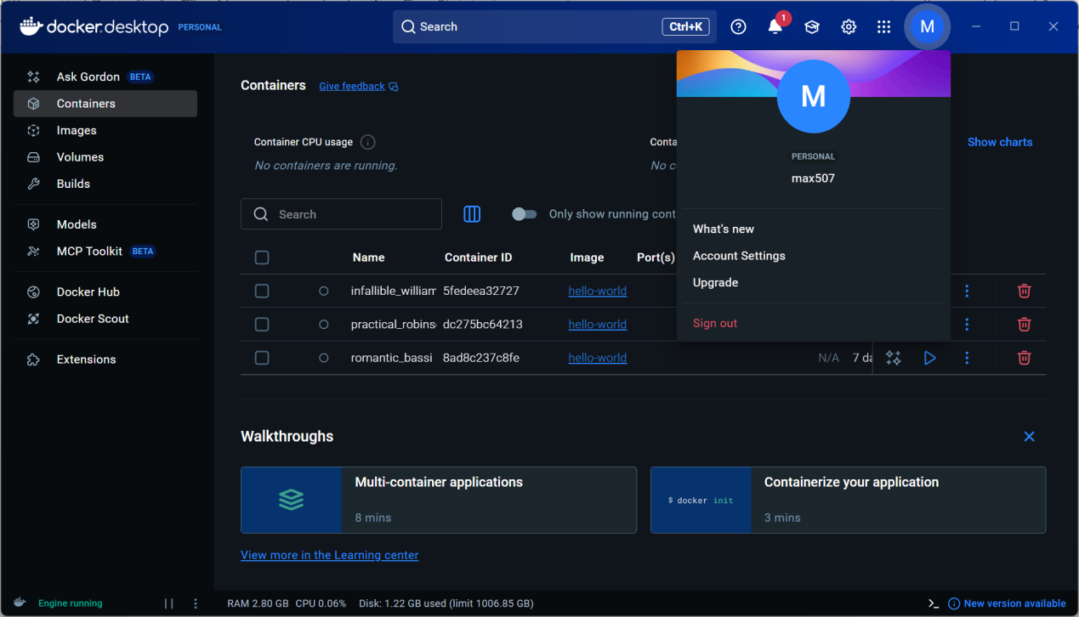

Run “docker run hello-world” in cmd and see:

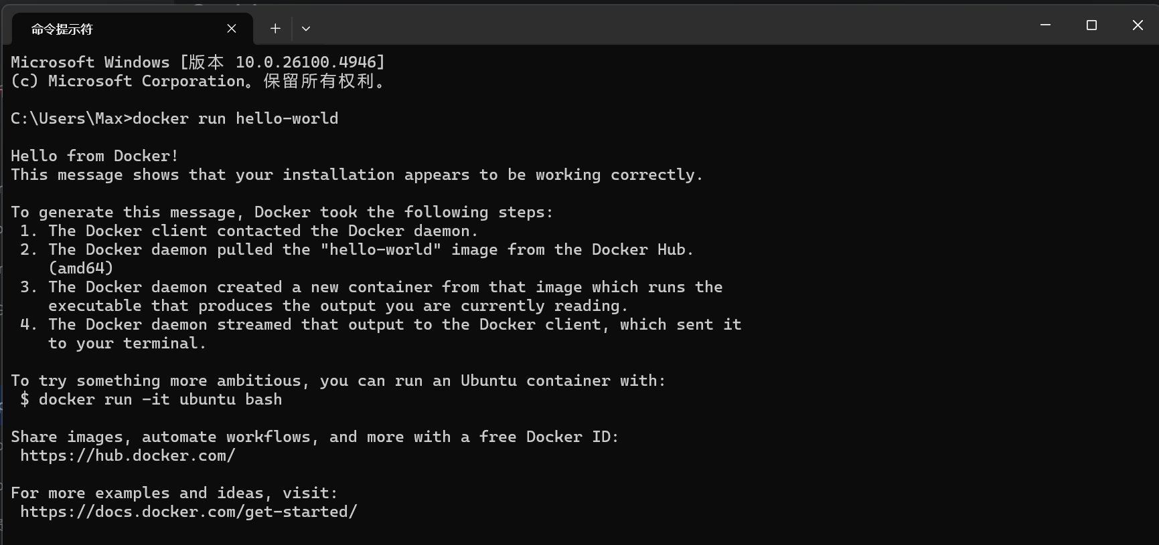

1. Use Docker to install Gitea
2. Create the directories required by Gitea

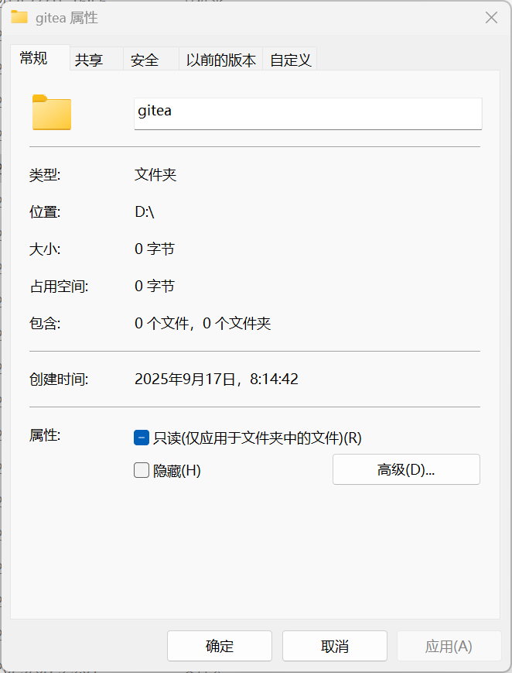

In this folder, create a subfolder named data to store database, warehouse and other data.

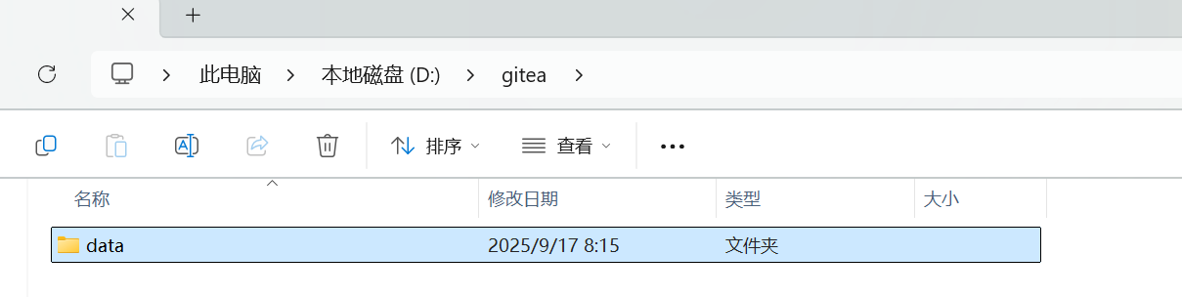

1. Running the Gitea container with Docker
2. run “docker pull gitea/gitea:latest” to pull (download) Gitea's Docker image

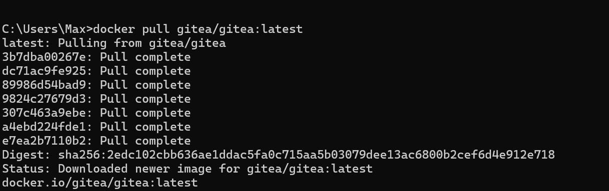

1. run “docker run -it -p 3000:3000 -p 2222:22 --name gitea -v D:/gitea/data:/data gitea/gitea:latest” to run Gitea Docker

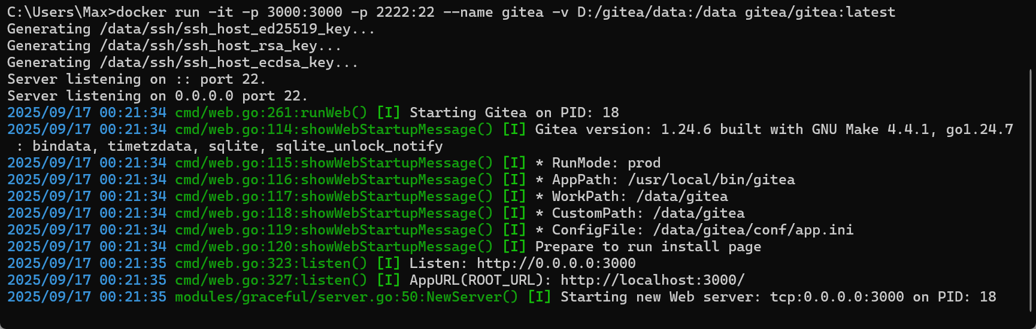

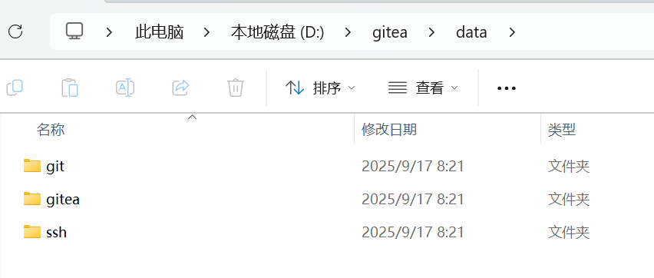

1. Configure Gitea
2. Visit http://localhost:3000 in your browser.
3. see the Gitea installation configuration page. Fill in the following information:

Database Type: Select SQLite3 (the simplest, no additional installation required).

Application URL: http://localhost:3000.

Gitea installation path: /data/gitea.

Administrator Account and Password: Create your own administrator account.

1. Click "Install Gitea Now."

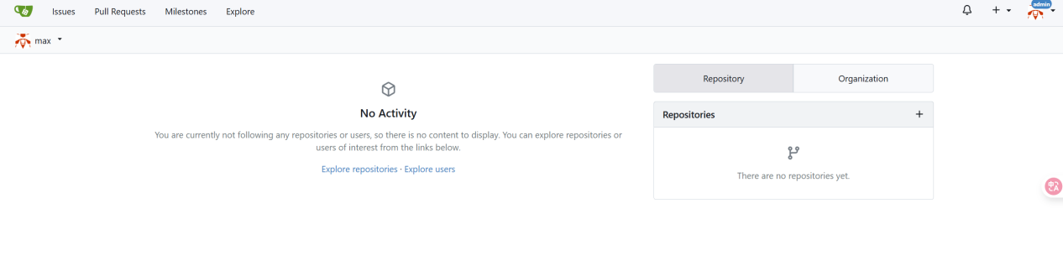

1. finish the lab task
2. gitea suport LFS 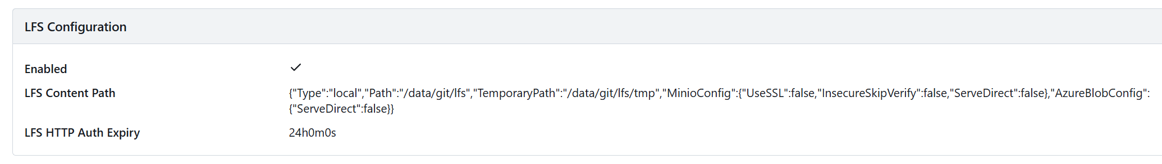
3. Create a repo with a large file(1G+)

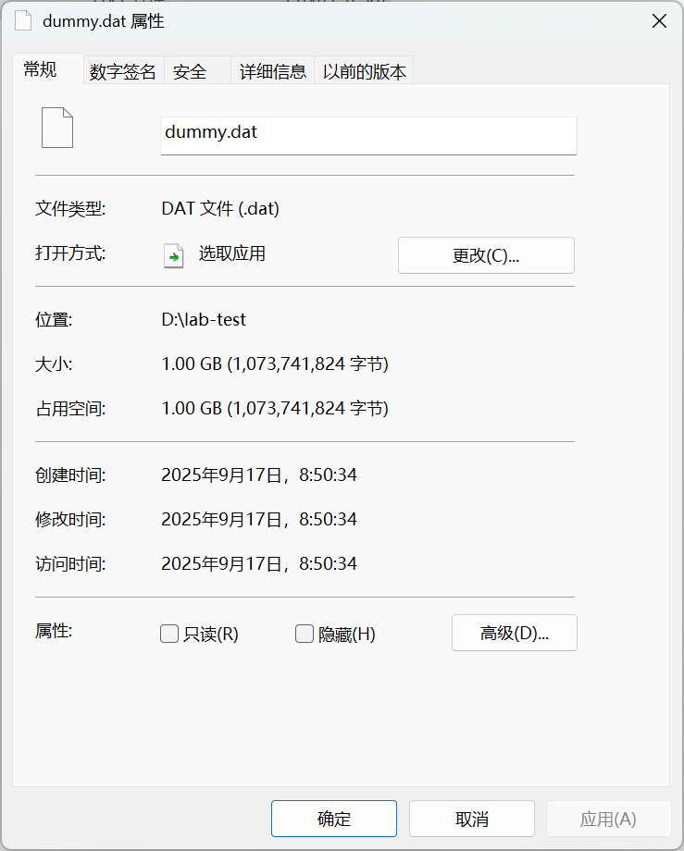

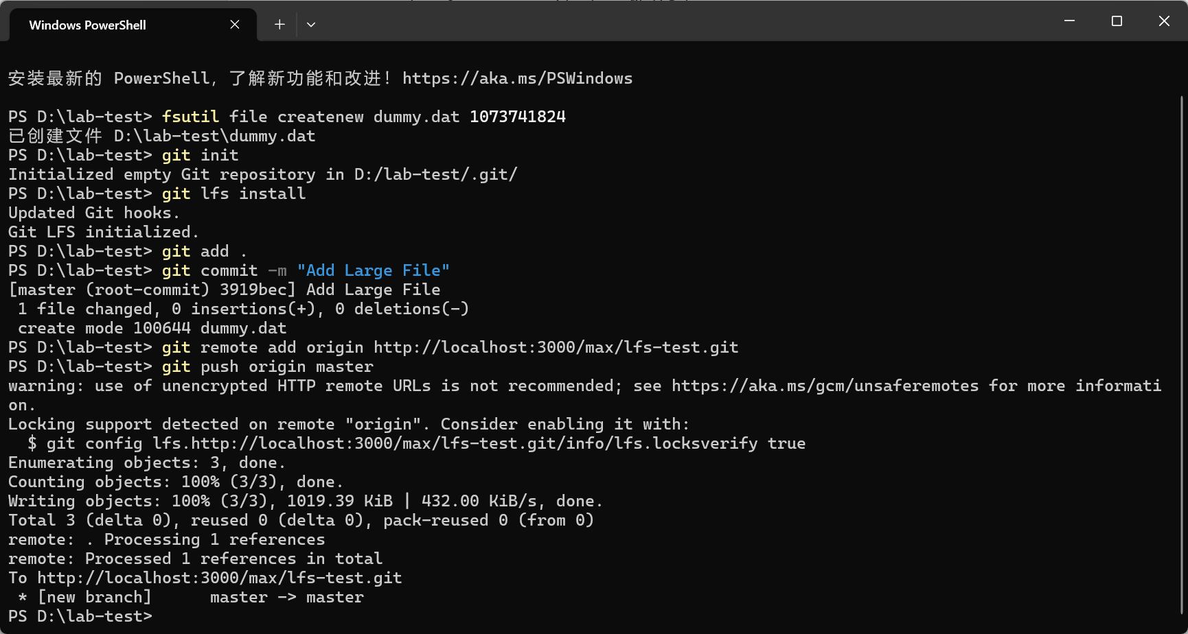

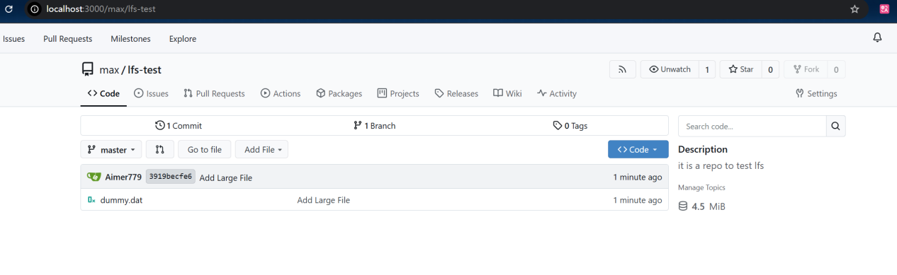

1. Create a module repository and submit your work

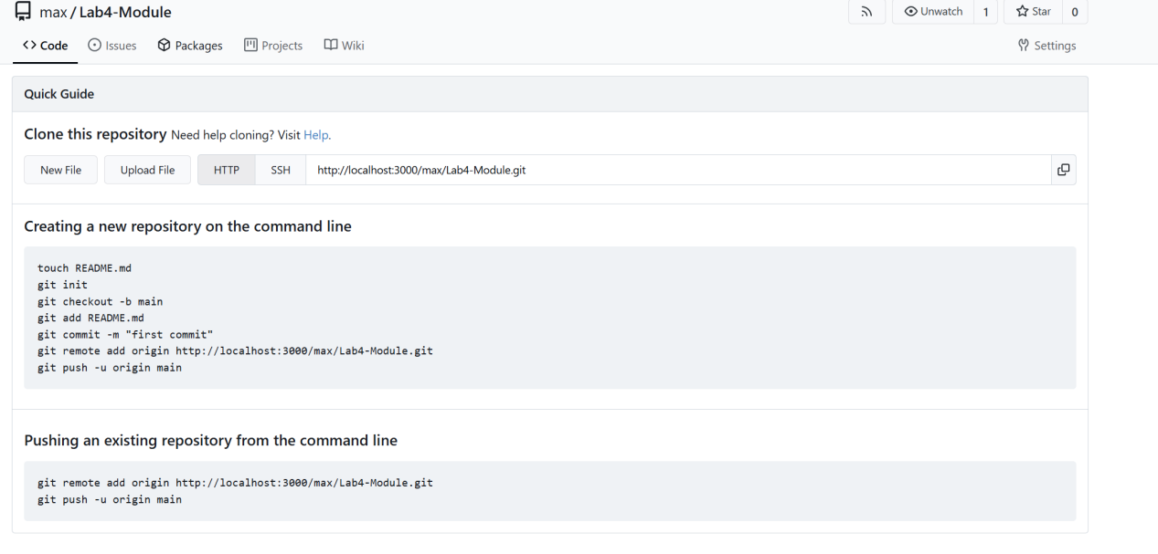

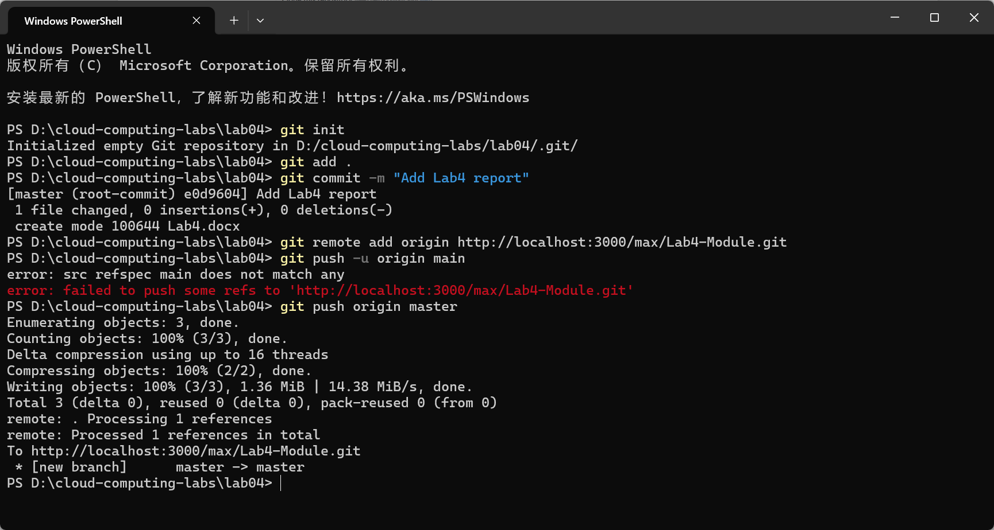

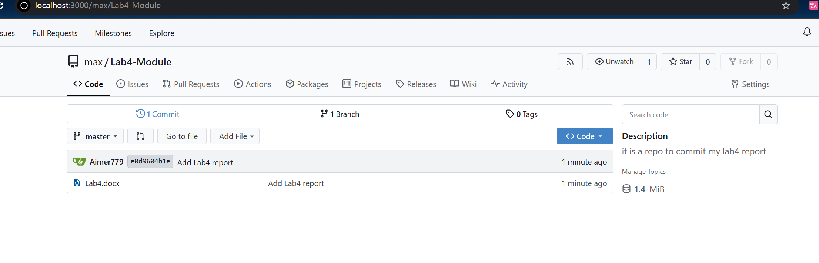

Others:

Install gitea without docker

1. Download MySQL database
2. Download Gitea binaries from the official website

