- 使用pycharm本地用napari看3D
1、使用方法，在终端：conda run -n cellseg python "E:\Undergraduate graduation project\model\UNet-version\可视化调参测试阶段\3.16\napari_lookup.py"
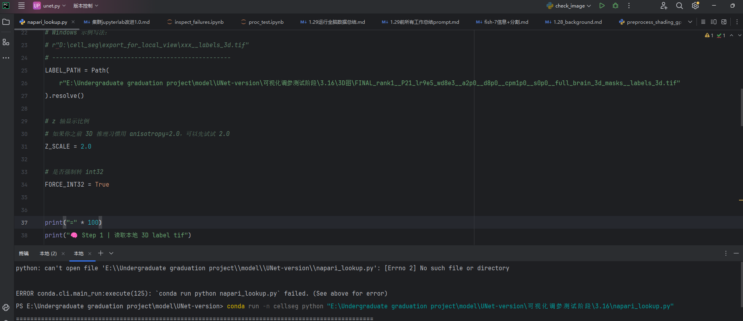
强制调用cellseg环境，不知道为啥conda activate cellseg不起作用。

本处图片地址：
r"E:\Undergraduate graduation project\model\UNet-version\可视化调参测试阶段\3.16\3D图\FINAL_rank1__P21_lr9e5_wd8e3__a2p0__d8p0__cpm1p0__s0p0__full_brain_3d_masks__labels_3d.tif"

（1）70740：
3.16\3D图\FINAL_rank1__P21_lr9e5_wd8e3__a2p0__d8p0__cpm1p0__s0p0__full_brain_3d_masks__labels_3d.tif

（2）69100：
3.16\FINAL_rank2__P21_lr9e5_wd8e3__a2p0__d8p0__cp1p0__s0p0__full_brain_3d_masks (1).tif

（3）65451：
3.18\P21_lr9e5_wd8e3__a2.0__d8.0__cp2p5__ms50__full_brain_3d_masks_raw.tif

