
DATE OF BIRTH
Aug 04, 1979
NATIONALITY
Ukrainian

HARD SKILLS
Programming Languages:
Java, SQL, HTML, CSS, Python, C++, VBA, 1C 7.7, FoxPro, x86 Intel Assembler
Web Technologies:
RESTful APIs, JSON, XML
Java Frameworks:
Spring, Hibernate
Testing Frameworks:
JUnit, Mockito, Testconainers
Build Tools:
Maven
Database Systems:
PostgreSQL, Microsoft SQL Server, Interbase, Btrieve Pervasive SQL
Database Migration:
Flyway
Version Control Systems:
Git
Containerization:
Docker
Operating Systems:
Microsoft Windows, Ubuntu/Debian, Novell NetWare, MS-DOS/PC-DOS
Network Devices:
Cisco IOS, OpenWrt, Microtik RouterOS

HUMANS LANGUAGES
English – B1
Ukrainian – Native Speaker
Russian – Native Speaker

MAXIM (PETROVICH) KOSEY
Java Backend Engineer/Developer
Location: Kryvyi Rih, Ukraine
Phone/Viber/WhatsApp/Telegram: +380 67 759 63 11
Spare Phone: +380 63 290 20 06
Skype: live:.cid.3f50320b2dd42fa1
E-mail: koseymax@gmail.com
GitHub: https://github.com/Max11mus
LinkedIn: https://www.linkedin.com/in/maxim-kosey-a24747248
Profile
Developed and Maintained Enterprise-Level JAVA Applications using Spring Framework and Maven Build Tool, Ensuring Efficient and Scalable Software Solutions.
Utilized Docker for Containerization, Enabling Consistent Deployment across Multiple Environments and Simplifying the Deployment Process.
Designed and Implemented RESTful APIs to Integrate the Application with External Systems, Resulting in Enhanced Functionality and Improved User Experience.
Employment History
Sole Proprietor (FOP 3 Group), Self Employed – 2002 - 2023
Development of "UMS - University Management System" with SpringBoot, Maven, JUnit, Mockito, PostgreSQL, RESTful API, Flyway, Git, Docker in 2022-2023 (https://github.com/Max11mus/UMS---University-Managment-System)
Programming with Excel VBA and 1C:Enterprise 7.7 @ Microsoft SQL Server in 2002 - 2014
Configuration and Repair of Computer, Network (OpenWrt, Microtik RouterOS), and Office Equipment (2002 - 2023)
Typography Design and Printing with Using Computer Software: CorelDRAW, Adobe Illustrator, Microsoft Word in 2002 – 2023
Founder, LLC "PRIME ELECTRIC" – 2019 - 2023
Development of Electrical Engineering Projects with Using AutoCad and other CAD Software (2019 - 2023)
Head of the Group in Electrical Engineering Department – 2017 - 2019
Leading, Managing and Mentoring the Group of 3 Design Engineers
Development of Electrical Engineering Projects with Using AutoCad and other CAD Software
Design Engineer in Electrical Engineering Department, State Institute for Enterprise Design in the Mining Industry "KryvbasProject" – 2004 - 2017
Development of Electrical Engineering Projects with Using AutoCad and other CAD Software
Development of a desktop applications for electrical calculations using Borland C++ Builder @ Excel VBA in 2004 - 2008
System Administrator, Pension Fund of Ukraine – 2001 - 2002
Maintenance of a Network of 100 Computers and a Client-server Software System ASOPD: Btrieve Pervasive SQL Database Server under Novell Netware, Clients under Windows 98 in DOS Mode
Development of Applications for Generating and Printing Reports with FOXPRO for DOS
Schoolboy, Kryvyi Rih Gymnasium No. 95 – 1994 - 1995
Development of the Device for Pairing "ACPU SM-6315" (Soviet Fast Drum-Type Printer Produced by NPO "ELECTRONMASH") with an IBM-compatible PC under MS-DOS: the Hardware Part Converts Electrical Signals from the IFSP Interface to the
SOFT SKILLS
Strong problem-solving and analytical skills
Excellent communication and collaboration abilities
Detail-oriented and committed to delivering high-quality code
Centronics Interface; the Software Part Represents a Driver Written with Intel X86-Assembler for MS-DOS, Converts Symbols from KOI-7 Code Page to ASCII 8-bit Code Page
Education
Master's Degree Diploma «Computer Engineering» - Kryvyi Rih National University – 2022 - Present
Master's Degree Diploma «Electromechanical Systems Automation and Electric Drive» - Kryvyi Rih National University – 1996 – 2001
Middle School Diploma with Specialization in Mathematics - Kryvyi Rih Gymnasium No. 95 – 1990 – 1996
Courses
JAVA SPRING MENTORING COURSE - FOXMINDED.UA - #22120260 27.12.2022
CCNA 7: SWITCHING, ROUTING, AND WIRELESS ESSENTIALS - Cisco Networking Academy – 06.02.2023
Certificate of Responsible Executor - Chief Project Engineer (CPE) - Guild of Designers in Construction - АР 015476 26.04.2019
Hobbies
Learning Foreign Languages: Actively learning English to enhance cross-cultural communication skills.
Data Science: Passionate about data analysis, visualization, and machine learning algorithms.
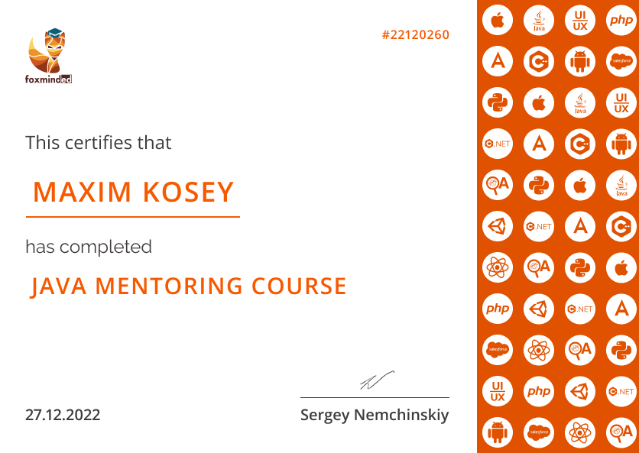
AI & Neural Networks: Fascinated by artificial intelligence, particularly neural networks.
