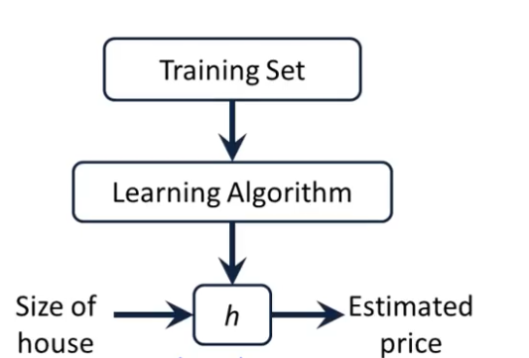

Linear regression with one variable.

Univariate linear regression

To establish notation for future use, we’ll use *x*(*i*) to denote the “input” variables (living area in this example), also called input features, and *y*(*i*) to denote the “output” or target variable that we are trying to predict (price). A pair (*x*(*i*),*y*(*i*)) is called a training example, and the dataset that we’ll be using to learn—a list of m training examples (*x*(*i*),*y*(*i*));*i*=1,...,*m*—is called a training set. Note that the superscript “(i)” in the notation is simply an index into the training set, and has nothing to do with exponentiation. We will also use X to denote the space of input values, and Y to denote the space of output values. In this example, X = Y = ℝ.

To describe the supervised learning problem slightly more formally, our goal is, given a training set, to learn a function h : X → Y so that h(x) is a “good” predictor for the corresponding value of y. For historical reasons, this function h is called a hypothesis. Seen pictorially, the process is therefore like this:

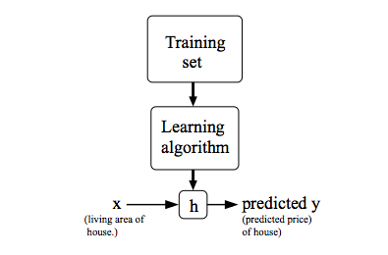

When the target variable that we’re trying to predict is continuous, such as in our housing example, we call the learning problem a regression problem. When y can take on only a small number of discrete values (such as if, given the living area, we wanted to predict if a dwelling is a house or an apartment, say), we call it a classification problem.

Df: 3368

X: 3334 (因为舍弃了最后的34个)

Y: 3334

X_train: 2667

X_test: 667

y_train: 2667

y_test: 667

一共有3368个数据，然后先拿出来3334个作为已有的数据集来训练模型测试模型

剩下的这34个其实是当做新来的数据来预测的

Lastday 2017-11-14