W-Shape Steel Members
Data Report

Noah Morland, Jacob Lamoureux, Max Perry

Department of Civil & Environmental Engineering, University of Nebraska-Lincoln

CIVE 202: Civil Engineering Analysis II

Dr. Kaycie Lane

May 8, 2026

Contents
Introduction and Background 3
Summary 4
Methods 4
Data Source and Cleaning 4
Functions 5
Strength Calculations 5
Visualization 6
Results and Discussion 6
Comparison of LRFD and ASD 9
Analysis of Bias in Coding 10
Choice of x̄ Formula 10
Material Assumption (Fu = 65 ksi) 10
Welded Connection Assumption 10
Polars Type Inference 11
Shape Selection by User Input 11
Conclusion 11
References 12

Introduction and Background
Steel tension members are widely used in structural engineering applications such as bridge trusses, roof systems, and lateral bracing systems. A tension member is defined as a structural element that carries axial load through tension along its longitudinal axis (Segui, 2018). When load is transferred through a welded connection, not all parts of the cross-section contribute equally to resisting the applied force. Portions of the section that are not directly connected to the load path experience delayed stress development. This phenomenon is known as shear lag. Shear lag reduces the effective efficiency of a tension member and is explicitly accounted for in the AISC Specification through a reduction in effective area used for rupture strength calculations (American Institute of Steel Construction, 2022).
The American Institute of Steel Construction (AISC) Steel Construction Manual outlines the design requirements for tension members in Chapter D. Two primary limit states govern design: tensile yielding and tensile rupture. Tensile yielding refers to the gradual elongation of the gross cross-section when the yield stress is reached. Tensile rupture, on the other hand, is a sudden fracture that occurs across the reduced net section at the connection (Segui, 2018). For most welded tension connections, rupture of the effective net section governs the design rather than yielding.
The effective net area is determined by applying a shear lag factor, U, to the net area of the section. This factor is defined in AISC Table D3.1 and depends on the connection geometry. For typical welded W-shape connections, shear lag significantly influences the available tensile strength.
For W-shapes connected through both flanges using welds, AISC Table D3.1 Case 2 defines the shear lag factor as a function of the connection length and the eccentricity of the connected area. The parameter x̄ represents the distance from the connection plane to the centroid of the connected element, while L is the length of the connection. A longer connection length allows more uniform stress distribution, which increases the shear lag factor and therefore increases the effective strength of the member (AISC, 2022).
This project evaluates both Load and Resistance Factor Design (LRFD) and Allowable Stress Design (ASD) approaches. LRFD applies resistance factors to nominal strengths and load factors to applied loads to account for variability in material properties and loading conditions. ASD, in contrast, applies a single safety factor to nominal strength to ensure service-level loads remain within allowable limits (Segui, 2018). Both methods are used to evaluate the tensile rupture strength of selected W-shapes under a specified connection length.

Summary
This project developed a computational tool in Python to evaluate tensile rupture strength for W-shaped steel sections in accordance with AISC Chapter D provisions. The program reads AISC section property data, filters for W-shapes, and computes the shear lag factor, effective net area, nominal rupture strength, LRFD design strength, and ASD allowable strength.
Three W-shapes were analyzed: W14X48, W10X33, and W8X24, each with a connection length of 4.0 inches. The W14X48 produced the highest nominal strength, followed by the W10X33 and W8X24. All shapes exhibited shear lag factors below 1.0, indicating a reduction in effective area due to partial connection of the cross-section (AISC, 2022).
The results demonstrate that the W14X48 provides the greatest tensile capacity under both LRFD and ASD design methods, while the W8X24 and W10X33 show progressively lower capacities due to reduced cross-sectional area and geometry effects influencing shear lag.

Methods
Python was used for all data loading, filtering, calculation, and visualization in this project. Three packages were installed and used: Polars for data handling, Matplotlib for creating charts, and Seaborn for styled grouped bar charts.

Data Source and Cleaning
Section property data came from the AISC Steel Construction Manual (AISC, 2022), provided as a CSV file containing all standard AISC sections. The file has 2,299 rows and 166 columns covering W-shapes, S-shapes, channels, angles, and hollow sections. Because this analysis only needed W-shapes, the dataset was filtered using the Type column to keep only rows where Type equals W. This left 289 W-shapes in the working dataset.
Polars was used instead of Pandas for reading and filtering the data. The infer_schema_length parameter was set to 10,000 rows when loading the CSV. This tells Polars to scan more rows before deciding what data type each column is, which prevents it from incorrectly reading columns as integers when those columns contain decimal values further down in the file. Without this setting, some section property columns would have been read as the wrong type and caused errors or truncated values during the calculations.

Functions
Two functions were defined to carry out the calculations. The first function, calculate_U, takes x̄ and L as inputs and returns the shear lag factor U using the formula from AISC Table D3.1 Case 2:
U = 1 - ( x̄ / L)
Isolating this in its own function makes it easy to test and reuse independently if a different connection case is needed later.
The second function, tensile_rupture, takes a shape name and a connection length as inputs. It looks up the matching row in the filtered W-shapes dataset by the AISC_Manual_Label column, pulls out the gross area Ag and flange width bf, calculates x̄ as bf divided by four per AISC guidance for W-shapes connected at the flanges, calls calculate_U to get U, and then steps through the rest of the calculation (AISC, 2022).
Since this is a welded connection, no bolt hole deductions are made and the net area An is set equal to Ag. The material ultimate tensile stress Fu is set to 65 ksi, which is the standard value for ASTM A992 steel used for all modern wide flange sections (ASTM International, 2022). The function calculates the effective net area Ae as An X U, then calculates the nominal strength Pn as Fu X Ae, the LRFD design strength as 0.75 X Pn, and the ASD allowable strength as Pn / 2.00. All results are printed in a formatted summary and returned as a list for use in the plots.

Strength Calculations
The nominal tensile rupture strength Pn was calculated as:
Pn = Fu X Ae
The LRFD available strength was calculated using the AISC resistance factor of 0.75 for tensile rupture:
LRFD = 0.75 X Pn
The ASD allowable strength was calculated using the AISC safety factor of 2.00 for tensile rupture:
ASD = Pn / 2.00
These factors come directly from AISC Chapter D for tensile rupture on the effective net area (AISC, 2022).

Visualization
Two graphs were produced. The first is a grouped bar chart made with Seaborn that shows Pn, the LRFD strength, and the ASD strength side by side for all three shapes. The three strength types are color coded so they can be compared across shapes without looking at multiple graphs. The second chart is a bar chart made with Matplotlib that shows the shear lag factor U for each shape, with a dashed red reference line at U equal to 1.0 to mark the theoretical maximum where no shear lag penalty applies. Value labels above each bar show the exact U value to four decimal places.

Results and Discussion
The tensile_rupture function was run for W14X48, W10X33, and W8X24, all with a connection length of 4.0 inches. The full printed output for each shape is shown below.
Table 1 Results from code for selected W beams
Parameter | W14X48 | W10X33 | W8X24
Connection Length (L) | 4.0 in | 4.0 in | 4.0 in
Gross Area (Ag) | 14.1 in² | 9.71 in² | 7.08 in²
Flange Width (bf) | 8.03 in | 7.96 in | 6.50 in
Centroid Distance ( x̄ ) | 2.007 in | 1.990 in | 1.625 in
Shear Lag Factor (U) | 0.4981 | 0.5025 | 0.5938
Effective Net Area (Ae) | 7.024 in² | 4.879 in² | 4.204 in²
Nominal Strength (Pn) | 456.53 kips | 317.15 kips | 273.24 kips
LRFD (0.75 x Pn) | 342.40 kips | 237.86 kips | 204.93 kips
ASD (Pn / 2.00) | 228.27 kips | 158.58 kips | 136.62 kips

Figure 1 compares Pn, the LRFD design strength, and the ASD allowable strength for all three shapes. The W14X48 had the highest strength values under all three measures, followed by the W10X33 and then the W8X24. The LRFD and ASD values are consistently proportional to Pn for every shape, at 75 percent and 50 percent respectively, which confirms that the resistance and safety factors were applied correctly in the function.
The differences in strength between shapes are driven by gross area. The W14X48 has a gross area of 14.1 square inches, compared to 9.71 and 7.08 square inches for the W10X33 and W8X24. Even though all three shapes had similar shear lag factors in this run, the larger section carries more load simply because there is more material available to resist the force.
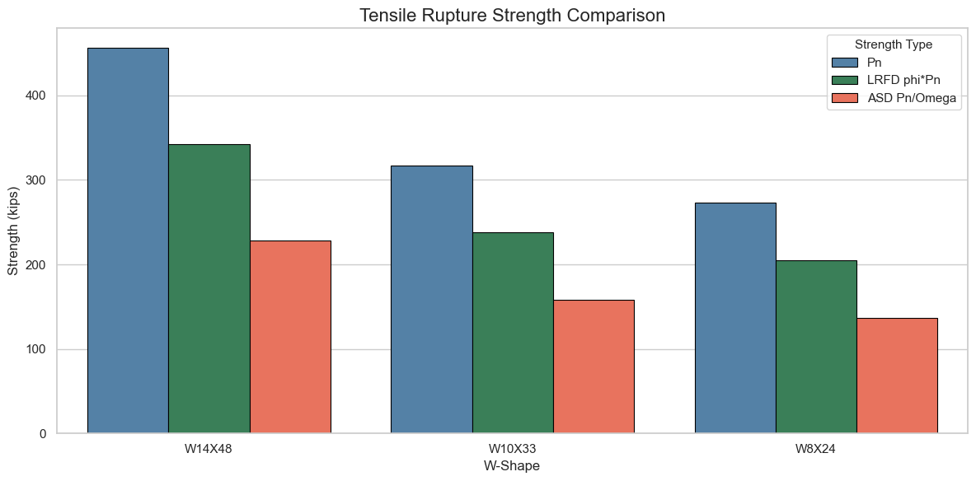
Figure 1 Tensile Rupture Strength Comparison (W14X48, W10X33, W8X24 at L = 4.0 in)
Figure 2 shows the shear lag factor U for each of the three shapes. All three values are well below the reference line at U equal to 1.0, which indicates that shear lag caused a significant reduction in effective area for every shape in this run. The W8X24 had the highest U value at 0.5938, while the W14X48 had the lowest at 0.4981. The W10X33 fell in the middle at 0.5025.
The reason the W8X24 has a higher U value than the other two shapes, even though it has the narrowest flange, is that its x̄ value is also smaller. The W8X24 has a flange width of 6.50 inches, giving an x̄ of 1.625 inches. The W14X48 has a flange width of 8.03 inches, giving an x̄ of 2.007 inches. When divided by the same connection length of 4.0 inches, the W8X24 produces a smaller x̄/L ratio, which results in a smaller shear lag penalty and a higher U value. This relationship follows the AISC shear lag formulation for welded W-shape connections (AISC, 2022).
This shows that it is not only the size of the section that controls shear lag effects, but the relationship between flange width and connection length defined in the AISC connection model (AISC, 2022).
All three U values in this run are close to 0.50, meaning effective load transfer is reduced at the connection due to shear lag. This represents a significant reduction in effective capacity. Increasing the connection length would increase U for all three shapes and directly improve the available tensile rupture strength as described in the AISC effective net area provisions (AISC, 2022).

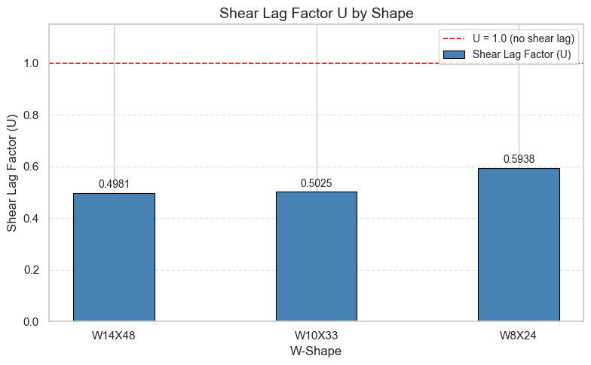
Figure 2 Shear Lag Factor U by Shape (W14X48, W10X33, W8X24 at L = 4.0 in)

Comparison of LRFD and ASD
Both LRFD and ASD design strengths are included in the output because engineers may work under either method depending on the project. LRFD is more common for most building structures while ASD is used in some infrastructure and industrial applications. For tensile rupture specifically, the AISC factors of 0.75 and 2.00 produce an LRFD to ASD ratio of 1.50, meaning LRFD always allows 50 percent more strength than ASD for this limit state. This is visible in Figure 1 where the LRFD bars are consistently taller than the ASD bars by that same proportion for all three shapes.

Analysis of Bias in Coding
Every decision made while writing the code has assumptions built into it that affect the output. This section identifies the main choices made in this analysis and discusses what kind of bias or limitation each one introduces.

Choice of x̄ Formula
The centroid ( x̄ ) was calculated as flange width divided by four for all shapes. This follows AISC guidance for W-shapes connected through both flanges with welds. It is a simplification of the exact centroid distance, which would require integrating the full cross-sectional geometry. For standard W-shapes this approximation is well established and produces results consistent with handbook values. However, if the same function were applied to a non-standard section or a shape with unusual proportions, the actual x̄ could differ from the bf over four approximation and the results would be slightly wrong. A more exact implementation would calculate x̄ from the full geometry stored in the AISC data file rather than using the simplified formula.

Material Assumption (Fu = 65 ksi)
The ultimate tensile stress Fu was fixed at 65 ksi for all calculations. This is correct for ASTM A992 steel, which covers all modern hot-rolled wide flange sections. However, older W-shapes produced to ASTM A36 have a lower Fu of 58 ksi, and higher-strength grades have higher values. Applying 65 ksi to a shape specified in a different material will give the wrong answer. The function should either accept Fu as a user input or look it up from a material grade table so it cannot be applied to the wrong material by accident.

Welded Connection Assumption
The net area was set equal to the gross area because a welded connection does not remove material from the section. If this function is used for a bolted connection, bolt hole deductions would need to be subtracted from Ag before calculating Ae. The current code does not check the connection type, so it will overestimate the strength for any bolted case. Adding an optional hole deduction input or a connection type flag would make the function safer to use across different design scenarios.

Polars Type Inference
Setting infer_schema_length to 10,000 rows ensures that Polars scans enough of the file to correctly identify the data type of each column. The AISC CSV is well-structured and consistent, so this setting works correctly for this dataset. However, for a different CSV file with unusual formatting or mixed types in the first several hundred rows, Polars could still infer the wrong type even with this setting. A more defensive approach would be to specify column types explicitly when loading any unknown file rather than relying on Polars to guess from a sample.

Shape Selection by User Input
The three shapes evaluated in each run are entered manually by the user. This means the results only reflect whichever shapes were tested and cannot be generalized to the W-shape family. A user who tests only large sections will see high strengths, while a user who tests only small sections will see low values. The code gives the correct answer for whatever shapes are entered, but it introduces selection bias in the comparison if the shapes are not chosen systematically. A more complete analysis would loop through a defined set of shapes, such as all W14 sections, to give a broader picture of how rupture strength varies across a shape series.

Conclusion
This report presented a Python tool for calculating tensile rupture strength of W-shaped steel sections using AISC Chapter D. The tool used three packages, Polars, Matplotlib, and Seaborn, to load and filter the AISC section property database, run multi-step strength calculations through two user-defined functions, and produce two comparison charts. It accepted user-entered shape names and connection lengths, applied the AISC Table D3.1 Case 2 shear lag formula, and returned all strength values for three shapes in a single run.
The code was run for W14X48, W10X33, and W8X24, all with a connection length of 4.0 inches. The W14X48 produced the highest design strength at 342.40 kips under LRFD and 228.27 kips under ASD, driven by its larger gross area of 14.1 square inches. All three shapes had shear lag factors near 0.50, which cut the effective net area roughly in half compared to the gross area. The W8X24 had the highest U value at 0.5938 because its narrower flange produces a smaller centroid eccentricity x̄ relative to the connection length, which reduces the shear lag penalty compared to the other two shapes.
The bias analysis identified five key assumptions in the code: the bf over four approximation for x̄ , the fixed material strength of 65 ksi, the welded connection assumption that sets net area equal to gross area, the Polars type inference setting, and the fact that shape selection is left to the user. Each of these could produce wrong results if the tool is applied outside the conditions it was designed for. Documenting these assumptions clearly and adding input checks or optional parameters would make the tool more reliable in a production setting.
The results show that automated code-based tools can make routine tensile rupture calculations faster and more repeatable while keeping every intermediate step traceable. The same structure could be extended to other AISC limit states, different material grades, or bolted connections with modest changes to the existing functions.

References
American Institute of Steel Construction. (2022). Steel construction manual (16th ed.). American Institute of Steel Construction.
American Institute of Steel Construction. (n.d.). AISC shapes database (v16.0) [Data set]. Retrieved May 7, 2026, from https://www.aisc.org/publications/steel-construction-manual-resources/
ASTM International. (2022). ASTM A992/A992M: Standard specification for structural steel shapes. https://www.astm.org
Segui, W. T. (2018). Steel design (6th ed.). Cengage Learning

