1. Git init = create repo = creation git directory
2. Git config –global user.name “ ”

If not local = global

1. Git config user.email mail.com
2. Git config –list = current configuration

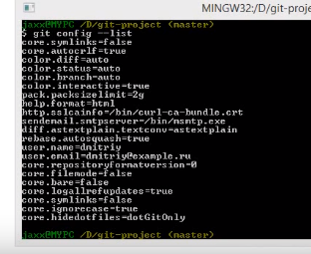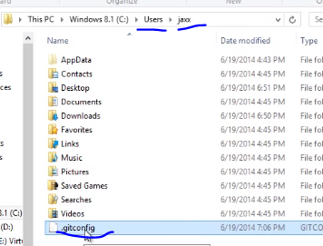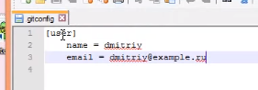

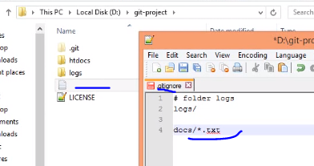file .gitignore = all types\*

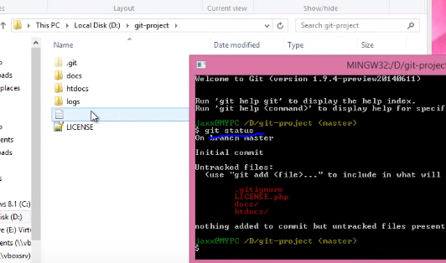git status = there is no logs file