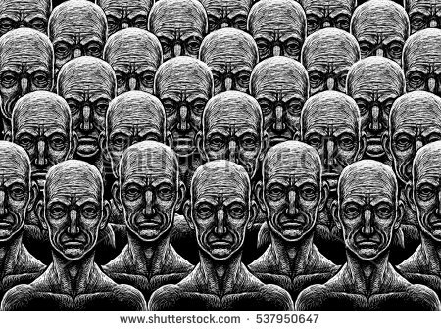**MATERIAL 6**

**Tasks Extract 1 (chapter one)**

Read the extract. Don’t bother if you don not understand every detail but make sure that you can follow the main contents.

a) Check the meaning of:

*hatchery, to hatch*

*to condition*

*incubator*

*ova, ovary*

*gamete*

*viviparous*

b) The extract mentions the ***year of stability, A****(nno)* ***F****(ord)* ***632***.

Why would a society give Henry Ford such an important status as to base their calendar on him?

Which year would A.F. 632 be in our calendar?

c) The Director celebrates the processes in the hatchery as ***the principle of mass production at last applied to biology***. Which connotations does the term ***mass production*** have? What does it mean in the context that it appears?

d) The *Hatchery and Conditioning Centre* “produces” the social members belonging to the different casts in *Brave New World*: ***Alphas, Betas, Gammas, Deltas and Epsilons***. Which different procedures do they use for the single groups? What is the purpose of these procedures?

e) Asked what the advantage of ***Bokanovsky’s Process*** is, the Director proudly answers that ***“is one of the major instruments od social stability.”***

What do you think does he want to say?

|  |
| --- |
|  |

**Tasks Extract 2 (chapter two)**

a) In this extract the reader learns what ***conditioning*** means in *Brave New World*.

Why do you think books were considered as potentially “destabilising”?

b) The Director’s explanation why Deltas are conditioned to hate flowers reveals another pillar this society is based on. What is it? Why is it so important?

c) At the end of the demonstration the Director says: ***“What man has joined, nature is powerless to put asunder.”*** It sounds suspiciously similar to the Bible verse, ***What God has joined together let no one separate***, only that it replaces the subjects. What was Huxley’s intention here? What effect should it have on the reader?

|  |
| --- |
|  |

**Tasks Extract 3 (chapter six)**

a) In the introducing paragraph to chapter six Lenina voices three of Brave New World’s major creeds:

***promiscuity, entertainment and consumerism, class privilege***

In the table below describe how these mottos are implemented by the citizens

|  |  |
| --- | --- |
| ***creed*** | ***implementation*** |
| *PROMISCUITY* |  |
| *ENTERTAINMENT AND CONSUMERISM* |  |
| *CLASS PRIVILEGE* |  |

b) Throughout the extract Lenina counters Bernard’s thoughts and feelings by quoting state mottos she has been “conditioned” to. For example, to Bernard’s grumpy mood she retorts with ***“A gramme [of the drug soma] in time saves nine”.***

Find some more examples of such mottos. What is their purpose? What do Lenina and Bernard respectively think about these mottos?

c) The chapter starts with the word “***odd***” referring to Bernard’s behaviour. What is it that makes Bernard appear as an odd and scary character for Lenina?

d) Shortly describe the impression you have won of this society.

|  |
| --- |
|  |

**Tasks Extract 4 (chapter seven)**

Lenina and Bernard are spending a few days in the USA, in an Indian reservation whose inhabitants live in the way they have done for centuries.

Read the extract and think of **three challenging questions** related to the contents of this extract.

Share your questions with a partner and discuss the possible answers.