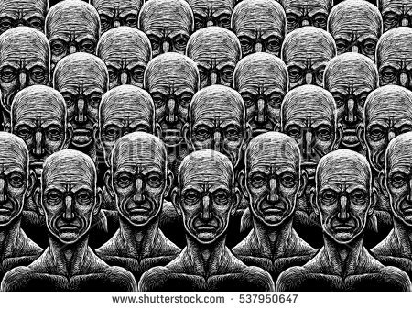 **Utopia and dystopia**

**Tasks**

1. **Utopias versus dystopias:**

Watch the **video** about dystopias and complete the worksheet (Material 1, ex. 1-4).

Read the two **articles** (Material 2 and 3) about the differences between utopia and dystopia. Collect the information in a table. Do the **writing exercise** (Material 1, ex. 5-6) and hand in.

1. **Short story *Examination Day* by Henry Slesar (**Material 4**)**

<http://www.gdhsenglish.com/thompson/assets/pdfs/ENG3U1%20pdf%27s/Short%20Stories/Examination%20Day.pdf>

1. **Aldous Huxley**

Use any (or all) of the links below to learn about the writer Aldous Huxley.

<https://www.cliffsnotes.com/literature/b/brave-new-world/aldous-huxley-biography>

<https://www.biography.com/people/aldous-huxley-9348198>

<https://somaweb.org/w/huxbio.html>

Draw a timeline reporting the MOST RELEVANT events in Huxley’s life.

Listen to the interview with A. Huxley

<https://www.youtube.com/watch?v=oIgjujAI6eE>

and complete the task (Material 5)

1. ***Brave New World***

For a general idea about the contents of the novel, watch the animated summary at

<https://www.youtube.com/watch?v=raqVySPrDUE>

(or find a written summary online if you prefer)

1. **Extracts (**Material 6**)**

Complete the task sheets

1. **From fiction to fact**

Read the list of 14 Things that have been predicted in dystopian novels.

**Over to you:**

Have a closer look at a country (Turkey, Hungary, Poland, North Korea, …) that has hit the headlines recently because of racist, discriminatory, totalitarian, … measures introduced in their policies. Report the result of your research in a written text. Consult **SEVERAL** sources for your research in order to guarantee an objective result.