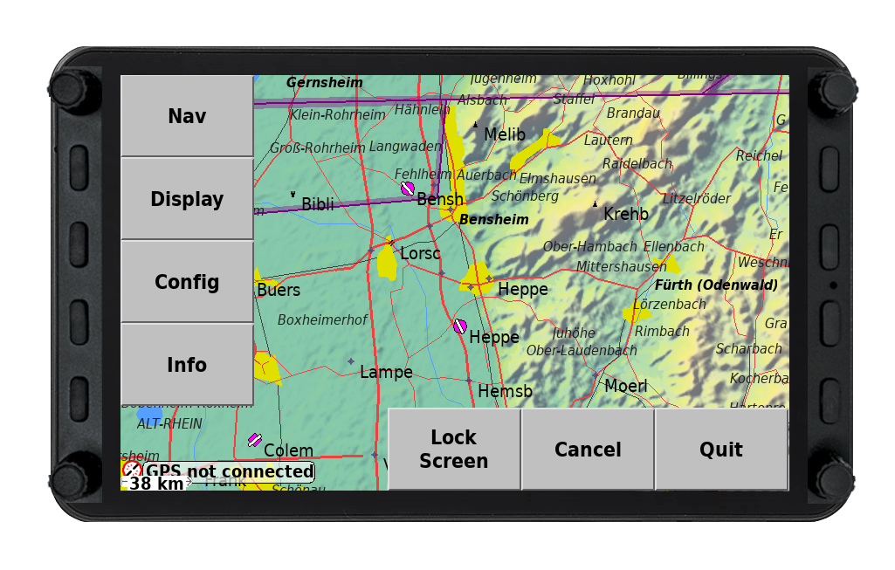

Vol+/Vol- ?/?
? ?

Nav Flarm

Display Waypoint

Config Task

Info Flight Setup

Up/Down Left/Right
<ESC> <Enter>

