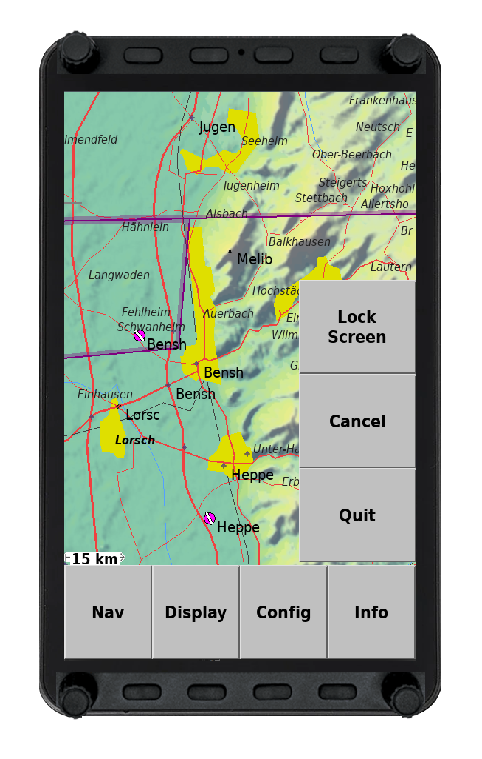

Vol+/Vol- | Flarm | Waypoint | Task | Flight Setup | ?/?
? |  |  |  |  | ?

Up/Down | Nav | Display | Convig | Info | Left/Right
<ESC> |  |  |  |  | <Enter>

