Iteration 3

As a customer I want to be able to have access to any relevant information about the shop see what products are available at the school shop and be able to place an order.

As a shop manager I want to be able to see all the placed orders and edit the products available for purchase.

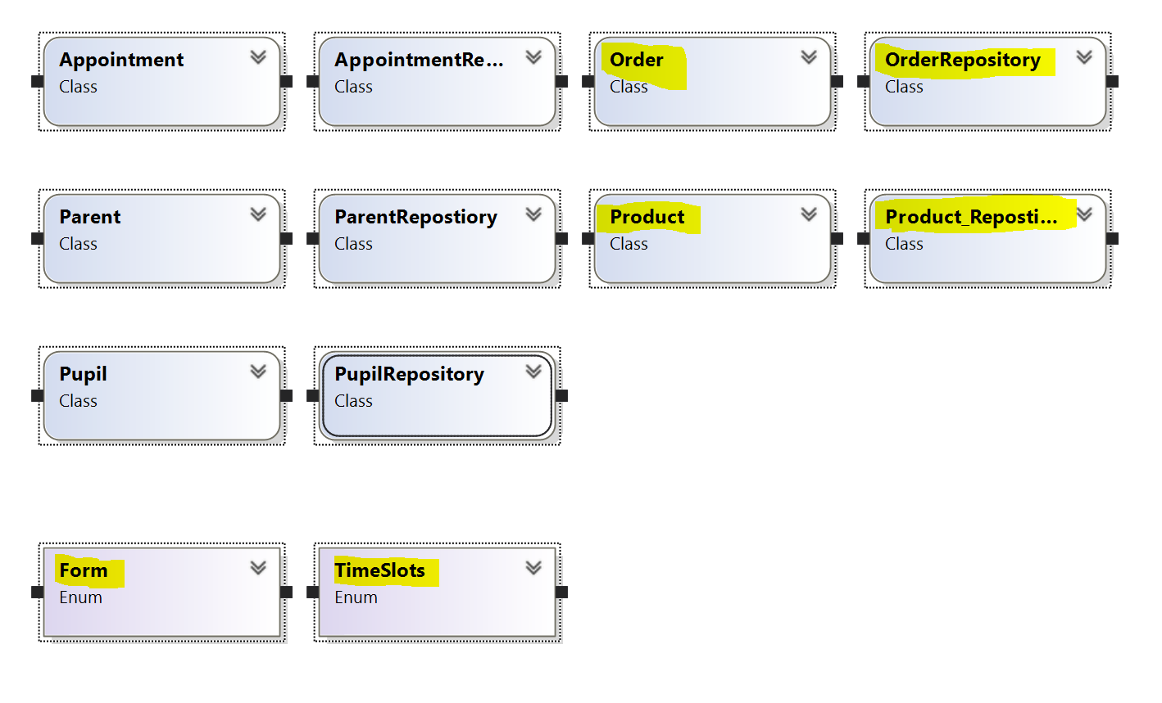

I decided to add the relevant information about the school shop for the customers in this iteration. So I included an information class, but this would be static data and wouldn’t be suitable for the core code of the system so I removed it. A more suitable approach is to adapt the web based interface to contain this data. This was not achievable in this iteration so it will therefore be added later.

I have learnt new techniques of customising the user interface including assigning the colour of objects and adding classes to the main menu.

I have added photos to the product class so the customers can see the products before purchasing.

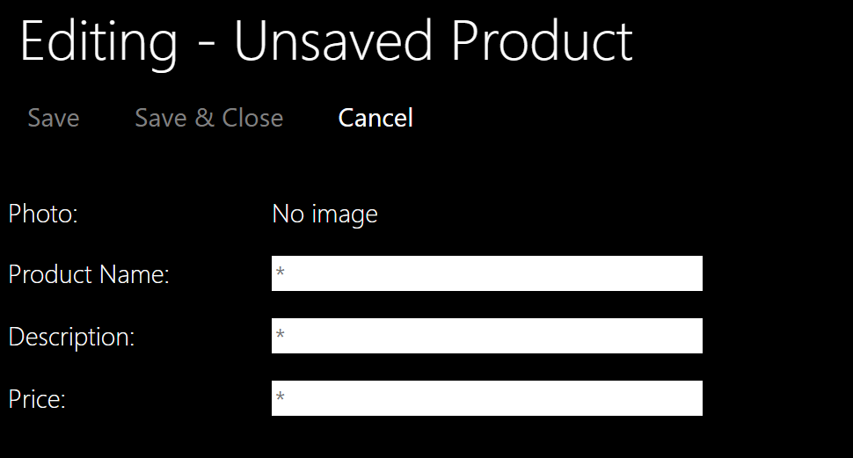

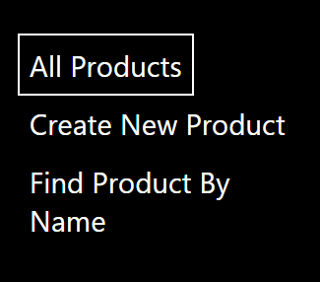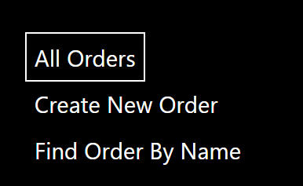

I did not complete the objective for this iteration. I could have but it wouldn’t be a good solution for having the customer information in the system. The web based solution will be more complex but will be a more elegant solution. I will carry this into a later iteration once I understand how to modify the interface between the user interface, this has been added to my backlog for a later date.