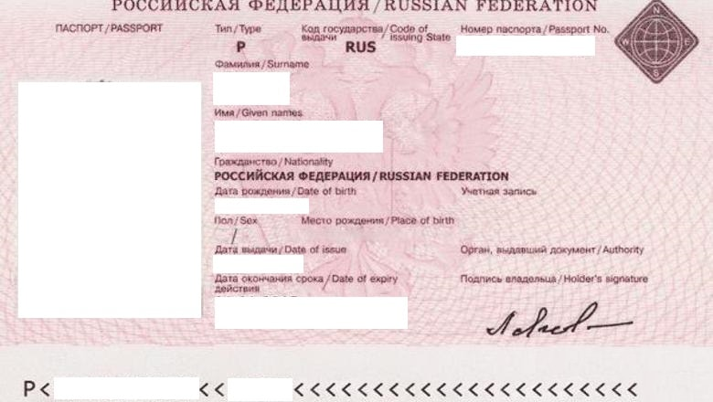 <NumberPasport>

<Surname>

<Image>

<Name>

<DateOfBirth>

<Sex> <Place>

<DateOfIssue> <Authority>

<DateEnd>

<Surname2> <Name2>