Network and Port Scanner

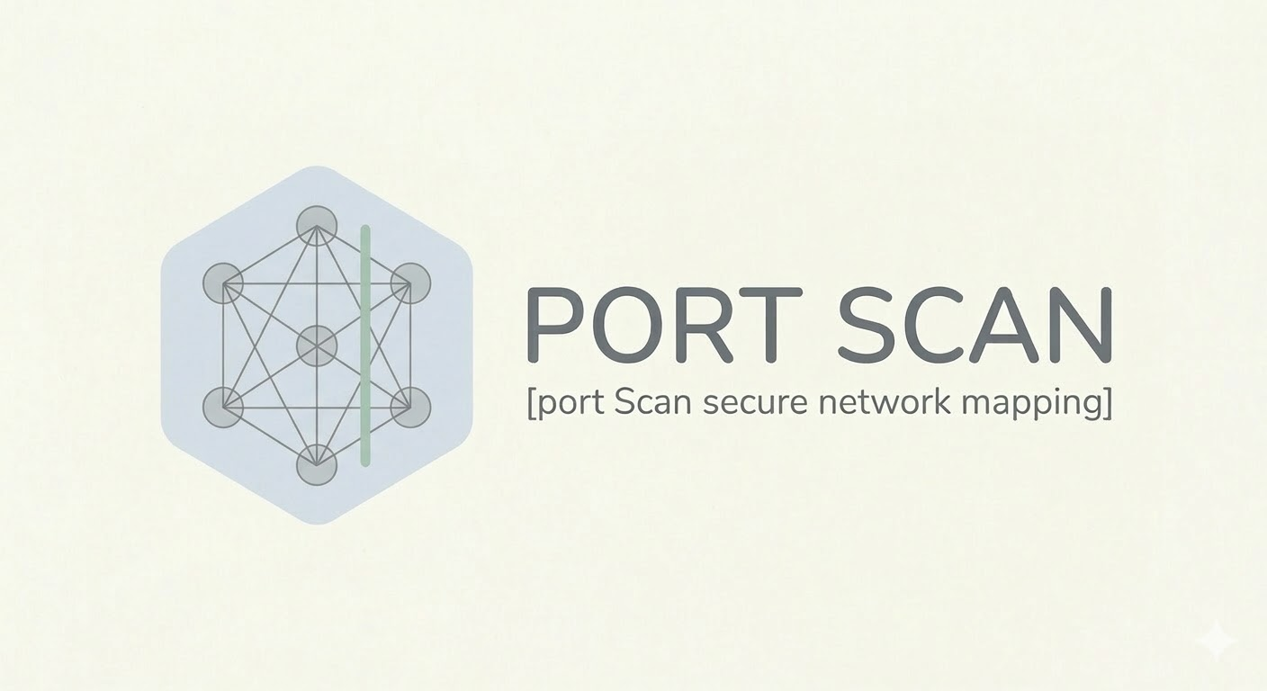
PREPARED BY
Muza
Max
Mahmoud Hasan
INDEX
1 INTRODUCTION 3
1.1 Project Background 3
1.2 Purpose of the Project 3
1.3 Scope of the Project………………………………………………………………………………3
2 PROJECT OBJECTIVES 4
2.1 Technical Objectives 4
2.2 Learning Objectives 4
2.3 Security Awarness Objectives 4
3 LAB ENVIRONMENT SETUP 5
3.1 Virtualization Platform 5
3.2 Scanner Machine Configuration 5
3.3 Target Machine Configuration 5
3.4 Network Isolation Configuration 5
4 OBSERVATION PHASE NETWORK-ANALYSIS 7
4.1 Introduction to Network Traffic Analysis 5
4.2 Host Discovery Analysis 5
4.3 Port Scanning Behavior 5
4.4 TCP Handshake Observation 5
4.5 Identifying Open vs Closed Ports 5
4.6 Wireshark Packet Analysis 5
4.7 Scan Pattern Recognition 5
5 SCANNER DESIGN 8
5.1 Tool Architecture 5
5.2 Scanner Workflow 5
5.3 Port Scanning Methodology 5
5.4 Error Handling Strategy 5
5.5 Data Storage Strategy 5
6 IMPLEMENTATION 9
6.1 Programming Language and Tools 5
6.2 Python Libraries Used 5
6.3 Core Components of the Scanner 5
6.4 Input Handling and Validation 5
6.5 Port Scanning Logic 5
6.6 Result Classification (OPEN, CLOSED, FILTERED) 5
6.7 Saving Scan Results to File 5

7 PERFORMANCE ENHANCEMENTS ( Optional Features ) 11
7.1 Multithreaded Port Scanning 11
7.2 Rate Limiting Mechanism 12
7.3 Service Name Mapping 13
7.4 Command Line Interface using argparse 13
7.5 Logging Implementation 14
8 TESTING METHODOLOGY 19
8.1 Testing Environment 19
8.2 Testing Scenarios 19
8.3 Validation of Scan Results 19
8.4 Comparison with Nmap Results 19
9 RESULTS AND OBSERVATIONS 19
9.1 Discovered Open Ports 19
9.2 Closed and Filtered Ports 19
9.3 Performance Observations 19
9.4 Limitations of the Scanner 19
10 ETHICS AND SECURITY CONSIDERATIONS 22
10.1 Legal Considerations of Port Scanning. 22
10.2 Importance of Authorization. 22
10.3 Lab-Only Testing Policy. 22
11 DETECTION AND DEFENSIVE PERSPECTIVE 24
11.1 How Port Scanning Appears on the Network. 22
11.2 Detecting Scanning Activity using Network Monitoring 22
11.3 Indicators of a Port Scan in Wireshark 22
12 FUTURE IMPROVEMENTS 25
12.1 SYN Scanning Implementation 22
12.2 Operating System Detection 22
12.3 Graphical User Interface 22
13 CONCLUSION 25
14 APPENDIX 26
14.1 Wireshark Capture Screenshots 26
14.2 Sample Scan Output 27
14.3 Selected Code Snippets 27
14.4 References and Resources 28

INTRODUCTION

Project Background
Modern computer networks expose a wide variety of services that allow systems to communicate and exchange data. These services typically run on specific network ports, each associated with a particular protocol or application such as web servers, file transfer services, or remote administration tools. While these services are essential for normal network operations, they can also become potential entry points for attackers if they are misconfigured or vulnerable.
One of the first steps performed during a cybersecurity assessment is port scanning, a technique used to identify which ports on a target system are open and which services are running on them. By analysing the responses of a target machine to connection attempts, a scanner can determine whether a port is open, closed, or filtered by a firewall. This information helps security professionals understand the attack surface of a system and identify possible security risks.
Tools such as the well-known scanner Nmap are widely used by penetration testers and security analysts to perform this type of reconnaissance. However, understanding how these tools operate internally is essential for developing strong cybersecurity and networking skills. Observing the network traffic generated by scanning activity also helps defenders recognize suspicious patterns and detect malicious reconnaissance attempts.
In this project, a Python-based network and port scanner is developed in order to explore these concepts in practice. Before implementing the tool, network traffic generated by scanning activity is analysed using packet analysis software to understand how port scanning appears at the network level. The project therefore combines network analysis, Python programming, and cybersecurity principles to demonstrate how scanning tools operate and how their behaviour can be detected.

Purpose of the Project
The purpose of this project is to design and implement a Python-based network and port scanning tool capable of identifying active services on a target machine within a controlled laboratory environment. The scanner is intended to analyse a specified target IP address and a range of ports, determine whether each port is open, closed, or filtered, and record the results in a structured output file.
A key objective of the project is not only to build the scanning tool but also to understand how port scanning behaves at the network level. Prior to implementing the scanner, network traffic generated by existing scanning tools is analysed using packet capture software. This observation phase allows the team to study how connection attempts are performed and how different port states are reflected in network traffic.
The project therefore serves as a practical exercise that combines concepts from networking, cybersecurity, and Python programming. By developing the scanner and analysing its behaviour, the team gains a deeper understanding of how reconnaissance techniques are used in security assessments and how such activities can be detected from a defensive perspective.

Scope of the Project
This project focuses on the development and testing of a Python-based network and port scanner within a controlled, isolated laboratory environment. The scanner is designed to:
- Identify active hosts on a network using host discovery techniques.
- Scan a user-specified range of TCP ports and determine whether each port is OPEN, CLOSED, or FILTERED.
- Save scan results to a structured output file (e.g., .txt, .csv, or .json) for further analysis.
The project does not cover:
- Unauthorized scanning of external networks or devices.
- Exploitation of detected vulnerabilities or automated attacks.
- Advanced scanning techniques such as full UDP scanning, OS detection, or banner grabbing (these may be considered as future improvements).
By clearly defining the scope, the project ensures that all activities remain ethical, legal, and restricted to the lab environment, while providing a practical experience in network analysis, cybersecurity principles, and Python programming.

PROJECT OBJECTIVES
The objectives of this project are divided into three categories: technical, learning, and security awareness objectives. These objectives guide the development, testing, and analysis phases of the Python-based network and port scanner.

Technical Objectives
- Develop a Python tool capable of scanning a specific range of TCP ports on a target host.
- Accurately identify and classify ports as OPEN, CLOSED, or FILTERED.
- Store scan results in a structured output file for later analysis.
- Implement a modular and reusable code structure with proper error handling and input validation.
- Optionally, enhance the scanner with features such as multithreading, rate limiting, service name mapping, and command-line interface.

Learning Objectives
- Gain hands-on experience in Python networking programming, including the use of sockets and exception handling.
- Understand the underlying mechanisms of port scanning and network reconnaissance.
- Analyse network traffic using packet capture tools (Wireshark) to observe how scanning activities appear at the network level.
- Learn to design, implement, and test a software tool in a team environment

Security Awareness Objectives
- Understand the ethical and legal considerations of port scanning.
- Recognize the potential impact of scanning activity from a defender’s perspective.
- Develop awareness of how reconnaissance can be detected and mitigated in real networks.
- Ensure that all testing is performed exclusively within a controlled laboratory environment.

LAB ENVIRONMENT SETUP

Virtualization Platform

Scanner Machine Configuration

Target Machine Configuration

Network Isolation Configuration

OBSERVATION PHASE – NETWORK ANALYSIS

Introduction to Network Traffic Analysis

Host Discovery Analysis

Port Scanning Behaviour

TCP Handshake Observation

Identifying Open vs Closed Ports

Wireshark Packet Analysis

Scan Pattern Recognition

SCANNER DESIGN

Tool Architecture

Scanner Workflow

Port Scanning Methodology

Error Handling Strategy

Data Storage Strategy

IMPLEMENTATION

Programming Language and Tools

Python Libraries Used

Core Components of the Scanner

Input Handling and Validation

Port Scanning Logic

Result Classification (OPEN, CLOSED, FILTERED)

Saving Scan Results to File

PERFORMANCE ENHANCEMENTS

Multithreaded Port Scanning

Rate Limiting Mechanism

Service Name Mapping

Logging Implementation

TESTING METHODOLOGY

Testing Environment

Test Scenarios

Validation of Scan Results

Comparison with Nmap Results

RESULTS AND OBSERVATIONS

Discovered Open Ports

Closed and Filtered Ports

Performance Observations

Limitations of the Scanner

ETHICS AND SECURITY CONSIDERATIONS

Legal Considerations of Port Scanning

Importance of Authorization

Lab-Only Testing Policy

DETECTION AND DEFENSIVE PERSPECTIVE

How Port Scanning Appears on the Network

Detecting Scanning Activity using Network Monitoring

Indicators of a Port Scan in Wireshark

FUTURE IMPROVEMENTs

SYN Scanning Implementation

Operating system detection

Graphical User Interface

CONCLUSION

APPENDIX

Wireshark Capture Screenshots

Sample Scan Output

Selected Code Snippets

References and Resources

