Network & Port Scanner Design Report
A structured explanation of the architecture, libraries, and network observations behind the Python scanning tool.
Author: Max/Mahmoud/Muza
Course: Cybersecurity / Networking Project

1. Introduction
This report explains the design and structure of the Python Network & Port Scanner developed during the project. The goal of the scanner was to explore how security tools detect open services on a network by sending packets (Tcp specifically)and analyzing responses from target hosts.
The report focuses on three main areas: code structure, libraries used , and observations made with Wireshark before building the scanner.

2. Code Structure and Design

2.1 Modular Function Organization
The scanner was designed using modular functions so that each part of the code has a clear responsibility. This approach improves readability, debugging, and maintainability.
The main components of the code include:
Component | Purpose
Import Section | Loads required Python libraries used for networking, file management, timing, and threading.
Scan File Management | Handles saved scan results and ensures previous results are not overwritten.
TCP Scan Module | Attempts TCP connections to determine if ports are open or closed.
UDP Scan Module | Sends UDP probes and analyzes responses to determine port status.
Threaded Scan Runner | Uses multiple threads to scan many ports simultaneously.
Result Display System | Formats and prints results based on user-selected display modes.
Menu Interface | Provides an interactive interface for users to run scans or view saved results.
Reconnaissance Tools | Includes ping, DNS lookup, and ARP table viewing tools.

2.2 Threading for Performance
The scanner uses Python's ThreadPoolExecutor to run multiple port scans at the same time. Network scanning involves waiting for responses from remote hosts, so scanning sequentially would be slow. By running many scans concurrently, the program significantly reduces total scan time.

2.3 Design

1. Import section
At the top, the code imports Python modules like:
- socket
- time
- os
- re
- ThreadPoolExecutor
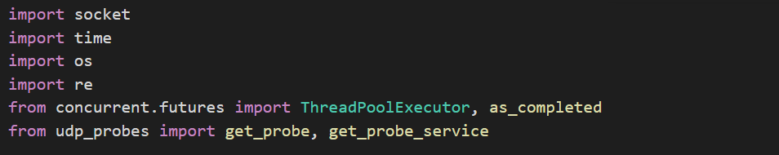
These are tools Python gives us.
They help the program:
- talk to other computers on the network
- measure time
- read and write files
- search for saved scan files
- run many scan tasks at the same time

2. Managing saved result files
The functions:
- get_scan_files()
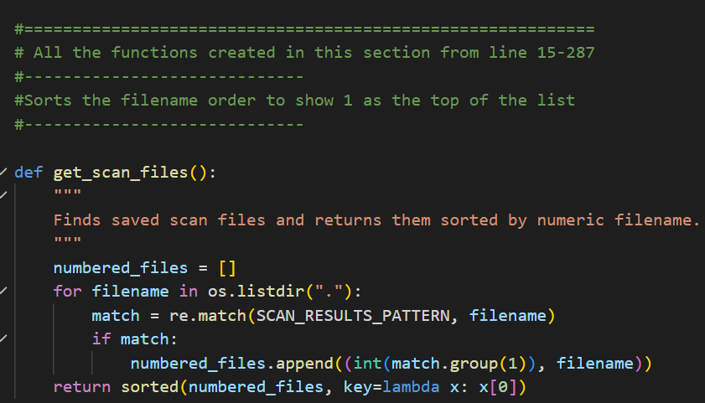
- get_scanned_targets()
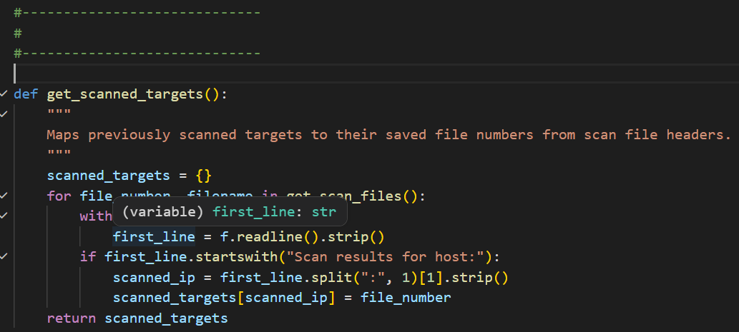

- get_next_scan_file_number()
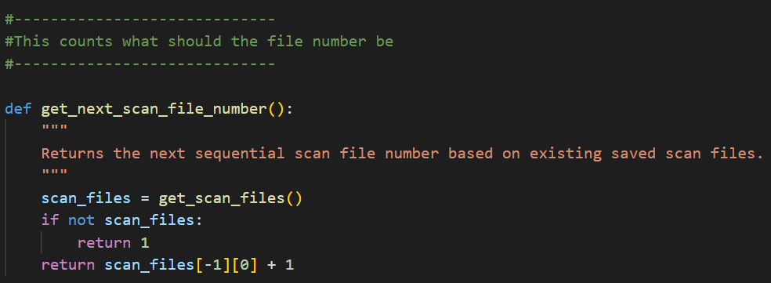
- get_next_available_scan_filename()
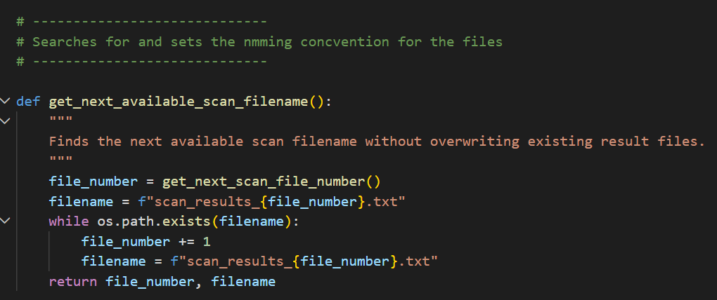
are used to manage saved scan results.
What they do
They make sure that when a scan is saved, the program creates files like:
- scan_results_1.txt
- scan_results_2.txt
- scan_results_3.txt
instead of overwriting old results.
This is useful because it keeps a history of previous scans. We could have added date and time when scans were implemented but decided not to go forward with it.

3. Saving scan results
The function:
save_scan_results(target_ip, results, scan_type, ports)
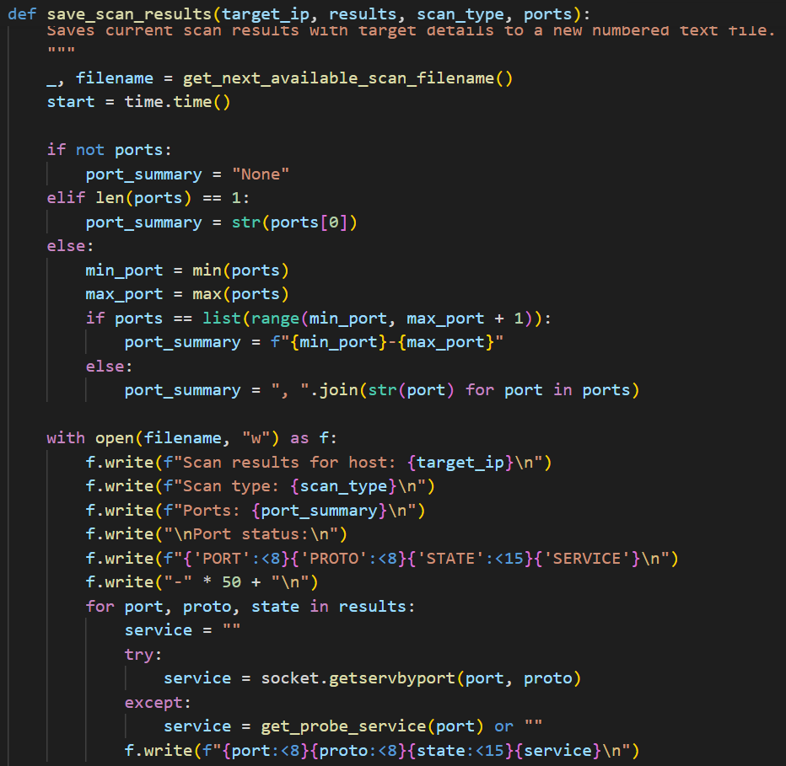
takes the scan output and writes it into a file.
What it includes
It saves:
- the target IP address
- the type of scan
- the ports checked
- whether each port was open, closed, or filtered
- the likely service name for the port
This helps make the project more practical, because users can review results later instead of only seeing them on screen once.

4. TCP scanning
The function:
scan_tcp(ip, port)
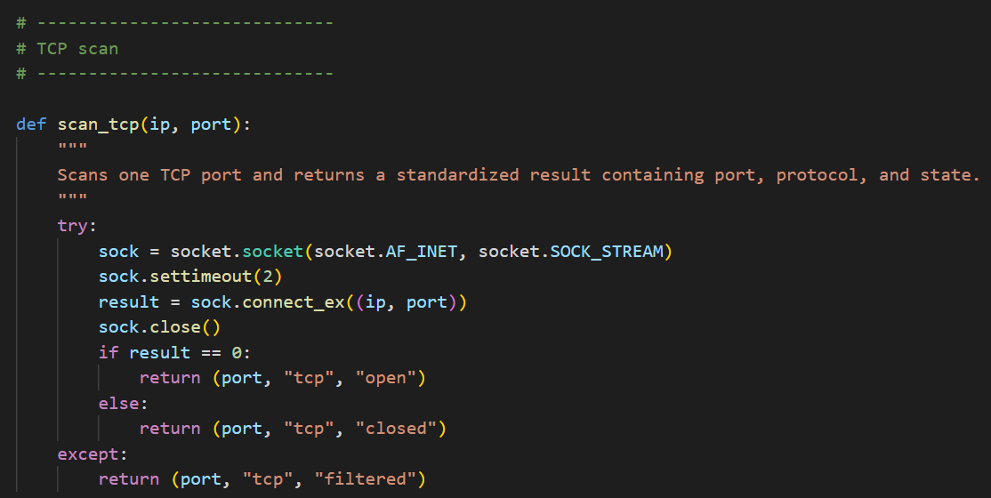
checks one TCP port.
What it does in simple language
It tries to connect to a port.
- If the connection works, the program says the port is open
- If it does not work, it says closed
- If something unusual happens, it may label it filtered
This is a very straightforward way to test TCP ports.

5. UDP scanning
The function:
scan_udp(ip, port)
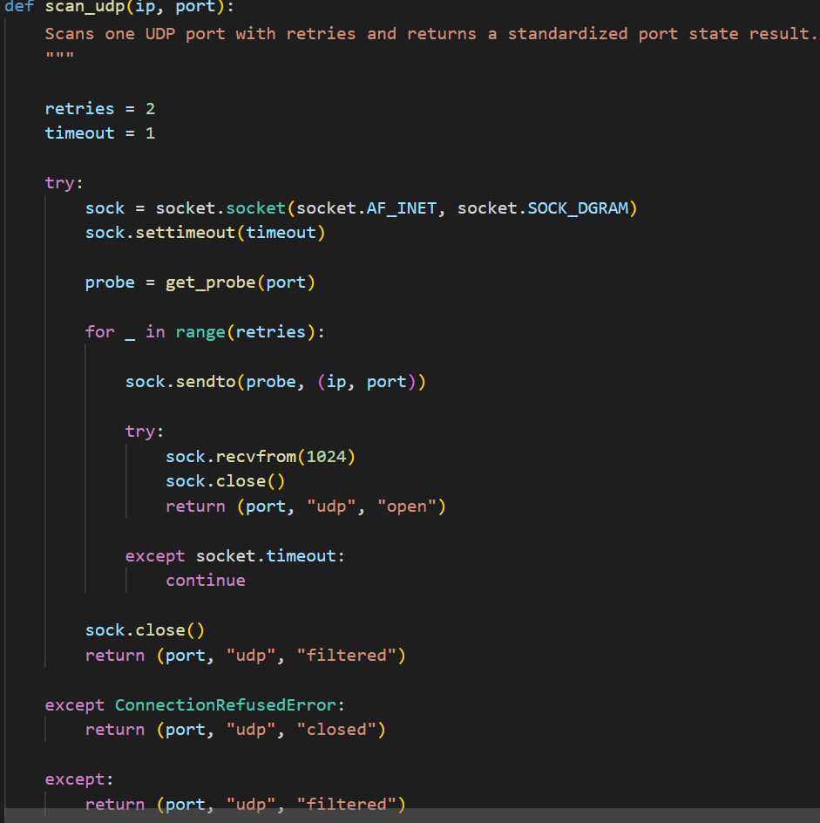
checks one UDP port.
UDP is harder to scan than TCP because UDP often gives less clear answers.
What the code does
It sends a small test message, called a probe, to the target port and waits for a reply.
- If a reply comes back, the port is treated as open
- If no reply comes after retries, it is marked filtered
- If the target rejects it, it may be marked closed
This is why UDP scanning is often slower and less certain than TCP scanning.

6. Running many scans at once with threading
The function:
run_scan(ip, ports, scan_type)
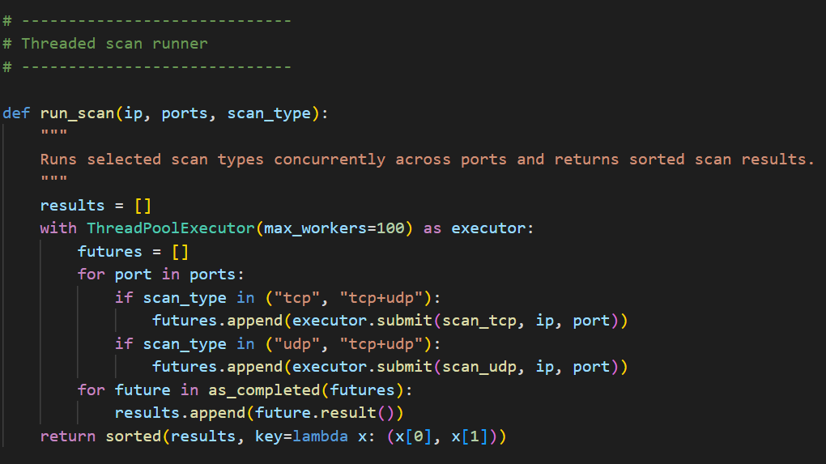
is where the threading happens.
It uses:
ThreadPoolExecutor(max_workers=100)
This means the program can work on many ports at the same time instead of checking one by one.

7. Why we used threading
This is one of the most important design choices in the program.
Example without threading(our first initial program just reading sockets or ports one at a time):
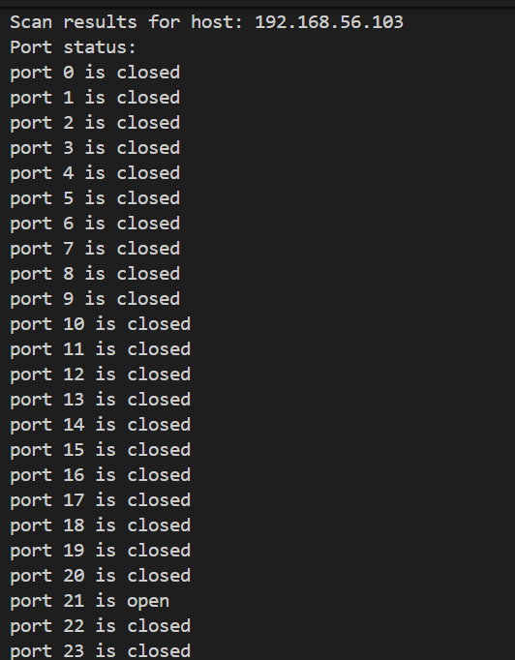
It took too long and not accurate at all.
Without threading
The scanner would do this:
- check port 1
- wait
- check port 2
- wait
- check port 3
- wait
That would be slow, especially if scanning many ports.
With threading
The scanner can check many ports at the same time.
So instead of waiting for each one to finish before starting the next, it can launch many scan tasks together.

Why this matters
Port scans often spend a lot of time waiting for network responses. Since waiting is the main delay, threading helps reduce total scan time a lot.

8. Why threading was useful in our project
We used threading because:
- it made the scanner faster
- it let us scan a range of ports more efficiently
- it made the program feel closer to a real security tool
- it reduced waiting time for the user
In other words, threading improved the performance and usability of the scanner.

9. Display options in the code
The program also lets the user choose how much detail to show.
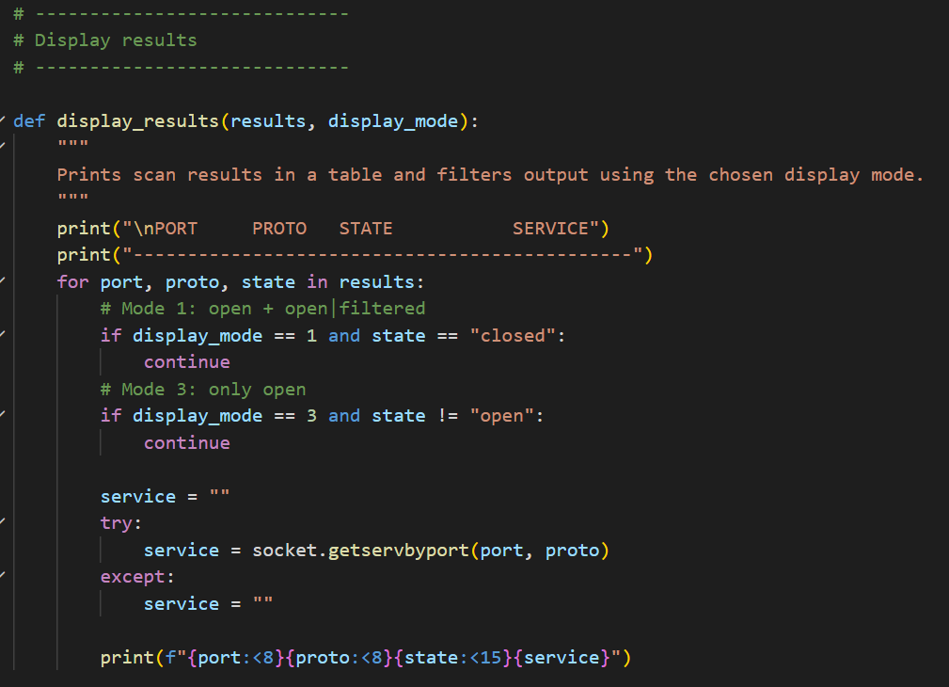
The display_results() function can:
- show only open ports
- show open and filtered ports
- show open, filtered, and closed ports
Why that is useful
If a user scans many ports, showing every closed port can make the output messy.
Filtering the display makes the results easier to read.

10. Menu system and user interaction
The code includes a menu so the user can choose from different options:
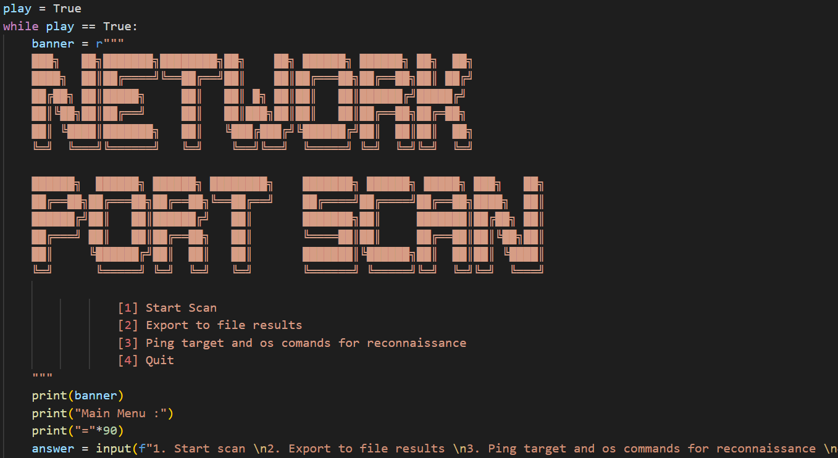
- start scan
- view saved scan files
- use simple reconnaissance commands
- quit
This makes the program easier to use because it behaves more like a small application instead of just a single script.

10. Extra reconnaissance tools
The program also includes:
- ping_host()
- dns_lookup()
- show_arp()
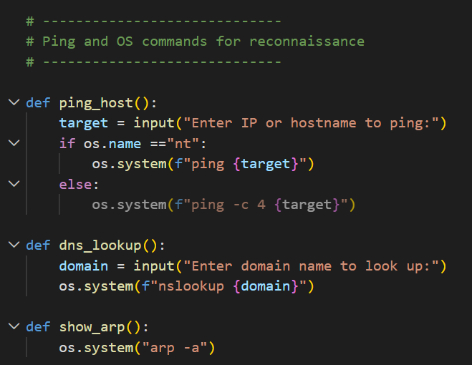
These are simple support tools.
Why they matter
Before scanning, a user may want to:
- check whether a host is reachable
- look up a domain name
- view nearby network devices in the ARP table
These are small but useful additions that make the scanner more complete.

3. Libraries Used
Library | Purpose
socket | Creates TCP and UDP connections used to test whether ports are open.
time | Used to measure scan timing and execution duration.
os | Allows interaction with the operating system for file management and system commands.
re | Used for pattern matching when managing scan result filenames.
concurrent.futures | Provides threading tools that allow many scan tasks to run simultaneously.
udp_probes | Provides probe payloads and service detection hints for UDP scanning.

4. Wireshark Observations Before Implementation
Before writing the scanner, packet captures were analyzed using Wireshark to understand how port scanning works at the network level.

4.1 TCP Behavior
Wireshark demonstrated how TCP connections behave when a port is open or closed. When a scanner attempts to connect to a port, the host responds differently depending on the service status. These response patterns allow the scanner to determine whether a port is open, closed, or filtered.

4.2 UDP Behavior
UDP scanning is less reliable because UDP does not use a connection handshake. In many cases, a service may not respond at all. Observing UDP traffic in Wireshark helped demonstrate why scanners sometimes classify ports as 'open|filtered'.

4.3 Understanding Scanner Logic
The Wireshark analysis reinforced the idea that scanning tools simply send packets and interpret responses. The logic implemented in the scanner follows this same principle: generate traffic, wait for a reply, and classify the port based on the response or lack of response.

5. Project Strengths
The final scanner includes several useful features:
- Support for both TCP and UDP scanning
- Threaded scanning for improved performance
- Saving scan results to numbered files
- Interactive menu system
- Reconnaissance tools such as ping and DNS lookup
- Configurable display modes for scan output

6. Conclusion
Building this scanner provided practical insight into how network security tools operate. By analyzing packet behavior in Wireshark and implementing scanning logic in Python, the project demonstrated the relationship between network traffic, protocol behavior, and Python.

