Normal k-means

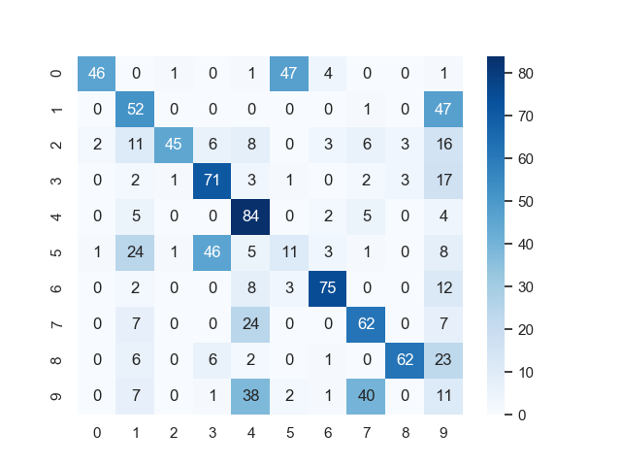

Accuracy: 0.519

K-means with feature vectors from autoencoder (trained 20 epochs)

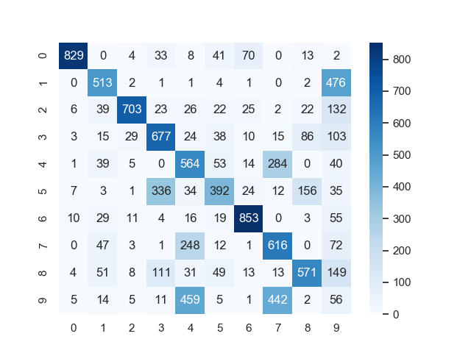Accuracy = 0.5774