network_analysis
Pietro Olivetti
2024-10-17

Network analysis of Depression and Anxiety Symptomatology

Packages and loading
library(dplyr)
library(igraph)
library(qgraph)
library(bootnet)
library(corpcor)
library(openxlsx)
library(ggplot2)
library(tidyr)
library(matrixcalc)
library(e1071)
library(networktools)
library(EGAnet)
#library(smacof)
source('../data/questions.R')
multiC <- function(cor_mat, t_hold = 0.8, name = ""){threshold <- t_hold
high_corr_pairs <- which(abs(cor_mat) > threshold & abs(cor_mat) < 1, arr.ind = TRUE)
# variable names and corresponding correlation values
high_corr_list <- data.frame(
Variable1 = rownames(cor_mat)[high_corr_pairs[, 1]],
Variable2 = colnames(cor_mat)[high_corr_pairs[, 2]],
Correlation = cor_mat[high_corr_pairs]
)
# variables and their correlation values
df <- high_corr_list %>%
arrange(desc(Correlation))}

Organizing data

All variables
Creating the dataframe and the group’s list for all variables
# Dataframe
df <- read.csv('../data/data_cleaned.csv')
# Groups
groups_all_variables <- list(Ids = 1, Sociodem = 2:8, Pers_BFI2 = 9:23, Pers_hexaco = 24:33, Depr_cesd = 34:53, Depr_phq = 54:62, Depr_promis = 63:90, Depr_qids = 91:106, Depr_Ans_dass = 107:120, Depr_Ans_hads = 121:134, Ans_gad = 135:141, Ans_tmas = 142:191, Ans_sas = 192:206)
########

All Scales
Creating the dataframe and the group’s list for all scales
# Dataframe
df_all_scales <- df[9:206]
groups_all_scales <- list(Pers_BFI2 = 1:15, Pers_hexaco = 16:25, Depr_cesd = 26:45, Depr_phq = 46:54, Depr_promis = 55:82, Depr_qids = 83:98, Depr_Ans_dass = 99:112, Depr_Ans_hads = 113:126, Ans_gad = 127:133, Ans_tmas = 134:183, Ans_sas = 184:198)
group_names <- c("Ids", "Sociodem", "Pers_BFI2", "Pers_hexaco", "Depr_cesd", "Depr_phq", "Depr_promis", "Depr_qids", "Depr_Ans_dass", "Depr_Ans_hads", "Ans_gad", "Ans_tmas", "Ans_sas")
#######

Scales related to anxiety and depression
Creating the dataframe and the group’s list for all scales related to depression and anxiety
# Dataframe
df_anx_dp <- df[34:206]
# Groups
groups_anx_dep <- list(D_cesd = 1:20, D_phq = 21:29, D_promis = 30:57, D_qids = 58:73, A_dass = 74:80 , D_dass = 81:87 , A_hads = 88:94, D_hads = 95:101, A_gad = 102:108, A_sas = 109:123, A_tmas = 124:173)

Scales related to anxiety and depression without TMAS
TMAS items are excluded because they are binary, unlike the Likert-scale items in the dataset, which could affect the accuracy of network analysis by increasing multicollinearity and distorting symptom relationships. Dichotomizing data, such as converting scores to binary categories, risks information loss, and while Cai (2022) uses binary data in network analysis, the potential impact of this on network structure is not addressed. Studies like Burger et al. (2022) advise caution when transforming data for network analysis, particularly with binarization. Excluding TMAS is a methodological choice that aims to ensure a more reliable and consistent analysis by using Likert scales for all symptoms.
# Dataframe
D_cesd <- df_anx_dp[1:20]
D_phq <- df_anx_dp[21:29]
D_promis <- df_anx_dp[30:57]
D_qids <- df_anx_dp[58:73]
A_dass <- df_anx_dp[c(74, 76, 78, 79, 82, 85, 86)] #74 ...80
D_dass <- df_anx_dp[c(75, 77, 80, 81, 83, 84, 87)] #81 ... 87
A_hads <- df_anx_dp[c(88,90,92,94,96, 98, 100)] # 88 ... 94
D_hads <- df_anx_dp[c(89,91,93,95,97,99,101)] # 95 ... 101
A_gad <- df_anx_dp[102:108]
A_sas <- df_anx_dp[159:173] #109 ... 123
A_tmas <- df_anx_dp[109:158] #124 ... 174
df_anx_dp_adj <- as.data.frame(list(D_cesd, D_phq, D_promis, D_qids, A_dass, D_dass, A_hads, D_hads, A_gad, A_sas))
# Groups
groups_anx_dep_adj <- list(D_cesd = 1:20, D_phq = 21:29, D_promis = 30:57, D_qids = 58:73, A_dass = 74:80 , D_dass = 81:87 , A_hads = 88:94, D_hads = 95:101, A_gad = 102:108, A_sas = 109:123)
# To be more readable on Network Graphs here is a vector of shortenned names
readable_anx_dp <- c("c01", "c02", "c03", "c04", "c05", "c06", "c07", "c08", "c09", "c10", "c11", "c12", "c13", "c14", "c15", "c16", "c17", "c18", "c19", "c20",
"ph01", "ph02", "ph03", "ph04", "ph05", "ph06", "ph07", "ph08", "ph09",
"pr01", "pr02", "pr03", "pr04", "pr05", "pr06", "pr07", "pr08", "pr09", "pr10", "pr11", "pr12", "pr13", "pr14", "pr15", "pr16", "pr17", "pr18", "pr19", "pr20", "pr21", "pr22", "pr23", "pr24", "pr25", "pr26", "pr27", "pr28",
"q01", "q02", "q03", "q04", "q05", "q06", "q07", "q08", "q09", "q10", "q11", "q12", "q13", "q14", "q15", "q16",
"d02", "d04", "d07", "d09", "d15", "d19", "d20", "d03", "d05", "d10", "d13", "d16", "d17", "d21",
"h01", "h03", "h05", "h07", "h09", "h11", "h13", "h02", "h04", "h06", "h08", "h10", "h12", "h14",
"g01", "g02", "g03", "g04", "g05", "g06", "g07",
"s01", "s02", "s03", "s04", "s05", "s06", "s07", "s08", "s09", "s10", "s11", "s12", "s13", "s14", "s15")
#"t01", "t02", "t03", "t04", "t05", "t06", "t07", "t08", "t09", "t10", "t11", "t12", "t13", "t14", "t15", "t16", "t17", #"t18", "t19", "t20", "t21", "t22", "t23", "t24", "t25", "t26", "t27", "t28", "t29", "t30", "t31", "t32", "t33", "t34", #"t35", "t36", "t37", "t38", "t39", "t40", "t41", "t42", "t43", "t44", "t45", "t46", "t47", "t48", "t49", "t50")
# Group names
group_names_anx_dep <- c("Depr_cesd", "Depr_phq", "Depr_promis", "Depr_qids", "Ans_dass" , "Depr_dass" , "Ans_hads", "Depr_hads", "Ans_gad", "Ans_sas")

Descriptive Statistics

Demographics
#to be done

General Statistics about the scales
Summary, Graphs, range, mean, sd, etc…
#to be done

Force-directed plotting with Fruchterman–Reingold
Most studies on networks in psychopathology have used the Fruchterman-Reingold (FR) algorithm to create graphs (Borsboom et al., 2021). This algorithm is like setting up a system of balls connected by stretchy strings. The strings pull connected balls closer, while the other balls push them apart, resulting in a graph where nodes are well-spaced and edges are evenly distributed (Deserno et al., 2022).
The goal of force-directed algorithms is not to place nodes in specific meaningful locations, but to make the network easy to view, showing connections and clusters clearly. The arrangement produced by these algorithms is primarily driven by the need for visual clarity and does not necessarily reflect any inherent structure or meaning beyond the connections themselves. Therefore, it is crucial to focus on the connections between nodes and their strengths, rather than the spatial arrangement of nodes, when interpreting a force-directed graph (Deserno et al., 2022).
The spatial positions of nodes in these graphs are highly sensitive to variations in edge weights, even those as small as 0.01. A slight alteration in edge weights can lead to significant changes in the node arrangement (Burger et al., 2022). Therefore, the layout should not be interpreted as reflecting inherent properties or relationships among the nodes beyond their connection.

Testing different correlation methods
Spearman Correlation, as mentioned, is particularly useful for analyzing non-parametric data. Spearman correlations, or rank-based correlations, can be used to handle non-normal continuous or ordered categorical data. On the other hand, automatic recognition of data type with cor_auto function from qgraph typically creates a dense correlation matrix, incorporating automatic correction for ordinal and continuous data, which can lead to multicollinearity. ForcePD forces the matrix to be positive definite. A positive definite matrix guarantees that all its eigenvalues are positive, a condition crucial for methods like testing the robustness of the network. Multicollinearity arises when predictor variables in a model are highly correlated, making it challenging to discern the unique effect of each predictor (Epskamp, Borsboom, & Fried, 2018). Therefore, testing which adjencency matrix is better in terms of multicollinearity and knowing whether it is positive. The results below show that both matrices are positive definite but what actually indicates that Spearman is the most suitable method for our data is the amount of variable pairs over a threshold of 0.8. While Spearman hasarount 34 pairs with that extremelly high correlation, the cor_auto function has 1232 pairs.
# cor_auto
symp_auto <- cor_auto(df_anx_dp_adj, forcePD = TRUE)
# Spearman Correlation
symp_spear <- cor(df_anx_dp_adj, method = "spearman")
# Estimating and penalizing connections
n1 <- estimateNetwork(df_anx_dp_adj, default="EBICglasso", corMethod = "spearman")
mc_auto <- multiC(symp_auto)
head(mc_auto, 5)
## Variable1 Variable2 Correlation
## 1 cesd_06 cesd_04 0.9395364
## 2 cesd_04 cesd_06 0.9395364
## 3 cesd_04 cesd_02 0.9318807
## 4 cesd_02 cesd_04 0.9318807
## 5 promis_12 promis_10 0.9257129
cat("\nAutomatic correlation method is positive definite = ", is.positive.definite(symp_auto), "\nIts amount of variable pairs over the threshold of 0.8 is:", nrow(mc_auto))
##
## Automatic correlation method is positive definite = TRUE
## Its amount of variable pairs over the threshold of 0.8 is: 1300
mc_spear <- multiC(symp_spear)
head(mc_spear, 5)
## Variable1 Variable2 Correlation
## 1 promis_12 promis_10 0.8486060
## 2 promis_10 promis_12 0.8486060
## 3 promis_05 promis_02 0.8340622
## 4 promis_02 promis_05 0.8340622
## 5 cesd_06 cesd_04 0.8288046
cat("\nSpearman method is positive definite = ", is.positive.definite(symp_spear), "\nIts amount of variable pairs over the threshold of 0.8 is:", nrow(mc_spear))
##
## Spearman method is positive definite = TRUE
## Its amount of variable pairs over the threshold of 0.8 is: 34
mc_n1 <- multiC(n1$graph)
head(mc_n1, 5)
## [1] Variable1 Variable2 Correlation
## <0 rows> (or 0-length row.names)
cat("\nSpearman method is positive definite = ", is.positive.definite(n1$graph), "\nIts amount of variable pairs over the threshold of 0.8 is:", nrow(mc_n1))
##
## Spearman method is positive definite = FALSE
## Its amount of variable pairs over the threshold of 0.8 is: 0

Creating networks out of individual scales using FR algorithm and Spearman Correlation
The Spearman correlation is particularly useful for analyzing non-parametric data, such as those generated by Likert scales, which are commonly employed in psychological research. Likert scales typically consist of a set of statements or questions with ordered response categories, such as “strongly agree,” and “strongly disagree”. The ordered nature of these responses often violates the assumptions of parametric statistical methods that require continuous, normally distributed data (Blanken et al., 2022)*. Spearman correlation, as a non-parametric method, does not rely on these assumptions and can be used to assess the strength and direction of the association between variables measured on Likert scales. This makes it a valuable tool for examining relationships between variables that do not meet the criteria for parametric analyses, providing researchers with a robust alternative for analyzing data commonly encountered in psychological research.
n <- 1
for(sc in groups_anx_dep_adj){
zero_order_scale <- cor(df_anx_dp_adj[sc], method = "spearman")
qgraph(zero_order_scale, layout="spring", labels = colnames(zero_order_scale), color = sample(colors(), 1), theme="TeamFortress", height = 180, width = 140, title = paste("Network of", group_names_anx_dep[n]))
n <- n + 1
}
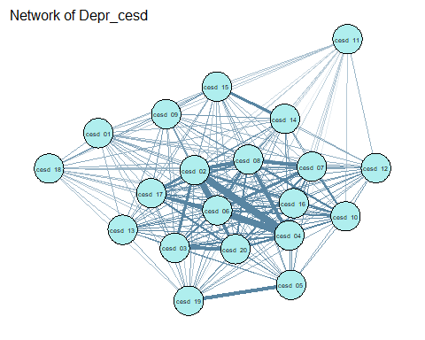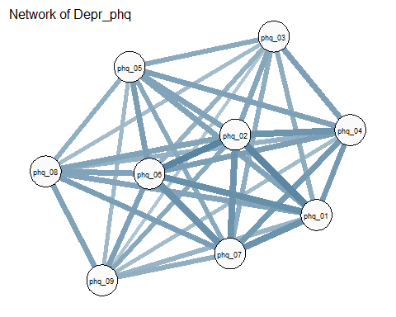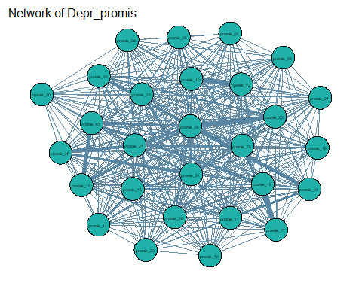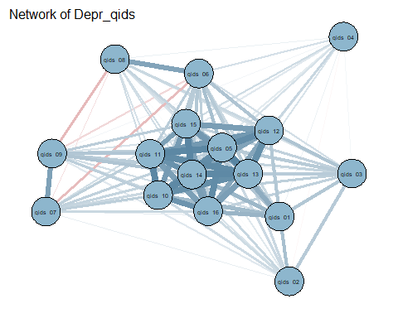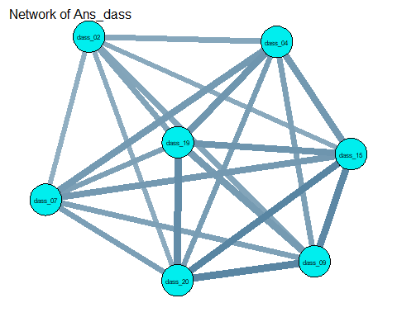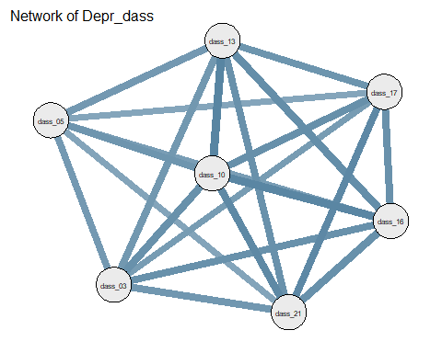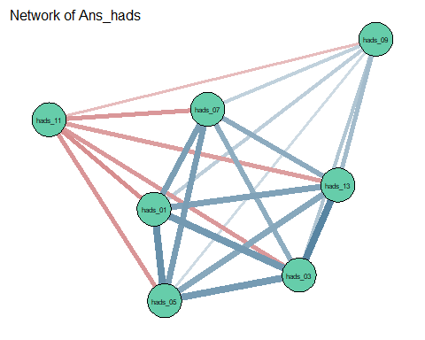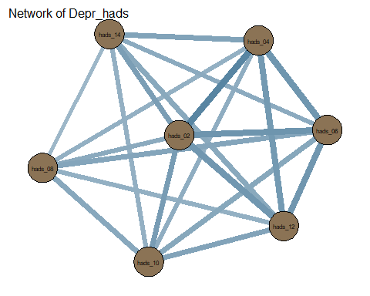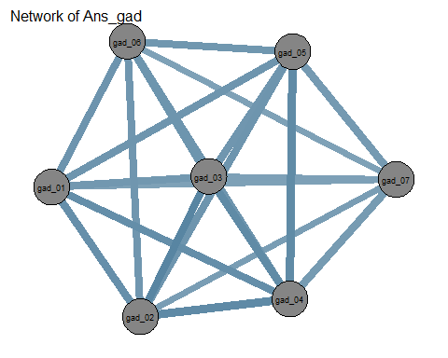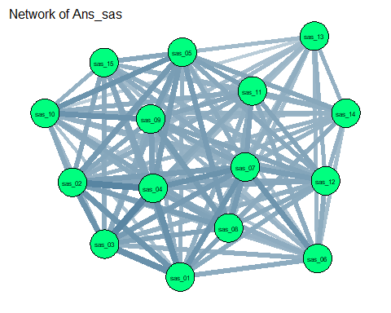

Network graphs and analysis
At first glace, the items seem to be rather clustered together. In spite of the visual impression, it is crucial to explore some measures in order to explore the network.
## png
## 2
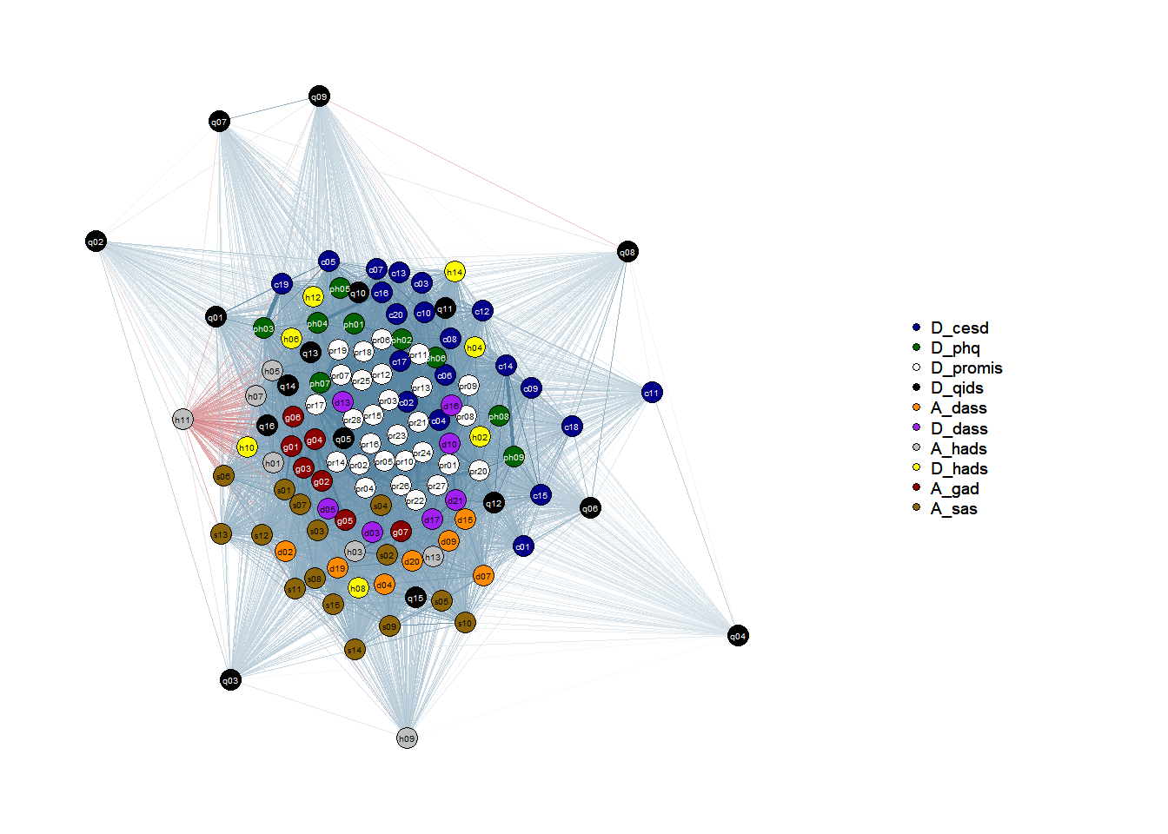
<<<<<<< HEAD ### Networks by nosological entities aimed by the scale ======= ## Centrality Measures for Individual Scales (Strength, Betweenness, Closeness):
spearman_cesd <- cor(D_cesd, method = "spearman")
centrality_cesd <- centrality_auto(spearman_cesd)
spearman_phq <- cor(D_phq, method = "spearman")
centrality_phq <- centrality_auto(spearman_phq)
spearman_promis <- cor(D_promis, method = "spearman")
centrality_promis <- centrality_auto(spearman_promis)
spearman_qids <- cor(D_qids, method = "spearman")
centrality_qids <- centrality_auto(spearman_qids)
spearman_dass_a <- cor(A_dass, method = "spearman")
centrality_dass_a <- centrality_auto(spearman_dass_a)
spearman_dass_d <- cor(D_dass, method = "spearman")
centrality_dass_d <- centrality_auto(spearman_dass_d)
spearman_hads_a <- cor(A_hads, method = "spearman")
centrality_hads_a <- centrality_auto(spearman_hads_a)
spearman_hads_d <- cor(D_hads, method = "spearman")
centrality_hads_d <- centrality_auto(spearman_hads_d)
spearman_gad <- cor(A_gad, method = "spearman")
centrality_gad <- centrality_auto(spearman_gad)
spearman_sas <- cor(A_sas, method = "spearman")
centrality_sas <- centrality_auto(spearman_sas)
spearman_tmas <- cor(A_tmas, method = "spearman")
centrality_tmas <- centrality_auto(spearman_tmas)
d5b403185badaf959096b494ef3bf2a688a3cf61
Identifying nodes only by the nosological entity one can see that the quantity of items related to depressive symptoms is far superior. It is no surprise since we excluded TMAS from the dataset.Anxiety items are in total 36 and the other 87 are related to depression. Despite representing a different nosological entity, these items seem to be clustered together with those of depression. Later, we investigate if the items about anxiety will form their own communities or blend with the others.
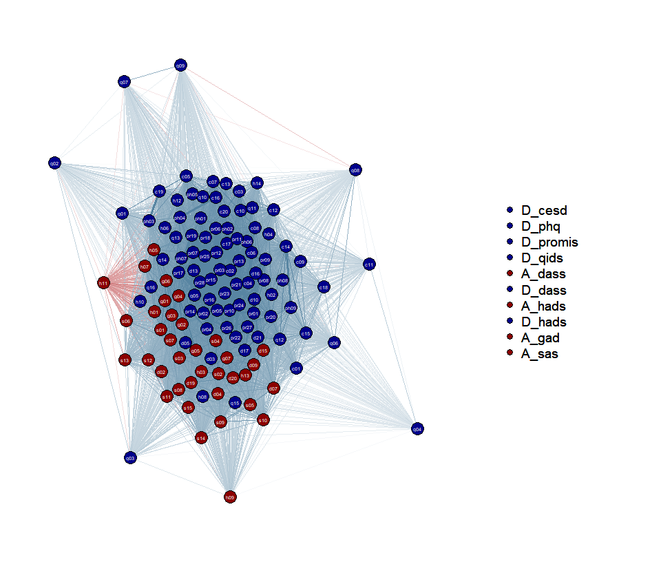

4. Robustness Network
Once we have find a correlation matrix that is positive determinate is controlled for multicollinearity, it is necessary to test the robustness of this weighted network. In order to do it, we will use the bootnet package (Version 1.6; Epskamp, 2024). Bootnet uses bootstrapping to calculate standard errors and confidence intervals and is able to poerform it in nonparametric data, such as ours.

Edges Robustness
In the graph below the red dots represent the mean from each edge of the original data and the black dots represent the same but for the bootstrap edges. In spite of the wider confidence interval band when it comes close to zero, all the dots seem to be tight together, indicating strong stability and reliability.
### 4.1 edge weight bootstrap
#m1<-bootnet(df_anx_dp_adj, nBoots=500, default="EBICglasso", labels=colnames(df_anx_dp_adj), type="nonparametric", statistics =c("edge", "strength", "closeness", "betweenness"))
#save(m1, file = "boot_symp_df_edgeweights.Rdata")
load(file = "../images/boot_symp_df_edgeweights.Rdata")
plot(m1, labels = FALSE, order = "sample")
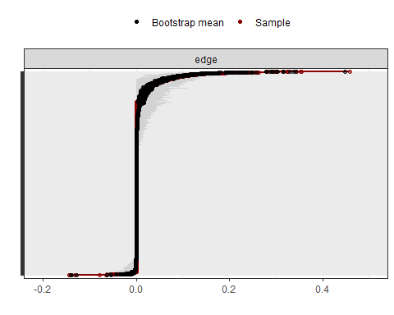
#pdf("../images/boot_symp_df_edgeweights.pdf", useDingbats=FALSE)
#plot(m1, labels = F, order = "sample")
#dev.off()

Node dropping
This bootstring method removes the nodes progressively and measures the correlation of the network for each removal. When there is only around 35% of the original nodes the correlation goes down quickly, increasing variability. This suggests that the network is significantly stable since it takes a huge amount of nodes removal to make it reduce the reliability of general node strength.
#m2<- bootnet(df_anx_dp_adj, default = "EBICglasso", nBoots=500, type = "node", labels=colnames(df_anx_dp_adj), statistics =c("strength", "closeness", "betweenness"))
#save(m2, file = "boot_symp_df_nodedropping.Rdata")
load(file = "../images/boot_symp_df_nodedropping.Rdata")
plot(m2)
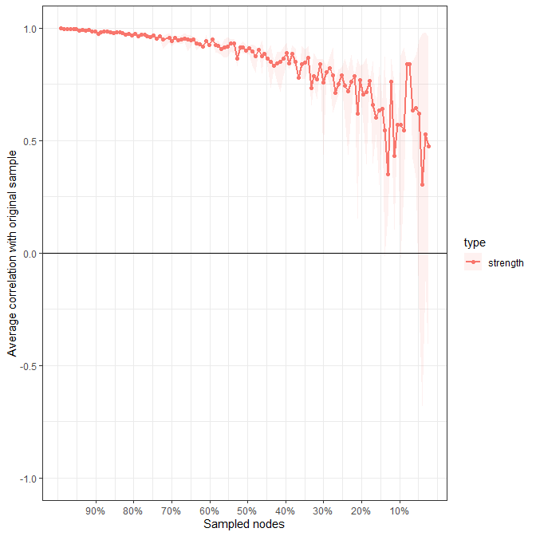
#plot(m2, perNode = T, legend = T, statistics =c("strength"))

Centrality Measures (Strength, Betweenness, Closeness):
Centrality measures are used to understand the relative importance or influence of nodes within a network. It is important to acknowledge that while centrality measures can provide valuable insights into the structure of a network, they should not be directly interpreted as measures of causal influence (Borsboom, 2017). The sources emphasize that network models, especially those based on correlation or partial correlation, do not inherently specify the direction of causal effects (Borsboom et al., 2021).
These measures help identify the most important nodes (symptoms) in the network. Strength indicates how connected a node is (Cai et al., 2022); Betweenness represents how often a node lies on the shortest path between other nodes; Closeness measures how quickly a node can reach other nodes.
# creating the table with all measures requested
cent_table_spear <- centrality_auto(symp_spear)
### Centrality Measures
pdf("../images/centrality_spear.pdf")
cent_graph_spear <- centralityPlot(symp_spear, scale = "raw0", include = c("Strength", "Closeness", "Betweenness"), decreasing = T, labels = readable_anx_dp)
dev.off()
## png
## 2
cent_graph_spear
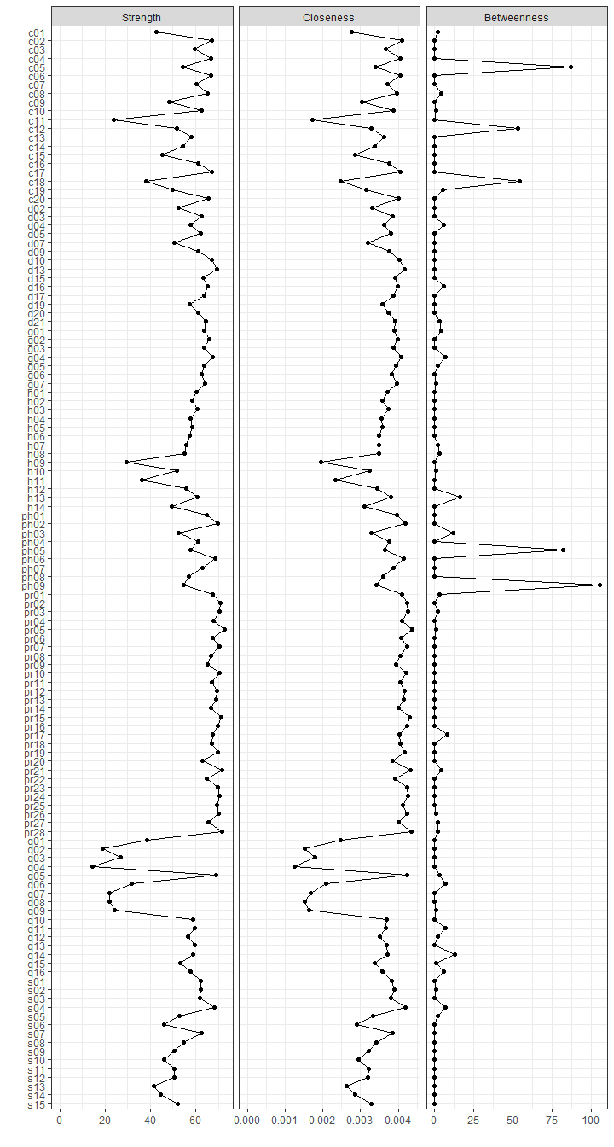
####Strength
Strength is the sum of the correlations of one node to all other nodes with higher values reflecting greater centrality in the network (Cai et al., 2022).
There is a remarkable dominance of promis items among the strongest ones. Almost all of the top 10 are arguably items related to the core DSM-V-TR symptom “depressed mood”. The data distribution for “Strength” is substantially skewed to the right, as presented in the graph. Most items have moderate to high strength, which could indicate that many nodes are strong within their own clusters but less connected across clusters. This hypothesis makes even more sense when we take into consideration the near-zero correlation between Strength and Betweenness measures (-0.0187) that suggests that nodes with high strength are not acting as bridges between clusters, but are tightely connected within their groups. Core Major Depression symptoms like depressed mood and anhedonia are particularly prominent here.
top_str <- cent_table_spear$node.centrality %>%
arrange(desc(Strength))
head(top_str, 10)
## Betweenness Closeness Strength ExpectedInfluence
## promis_05 1 0.004365505 72.76541 72.10187
## promis_21 4 0.004315606 71.70724 71.02427
## promis_28 2 0.004349012 71.62770 70.87923
## promis_15 0 0.004311767 71.46486 70.77000
## promis_02 0 0.004246198 70.95327 70.28330
## promis_24 0 0.004251037 70.55769 69.92529
## promis_10 0 0.004221163 70.51280 69.82857
## promis_07 0 0.004234416 70.41204 69.67582
## promis_03 2 0.004262541 70.38916 69.75880
## promis_26 1 0.004227029 70.03546 69.46545
tail(top_str, 10)
## Betweenness Closeness Strength ExpectedInfluence
## hads_11 0 0.002340342 36.32468 -36.32468
## qids_06 7 0.002086622 31.89005 30.88587
## hads_09 0 0.001943953 29.45306 28.99017
## qids_03 0 0.001790776 26.86590 26.61916
## qids_09 1 0.001643137 24.06010 22.96374
## cesd_11 0 0.001720255 23.87546 23.63657
## qids_07 0 0.001683269 21.98051 21.00595
## qids_08 0 0.001535180 21.80473 20.94286
## qids_02 0 0.001517898 18.92350 18.57312
## qids_04 0 0.001251495 14.29942 14.14807
cat("Top 10 Strength \n\n")
## Top 10 Strength
#questions[c("promis_05", "promis_21", "promis_28","promis_15", "promis_02")]
questions[c(which(colnames(df_anx_dp_adj) %in% sort(row.names(top_str)[1:10])))]
## $promis_02
## [1] "Sentí que nada me ilusionaba"
##
## $promis_03
## [1] "Me sentí indefenso/a (que no podía hacer nada para ayudarme)"
##
## $promis_05
## [1] "Sentí que nada me podía animar"
##
## $promis_07
## [1] "Me sentí triste"
##
## $promis_10
## [1] "Me sentí fracasado/a"
##
## $promis_15
## [1] "Me sentí deprimido/a"
##
## $promis_21
## [1] "Me sentí desesperanzado/a"
##
## $promis_24
## [1] "Sentí que nada me interesaba"
##
## $promis_26
## [1] "Sentí que mi vida estaba vacía"
##
## $promis_28
## [1] "Me sentí completamente agotado/a emocionalmente"
cat("\nBottom 20 Strength \n\n")
##
## Bottom 20 Strength
#questions[c("cesd_11", "qids_07", "qids_08","qids_02", "qids_04")]
questions[c(which(colnames(df_anx_dp_adj) %in% sort(row.names(top_str)[104:123])))]
## $cesd_01
## [1] "Tenía poco apetito"
##
## $cesd_09
## [1] "Sentía que era una mala persona"
##
## $cesd_11
## [1] "Dormía más de lo habitual"
##
## $cesd_15
## [1] "Quería hacerse daño"
##
## $cesd_18
## [1] "Perdió peso sin intentarlo"
##
## $qids_01
## [1] "Problemas a la hora de dormirse"
##
## $qids_02
## [1] "Sueño nocturno alterado"
##
## $qids_03
## [1] "Despertarse demasiado temprano"
##
## $qids_04
## [1] "Dormir demasiado"
##
## $qids_06
## [1] "Ha habido disminución del apetito"
##
## $qids_07
## [1] "Ha habido aumento del apetito"
##
## $qids_08
## [1] "Ha habido pérdida de peso"
##
## $qids_09
## [1] "Ha habido aumento de peso"
##
## $hads_09
## [1] "Tengo una sensación extraña, como si tuviera mariposas en el estómago"
##
## $hads_11
## [1] "Me siento inquieto/a, como si no pudiera parar de moverme"
##
## $hads_14
## [1] "Me divierto con un buen libro, la radio, o un programa de televisión"
##
## $sas_06
## [1] "Me molestan los dolores de cabeza, cuello y dolor de espalda"
##
## $sas_10
## [1] "Tengo desmayos o sensación de desmayos"
##
## $sas_13
## [1] "Tengo que vaciar mi vejiga con frecuencia"
##
## $sas_14
## [1] "Se me calienta la cara y se me pone enrojecida"
summary(top_str$Strength)
## Min. 1st Qu. Median Mean 3rd Qu. Max.
## 14.30 53.04 61.14 57.91 66.97 72.77
top_str
## Betweenness Closeness Strength ExpectedInfluence
## promis_05 1 0.004365505 72.76541 72.10187
## promis_21 4 0.004315606 71.70724 71.02427
## promis_28 2 0.004349012 71.62770 70.87923
## promis_15 0 0.004311767 71.46486 70.77000
## promis_02 0 0.004246198 70.95327 70.28330
## promis_24 0 0.004251037 70.55769 69.92529
## promis_10 0 0.004221163 70.51280 69.82857
## promis_07 0 0.004234416 70.41204 69.67582
## promis_03 2 0.004262541 70.38916 69.75880
## promis_26 1 0.004227029 70.03546 69.46545
## promis_16 0 0.004247373 69.84445 69.13925
## promis_23 0 0.004226995 69.80930 69.09570
## phq_02 0 0.004199282 69.74711 69.13069
## promis_19 0 0.004167235 69.62472 68.82916
## promis_25 0 0.004127187 69.51043 68.85726
## promis_12 0 0.004179470 69.50268 68.82247
## dass_13 0 0.004174714 69.34869 68.64348
## qids_05 3 0.004226433 69.22826 68.53338
## promis_13 0 0.004157139 69.18391 68.58634
## phq_06 0 0.004135586 68.71430 68.13412
## sas_04 7 0.004194146 68.41047 67.74584
## promis_04 0 0.004095054 67.73403 67.11397
## promis_17 8 0.004043714 67.71474 66.99984
## promis_01 3 0.004096780 67.55858 66.98393
## promis_06 0 0.004079000 67.49035 66.88234
## gad_04 7 0.004087235 67.36120 66.45176
## promis_11 0 0.004061058 67.31300 66.70663
## promis_18 0 0.004065504 67.13045 66.52045
## cesd_02 0 0.004095002 67.11337 66.46290
## dass_10 0 0.004043313 67.04027 66.47720
## cesd_17 0 0.004055556 66.98225 66.40246
## cesd_04 0 0.004066901 66.95792 66.34563
## promis_14 0 0.004008120 66.89616 66.28869
## promis_08 0 0.004050334 66.81481 66.26287
## cesd_06 0 0.004048560 66.73220 66.08963
## gad_02 0 0.003988842 65.85789 65.02218
## promis_27 2 0.004013408 65.81898 65.21915
## cesd_20 0 0.004021614 65.49416 64.81890
## promis_09 0 0.003942218 65.35468 64.71848
## cesd_08 4 0.003967253 65.35340 64.79722
## dass_16 6 0.003987713 65.20574 64.65450
## phq_01 0 0.003961423 65.03949 64.37323
## promis_22 0 0.003919588 64.84493 64.25700
## dass_21 3 0.003919996 64.53676 64.08782
## gad_07 1 0.003958294 64.26399 63.56580
## gad_03 0 0.003865575 63.93473 63.21244
## gad_05 2 0.003947502 63.83019 62.98978
## gad_01 4 0.003900918 63.68041 62.74014
## dass_17 0 0.003869430 63.66582 63.17903
## dass_15 0 0.003909181 63.45704 62.94351
## promis_20 0 0.003851671 62.95447 62.52618
## phq_07 0 0.003877604 62.92737 62.30008
## cesd_10 1 0.003864541 62.77519 62.16929
## gad_06 0 0.003826367 62.67095 61.95579
## sas_07 0 0.003850001 62.65721 61.94906
## dass_03 0 0.003856149 62.53519 61.90497
## sas_02 1 0.003886191 62.44665 61.71195
## dass_05 0 0.003807290 62.30481 61.68498
## sas_01 0 0.003821499 62.23201 61.35565
## sas_03 0 0.003814324 61.85838 61.14196
## cesd_16 0 0.003762756 61.17733 60.53834
## phq_04 0 0.003753760 61.14090 60.48965
## dass_20 0 0.003745179 60.99948 60.41252
## dass_09 0 0.003764482 60.99858 60.34265
## hads_13 16 0.003799790 60.91073 60.23454
## hads_03 0 0.003749486 60.70202 59.98904
## hads_01 0 0.003722996 60.56362 59.77613
## cesd_07 0 0.003707139 60.37425 59.80822
## qids_13 0 0.003684406 59.67399 59.12208
## cesd_03 0 0.003677162 59.57916 58.93214
## qids_11 7 0.003680638 59.53475 58.94672
## qids_14 13 0.003707683 59.04593 58.36471
## qids_10 0 0.003684553 58.74389 57.95845
## hads_05 0 0.003579597 58.65758 57.92425
## hads_02 0 0.003592106 58.49023 57.88499
## cesd_13 0 0.003634867 58.08730 57.42054
## hads_04 0 0.003562676 57.90110 57.31156
## qids_16 6 0.003582511 57.66363 56.70060
## dass_04 6 0.003628298 57.60559 57.07628
## phq_05 82 0.003644281 57.56202 56.90769
## dass_19 0 0.003592053 57.47805 56.87018
## hads_06 0 0.003496237 57.34211 56.73716
## phq_08 0 0.003603120 57.13730 56.64477
## qids_12 2 0.003515792 56.52034 56.16213
## hads_07 2 0.003489004 56.01847 55.29853
## hads_12 0 0.003440434 55.88313 55.28843
## hads_08 3 0.003499152 55.00555 54.34730
## phq_09 105 0.003422915 54.87306 54.54851
## sas_08 0 0.003433762 54.57348 53.91405
## cesd_14 0 0.003380698 54.45320 54.10374
## cesd_05 87 0.003403429 54.43822 53.76546
## qids_15 1 0.003388400 53.09728 52.53227
## sas_05 2 0.003331664 52.97355 52.50780
## phq_03 12 0.003286658 52.61150 51.98602
## dass_02 0 0.003301581 52.46602 51.81014
## sas_15 0 0.003296275 52.13075 51.58019
## cesd_12 53 0.003296921 51.77073 51.20715
## hads_10 1 0.003241431 51.72416 51.11984
## sas_09 0 0.003224010 50.73023 50.17564
## sas_11 0 0.003217828 50.70392 50.04507
## sas_12 0 0.003207713 50.50690 49.90328
## dass_07 0 0.003193651 50.43371 50.04382
## cesd_19 5 0.003148846 49.87952 49.23213
## hads_14 0 0.003107213 49.33823 48.77632
## cesd_09 0 0.003048508 48.49581 48.11945
## sas_06 0 0.002900075 46.21623 45.53144
## sas_10 0 0.002943170 46.13589 45.73820
## cesd_15 0 0.002867918 45.30223 45.03493
## sas_14 0 0.002851414 44.58144 44.08725
## cesd_01 2 0.002777187 42.74144 42.16380
## sas_13 0 0.002634876 41.49381 40.92050
## qids_01 0 0.002472004 38.55671 38.03457
## cesd_18 54 0.002465097 38.02216 37.62203
## hads_11 0 0.002340342 36.32468 -36.32468
## qids_06 7 0.002086622 31.89005 30.88587
## hads_09 0 0.001943953 29.45306 28.99017
## qids_03 0 0.001790776 26.86590 26.61916
## qids_09 1 0.001643137 24.06010 22.96374
## cesd_11 0 0.001720255 23.87546 23.63657
## qids_07 0 0.001683269 21.98051 21.00595
## qids_08 0 0.001535180 21.80473 20.94286
## qids_02 0 0.001517898 18.92350 18.57312
## qids_04 0 0.001251495 14.29942 14.14807
ggplot(top_str, aes(x = Strength)) +
geom_area(stat = "bin", bins = 30, fill = "skyblue", alpha = 0.6) +
labs(title = "Distribution of Strength Values",
x = "Strength",
y = "Frequency") +
theme_minimal()
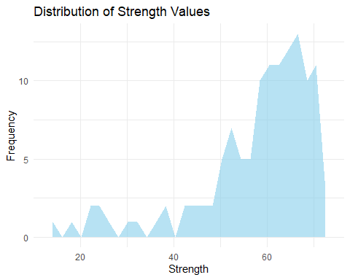
####Betweenness
A node with high betweenness is a node that tends to connect clusters of nodes together (Deserno et al., 2022). In our investigation, there is a significant difference between the top 5 and all the rest, which indicates that only certain items, and therefore only certain symptoms, act as bridges between the different clusters. These items indicate the constructs of weight/appetite issues, sleep issues and suicidal thoughts. They essentially act as bridges between the most central nodes and the peripherical nodes, which, in turn are have an importantantly low value for closenness. In our case, the peripheral items (low closenness) are connected to the strong central items through the ones having high betweenness values.
top_bet <-cent_table_spear$node.centrality %>%
arrange(desc(Betweenness))
head(top_bet, 10)
## Betweenness Closeness Strength ExpectedInfluence
## phq_09 105 0.003422915 54.87306 54.54851
## cesd_05 87 0.003403429 54.43822 53.76546
## phq_05 82 0.003644281 57.56202 56.90769
## cesd_18 54 0.002465097 38.02216 37.62203
## cesd_12 53 0.003296921 51.77073 51.20715
## hads_13 16 0.003799790 60.91073 60.23454
## qids_14 13 0.003707683 59.04593 58.36471
## phq_03 12 0.003286658 52.61150 51.98602
## promis_17 8 0.004043714 67.71474 66.99984
## qids_06 7 0.002086622 31.89005 30.88587
#tail(top_bet, 10)
#head(cent_table_spear$node.centrality %>%arrange(Betweenness, Strength), 10)
cat("Top 10 Betweenness \n\n")
## Top 10 Betweenness
questions[c(which(colnames(df_anx_dp_adj) %in% sort(row.names(top_bet)[1:10])))]
## $cesd_05
## [1] "Su sueño era inquieto"
##
## $cesd_12
## [1] "Sentía que se movía muy lento"
##
## $cesd_18
## [1] "Perdió peso sin intentarlo"
##
## $phq_03
## [1] "Tener problemas para dormir o mantenerse dormido, o dormir demasiado"
##
## $phq_05
## [1] "Tener poco apetito o comer en exceso"
##
## $phq_09
## [1] "Tener pensamientos sobre estar muerto(a) o sobre hacerse daño a sí mismo(a) de alguna manera"
##
## $promis_17
## [1] "Me sentí desanimado/a acerca del futuro"
##
## $qids_06
## [1] "Ha habido disminución del apetito"
##
## $qids_14
## [1] "Nivel de energía"
##
## $hads_13
## [1] "Me asaltan sentimientos repentinos de pánico"
cat("\nBottom Betweenness: 83 items had betweenness = 0 \n\n")
##
## Bottom Betweenness: 83 items had betweenness = 0
#which(colnames(df_anx_dp_adj) %in% sort(row.names(top_bet)[1:40]))
####Closeness
Closeness quantifies how far removed a node is from every other node in the network (Deserno et al., 2022). As mentioned above, low closenness means being more peripheral. In our network, given that the intercorrelation between strength and closenness is almost perfect, if a node is strong it is within a central cluster, well connected to the other local nodes.
top_clo <- cent_table_spear$node.centrality %>%
arrange(desc(Closeness))
bottom_clo <- cent_table_spear$node.centrality %>%
arrange(Closeness)
head(top_clo, 10)
## Betweenness Closeness Strength ExpectedInfluence
## promis_05 1 0.004365505 72.76541 72.10187
## promis_28 2 0.004349012 71.62770 70.87923
## promis_21 4 0.004315606 71.70724 71.02427
## promis_15 0 0.004311767 71.46486 70.77000
## promis_03 2 0.004262541 70.38916 69.75880
## promis_24 0 0.004251037 70.55769 69.92529
## promis_16 0 0.004247373 69.84445 69.13925
## promis_02 0 0.004246198 70.95327 70.28330
## promis_07 0 0.004234416 70.41204 69.67582
## promis_26 1 0.004227029 70.03546 69.46545
tail(top_clo, 10)
## Betweenness Closeness Strength ExpectedInfluence
## hads_11 0 0.002340342 36.32468 -36.32468
## qids_06 7 0.002086622 31.89005 30.88587
## hads_09 0 0.001943953 29.45306 28.99017
## qids_03 0 0.001790776 26.86590 26.61916
## cesd_11 0 0.001720255 23.87546 23.63657
## qids_07 0 0.001683269 21.98051 21.00595
## qids_09 1 0.001643137 24.06010 22.96374
## qids_08 0 0.001535180 21.80473 20.94286
## qids_02 0 0.001517898 18.92350 18.57312
## qids_04 0 0.001251495 14.29942 14.14807
cat("Top 10 Closenness \n\n")
## Top 10 Closenness
#questions[c("promis_05", "promis_28", "promis_21","promis_15", "promis_03")]
questions[c(which(colnames(df_anx_dp_adj) %in% sort(row.names(top_clo)[1:10])))]
## $promis_02
## [1] "Sentí que nada me ilusionaba"
##
## $promis_03
## [1] "Me sentí indefenso/a (que no podía hacer nada para ayudarme)"
##
## $promis_05
## [1] "Sentí que nada me podía animar"
##
## $promis_07
## [1] "Me sentí triste"
##
## $promis_15
## [1] "Me sentí deprimido/a"
##
## $promis_16
## [1] "Tuve problemas para tomar decisiones"
##
## $promis_21
## [1] "Me sentí desesperanzado/a"
##
## $promis_24
## [1] "Sentí que nada me interesaba"
##
## $promis_26
## [1] "Sentí que mi vida estaba vacía"
##
## $promis_28
## [1] "Me sentí completamente agotado/a emocionalmente"
cat("\nBottom 10 Closenness \n\n")
##
## Bottom 10 Closenness
questions[c(which(colnames(df_anx_dp_adj) %in% sort(row.names(bottom_clo)[1:10])))]
## $cesd_11
## [1] "Dormía más de lo habitual"
##
## $qids_02
## [1] "Sueño nocturno alterado"
##
## $qids_03
## [1] "Despertarse demasiado temprano"
##
## $qids_04
## [1] "Dormir demasiado"
##
## $qids_06
## [1] "Ha habido disminución del apetito"
##
## $qids_07
## [1] "Ha habido aumento del apetito"
##
## $qids_08
## [1] "Ha habido pérdida de peso"
##
## $qids_09
## [1] "Ha habido aumento de peso"
##
## $hads_09
## [1] "Tengo una sensación extraña, como si tuviera mariposas en el estómago"
##
## $hads_11
## [1] "Me siento inquieto/a, como si no pudiera parar de moverme"

Intercorrelation of Centrality Measures:
High intercorrelations suggest that certain centrality measures may be capturing similar network properties and these intercorrelations are loud and clear: Strength and Closenness are intercorrelated almost perfectly, while Betweenness has nearly no correlation with them.
cat("Correlation of the measures\n\n")
## Correlation of the measures
cat("Strength x Closeness: ", cor(cent_table_spear$node.centrality$Strength, cent_table_spear$node.centrality$Closeness, method="spearman"), "\n")
## Strength x Closeness: 0.9969303
cat("Strength x Betweenness: ",cor(cent_table_spear$node.centrality$Strength, cent_table_spear$node.centrality$Betweenness, method="spearman"), "\n")
## Strength x Betweenness: -0.01877488
cat("Betweenness x Closeness: ",cor(cent_table_spear$node.centrality$Betweenness, cent_table_spear$node.centrality$Closeness, method="spearman"), "\n")
## Betweenness x Closeness: 2.325542e-05
Joining closenness and strength. There is no meaning in creating a bottom 5 for betweenness since there are 83 nodes (67%) having zero as value for this measure.Instead, we will merge strength and closenness only for visualization purposes and explore the 15 top and bottom closenness/strength nodes. Also, we will visualize all the nodes that have a betweenness value bigger than zero.
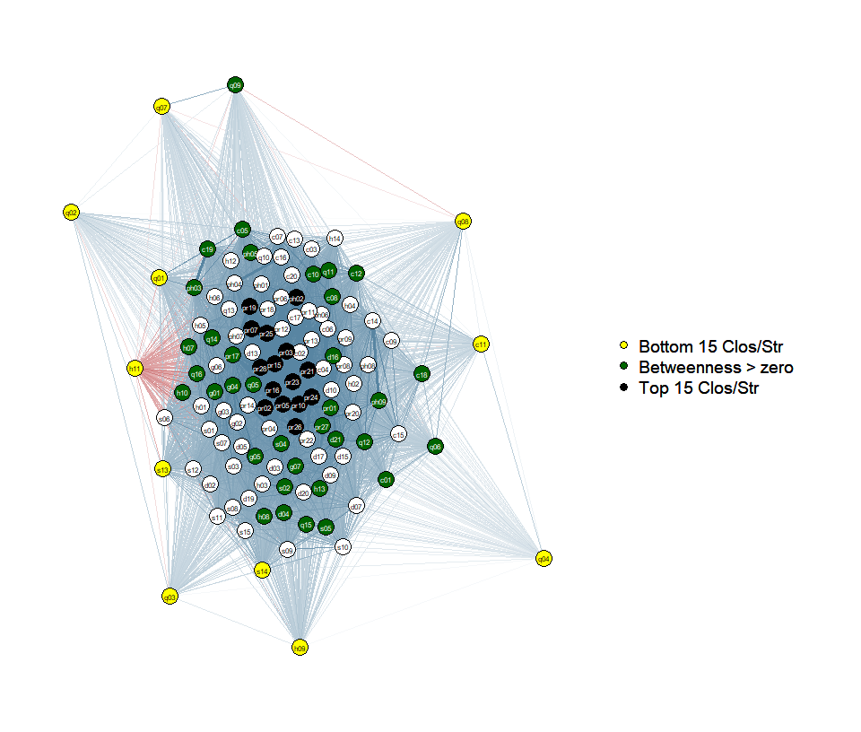

Clustering
We have been talking a lot about clustering, so it is time to start investigating this feature. The clustering coefficient measures how tightly connected the neighbors of a node are. High values indicate that a node’s neighbors are also likely to be connected, forming local clusters of related symptoms.

Clustering Coefficient
Clustering measures, such as Onnela, Zhang, and WS, are statistical techniques used to identify groups or clusters within a dataset. These methods help uncover hidden patterns and relationships between data points. In the context of symptom networks, these measures can be used to group similar symptoms together. Onnela’s clustering coefficient is more sensitive to the overall network structure, capturing subtle clustering patterns (Constantini et al., 2015). Zhang and Horvath’s method focuses on identifying densely connected modules, while Watts and Strogatz’s transitivity emphasizes local clustering and the formation of triangles(Constantini et al., 2015).
In our network, it is possible to see that a high clustering coefficient, specially in WS and Zhang plots. All methods detect consistent clusters for some items, especially in the SAS, QIDS, and CESD scales, where items related to sleep, appetite/weight, and somatic issues tend to vary more than the other items. We have already seen that these type of items tend to be either peripheral (low strength and closenness) or bridges the periphery (betweenness).
# Creating a copy of the symptom similarity matrix
cl_symp <- symp_spear
# Making the matrix symmetric by copying the upper triangle to the lower triangle
cl_symp[upper.tri(cl_symp)] <- t(cl_symp)[upper.tri(cl_symp)]
# Creating a clustering plot based on the symmetric similarity matrix
clusteringPlot(cl_symp, signed = T, decreasing = T)
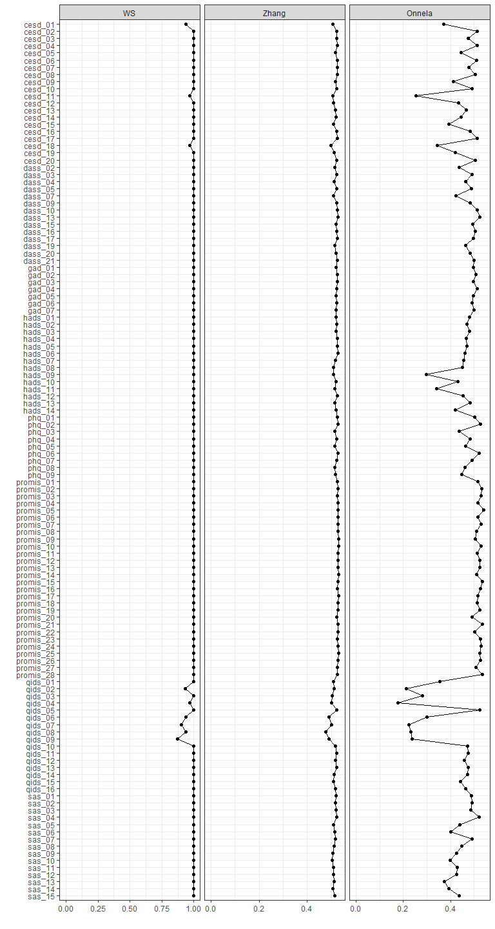

Density and Small-Worldness (Transitivity, APL - Average Path Length, Small-World Index):
Network density refers to the proportion of possible edges that are actually present. Small-worldness combines transitivity (the likelihood that two connected nodes share a neighbor) and average path length (the average number of steps between two nodes) to determine if the network has a small-world structure, where symptoms are highly clustered but still have short paths between them.
A transitivity of 0.46 means that around 46% of all possible connections between nodes are present. This indicates a relatively well-connected network but not saturated. The value of observed transitivity (1) compared to a random network (0.99) suggests a strong clustering structure. The APL 1 means that most nodes are directly connected. It is slightly shorter than the APL in a random network (1.38). The nodes are directly connected, which is slightly shorter than the APL in a random network (1.38). ⁤⁤The small-world index of 1.39 indicates that the network combines high clustering with short paths between nodes and this makes efficient connections within clusters possible.

Density and smallworldness
#Density:
cat("Density: ", mean(symp_spear[lower.tri(symp_spear)]), "\n")
## Density: 0.4647429
#APL, transitivity and small-worldness:
smallworldIndex(qgraph(symp_spear))
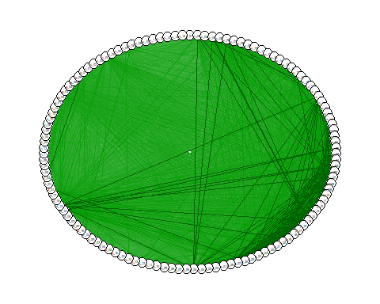
## $transitivity
## [1] 1
##
## $transitivity_random
## [1] 0.9918699
##
## $APL
## [1] 1
##
## $APL_random
## [1] 1.381547
##
## $index
## [1] 1.392871

Groups of symptoms based on core symptoms from DSM-V-TR

descripción de los síntomas y su atribución
quizás añadir qgraph con grupos separados por síntomas

Louvain Communities
Explicar el concepto de louvain Explicar el concepto de modularidad

Creating the absolute values adjacency matrix
# Converting the correlation matrix into an adjacency matrix
adj_matrix <- as.matrix(symp_spear)
# threshold to binarize the matrix (only keep strong correlations)
#adj_matrix[abs(adj_matrix) < 0.3] <- 0 # Set a threshold of 0.3 (or adjust as needed)
# attribute abs values to negative edges
adj_matrix[adj_matrix < 0] <- abs(adj_matrix[adj_matrix < 0])
# Converting the adjacency matrix to an igraph object
graph_symp <- graph_from_adjacency_matrix(adj_matrix, mode = "undirected", weighted = TRUE, diag = FALSE)

Refining the resolution
Changing resolution levels in order to find the most fine-grained set of communities. Counting the number of symptoms represented in all scales we arrived at 15 core symptoms related or not to DSM-V-TR. Using resolutions between 1.05 to 1.1 creates communities from 8 to 17 communities. Therefore, the idea of employing this range comes from the estimation of 15 main symptoms that we classified earlier. ** ESCRIBIR SÍNTOMAS / PROFUNDIZAR
# Running the Louvain algorithm 41 times to detect communities with a slowly growing modularity
decseq <- seq(from = 1.05, to = 1.1, by = 0.00025)
templist <- c()
# For loop to get all results as new columns
for(i in decseq){
louvain_commu_temp <- cluster_louvain(graph_symp, resolution = i)
comm_df <- as.data.frame(membership(louvain_commu_temp))
templist[[as.character(i)]] <- comm_df}
louvain_rep <- as.data.frame(templist)
tlouvain <- t(louvain_rep)
#write.xlsx(as.data.frame(tlouvain), "louvain.xlsx", rowNames = TRUE)

Choosing the best communities
Find which result has the best correlation from all communities
# Obtaining correlations
correlation_matrix <- cor(louvain_rep, method = "pearson")
clou <- as.data.frame(correlation_matrix)
#
#colnames(clou)
# summing each column - summing is enough because all correlations are positive and have self cor values
l <- list()
for(i in colnames(clou)){
cat(i, " = ",sum(clou[[i]]), "\n")
l <- append(l, sum(clou[[i]]))
}
## x = 143.1521
## x.1 = 143.1521
## x.2 = 102.9735
## x.3 = 75.35995
## x.4 = 143.1521
## x.5 = 143.1521
## x.6 = 148.388
## x.7 = 143.48
## x.8 = 143.48
## x.9 = 146.8067
## x.10 = 97.29128
## x.11 = 97.50027
## x.12 = 143.48
## x.13 = 143.1521
## x.14 = 138.1459
## x.15 = 143.48
## x.16 = 143.5284
## x.17 = 167.197
## x.18 = 72.89322
## x.19 = 146.3905
## x.20 = 146.3905
## x.21 = 99.03205
## x.22 = 144.3291
## x.23 = 167.197
## x.24 = 99.03205
## x.25 = 99.03205
## x.26 = 144.7852
## x.27 = 160.551
## x.28 = 167.197
## x.29 = 165.4244
## x.30 = 166.514
## x.31 = 131.9911
## x.32 = 144.7738
## x.33 = 151.8843
## x.34 = 142.6312
## x.35 = 164.5141
## x.36 = 159.1625
## x.37 = 159.1625
## x.38 = 164.5141
## x.39 = 151.8843
## x.40 = 134.9604
## x.41 = 142.753
## x.42 = 79.43199
## x.43 = 167.2895
## x.44 = 159.1625
## x.45 = 167.2126
## x.46 = 146.8067
## x.47 = 168.39
## x.48 = 146.8067
## x.49 = 150.303
## x.50 = 149.4915
## x.51 = 140.3914
## x.52 = 39.13062
## x.53 = 165.53
## x.54 = 138.3648
## x.55 = 130.8415
## x.56 = 137.6417
## x.57 = 166.4652
## x.58 = 168.1239
## x.59 = 170.043
## x.60 = 167.8217
## x.61 = 163.5403
## x.62 = 138.4126
## x.63 = 144.1696
## x.64 = 167.8217
## x.65 = 165.7929
## x.66 = 163.9155
## x.67 = 143.2162
## x.68 = 161.8018
## x.69 = 162.7791
## x.70 = 166.5038
## x.71 = 150.1455
## x.72 = 167.1617
## x.73 = 133.5112
## x.74 = 164.8616
## x.75 = 165.6621
## x.76 = 170.6527
## x.77 = 165.6621
## x.78 = 165.1596
## x.79 = 158.5363
## x.80 = 170.1745
## x.81 = 166.8735
## x.82 = 169.4512
## x.83 = 167.8585
## x.84 = 140.7414
## x.85 = 167.9558
## x.86 = 158.4736
## x.87 = 78.29418
## x.88 = 170.2579
## x.89 = 167.516
## x.90 = 137.0693
## x.91 = 166.1854
## x.92 = 167.516
## x.93 = 171.6934
## x.94 = 162.2683
## x.95 = 168.9775
## x.96 = 170.9552
## x.97 = 171.6896
## x.98 = 164.7919
## x.99 = 163.3692
## x.100 = 166.7201
## x.101 = 168.7421
## x.102 = 165.0706
## x.103 = 170.4471
## x.104 = 167.267
## x.105 = 168.9715
## x.106 = 121.4003
## x.107 = 163.426
## x.108 = 167.267
## x.109 = 169.1196
## x.110 = 171.0771
## x.111 = 170.4312
## x.112 = 168.7421
## x.113 = 168.7421
## x.114 = 170.7803
## x.115 = 170.696
## x.116 = 162.2553
## x.117 = 169.6138
## x.118 = 165.7383
## x.119 = 67.89111
## x.120 = 145.9566
## x.121 = 169.5752
## x.122 = 170.6365
## x.123 = 171.061
## x.124 = 171.877
## x.125 = 170.4312
## x.126 = 170.4935
## x.127 = 169.814
## x.128 = 165.2683
## x.129 = 171.7546
## x.130 = 169.3184
## x.131 = 139.4631
## x.132 = 170.261
## x.133 = 145.553
## x.134 = 170.4471
## x.135 = 170.6834
## x.136 = 163.5883
## x.137 = 170.4
## x.138 = 165.9765
## x.139 = 168.0969
## x.140 = 139.5482
## x.141 = 172.8367
## x.142 = 166.8237
## x.143 = 171.0049
## x.144 = 150.5836
## x.145 = 164.8643
## x.146 = 172.1497
## x.147 = 162.9078
## x.148 = 171.6137
## x.149 = 160.3132
## x.150 = 170.8857
## x.151 = 157.4945
## x.152 = 173.314
## x.153 = 159.0001
## x.154 = 172.4004
## x.155 = 150.3462
## x.156 = 173.115
## x.157 = 157.6142
## x.158 = 170.4199
## x.159 = 171.0808
## x.160 = 162.258
## x.161 = 173.115
## x.162 = 171.3644
## x.163 = 172.7363
## x.164 = 168.5235
## x.165 = 157.2316
## x.166 = 162.5835
## x.167 = 151.7208
## x.168 = 168.0613
## x.169 = 164.3954
## x.170 = 157.2316
## x.171 = 169.9426
## x.172 = 170.8513
## x.173 = 163.9937
## x.174 = 172.4839
## x.175 = 170.8513
## x.176 = 171.3452
## x.177 = 164.8981
## x.178 = 172.6096
## x.179 = 171.1936
## x.180 = 161.2355
## x.181 = 161.9135
## x.182 = 157.439
## x.183 = 170.776
## x.184 = 165.7762
## x.185 = 161.3775
## x.186 = 164.9781
## x.187 = 171.6207
## x.188 = 167.4354
## x.189 = 170.8618
## x.190 = 172.1405
## x.191 = 169.4673
## x.192 = 167.982
## x.193 = 171.5492
## x.194 = 154.617
## x.195 = 161.9055
## x.196 = 160.8013
## x.197 = 156.622
## x.198 = 171.9611
## x.199 = 173.1738
## x.200 = 167.5771
#value with the strongest correlations from all
clou[which.max(unlist(l))]
## x.152
## x 0.7501737
## x.1 0.7501737
## x.2 0.5429202
## x.3 0.4448589
## x.4 0.7501737
## x.5 0.7501737
## x.6 0.7857463
## x.7 0.7537169
## x.8 0.7537169
## x.9 0.7776089
## x.10 0.4954775
## x.11 0.4976101
## x.12 0.7537169
## x.13 0.7501737
## x.14 0.7167289
## x.15 0.7537169
## x.16 0.7649655
## x.17 0.9357688
## x.18 0.4309493
## x.19 0.7721425
## x.20 0.7721425
## x.21 0.5179179
## x.22 0.7601490
## x.23 0.9357688
## x.24 0.5179179
## x.25 0.5179179
## x.26 0.7626778
## x.27 0.8882249
## x.28 0.9357688
## x.29 0.9264463
## x.30 0.9300764
## x.31 0.7445547
## x.32 0.7628889
## x.33 0.8056726
## x.34 0.7503741
## x.35 0.9164618
## x.36 0.8803409
## x.37 0.8803409
## x.38 0.9164618
## x.39 0.8056726
## x.40 0.7573069
## x.41 0.7520109
## x.42 0.4562743
## x.43 0.9319831
## x.44 0.8803409
## x.45 0.9285538
## x.46 0.7776089
## x.47 0.9345438
## x.48 0.7776089
## x.49 0.7948516
## x.50 0.7939234
## x.51 0.7304346
## x.52 0.2542200
## x.53 0.9098084
## x.54 0.7146140
## x.55 0.7386340
## x.56 0.7190198
## x.57 0.9262123
## x.58 0.9329868
## x.59 0.9455014
## x.60 0.9381561
## x.61 0.8990688
## x.62 0.7157043
## x.63 0.7521970
## x.64 0.9381561
## x.65 0.9226462
## x.66 0.9092941
## x.67 0.7391141
## x.68 0.8928147
## x.69 0.9087141
## x.70 0.9374295
## x.71 0.8176572
## x.72 0.9396916
## x.73 0.7284027
## x.74 0.8999349
## x.75 0.9221309
## x.76 0.9542525
## x.77 0.9221309
## x.78 0.9205576
## x.79 0.8624291
## x.80 0.9504127
## x.81 0.9143678
## x.82 0.9549495
## x.83 0.9341762
## x.84 0.7584308
## x.85 0.9404197
## x.86 0.8534994
## x.87 0.4621049
## x.88 0.9646060
## x.89 0.9354212
## x.90 0.7105941
## x.91 0.9191056
## x.92 0.9354212
## x.93 0.9675649
## x.94 0.8924061
## x.95 0.9443471
## x.96 0.9693731
## x.97 0.9610092
## x.98 0.9109069
## x.99 0.8991860
## x.100 0.9298657
## x.101 0.9428792
## x.102 0.9273975
## x.103 0.9513744
## x.104 0.9349471
## x.105 0.9488429
## x.106 0.6998491
## x.107 0.8921654
## x.108 0.9349471
## x.109 0.9420672
## x.110 0.9429478
## x.111 0.9499273
## x.112 0.9428792
## x.113 0.9428792
## x.114 0.9561473
## x.115 0.9382359
## x.116 0.9018787
## x.117 0.9399673
## x.118 0.8903471
## x.119 0.3910576
## x.120 0.7782788
## x.121 0.9443162
## x.122 0.9591949
## x.123 0.9420360
## x.124 0.9593671
## x.125 0.9499273
## x.126 0.9542908
## x.127 0.9467881
## x.128 0.8900305
## x.129 0.9575738
## x.130 0.9503119
## x.131 0.7685980
## x.132 0.9554693
## x.133 0.7987642
## x.134 0.9513744
## x.135 0.9584552
## x.136 0.9110292
## x.137 0.9513822
## x.138 0.9043925
## x.139 0.9484660
## x.140 0.7930585
## x.141 0.9837522
## x.142 0.9131517
## x.143 0.9506610
## x.144 0.8338627
## x.145 0.8944077
## x.146 0.9830180
## x.147 0.8982643
## x.148 0.9674699
## x.149 0.8712891
## x.150 0.9519891
## x.151 0.8655464
## x.152 1.0000000
## x.153 0.8780079
## x.154 0.9599172
## x.155 0.8145437
## x.156 0.9870937
## x.157 0.8663642
## x.158 0.9551168
## x.159 0.9512179
## x.160 0.8868812
## x.161 0.9870937
## x.162 0.9663877
## x.163 0.9864093
## x.164 0.9453588
## x.165 0.8649250
## x.166 0.8757511
## x.167 0.8212823
## x.168 0.9419720
## x.169 0.8992852
## x.170 0.8649250
## x.171 0.9598892
## x.172 0.9470643
## x.173 0.8981450
## x.174 0.9598339
## x.175 0.9470643
## x.176 0.9608333
## x.177 0.8943453
## x.178 0.9800480
## x.179 0.9507007
## x.180 0.8920242
## x.181 0.8879296
## x.182 0.8684654
## x.183 0.9485015
## x.184 0.9006163
## x.185 0.8926688
## x.186 0.9030107
## x.187 0.9781110
## x.188 0.9319637
## x.189 0.9725506
## x.190 0.9823765
## x.191 0.9418865
## x.192 0.9384576
## x.193 0.9687471
## x.194 0.8535367
## x.195 0.8980038
## x.196 0.8569199
## x.197 0.8688927
## x.198 0.9646802
## x.199 0.9844750
## x.200 0.9291315
modularity <- decseq[145]
found_solution <- louvain_rep[145]
Having found the fittest modularity, we could iterate it in order to find a consensus.
#comm_consensus <- community.consensus(graph_symp, resolution = modularity)
#cons <- as.data.frame(comm_consensus)

Walktrap Communities
Explicar el concepto de walktrap
wt <- cluster_walktrap(graph_symp)
dfwt <- as.data.frame(wt$membership)
df_comm <- read.csv('../data/communities.csv')
df_comm
## n
## 1 10
## 2 21
## 3 53
## 4 95
## 5 70
## 6 85
## 7 83
## 8 1
## 9 18
## 10 63
## 11 65
## 12 25
## 13 64
## 14 66
## 15 3
## 16 20
## 17 27
## 18 67
## 19 45
## 20 82
## 21 87
## 22 36
## 23 2
## 24 4
## 25 6
## 26 22
## 27 44
## 28 62
## 29 8
## 30 37
## 31 39
## 32 46
## 33 48
## 34 31
## 35 33
## 36 34
## 37 40
## 38 43
## 39 47
## 40 50
## 41 51
## 42 52
## 43 54
## 44 55
## 45 97
## 46 99
## 47 100
## 48 101
## 49 96
## 50 84
## 51 81
## 52 16
## 53 24
## 54 7
## 55 71
## 56 57
## 57 115
## 58 72
## 59 98
## 60 77
## 61 78
## 62 80
## 63 89
## 64 94
## 65 108
## 66 110
## 67 107
## 68 111
## 69 28
## 70 13
## 71 12
## 72 112
## 73 73
## 74 88
## 75 90
## 76 91
## 77 93
## 78 102
## 79 103
## 80 104
## 81 105
## 82 106
## 83 109
## 84 11
## 85 61
## 86 5
## 87 19
## 88 23
## 89 58
## 90 59
## 91 60
## 92 123
## 93 76
## 94 113
## 95 118
## 96 114
## 97 121
## 98 74
## 99 75
## 100 79
## 101 92
## 102 116
## 103 117
## 104 119
## 105 120
## 106 122
## 107 14
## 108 15
## 109 29
## 110 69
## 111 49
## 112 9
## 113 17
## 114 26
## 115 30
## 116 35
## 117 38
## 118 41
## 119 56
## 120 68
## 121 32
## 122 42
## 123 86
## question
## 1 Había perdido interés en sus actividades diarias
## 2 Tener poco interés o disfrutar poco haciendo las cosas
## 3 Sentí que nada me interesaba
## 4 Todavía disfruto con lo que antes me gustaba
## 5 Interés general
## 6 He sido incapaz de entusiasmarse por nada
## 7 He sentido que no había nada que me ilusionara
## 8 Tenía apetito
## 9 Perdió peso sin intentarlo
## 10 Ha habido disminución del apetito
## 11 Ha habido pérdida de peso
## 12 Tener poco apetito o comer en exceso
## 13 Ha habido aumento del apetito
## 14 Ha habido aumento de peso
## 15 Tenía dificultad para mantener su mente en lo que estaba haciendo
## 16 Era difícil concentrarse en las cosas importantes
## 17 Tener dificultades para concentrarse en cosas tales como leer el periódico o ver la televisión
## 18 Concentración/Toma de decisiones
## 19 Tuve problemas para tomar decisiones
## 20 Me ha resultado difícil tener iniciativa para hacer cosas
## 21 He sentido que la vida no tenía ningún sentido
## 22 Me sentí triste
## 23 No podía quitarse la tristeza
## 24 Se sentía deprimido/a
## 25 Se sintió triste
## 26 Sentirse desanimado/a, deprimido/a o sin esperanza
## 27 Me sentí deprimido/a
## 28 Sentirse triste
## 29 Nada le hacía feliz
## 30 Sentí que quería darme por vencido/a en todo
## 31 Me sentí fracasado/a
## 32 Me sentí desanimado/a acerca del futuro
## 33 Me sentí descontento/a
## 34 Sentí que nada me ilusionaba
## 35 Me distancié de los demás
## 36 Sentí que nada me podía animar
## 37 Me costó trabajo sentir una relación estrecha (cercana) con la gente
## 38 Me sentí solo/a
## 39 Descubrí que había cosas en mi vida que eran demasiado para mí
## 40 Me sentí desesperanzado/a
## 41 Sentí que la gente no me hacía caso
## 42 Me sentí angustiado/a sin ningún motivo
## 43 Me sentí pesimista (que veía las cosas de modo negativo)
## 44 Sentí que mi vida estaba vacía
## 45 Me siento alegre
## 46 He perdido interés en mi aspecto personal
## 47 Me siento optimista respecto al futuro
## 48 Me divierto con un buen libro, la radio, o un programa de televisión
## 49 Puedo reírme y ver el lado divertido de las cosas
## 50 Me he sentido desanimado/a y triste
## 51 No he podido sentir ninguna emoción positiva
## 52 Se sentía cansado/a todo el tiempo
## 53 Sentirse cansado/a o tener poca energía
## 54 No tenía ganas de hacer nada
## 55 Nivel de energía
## 56 Me sentí completamente agotado/a emocionalmente
## 57 Me siento débil y me canso fácilmente
## 58 Sentimiento de mayor lentitud
## 59 Me siento como si cada día estuviera más lento/a.
## 60 He estado preocupado/a por situaciones en las que pudiera ser presa del pánico y hacer el ridículo
## 61 He sentido que estaba al borde del pánico
## 62 Me he sentido asustado/a sin una razón de peso
## 63 Tengo una sensación de miedo, como si algo horrible me fuera a suceder
## 64 Me asaltan sentimientos repentinos de pánico
## 65 Ha tenido miedo, como si fuera a suceder algo terrible
## 66 Me da miedo sin razón alguna
## 67 Se ha irritado o enfadado con facilidad
## 68 Me enojo fácilmente o siento pánico
## 69 Moverse o hablar tan lentamente que los demás lo han notado. O bien al contrario, estar tan agitado/a o inquieto/a que se mueve mucho más de lo habitual
## 70 Se sentía agitado/a
## 71 Sentía que se movía muy lento
## 72 Siento que me estoy desmoronando
## 73 Sensación de inquietud
## 74 Me siento tenso/a o nervioso/a
## 75 Tengo mi mente llena de preocupaciones
## 76 Puedo estar sentado/a confortablemente y sentirme relajado/a
## 77 Me siento inquieto/a, como si no pudiera parar de moverme
## 78 Se ha sentido nervioso/a, ansioso/a o muy alterado/a
## 79 No ha podido dejar de preocuparse
## 80 Se ha preocupado excesivamente por diferentes cosas
## 81 Ha tenido dificultad para relajarse
## 82 Se ha sentido tan intranquilo/a que no ha podido quedarse quieto/a
## 83 Me siento más nervioso/a y ansioso/a que de costumbre
## 84 Dormía más de lo habitual
## 85 Dormir demasiado
## 86 Su sueño era inquieto
## 87 Le costaba mucho trabajo dormir
## 88 Tener problemas para dormir o mantenerse dormido, o dormir demasiado
## 89 Problemas a la hora de dormirse
## 90 Sueño nocturno alterado
## 91 Despertarse demasiado temprano
## 92 Tengo pesadillas
## 93 He tenido temblores (p.ej., en las manos)
## 94 Mis brazos y piernas tiemblan
## 95 Tengo desmayos o sensación de desmayos
## 96 Me molestan los dolores de cabeza, cuello y dolor de espalda
## 97 Tengo que vaciar mi vejiga con frecuencia
## 98 He notado la boca seca
## 99 He tenido dificultades para respirar (p.ej., respiración excesivamente rápida, falta de aliento sin haber hecho esfuerzo físico)
## 100 He notado mi corazón sin hacer esfuerzo físico (p.ej., aumento del ritmo cardiaco, ausencia de algún latido)
## 101 Tengo una sensación extraña, como si tuviera mariposas en el estómago
## 102 Puedo sentir mi corazón latir rápido
## 103 Me molestan los mareos
## 104 Tengo sensación de entumecimiento y hormigueo en mis dedos de manos y pies
## 105 Me molestan los dolores de estómago o la indigestión
## 106 Se me calienta la cara y se me pone enrojecida
## 107 Sentía deseos de estar muerto/a
## 108 Quería hacerse daño
## 109 Tener pensamientos sobre estar muerto(a) o sobre hacerse daño a sí mismo(a) de alguna manera
## 110 Pensamientos sobre la muerte o el suicidio
## 111 Sentí que no tenía ninguna razón para vivir
## 112 Sentía que era una mala persona
## 113 Estaba a disgusto consigo mismo/a
## 114 Sentirse mal consigo mismo/a o sentirse fracasado/a, o pensar que se ha decepcionado a sí mismo/a o a los que le rodean
## 115 Sentí que no valía nada
## 116 Sentí que no valía tanto como otras personas
## 117 Sentí que tenía la culpa de lo que pasaba
## 118 Me sentí decepcionado/a de mí mismo/a
## 119 Me sentí culpable
## 120 Opinión de sí mismo/a
## 121 Me sentí indefenso/a (que no podía hacer nada para ayudarme)
## 122 Sentí que nadie me necesitaba
## 123 He sentido que no valía mucho como persona
## items core_dsm_symptoms louvain_comm_consensus_r1.086
## 1 cesd_10 anhedonia 3
## 2 phq_01 anhedonia 3
## 3 promis_24 anhedonia 7
## 4 hads_02 anhedonia 8
## 5 qids_13 anhedonia 8
## 6 dass_16 anhedonia 11
## 7 dass_10 anhedonia 11
## 8 cesd_01 apetite/weight 1
## 9 cesd_18 apetite/weight 1
## 10 qids_06 apetite/weight 1
## 11 qids_08 apetite/weight 1
## 12 phq_05 apetite/weight 6
## 13 qids_07 apetite/weight 6
## 14 qids_09 apetite/weight 6
## 15 cesd_03 concentration 3
## 16 cesd_20 concentration 3
## 17 phq_07 concentration 3
## 18 qids_10 concentration 6
## 19 promis_16 concentration 7
## 20 dass_05 concentration 11
## 21 dass_21 depressed mood 1
## 22 promis_07 depressed mood 2
## 23 cesd_02 depressed mood 2
## 24 cesd_04 depressed mood 2
## 25 cesd_06 depressed mood 2
## 26 phq_02 depressed mood 2
## 27 promis_15 depressed mood 2
## 28 qids_05 depressed mood 2
## 29 cesd_08 depressed mood 3
## 30 promis_08 depressed mood 5
## 31 promis_10 depressed mood 5
## 32 promis_17 depressed mood 7
## 33 promis_19 depressed mood 7
## 34 promis_02 depressed mood 7
## 35 promis_04 depressed mood 7
## 36 promis_05 depressed mood 7
## 37 promis_11 depressed Mood 7
## 38 promis_14 depressed mood 7
## 39 promis_18 depressed mood 7
## 40 promis_21 depressed mood 7
## 41 promis_22 depressed mood 7
## 42 promis_23 depressed mood 7
## 43 promis_25 depressed mood 7
## 44 promis_26 depressed mood 7
## 45 hads_06 depressed mood 8
## 46 hads_10 depressed mood 8
## 47 hads_12 depressed mood 8
## 48 hads_14 depressed mood 8
## 49 hads_04 depressed mood 8
## 50 dass_13 depressed mood 11
## 51 dass_03 depressed mood 11
## 52 cesd_16 fatigue 3
## 53 phq_04 fatigue 3
## 54 cesd_07 fatigue 3
## 55 qids_14 fatigue 6
## 56 promis_28 fatigue 7
## 57 sas_07 fatigue 9
## 58 qids_15 fatigue 9
## 59 hads_08 fatigue 9
## 60 dass_09 fear/keyed up 9
## 61 dass_15 fear/keyed up 9
## 62 dass_20 fear/keyed up 9
## 63 hads_03 fear/keyed up 9
## 64 hads_13 fear/keyed up 9
## 65 gad_07 fear/keyed up 9
## 66 sas_02 fear/keyed up 9
## 67 gad_06 Irritability 10
## 68 sas_03 Irritability 10
## 69 phq_08 psychomotor 1
## 70 cesd_13 psychomotor 3
## 71 cesd_12 psychomotor 3
## 72 sas_04 restlessness/keyed up 9
## 73 qids_16 restlessness/keyed up 10
## 74 hads_01 restlessness/keyed up 10
## 75 hads_05 restlessness/keyed up 10
## 76 hads_07 restlessness/keyed up 10
## 77 hads_11 restlessness/keyed up 10
## 78 gad_01 restlessness/keyed up 10
## 79 gad_02 restlessness/keyed up 10
## 80 gad_03 restlessness/keyed up 10
## 81 gad_04 restlessness/keyed up 10
## 82 gad_05 restlessness/keyed up 10
## 83 sas_01 restlessness/keyed up 10
## 84 cesd_11 sleep 1
## 85 qids_04 sleep 1
## 86 cesd_05 sleep 4
## 87 cesd_19 sleep 4
## 88 phq_03 sleep 4
## 89 qids_01 sleep 4
## 90 qids_02 sleep 4
## 91 qids_03 sleep 4
## 92 sas_15 sleep 9
## 93 dass_07 somatic symptoms 9
## 94 sas_05 somatic symptoms 9
## 95 sas_10 somatic symptoms 9
## 96 sas_06 somatic symptoms 9
## 97 sas_13 somatic symptoms 9
## 98 dass_02 somatic symptoms 9
## 99 dass_04 somatic symptoms 9
## 100 dass_19 somatic symptoms 9
## 101 hads_09 somatic symptoms 9
## 102 sas_08 somatic symptoms 9
## 103 sas_09 somatic symptoms 9
## 104 sas_11 somatic symptoms 9
## 105 sas_12 somatic symptoms 9
## 106 sas_14 somatic symptoms 9
## 107 cesd_14 suicide 1
## 108 cesd_15 suicide 1
## 109 phq_09 suicide 1
## 110 qids_12 suicide 1
## 111 promis_20 suicide 1
## 112 cesd_09 worthlessness/guilt 1
## 113 cesd_17 worthlessness/guilt 5
## 114 phq_06 worthlessness/guilt 5
## 115 promis_01 worthlessness/guilt 5
## 116 promis_06 worthlessness/guilt 5
## 117 promis_09 worthlessness/guilt 5
## 118 promis_12 worthlessness/guilt 5
## 119 promis_27 worthlessness/guilt 5
## 120 qids_11 worthlessness/guilt 6
## 121 promis_03 worthlessness/guilt 7
## 122 promis_13 worthlessness/guilt 7
## 123 dass_17 worthlessness/guilt 11
## walktrap_communities
## 1 4
## 2 4
## 3 4
## 4 2
## 5 4
## 6 3
## 7 4
## 8 1
## 9 1
## 10 1
## 11 1
## 12 2
## 13 2
## 14 2
## 15 4
## 16 4
## 17 4
## 18 2
## 19 4
## 20 2
## 21 3
## 22 2
## 23 4
## 24 4
## 25 4
## 26 4
## 27 4
## 28 4
## 29 4
## 30 4
## 31 4
## 32 2
## 33 2
## 34 4
## 35 4
## 36 4
## 37 4
## 38 4
## 39 4
## 40 4
## 41 4
## 42 4
## 43 4
## 44 4
## 45 2
## 46 2
## 47 2
## 48 3
## 49 4
## 50 2
## 51 3
## 52 2
## 53 2
## 54 4
## 55 2
## 56 2
## 57 2
## 58 3
## 59 3
## 60 3
## 61 3
## 62 3
## 63 3
## 64 3
## 65 3
## 66 3
## 67 2
## 68 2
## 69 3
## 70 2
## 71 3
## 72 3
## 73 2
## 74 2
## 75 2
## 76 2
## 77 2
## 78 2
## 79 2
## 80 2
## 81 2
## 82 2
## 83 2
## 84 1
## 85 1
## 86 2
## 87 2
## 88 2
## 89 2
## 90 2
## 91 3
## 92 3
## 93 1
## 94 1
## 95 1
## 96 2
## 97 2
## 98 3
## 99 3
## 100 3
## 101 3
## 102 3
## 103 3
## 104 3
## 105 3
## 106 3
## 107 1
## 108 1
## 109 1
## 110 1
## 111 3
## 112 1
## 113 4
## 114 4
## 115 4
## 116 4
## 117 4
## 118 4
## 119 4
## 120 4
## 121 4
## 122 4
## 123 4
wt1 <- df_comm[df_comm$walktrap_communities == 1, ]$n
wt2 <- df_comm[df_comm$walktrap_communities == 2, ]$n
wt3 <- df_comm[df_comm$walktrap_communities == 3, ]$n
wt4 <- df_comm[df_comm$walktrap_communities == 4, ]$n
color_nodes_symp_df <- c("darkblue", "limegreen", "darkorange", "purple") #, "grey", "yellow", "black", "black", "magenta", "brown", "darkorchid4" ,"white", "black" )
qgraph(symp_spear, layout="spring", labels = colnames(readable_anx_dp), sampleSize = nrow(df_anx_dp_adj), groups = list('C1 - Sui/Sleep/Soma/Appe' = wt1, 'C2 - Sleep/Fatig/Rest/Dep' = wt2, 'C3 - Soma/Fear/Moto/Rest' = wt3, 'C4 - Anhe/Dep/Wort/Conc' = wt4), color = color_nodes_symp_df, theme="TeamFortress", label.prop=0.8, vsize=2, label.cex=1)
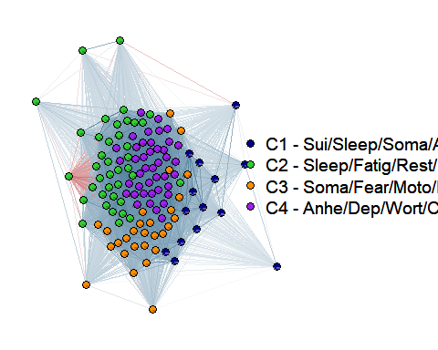
lv1 <- df_comm[df_comm$louvain_comm_consensus_r1.086 == 1, ]$n
lv2 <- df_comm[df_comm$louvain_comm_consensus_r1.086 == 2, ]$n
lv3 <- df_comm[df_comm$louvain_comm_consensus_r1.086 == 3, ]$n
lv4 <- df_comm[df_comm$louvain_comm_consensus_r1.086 == 4, ]$n
lv5 <- df_comm[df_comm$louvain_comm_consensus_r1.086 == 5, ]$n
lv6 <- df_comm[df_comm$louvain_comm_consensus_r1.086 == 6, ]$n
lv7 <- df_comm[df_comm$louvain_comm_consensus_r1.086 == 7, ]$n
lv8 <- df_comm[df_comm$louvain_comm_consensus_r1.086 == 8, ]$n
lv9 <- df_comm[df_comm$louvain_comm_consensus_r1.086 == 9, ]$n
lv10 <- df_comm[df_comm$louvain_comm_consensus_r1.086 == 10, ]$n
lv11 <- df_comm[df_comm$louvain_comm_consensus_r1.086 == 11, ]$n
color_nodes_symp_df <- c("darkblue", "limegreen", "darkorange", "purple", "grey", "yellow", "black", "magenta", "brown", "darkorchid4" ,"white" )
qgraph(symp_spear, layout="spring", labels = colnames(readable_anx_dp), sampleSize = nrow(df_anx_dp_adj), groups = list('C1 - Sui/Appe/Sleep' = lv1, 'C2 - Depressed Mood' = lv2, 'C3- Conc/Motor/Fatig' = lv3, 'C4 - Sleep' = lv4, 'C5 - Wort/Dep' = lv5, 'C6 - AppeUP' = lv6, 'C7 - Dep/Wort' = lv7, 'C8 - Dep/Anhe' = lv8, 'C9 - Soma/Fear' = lv9, 'C10 - Rest' = lv10, 'C11 - Anhe/Dep' = lv11 ), color = color_nodes_symp_df, theme="TeamFortress", label.prop=0.8, vsize=2, label.cex=1)
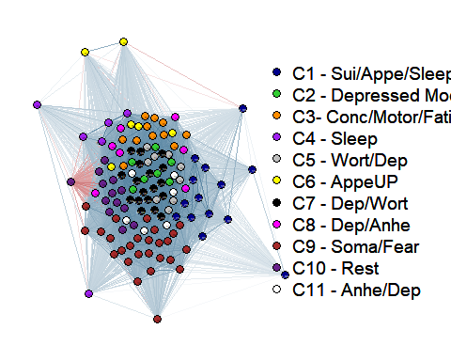

Creating the Network graph obtained with the best Louvain community
Each group has the name of the main symptom represented on its community. For example: the group related to suicide has some items related to weight loss and change of appetite. This happens likely because these items tend to cluster together
color_nodes_symp_df <- c("darkblue", "limegreen", "darkorange", "purple", "grey", "yellow", "black", "magenta", "brown", "darkorchid4" ,"white", "darkgreen", "red")
anhe <- df_comm[df_comm$core_dsm_symptoms == 'anhedonia', ]$n
appe <- df_comm[df_comm$core_dsm_symptoms == 'apetite/weight', ]$n
conc <- df_comm[df_comm$core_dsm_symptoms == 'concentration', ]$n
dep <- df_comm[df_comm$core_dsm_symptoms == 'depressed mood', ]$n
fat <- df_comm[df_comm$core_dsm_symptoms == 'fatigue', ]$n
fear <- df_comm[df_comm$core_dsm_symptoms == 'fear/keyed up', ]$n
irri <- df_comm[df_comm$core_dsm_symptoms == 'Irritability', ]$n
motor <- df_comm[df_comm$core_dsm_symptoms == 'psychomotor', ]$n
rest <- df_comm[df_comm$core_dsm_symptoms == 'restlessness/keyed up', ]$n
sleep <- df_comm[df_comm$core_dsm_symptoms == 'sleep', ]$n
soma <- df_comm[df_comm$core_dsm_symptoms == 'somatic symptoms', ]$n
sui <- df_comm[df_comm$core_dsm_symptoms == 'suicide', ]$n
wort <- df_comm[df_comm$core_dsm_symptoms == 'worthlessness/guilt', ]$n
lsymp <- list('suicide' = sui, 'depressed_mood' = dep, 'fatigue' = fat, 'sleep' = sleep, 'worthlessness' = wort, 'appetite' = appe, 'concentration' = conc , 'fear' = fear, "irritability" = irri , 'anhedonia' = anhe, 'psychomotor' = motor, 'restlessness' = rest, 'somatic' = soma)
qgraph(symp_spear, layout="spring", labels = colnames(readable_anx_dp),sampleSize = nrow(df_anx_dp_adj), groups = lsymp, color = color_nodes_symp_df, theme="TeamFortress", label.prop=0.8, vsize=2, label.cex=1)
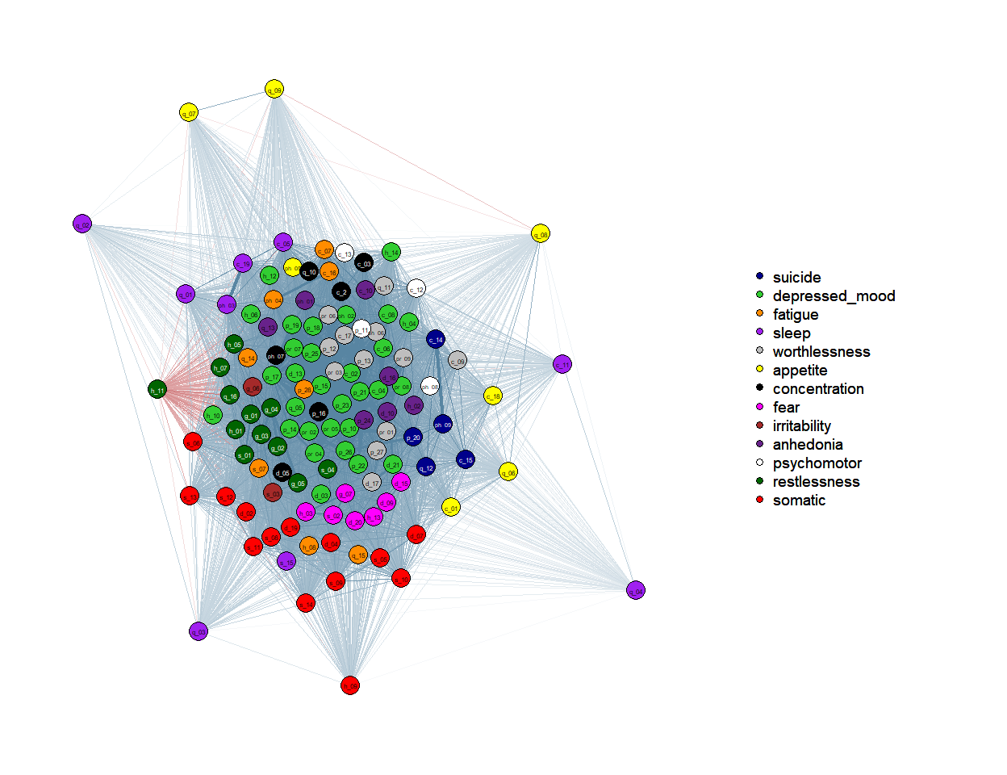 ## Conclusion
Conectar exploraciones de comunidades con medidas de centralidad. Hacer inferencias sobre o explorar más en relación a la naturaleza topológica de síntomas

