**Advanced Software Engineering**

**Problem Set-1 (PS-1)**

**Name: Hongkun Jin**

**Class ID: 16220459**

**System Design**

A software system is to be developed for online shopping. The purpose of the diagram is to define important terms for online shopping - Customer, Web User, Account, Shopping Cart, Product, Order, Payment, etc. and relationships between. It could be used as a common ground between business analysts and software developers. Each customer has unique id and is linked to exactly one account. Account owns shopping cart and orders. Customer could register as a web user to be able to buy items online. Customer is not required to be a web user because purchases could also be made by phone or by ordering from catalogues. Web user has login name which also serves as unique id. Web user could be in several states - new, active, temporary blocked, or banned, and be linked to a shopping cart. Shopping cart belongs to account. Account owns customer orders. Customer may have no orders. Customer orders are sorted and unique. Each order could refer to several **payments,** possibly none. Every payment has unique id and is related to exactly one account. Each order has current order status. Both order and shopping cart have **line items**linked to a specific product. Each line item is related to exactly one product. A product could be associated to many line items or no item at all.

* Create a *UML class diagram* for the online shopping system. Make sure each class is labeled with any key attributes or operations.

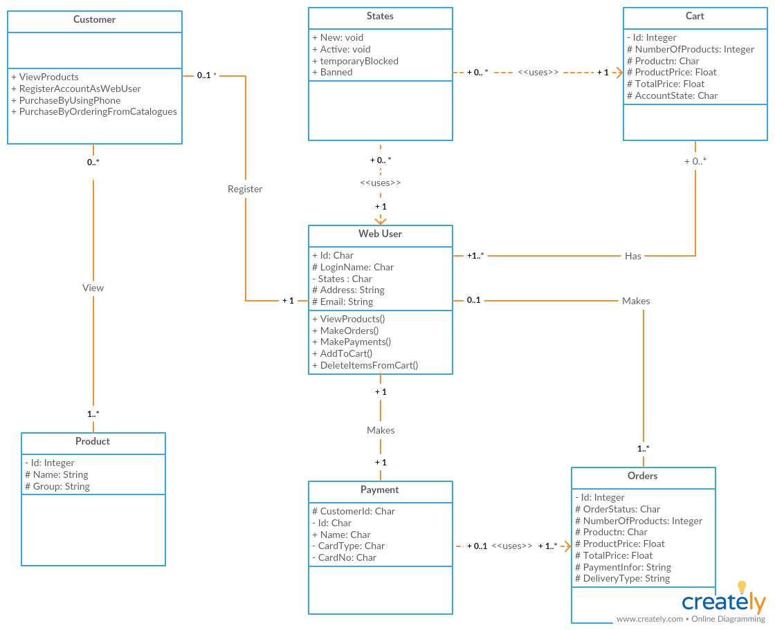

* Create *UML sequence diagrams* to show how the program responds to orders being placed, and how the operator can perform the necessary verification before approving them.

