**Web Technology**

**Coursework 1 Report**

Max Hodgson

[40274665@napier.ac.uk](mailto:40274665@napier.ac.uk)

Edinburgh Napier University – SET08101

**1. Introduction**

The following report is based upon the coursework assigned for the web technology module. The coursework assigned, requires a website to be made based upon the old, yet still used, encryption methods, known as ‘Classical Ciphers’. The website had to include at least two classical ciphers (coded in JavaScript) and contain a minimum of three html pages, those being: An index or home page, a page containing the ciphers themselves and a design page.

The site I went with contained two classical ciphers: Morse Code and Rot 13. Due to lack of knowledge on the subject, background reading was done using the following sites:

* practicalcryptography.com
* floppsie.comp.glam.ac.uk/Glamorgan/gaius/sechnd/2.pdf.4
* tutorialspoint.com/cryptography/traditional_ciphers.htm

The above sites provided a basic understanding of what ciphers are and different forms of ciphers.

**2. Software Design**

For designing the website, I used very simple wireframes, so that I would have a basic outline of how and what I needed to implement into the website. With these wireframes I also included a list of requirements. A navigation diagram is not required as every page can access every other page through the navigation bar located at the top.

**3. Implementation**

When implementing my website, the process was simple.

Help was used from the site: [www.w3schools.com](http://www.w3schools.com) to aid in some CSS and HTML concepts.

To begin with I started on the index or home page. The page was designed to be simple and introduced the user to a basic description of ciphers.

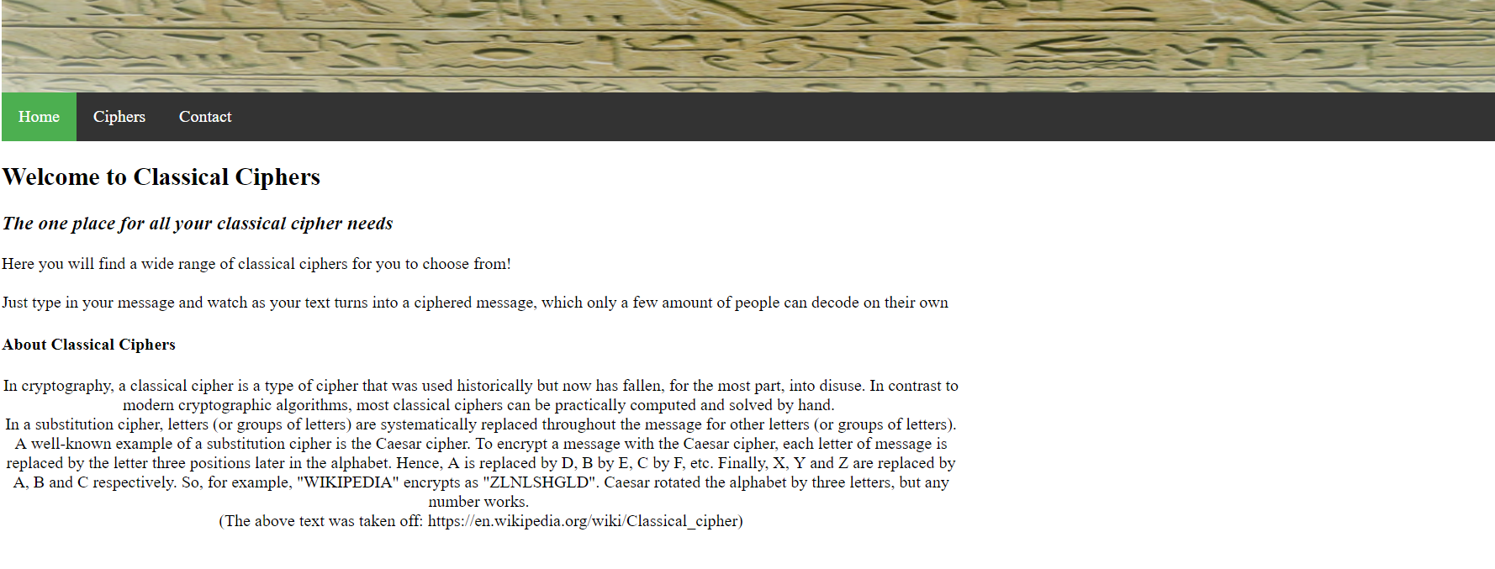

A side image would later be implemented to help add a bit of visual appeal to the home page as it looked very bland.

Implementing the ciphers page proved to be a challenge, working with the float alignment to add graphics and implementing the JavaScript used to create the ciphers. Once grasping how to use the float command correctly, along with input areas and buttons for the JavaScript, the page started to take form. The design page required multiple JS files, for each cipher, excluding the ROT 13 cipher. A point to note, the deciphering of the Morse code was consistently buggy and did not work. But the ROT 13 was able to function in, enciphering and deciphering text.

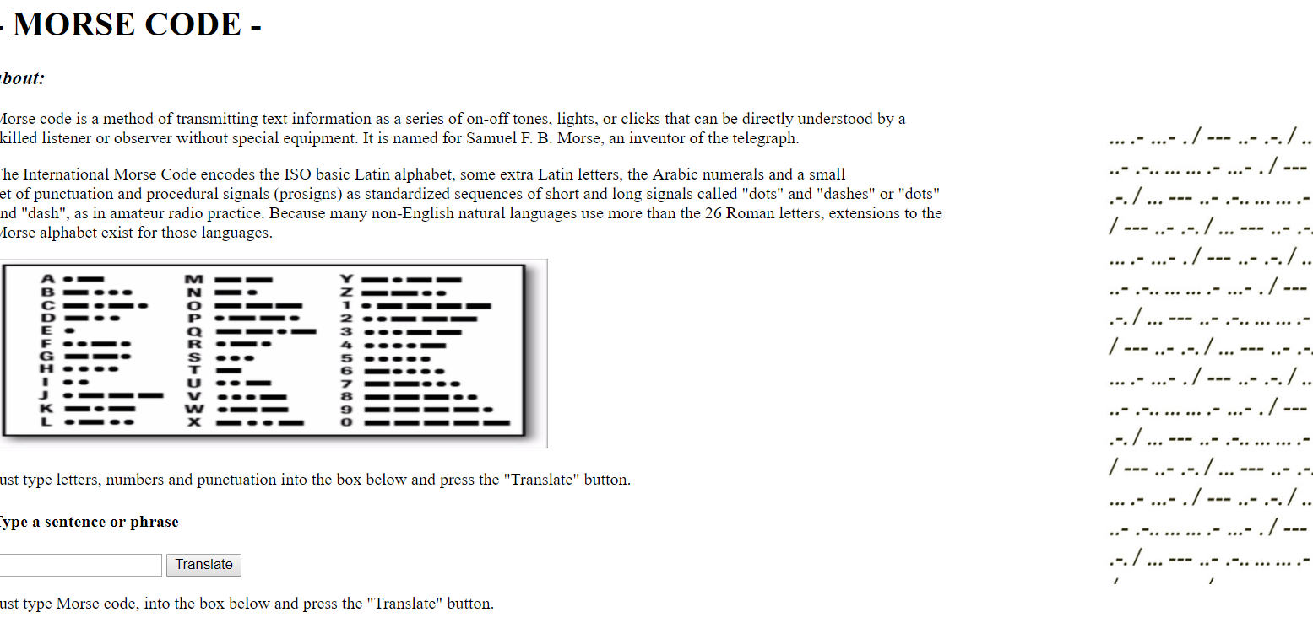

The page however is very basic and for any future iterations should have greater focus on the visual appeal.

Finally, the design page was implemented. The page was used to show the different typographical and presentational elements, so mimicking previously used HTML and CSS allowed me to show the different elements used.

**4. Critical Evaluation**

Although some critical evaluation was mentioned previously this section of the report will go into more detail.

As previously mentioned visual appeal was neglected and is probably a result due to rushed work. For future iterations of this and any piece of work should take more care in this area, mainly for any future users and to provide an improved and or better visual feel to the site.

An area missed, was the deciphering for one of the ciphers, Morse Code, this is due to a lack of understanding towards JS and any future iterations of this site should get more time invested into getting the main section of the site to work in its entirety rather, than partially finished.

Most of the implementation were consistent with the wireframes created in the beginning and covered most of the requirements for the site.

**5. Personal Evaluation**

Reflecting on the creation of the coursework, the main challenges came from coding JavaScript more than HTML and CSS. This is mainly due to previous knowledge in HTML and CSS. The issues with JavaScript were overcame through practice more than anything else.

I feel I performed moderately okay, though I feel I could have put a lot more effort into the actual implementation to make the site look better than it does.