EPU-61 Undulator Control System
Technical Documentation
Revision: | 1.2
Status: | Released
Repository: | acc
Project: | ACC-MAXlab-MAX_IV-EPU61
Folder: | Documentation
File: | EPU61_Technical_Documentation.odt
Owner: | Miroslav Pavleski
Last modification: | December 3, 2012
Created: | August 30, 2012

Document History
Revision | Date | Authors | Section | Modification
0.1 | 2012-08-20 | Miroslav Pavleski | All | Created.
0.2 | 2012-08-30 | Tadej Humar  Miroslav Pavleski | All | Sections merged. Review.
1.0 | 2012-09-03 | Miroslav Pavleski | All | Review. Released
1.1 | 2012-10-29 | Tadej Humar | 2. - 6. | Updated.
1.2 | 2012-11-8 | Tadej Humar | 2.,4.,6.,7. | Updated.
Confidentiality
This document is classified as a confidential document. As such, it or parts thereof must not be made accessible to anyone not listed in the Audience section, neither in electronic nor in any other form.
Scope
This document contains documentation for the motion controller software, Tango device server software and Taurus/PyTango GUI software implemented as part of the Control System for the Elliptically Polarizing Undulator (EPU) that is to be installed on the i511 beam-line at MAX-lab.
Audience
This document is intended for all Cosylab and MAX-lab employees involved in the MAX IV EPU-61 Control System project.
Typography
This document uses the following styles:
Style | Description
/usr/bin/perl, ConfigFile.xml | An identifier representing a filename or a directory.
Ctrl + Alt + Del . | A keystroke.
File - Open . | Used as a symbol for graphic interface elements
Identifier | Text used for various identifier reasons

Note: a box like this contains important information. Cosy&paste where needed.

Warning!
A box like this contains even more important information. Copy&paste where needed.

Glossary of Terms
- EPU – Elliptically Polarizing Undulator
- IOC – Input Output Computer
- MC – motion controller
- GUI – Graphical User Interface
- EPS – Equipment Protection System
- PLC – Programmable Logic Controller
References
- MAX IV EPU-61 Undulator Control System - Design Document ( DES-MaxIV-EPU61-ControlDesignDocument.pdf )
- EPU-61 User Guide ( EPU61_User_Guide.pdf )
- TANGO - Object Oriented control system ( http://www.tango-controls.org/ )
- Galil DMC-40x0 User Manual Rev 4/12, © Galil Motion Control, Inc.
- Galil Motion Control Firmware Command Reference - DMC40x0 11/11/2011, © Galil Motion Control, Inc.
- Development of Software to Control 8-motor Elliptically Polarizing Undulators, Proceedings of PAC07, Albuquerque, New Mexico, USA
- Control System of the EPU61, PPT presentation, 2011-06-11, © MAX-lab
- Request for offer - Control system for the EPU 61, 2011-12-20, © MAX-lab
Table of Contents
1 Architectural Overview 6
2 Motion controller software 7
2.1 ControlBox DMC Features Used 7
2.2 ControlBox Variables 8
2.3 Threads 10
2.4 Variables 11
2.4.1 Flags 11
2.4.2 Global configuration 11
2.4.3 Gap variables 12
2.4.4 Gap configuration 12
2.4.5 Phase variables 13
2.4.6 Phase movement configuration 13
2.4.7 Correction coil routines variables 13
2.5 Routines 14
2.5.1 #GAP 14
2.5.2 #PHASE 14
2.5.3 #STATETH 15
2.5.4 #COILS 15
3 Tango Device Server Software 16
3.1 Overview 16
3.2 Undulator Device Class 18
3.2.1 Device States 19
3.2.2 Device Properties 21
3.2.3 Device Commands 22
3.2.4 Device Attributes 22
4 Taurus Python Based GUI 25
4.1 Callback Python Classes 25
4.2 Python functions 25
4.3 Python Initialization Code 26
5 Build instructions 27
5.1 Soleil ControlBox Components 27
5.1.1 Yat and Yat4Tango installation 27
5.1.2 ControlBox installation 28
5.2 Undulator Device Server 28
5.3 DMC Microcode 28
6 Configuration 29
6.1 ControlBox Devices 29
6.2 Undulator device server 32
6.3 Python GUI configuration 34

Tables
Table 1: ControlBox DMC Variables 8
Table 2: DMC Threads 10
Table 3: Flag Variables 11
Table 4: Global Configuration Variables 11
Table 5: Gap Variables 12
Table 6: Gap Configuration Variables 12
Table 7: Phase Variables 13
Table 8: Phase Configuration Variables 13
Table 9: Correction Coil Routines Variables 13
Table 10: Undulator Device States 19
Table 11: Undulator Device Properties 21
Table 12: Undulator Device Commands 22
Table 13: Undulator Device Attributes 24
Table 14: DMC Axis Mapping 31
Table 15: GUI Mnemonic Substitutions 34

Figures
Figure 1: Software Architectural Overview 6
Figure 2: #GAP Routine Flowchart 14
Figure 3: #PHASE Routine Flowchart 15
Figure 4: Tango Devices Overview 16
Figure 5: Undulator State Diagram 19
Figure 6: Undulator UpdaterThread Flowchart 20
Figure 7: ControlBox Device Configuration 29
Figure 8: GalilAxis Device Configuration 30
Figure 9: GalilGearedAxes Device Configuration 31
Figure 10: Undulator Device Configuration 32

Architectural Overview
The control system software consists of lower level motion controller programming and upper level Tango device server support. For the purpose of this control system, the Soleil ControlBox solution, as modified by MAX-lab staff for compatibility with Galil 41x1 motion controllers is used as base. The goal is to keep as much of the ControlBox solution as possible, without extensive changes to the code. The only adaptations of the ControlBox solution are on the motion controller level.
On top of the existing ControlBox provided device servers (such as GalilAxis and GalilGearedAxes), an additional higher level Tango component representing the undulator will be developed.
The following figure outlines the proposed architecture:

Figure 1: Software Architectural Overview

Motion controller software
A modified version of the Soleil motion controller software is used for the phase and gap motion controllers. Separate source file defining the DMC programming is used for the gap motion controller (Galil-1) and for the phase motion controller (Galil-2).
Due to Galil programming language limitation when using the Linear Interpolation mode, the first 4 axes (A,B,C,D) must be used on both controllers. The EPU61 specific routines on both motion controllers assume that Z1..Z4 axes are A..D axes on Galil-1 and X1..X4 axes are A..D axes on Galil-2.

ControlBox DMC Features Used
The EPU61 specific routines added to the vanilla Soleil ControlBox code are used for the following purposes:
- executing coordinated gap movements – operator mode. See 2.5.1
- executing coordinated phase movements – operator mode. See 2.5.2
- device state handling code, including interlocks
- providing up-to-date feedback for undulator state and data for coil correction operation
The ControlBox functionalities are used for all other purposes:
- individual motor movements – engineering mode
- girder movements – engineering mode. This is using the Geared Axis features of the ControlBox DMC software.
- axis offsets
- axis states and statuses

ControlBox Variables
The following table provides documentation for ControlBox DMC software variables, as contained in the original code:
Variable | Data type | Description
Pos[x] | Double | Target position (abs)
Dbw[x] | Double | Required accuracy
IniPos[x] | Double | Initial position
IniSpeed[x] | Double | Initial speed
IniTyp[x] | ULong | Positioning strategy
Bck[x] | Double | Backlash
NbRetry[x] | Ulong | Number of retries (3)
CpMp[x] | Uint | Configuration bits
StabTime[x] | Ulong | Settling time
GrAxis[x] | int(axis id) | Master axis number
GrRation | Double | Gearing ratio
Cmd[x] | $1-$100 (flags) | Commands
Table 1: ControlBox DMC Variables

Flags contained in the Stat array variable are used for disabling movement, specifically the $40 flag. The meaning of the other status bits is as follows:
$1 Motor type - 0 = stepper, 1 = other (servo, piezo,...)
$2 - encoder present
$4 - stepper operated in maintenance (pseudo-closed-loop) mode
$8 - remote manual control is active
$10 - specific microcode is running
$20 - ON/OFF is authorized
$40 - moving is authorized. This is used for EPU61 customization.
$80 - position done, success (=0 : moving)
$100 - position done, error
$200 - position reference seeking in progress
$400 - position reference done, success
$800 - position reference done, failed
$1000 - position error global, too much axes in position error
$2000 - position following error see OE
$4000 - axis is operated in slave mode (gearing)
$8000 - axis is operated in master mode (gearing)
$10000 - is initialized
$20000 - lock pos. status (enabled or disabled?)

The Cmd array variable could receive the following commands:

$1 – stop
$2 – jog +
$4 – jog -
$8 – absolute positioning
$10 – Init reference position
$20 – Motor ON
$40 – Motor OFF
$80 – Update for gearing
$100 – Enable/Disable locking

Threads
The following table describes which threads are used for the EPU61 motion control, along with the routine names:
No | Routine | Description
0 |  | Main thread
1 | #POM | ControlBox in-use
2 | #CORCHK , #PECORR | ControlBox in-use
3 | Reserved | ControlBox reserved
4 | #STATETH | State checking thread. Handles StopAll and Interlock conditions
5 | #COILS | Coil correction thread. Used to calculate gap, center, taper, phase and phase mode for use in the CoilCorrection device server.
6 |  | Free
7 | #GAP, #PHASE | Executes gap and phase movements on appropriate controller. #GAP is used on Galil-1, #PHASE on Galil-2.
Table 2: DMC Threads
First four threads (0..3) are reserved for the original ControlBox DMC code.

Variables
Several global variables are introduced in the DMC code. Following sub-chapters describe those variables.

Flags
Variable | Description
IlockAct | Flag indicating whether interlock condition has been activated. Further motion is to be prohibited on all axes until the condition is cleared.
StopRq | Flag indicating whether “Stop All” was requested from the user. Further motion is to be prohibited on all axes until the flag is cleared.
AlwMvmt | Flag specifying whether movement is allowed on any axis. It is affected by “Stop All” and interlock conditions.
Table 3: Flag Variables

Global configuration
Variable | Description
Offsets[4] | Calibration offsets for each undulator motor on the DMC.
SegLimit | Constant representing the maximum segment size for linear interpolation segments, themselves limited to 2²³.
Table 4: Global Configuration Variables

Gap variables
Variable | Description
GapOfst | Desired center offset for gap movement. In counts.
Gap | Desired gap for gap movement. In counts.
Taper | Desired taper for gap movement. In counts.
FinalG[4] | Final axis destinations based on desired parameters. Used for positioning error compensation.
GapTmp[4] | Incremental movement needed for achieving new gap position. Used as temporary variable in gap movement.
Table 5: Gap Variables

Gap configuration
Variable | Description
EncRatio | Conversion ratio between rotary and linear encoders.  EncRatio =RotEncoderCts/LinEncoderCts.
GapThold | Threshold in counts over which gap movement is initiated.
TprThold | Threshold in counts over which a procedure to eliminate taper before gap positioning is invoked.
GapSpd | Gap movement speed in counts per second. Available as parameter attribute on Tango level.
GapAcc | Gap acceleration in counts per second square. Available as parameter attribute on Tango level.
TprSpd | Taper movement speed in counts per second. Available as parameter attribute on Tango level.
TprAcc | Taper movement acceleration in counts per second square. Available as parameter attribute on Tango level.
GapToler | Tolerance in counts for gap compensation routine. The routine uses the linear encoder feedback to correct errors in the position loops closed with the rotary encoders.
Table 6: Gap Configuration Variables

Phase variables
Variable | Description
PhMdRq | Requested phase mode.
PhMd | Current phase mode.
PhTmp[4] | Incremental movement needed for phase positioning. Temporary variable used in the #PHASE routine.
PhDest[4] | Final motor positions calculated on tango level for desired phase offset.
Table 7: Phase Variables

Phase movement configuration
Variable | Description
PhSpd | Phase movement final speed, in counts per second. Available as parameter attribute on Tango level.
PhAcc | Phase movement acceleration in counts per second squared.
PhThold | Threshold in change in the desired phase offset before commencing new phase movement.
Table 8: Phase Configuration Variables

Correction coil routines variables
Variable | Description
coilG | Current gap.
coilT | Current taper.
coilC | Current gap center offset
coilPM | Current phase mode
coilPO | Current phase offset
Table 9: Correction Coil Routines Variables

Routines

#GAP
The Gap routine is executed on the Galil-1 motion controller.
Inputs:
- Gap variable
- GapOfst variable
- Taper variable
Action:
This routine is invoked by the Undulator device server to start new gap movement. The input variables contain the parameters of the movement.
Flowchart:
Figure 2: #GAP Routine Flowchart

#PHASE
The #PHASE routine is executed on Galil-2 motion controller.
Inputs:
- PhMdRq variable
- PhDest array
Action:
This routine is invoked by the Undulator device server to start new phase movement. The input variable PhMdRq is set to the requested phase mode. The device server calculates end position and populates the PhDest array with those destinations.
If different phase mode from the current phase mode is requested, the routine first moves all sub-girders synchronously to zero-phase position.
Flowchart:
Figure 3: #PHASE Routine Flowchart

#STATETH
The #STATETH routine is present on both controllers.
Inputs:
- StopRq variable
- Digital Input 5 (Interlock)
Action:
The routine runs continuously in a thread and checks the status of the StopRq (Stop All Requested) and the interlock digital input. If either is activated all movement is aborted and further movement for all undulator motors is not allowed until both the StopRq and the DI5 are cleared.

#COILS
The #COILS routine is present on both controllers bit it's modified so it only calculates valid parameters.
Action:
The routine runs continuously in a thread calculating current gap, offset, taper, phase mode and phase offset. Those are placed in the coilG, coilC, coilT, coilPM, and coilPO variables respectively. The Undulator Tango device server uses those variables as inputs for the interpolation function.

Tango Device Server Software

Overview
The complete EPU61 Tango control system compromises the following device server processes:
- ControlBox Gap device server instance running:
  - 4 GalilAxis devices
  - 2 GalilGearedAxes devices
  - 1 ControlBox device
- ControlBox Phase device instance running:
  - 4 GalilAxis devices
  - 1 ControlBox device
- Undulator device server instance running:
  - 1 Undulator device
- OPC device server instance running:
  - 1 OPC device

This is illustrated on the following figure:
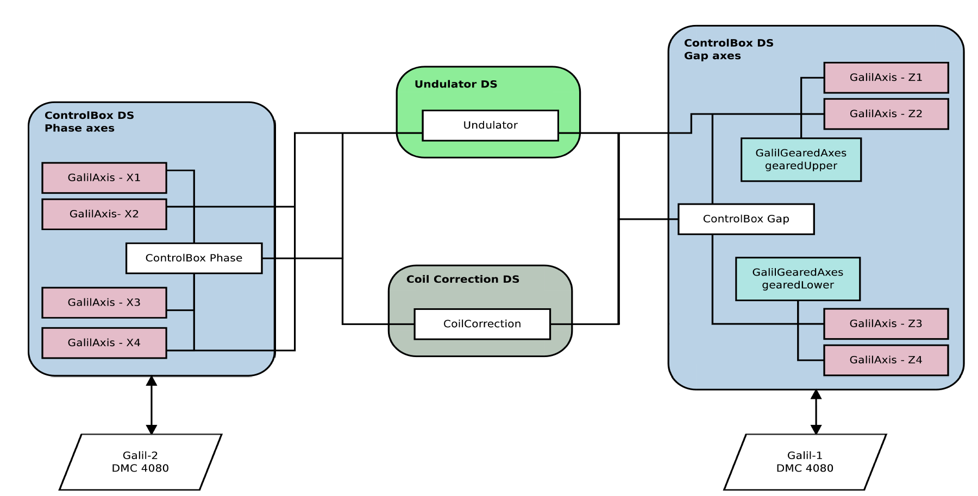Figure 4: Tango Devices Overview

The Undulator device requires references to:
- 8 GalilAxis ControlBox devices for controlling individual motors,
- 2 GalilGearedAxes devices for controlling girders in engineering mode
- 2 ControlBox devices for providing access to the customized DMC software running on both Galil-1 and Galil-2 motion controllers.
- 1 OPC device
- 4 attribute names representing power supply current on the OPC device server

Undulator Device Class
The Undulator device provides interface for executing high level operator movements. It relies on its dependent devices for providing access to the motion controller. Coordinated gap and phase movements are executed using the Undulator device. The Undulator device also manages the state of the whole system.
Apart from the functions mentioned above undulator device also controls correction coils output current.
Correction coils are used for applying corrections to the undulator magnetic field using four power supplies. The Undulator Tango device server continuously monitors the position of the magnet rows and uses this as input to interpolation function whose outputs are the currents for all four correction coils.
This interpolation function uses nearest neighbor interpolation for each phase mode, with gap and phase offset as inputs. The data for interpolation is empirically obtained and loaded by the device server in Comma Separated Values (CSV) format. Coil currents can also be manually controlled using the Undulator device. This is useful while constructing the interpolation table.

Device States
The following device states are used:
State Name | Description
STANDBY | Motors are ready to move.
FAULT | Error detected during operation. Device must be restarted to recover.
DISABLE | Movement is not allowed. Either a interlock signal was detected or the user put the device in »Stop All« condition. All 8 GalilAxis devices could not be moved, movement is prohibited on DMC software level.
MOVING | Motors are moving. Please use the GapMoving and PhaseMoving boolean attributes  for distinguishing between movement types.
ALARM | Unexpected condition detected. Engineering mode operation should be used to check the status on all 8 motors.
DISABLE | Interlock condition or StopAll status have disabled the device.
Table 10: Undulator Device States

Figure 5: Undulator State Diagram
A separate poller thread is used for each Undulator device. The thread manages state transitions depending on the states of the dependent devices and pulls values for calculating various attributes. Second thread is used to constantly poll coil correction data from DMC and third thread is used for retrieving data from OPC device server.
Figure 6: Undulator UpdaterThread Flowchart

Device Properties
Property Name | Description | Property type
ControlBoxGapProxy | Proxy to ControlBox with gap DMC | string
GapAxes | Proxies to axes that control gap movement. Order: Z1,Z2,Z3,Z4 | vector
PhaseAxes | Proxies to axes that control phase movement. Order: X1,X2,X3,X4 | vector
ControlBoxPhaseProxy | Proxy to ControlBox with phase DMC | string
GearedAxes | Proxies to GalilGearedAxes that control upper and lower girder. Order: Upper girder, Lower girder | vector
PowerSupplyProxy | Proxy to device controlling power supply output currents. | string
PowerSupplyAttributeNames | Attribute names that represent current on device controlling power supplies. | vector
DataFile (optional) | Path to file with correction coil data table. It will be loaded automatically. | string
Table 11: Undulator Device Properties

Device Commands
Name | Input type | Output type | Description
StopGap | DEV_VOID | DEV_VOID | Stops gap movement.
ToggleStopAll | DEV_BOOLEAN | DEV_VOID | Emergency stop all command. If called with the parameter set to TRUE, aborts all motion and inhibits all further requests for motion until the command is invoked again with the parameter set to FALSE.
DisableLimits | DEV_BOOLEAN | DEV_VOID | Disable software limits on the DMC. Set parameter to TRUE to disable the limits. To re-enable the limits invcoke command with FALSE parameter.
StopPhase | DEV_VOID | DEV_VOID | Stops phase movement.
CalibrateGap | DEVVAR_DOUBLEARRAY | DEV_VOID | Calculates gap axes offsets using given gap and center and reading positions from encoders.
CalibratePhase | DEV_VOID | DEV_VOID | Calculates phase axes offsets on zero phase.
LoadCorrectionData | DEV_STRING | DEV_VOID | Tries to open the file (path as input argument) and loads the data table if formating is correct.
Table 12: Undulator Device Commands

Device Attributes
Name | R/W type | Data type | Description
Gap | READ_WRITE | DEV_DOUBLE | Read-back and set-point for current gap in um. Writing to this attribute commences movement for the gap, using the current operator center offset and taper.
EngineeringLock | READ_WRITE | DEV_BOOLEAN | Setting this attribute to TRUE disables operator composite movements. Engineering movements to be done directly on the ControlBox axis devices.
GapAcceleration | READ_WRITE | DEV_DOUBLE | Gap movement average acceleration in um/s^2.
GapSpeed | READ_WRITE | DEV_DOUBLE | Final profile velocity in um/s for gap movements.
Offset | READ_WRITE | DEV_DOUBLE | Read-back and set-point value for the current vertical offset in um. Will be applied next time the Gap attribute is modified.
PhaseAcceleration | READ_WRITE | DEV_DOUBLE | Phase movement average acceleration in um/s^2.
PhaseMode | READ_WRITE | DEV_SHORT | Read-back and set-point for current phase mode. Writing to this attribute sets which phase mode to use next time Phase is written.
Phase | READ_WRITE | DEV_DOUBLE | Read-back and set-point for phase offset in um. When this attribute is written new phase movement commences using phase mode specified in PhaseMode.
PhaseSpeed | READ_WRITE | DEV_DOUBLE | Final profile velocity in um/s for phase (sub-girders) movement.
TaperAcceleration | READ_WRITE | DEV_DOUBLE | Taper movement average acceleration in um/s^2.
Taper | READ_WRITE | DEV_DOUBLE | Read-back and set-point for the current taper in um. Will be applied next time the Gap attribute is modified.
TaperSpeed | READ_WRITE | DEV_DOUBLE | Final profile velocity in um/s for taper movements.
LimitsDisabled | READ | DEV_BOOLEAN | Indicates that the software limits on the DMCs are disabled. Useful for commissioning and engineering movements.
StopAll | READ | DEV_BOOLEAN | Indicates that the undulator is in StopAll state inhibiting all motion.
GapMoving | READ | DEV_BOOLEAN | Indicates that gap movement is in progress. Used to distinguish whether gap, phase or both are moving.
PhaseMoving | READ | DEV_BOOLEAN | Indicates that phase movement is in progress. Used to distinguish whether gap, phase or both are moving.
EngineeringGapSpeed | READ_WRITE | DEV_DOUBLE | Final profile velocity in um/s for gap axes engineering movement. Value 0 means speeds are not the same for all gap axes.
EngineeringPhaseSpeed | READ_WRITE | DEV_DOUBLE | Final profile velocity in um/s for phase axes engineering movement. Value 0 means speeds are not the same for all phase axes.
EngineeringGapAcceleration | READ_WRITE | DEV_DOUBLE | Gap axes engineering movement average acceleration/deceleration in um/s^2. Value 0 means accelerations/decelerations are not the same for all gap axes.
EngineeringPhaseAcceleration | READ_WRITE | DEV_DOUBLE | Phase axes engineering movement average acceleration/deceleration in um/s^2. Value 0 means accelerations/decelerations are not the same for all phase axes.
Interlock | READ | DEV_BOOLEAN | Indicates that interlock is in effect.
Coil1 | READ_WRITE | DEV_DOUBLE | Read-back and set-point for Coil1 current.
Coil2 | READ_WRITE | DEV_DOUBLE | Read-back and set-point for Coil2 current.
Coil3 | READ_WRITE | DEV_DOUBLE | Read-back and set-point for Coil3 current.
Coil4 | READ_WRITE | DEV_DOUBLE | Read-back and set-point for Coil4 current.
CorrectionEnabled | READ_WRITE | DEV_BOOLEAN | Indicates operation mode for correction coils. True means automatic mode and false manual.
Table 13: Undulator Device Attributes

Taurus Python Based GUI
The Taurus toolkit working on top of PyTango is used for GUI.
All screens are contained in the Taurus Designer file Undulator.ui. This file is used for generating undulatorDesigner.py module containing the generated Taurus presentation layer. Additional Python module, undulator.py, contains:
- GUI logic
- customizations for the generated file
- entry point code – this Python module is to be executed to start the GUI
Following chapters are documenting the routines contained in undulator.py.

Callback Python Classes
Three callback classes are implemented to handle 3 events subscriptions.
PhaseModeCallback – Updates phase mode when it changes. As phase mode is represented as a number it also has a function (phaseToString) which handles the transformation from a number to a string name.
GapConfigCallback - When configuration parameters of gap change(min/max value) this callback updates the LCD displays on GUI.
PhaseConfigCallback - When configuration parameters of phase change(min/max value) this callback updates the LCD displays on GUI.

Python functions
init(ui) – Initializes GUI variables that are not read from device server.
setMaxGap(value) – Sets new maximal gap limit(value). If limit is different than current it updates it. Used for setting the Gap max_value property.
setMinGap(value) – Sets minimal gap limit(value). If limit is different than current it updates it. Used for setting the Gap min_value property.
setMaxPhase(value) – Sets maximal phase limit(value). If limit is different than current it updates the phase limits. Minimal phase is set to negative value as it is symmetrical.
updatePhaseMode(phaseMode) – Sets the desired phase mode(input) on the undulator device server.
gearUp(geared) – Input 1 will enable gearing on upper girder any other input will disable gearing.
gearDown(geared) - Input 1 will enable gearing on lower girder any other input will disable gearing.
stopAll(decision) – Input True will enable stopAll state on device server and inhibit all movements, False will disable it.
goCommand(link, refPos, mPos, suffix) – Command with execute relative movement of single axis connected to link. Movement needed is calculated using current motor position(mPos) and desired relative movement(refPos). Suffix is used to remove text from mPos parameter.
gapToRef(gap, center) – Executes CalibrateGap command on undulator device server and sends a double array containing gap and center as parameter.
lock(locked) – EngineeringLock on undulator device server will be set to input, which can be True or False.
connections(ui) – Takes reference to user interface and sets all signals and slots for GUI to be working correctly.

Python Initialization Code
When program starts UI is made from undulatorDesigner.py. Values are initialized, connections are setup and event subscriptions are created. Following all this, OPI screen is displayed to user.

Build instructions

Soleil ControlBox Components
ControlBox device server(version 2.5.4): To compile ControlBox successfully, two external libraries apart from Tango need to be installed on the system. First is Yat (version 1.7.2) and second Yat4Tango (version 1.6.1). Since there have been some drastic changes in newer Yat versions, it's preferred version 1.7.2 to be used.

Yat and Yat4Tango installation
Since libraries we use are a lot different than newer versions, we don't want to introduce them system wide as that could potentially break some references. For this not to happened copy the Yat and Yat4Tango folders to private place. (Example: /home/tango/opt).
First you have to install Yat. You do this by going to Yat/src folder(terminal) and executing next two commands:
make -f Makefile.linux all ARCH_TYPE=x86_64 RELEASE_TYPE=OPTIMIZED PROJECT_TYPE=STATIC_LIB
make -f Makefile.linux all ARCH_TYPE=x86_64 RELEASE_TYPE=DEBUG PROJECT_TYPE=STATIC_LIB
This will build 2 static libraries(optimized and debug) in Yat/lib folder.
Next step is to build Yat4Tango but this requires more configuration as it has dependencies to Yat and Tango.
Three environment variables should be defined:
- OMNIORB_ROOT
- TANGO_ROOT
- YAT_ROOT - this one is pointing to our Yat library previously installed. for example this would be: /home/tango/opt/Yat
After this is done execute the commands the same way as in Yat installation.
If everything was done correctly in each library folder there should be an include folder with header files and lib folder with 2 static library files.

ControlBox installation
The ControlBox is to be build using the packaged makefiles in the distribution.
The makefile uses four environment variables that should be updated before running make:
- MAKE_ENV - path to find common environment to build project (path to /usr/share/pogo/preferences)
- TANGO_HOME – path to tango control system installation directory (Example: /usr)
- YAT_ROOT - path to our custom Yat installation directory (same as in Yat4Tango installation)
- YAT4TANGO_ROOT – path to our custom Yat4Tango installation directory (Example: /home/tango/opt/Yat4Tango)
Executing make or make all in shell will build the ControlBox device server.
Note: mentioned versions were used when the Undulator device server was being developed and tested at Cosylab. There might be changes during commissioning.

Undulator Device Server
Apart for Tango there are no external library requirements.
The MAKE_ENV environmental variable should point to path to find common environment to build project (path to /usr/share/pogo/preferences)
Executing
make
or
make all
in shell will build the Undulator device server.

DMC Microcode
There are two files supplied:
- gap.dmc to be downloaded on the Gap axis motion controller - Galil-1
- phase.dmc to be downloaded on the Phase axis motion controller – Galil-2
The files can be uploaded to the motion controllers using the GalilTools software.

Configuration

ControlBox Devices
Because two motion controllers are to be used, there are two ControlBox device server instances to be configured to communicate with each own motion controller.
Configuration for phase and gap ControlBox device server is almost identical. Configuration for phase omits GalilGearedAxes part and axes use absolute encoder instead of incremental. Bellow, configuration for gap ControlBox will be shown.

After creating server with jive we need to configure ControlBox to communicate with the DMC. Create a ControlBox device and configure properties as shown in the picture.
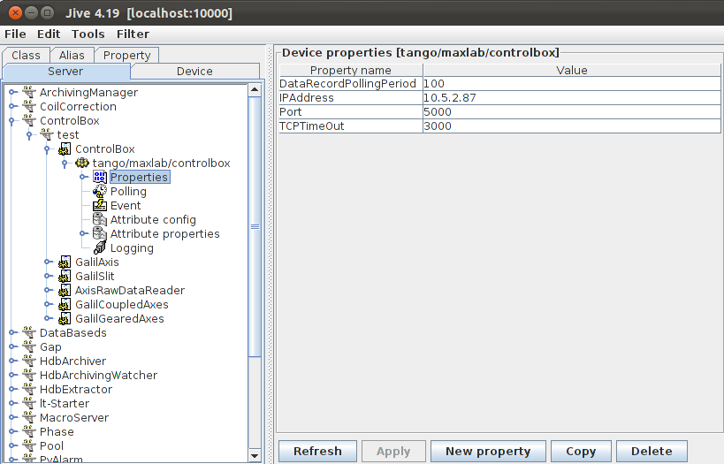Figure 7: ControlBox Device Configuration
Please change the IPAddress and port accordingly. DataRecordPollingPeriod recommended value is 200ms.
Unless there is a valid reason for changing TCPTimeOut, please leave the default value of 3000.
For gap movement four axes are being used. To represent this create four GalilAxis devices.
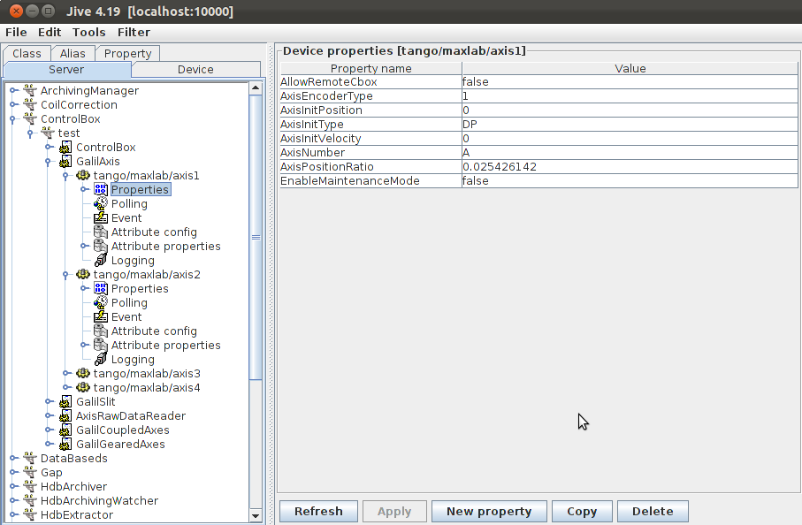Figure 8: GalilAxis Device Configuration
Gap axes use incremental encoder so under AxisEncoderType put 1 for all 4 axes.
Warning!
When configuring phase ControlBox under AxisEncoderType put 2 as phase axes use absolute encoder.
Gap and phase both use the same numbering (A-D), the naming table is presented below. The AxisNumber property should be adjusted accordingly.
Motors nomenclature | AxisNumber
Phase axis - X1 | A
Phase axis - X2 | B
Phase axis - X3 | C
Phase axis - X4 | D
Gap axis - Z1 | A
Gap axis - Z2 | B
Gap axis - Z3 | C
Gap axis - Z4 | D
Table 14: DMC Axis Mapping

AxisPositionRatio will be determined during commissioning.
Note: The following step is not required for phase ControlBox configuration.
Two additional GalilGearedAxes need to be created, representing upper and lower girder.
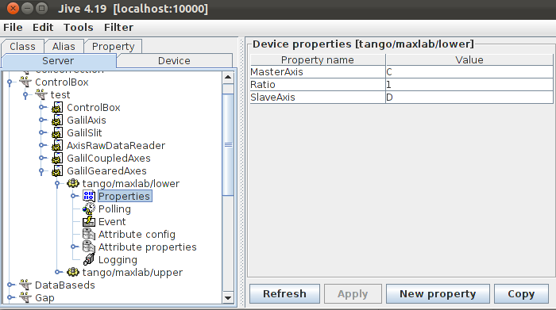Figure 9: GalilGearedAxes Device Configuration
Lower girder properties are show on the picture. For upper girder, MasterAxis must be A and SlaveAxis B. Ratio remains 1 for both.

OPC device server
For Undulator device server to work correctly an OPC device server has to be running. In order to run the OPC device server some properties must be defined otherwise the program will crash.
OPC uses two devices when running, one serves as an entry point and the other one is used for retrieving data.
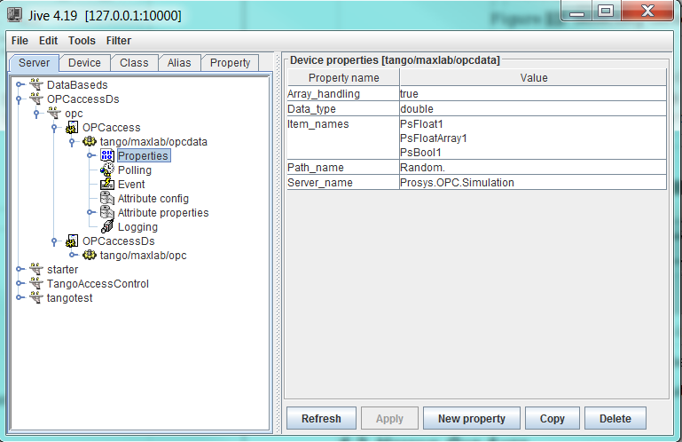Figure 10: OPC properties configuration
The OPCaccessDs is used as an entry point while OPCaccess is the data retrieving device server and has to be configured correctly in order to run.
Undulator will use the proxy to OPCaccess device server. In this case that would be “tango/maxlab/opcdata” and has to be written to Undulator device property (PowerSupplyProxy).

OPC Properties
The properties with * besides their names must be defined in order for device server to start.
Property name | Property Type | Value
Server_name * | Tango::DEV_STRING | Specifies the name of the OPC server to be used.
Path_name * | Tango::DEV_STRING | Specifies the path of the OPC item to be addressed on the OPC server.
Item_names * | Array of string | Specifies the OPC item names to be read from the OPC server via the given path.
Data_type | Tango::DEV_STRING | This is set as the requested data type for the OPC items to be read. The possible data types are "double", "long" or "short".
Array_handling | Tango::DEV_STRING | Specifies whether the OPC server used is capable to handle arrays or only scalar data types. array_handling = "true" , array data types are handled. array_handling = "false", only scalar data types are handled.
DataFromCache | Tango::DEV_SHORT | Triggers data reading from the OPC cache or directly from the OPC item. Set to 1 -> cache reading is enabled. Set to 0 -> direct access is enabled.
Table 15: OPC device properties

Array of item names will be represented as attributes of the same name on device server. The names for power supply “items” need to be written to Undulator device property (PowerSupplyAttributeNames).

Undulator device server
For undulator device server to be working correctly it needs proxies to both ControlBox devices, gap axes, phase axes, geared axes and power supply device. Under PowerSupplyAttributeNames names of attributes representing current for power supplies must be specified. There is an optional property DataFile where path to CSV file containing coil correction interpolation data can be set. It will automatically be loaded this way.

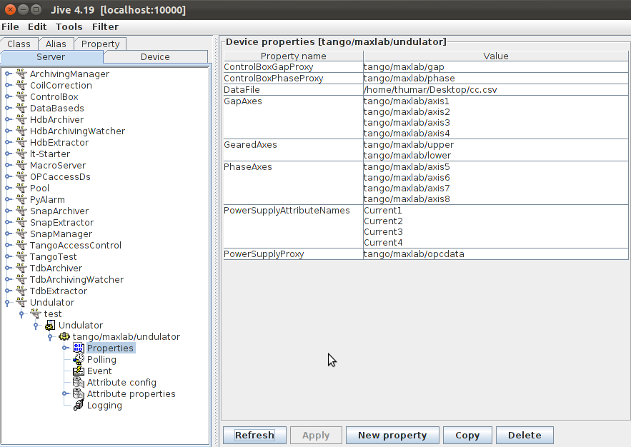Figure 11: Undulator Device Configuration

Configuration should look similar to the one in the picture.
Warning!
The order of gap, phase and geared axes links is important.
GearedAxes – Upper girder → Lower girder
GapAxes – Z1 → Z4
PhaseAxes – X1 → X4
PowerSupplyAttributeNames – Coil1 → Coil4
Polling, events and other configuration will be done during commissioning.

When starting the undulator device server please make sure both instances of ControlBox and OPC device server are running.

Offsets calculation

Phase
As phase axes use only linear encoder offsets calculation is straight forward as it only includes previous offsets and current encoder position.
In order to calibrate phase axes we need to use engineering mode and move axes to the destination representing phase offset 0. When this is done we calculate new offsets by pressing “Phase to zero reference” button.
If there were any previous offset set we need to add them to calculation as well since they were applied when engineering movement was used.
Formula for new offsets is:

Once this is done, the correct axes positions will be displayed.

Gap
Gap axes use incremental encoder for movement. This encoders need to be re-calibrated regularly to be precise. To achieve this we use auxiliary absolute linear encoders which measure distance from floor to lower girder and distance from lower girder to upper girder.
We want to achieve position report from incremental encoders as show in the picture. Both report the distance from center line. (virtual line representing gap 0 with offset 0)
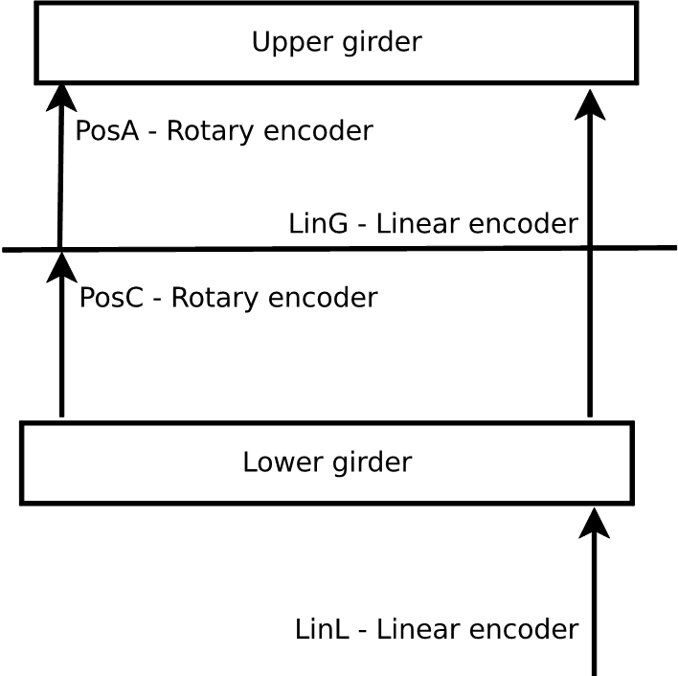Figure 12: Gap offset calibration
Every time the gap moves incremental encoders are re-calibrated using the following formulas:

Since linear and incremental encoder counts don't represent the same distance conversion needs to be done.
Offsets are applied on ControlBox level and need to be calculated correctly in order for axes to move to desired gap.
Calibration is done by using engineering mode to move axes to desired gap and offset with zero taper. Once this is done, gap and offset values need to be set in appropriate fields and “Gap to reference” button pressed.
This will recalculate the offsets, apply them and redefine axes incremental encoder positions.
To calculate offsets the following formulas are used:

Python GUI configuration
The Taurus Designer file and the Python module both use mnemonics in the form $undulator wherever a device name is needed. Prior to starting the GUI, the device names need to be configured according to the setup on-site.
To do that edit the file named setup.opt in GUI folder. All links in this file have to be changed to correct values.
Value name | Link
UNDULATOR | Proxy to undulator device server
GAPZ1 | Proxy to axis controling Z1 motor
GAPZ2 | Proxy to axis controling Z2 motor
GAPZ3 | Proxy to axis controling Z3 motor
GAPZ4 | Proxy to axis controling Z4 motor
PHASEX1 | Proxy to axis controling X1 motor
PHASEX2 | Proxy to axis controling X2 motor
PHASEX3 | Proxy to axis controling X3 motor
PHASEX4 | Proxy to axis controling X4 motor
GEARUP | Proxy to GalilGearedAxes controling upper girder (Z1+Z2)
GEARDOWN | Proxy to GalilGearedAxes controling lower girder (Z3+Z4)
OPC | Proxy to OPC bridge device server with tilt sensors and interlock signals
Table 16: GUI Mnemonic Substitutions

Now the build.sh script can be used to generate corrected Python files in out folder.
GUI can be run by invoking:
python undulator.py

Note: undulatorDesigner.py is created by the Taurus Designer. Customized code should not be be added to this source file as the Designer will overwrite it. Design changes should be made by opening undulator.ui in Taurus Designer and converting to Python code or by modifying undulator.py code.

