EPU-61 Undulator Control System
User Guide
Revision: | 1.3
Status: | Released
Repository: | acc
Project: | ACC-MAXlab-MAX_IV-EPU61
Folder: | Documentation
File: | EPU61_User_Guide.odt
Owner: | Miroslav Pavleski
Last modification: | January 23, 2013
Created: | August 31, 2012

Document History
Revision | Date | Authors | Section | Modification
0.1 | 2012-08-31 | Tadej Humar | All | Created.
1.0 | 2012-09-03 | Miroslav Pavleski | All | Review. Released.
1.1 | 2012-10-29 | Tadej Humar | 3. - 6. | Updated.
1.2 | 2012-11-08 | Tadej Humar | 3.,4.,6. | Updated.
1.3 | 2013-01-23 | Miroslav Pavleski | All | Updated to latest GUI
Confidentiality
This document is classified as a confidential document. As such, it or parts thereof must not be made accessible to anyone not listed in the Audience section, neither in electronic nor in any other form.
Scope
This document represents user's guide for the Control System for the Elliptically Polarizing Undulator (EPU) that is to be installed on the i511 beam-line at MAX-lab.
Audience
This document is intended for all Cosylab and MAX-lab employees involved in the MAX IV EPU-61 Control System project.
Typography
This document uses the following styles:
Style | Description
/usr/bin/perl, ConfigFile.xml | An identifier representing a filename or a directory.
Ctrl + Alt + Del . | A keystroke.
File - Open . | Used as a symbol for graphic interface elements
Identifier | Text used for various identifier reasons

Note: a box like this contains important information.

Warning!
A box like this contains even more important information.

References
- Control System of the EPU61, PPT presentation, 2011-06-11, © MAX-lab
- Request for offer - Control system for the EPU 61, 2011-12-20, © MAX-lab
- MAX IV EPU-61 Undulator Control System - Design Document ( DES-MaxIV-EPU61-ControlDesignDocument.pdf )
- EPU61 Technical Documentation – EPU61_Technical_Documentation.pdf
Table of Contents
1 Introduction 5
2 Safety 6
2.1 Personal Safety 6
2.2 Equipment Protection 7
3 Operator Mode tab 8
3.1 Phase Panel 8
3.2 Gap Panel 9
3.3 Motor Status 10
3.4 ID Status 11
3.5 Stop all Panel 12
3.6 Device State Panel 13
4 Engineering Mode tab 15
4.1 Upper Girder Panel 16
4.2 Phase Axes Panels 16
4.3 Engineering Lock 16
5 Calibration tab 17
5.1 Calibrating Gap 17
5.2 Calibrating Phase 18
5.3 Individual Encoder Offsets 18
6 Configuration tab 19
6.1 Speed Panel 19
6.2 Acceleration/Deceleration Panel 20
6.3 Operator Gap Movement Panel 20
6.4 Soft Limits Panel 20
Table of Figures
Figure 1: Emergency Stop Push-Button 6
Figure 2: Operator Mode tab 8
Figure 3: Phase mode definitions 9
Figure 4: “Motor Status” panel indicating all motors disabled and an encoder communication error on the Z4 motor 10
Figure 5: “ID Status” panel with X2 axis upper limit and over-travel switches activated 12
Figure 6: “Stop All” panel 12
Figure 7: “Device State” panel showing Device server in Disabled state, active Engineering Lock, Active Interlock status and active Emergency Stop 13
Figure 8: Engineering Mode tab 15
Figure 9: "Motors" panel 16
Figure 10: Calibration tab 17
Figure 11: Configuration tab 19

Introduction
EPU61 Undulator user interface is separated in four different tabs. First one is meant for normal users (Operators) and others for engineers to maintain the machine.
Engineering tabs are divided in three parts:
- Engineering Mode movements tab
- Undulator Calibration tab. Used for calibrating the linear encoder offsets during commissioning
- Undulator Configuration tab. Used for setting various parameters.
There are no restrictions between views so anyone can change and affect all parameters. It is recommended for non-engineers to only use Operator Mode tab as changing the configuration parameters can result in machine behaving incorrectly.

Safety

Personal Safety
The insertion device as well as the control cabinet are equipped with Emergency Stop Push-Buttons (see Figure 1). When any of these buttons is pressed, Interlock signal is activated prohibiting all motion on the device electrically. When interlock is active also all brakes are applied and motion is not possible.

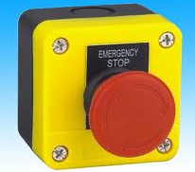Figure 1: Emergency Stop Push-Button

Warning!
If personal is to access the insertion device for maintenance or any other purpose, AT LEAST ONE of the Emergency Stop Push-Buttons must be pressed and activated. This will inhibit all movement on the device electrically regardless of control system level operations issued.

IT IS STRONGLY RECOMMENDED TO ADHERE TO THIS RULE.

Equipment Protection
The undulator control system contains an Equipment Protection System (EPS) PLC that is monitoring sensors to ensure safe machine operation. If invalid state is detected on EPS level, an Interlock signal is raised and this is clearly indicated on the OPI screens. For reference, see 3.6

Operator Mode tab
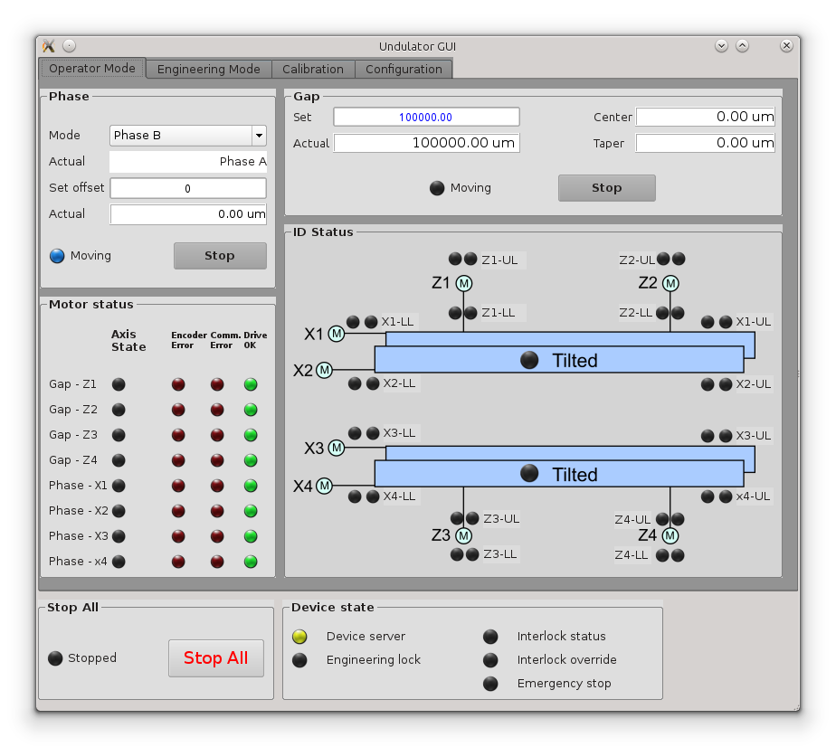Figure 2: Operator Mode tab

Main operator tab is divided into four panels (Phase, Gap, Motor status and Motor limits). The two panels in the bottom are shared between all four views.

Phase Panel
User can select desired phase mode by using combo-box labeled Mode. Under the combo-box the current phase mode is displayed.

Note: Actual phase mode is not the one user selected but the one that is calculated depending on current motor positions.

User can start phase movement by typing desired offset, in micrometers, in set offset field. As soon as the number is confirmed (Enter press) movement will start. During movement the “Moving” LED in the panel will turn blue and the appropriate gap axes in the “Motor status” panel will turn blue.
Stop can be pressed to stop phase movement.

Phase modes are defined as follows:
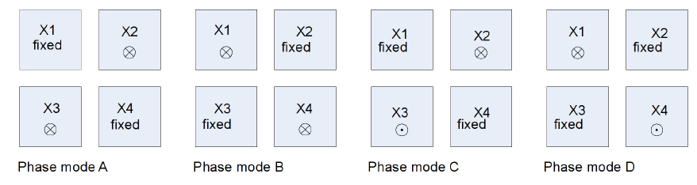Figure 3: Phase mode definitions

Gap Panel
Similar as in phase panel, user can start movement by typing desired gap, in micrometers, into set field. This will trigger movement updating current gap, offset and taper. During movement the “Moving” LED in the panel will turn blue and the appropriate gap axes in the “Motor status” panel will turn blue.

Motor Status
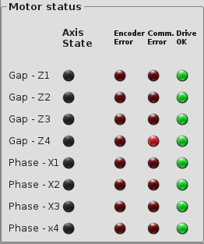
Figure 4: “Motor Status” panel indicating all motors disabled and an encoder communication error on the Z4 motor

The state of each motor (axis) is represented by a LED under “Axis State” label. Color code is as specified in the following table:

State | Preview
Motor deactivated, brake applied | OFF
Motor active, moving | MOVING
Motor active, at stand-by. | STANDBY
Fault, appropriate Tango device is in Fault state | FAULT
Alarm on the axis, e.g. limit switch is hit. | ALARM
Unknown | UNKNOWN
Table 1: State Color Codes

In addition, in the “Motor Status” panel, the following per-axis LED indicators are available:
- under “Encoder Error” label, LEDs indicating whether there is error while scanning the encoder strip on the linear absolute encoders
- under “Comm. Error” label, LEDs indicating whether there is communication error while communicating with the appropriate linear absolute encoder (e.g. encoder cable error)
- under “Drive OK” label, LEDs indicating whether the motor drive reports drive-healthy condition. If the appropriate green LED is inactive, the drive tripped – in fault.
When any of these groups of LEDs indicate abnormal condition, the Undulator device transitions into ALARM state, as indicated by the “Device server” LED in the “Device state” panel. Movement for the motors in the axis group (gap, phase or both) will be forbidden in alarmed state.

ID Status
A picture visualizing the undulator, along with limit and over-travel LEDs in each axis direction is available on the screen. Additionally, over-tilt indicators are present for each girder.
Each motor has four LEDs representing type (kill and limit) and direction(upper and lower) of switch. First LED (red) represents kill switch while second (green) represents limit switch.
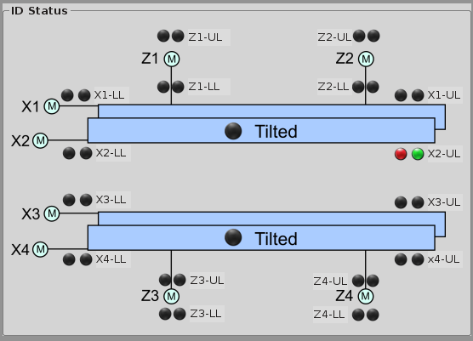Figure 5: “ID Status” panel with X2 axis upper limit and over-travel switches activated

Stop all Panel
A LED is indicating if “Stopped” condition has been activated by the user.

If this LED is signaled (red) all motion commands are restricted and the Undulator device is in disabled (Pink) state.
The provided  button aborts all ongoing movements and disables all motors (enables all brakes). When “Stopped” is indicated, further movement is forbidden until  button is pressed.

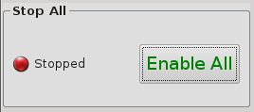Figure 6: “Stop All” panel

Device State Panel
This panel holds five LEDs displaying signals to the server and server current state.
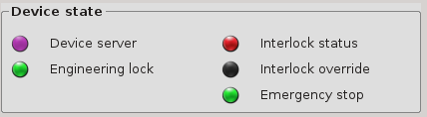
Figure 7: “Device State” panel showing Device server in Disabled state, active Engineering Lock, Active Interlock status and active Emergency Stop

The general insertion device status is indicated by the “Device server” LED in the “Device state” panel. Following color codes are used:

State | Preview
Undulator at Stand-by. Motion can be issued. | STANDBY
Movement on any axis is active. | MOVING
Fault. The Tango device-server has malfunctioned. Please Control Group personal to diagnose and fix the problem. | FAULT
Alarm. Either encoder read-out error, encoder communication (cable) error or motor drive tripped. Please consult Control Group and Engineering group personal to diagnose and fix the problem. | ALARM
Disabled state. Either Interlock is activated or “STOP ALL” condition is activated, or both. In case of Interlock condition caused by protection device activation (over-travel switch, tilt meter), please consult Control Group/Engineering group personal. | DISABLED
Table 2: Undulator device states

If “Interlock status” LED is activated, then the device is in invalid state and the protection system has disabled all movement. Engineering staff should be notified in order to be able to resume normal operation. Possible causes for activation of the Interlock signal are:
- emergency button mounted on the insertion device or in the control cabinet has been pressed, this is indicated by green activated “Emergency stop” LED
- safety over-travel switch has been hit, as indicated by red LED in the “ID Status” panel (see 3.4)
- girder has been over-tilted, as visible by the appropriate “Tilted” LED in the “ID Status” panel (see 3.4)
- other protection measures implemented in the Equipment Protection System PLC
“Interlock override” LED is activated when the cabinet-mounted Key-Switch has been used to override the Interlock condition caused by over-travel or tilt switch activation. This should be only done by engineering stuff in response to activated Interlock signal, in order to mitigate the condition.
Warning!
Interlock override should be INACTIVE during normal operation. Damage to the machine may occur if machine is operated in this state, as the protection system is overridden.
“Emergency stop” is activated when someone presses emergency stop button mounted on the insertion device or on the control cabinet.
If “Engineering lock” is green, operator screen issued movements will be prohibited.

Engineering Mode tab
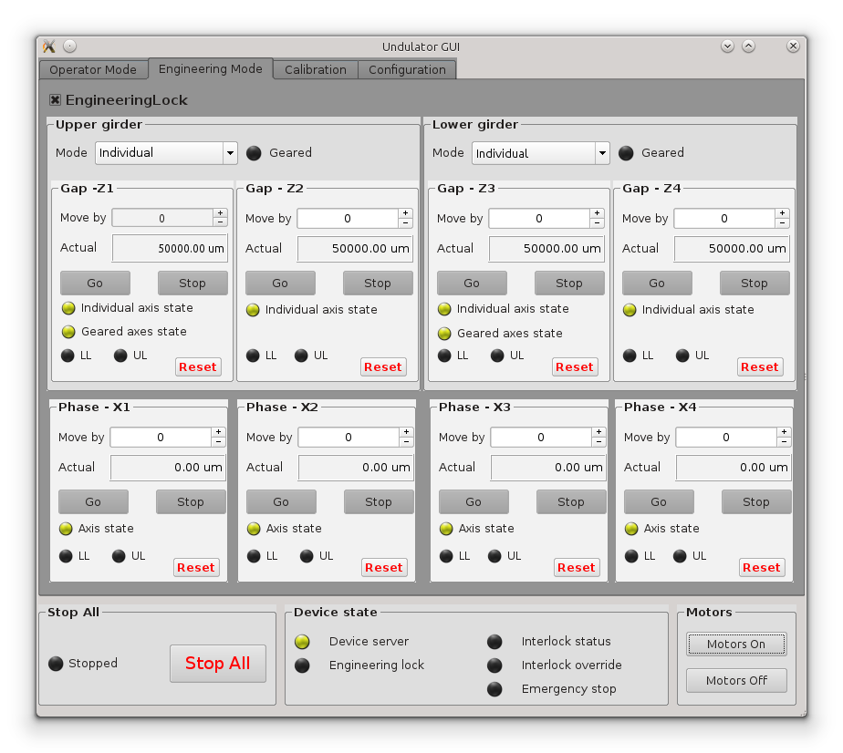
Figure 8: Engineering Mode tab
This tab is meant for engineers to:
- move individual motors
- move individual girders
- calibrate and commission the insertion device
- mitigate error conditions
Top two panels represent upper and lower girder. As both work the same way only upper girder panel will be presented.
Movement of motors in engineering mode requires the engineer to enable or disable the motors manually before movement. To do so, please use the and
buttons in the “Motors” panel.

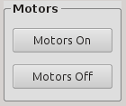
Figure 9: "Motors" panel

Upper Girder Panel
Engineer can move Z1 and Z2 axes individually or at the same time as geared (coupled) axes. The movement mode, Individual or Geared, can be changed by selecting desired mode in the combo-box. If axes are in geared mode, the appropriate “Geared” LED will turn green. Changing of geared mode only works while the appropriate motors are enabled and at stand-by (yellow axis state).
Note: When in geared mode commands issued should be done on first (Z1 or Z3) axis as it is set as master and some commands are restricted on slaves.
To move the motors user must first type desired relative movement in micrometers in the “Move By” field and then click on Go button. LEDs representing axes states will change colors according to the scheme explained in chapter 3.3.

Phase Axes Panels
Phase axes can only be moved individually. Moving works the same way as for gap axes when not geared. Relative movement is executed.

Engineering Lock
Engineers can restrict Operator mode (user) movement commands by issuing an Engineering Lock. To issue Engineering Lock, please click the check-box. When Engineering Lock is engaged, the LED indicating “Engineering Lock” in the “Device state” panel with turn green.

Calibration tab
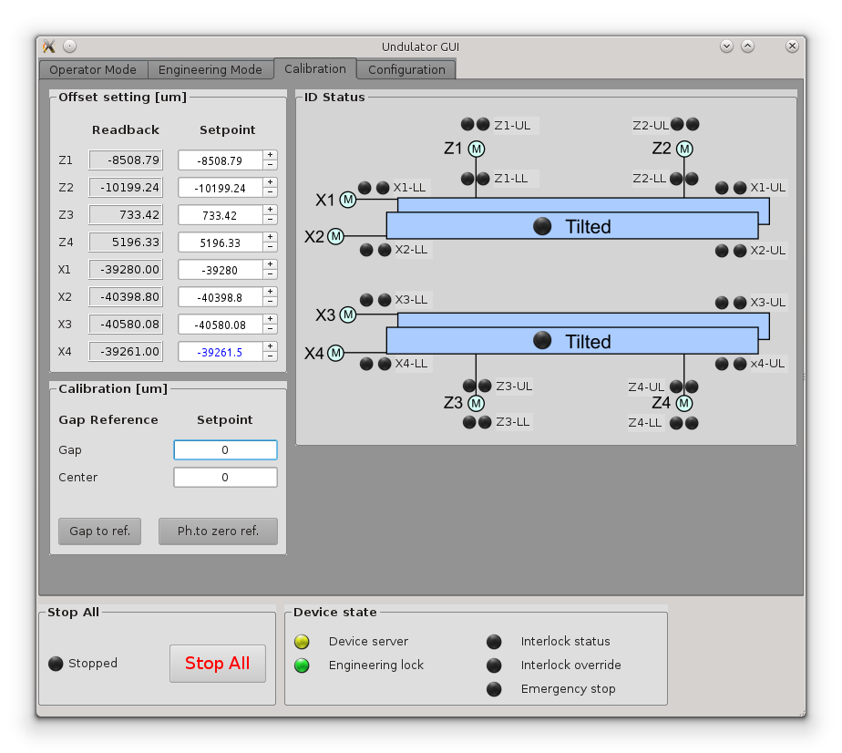
Figure 10: Calibration tab
Calibration view is to be used during commissioning to calibrate the device. The primary purpose is to be able to set and modify the linear encoder offsets.

Calibrating Gap
The engineer calibrating the device should:
- using Engineering Mode tab movements, perfectly align both girders with the X axis (horizontally)
- using Engineering Mode tab movements position both girders at a known, given reference gap (e.g. 100 mm) and at a given reference offset (e.g. 0 mm)
- after the girders are aligned, the reference gap should be entered in the in the Gap Reference Setpoint, in the “Calibration” panel, and the reference offset in the Center Reference Setpoint in the same “Calibration” panel
- in this state, if the button is pressed all linear gap encoder offsets will be automatically re-calibrated and from that moment on the device will display correct gap positioning values

Note: After calibration it is recommended that the engineer writes down the gap offsets. Offsets could be read from “Offset setting” panel appropriate Readback fields.
This is recommended in order to prevent calibration data loss due to software misconfiguration.

Calibrating Phase
Calibrating the sub-girder linear encoder offsets is done in a similar way:
- using Engineering Mode screen movements the engineer should move all girders to zero phase offset position
- in this state, if the button is pressed all phase linear encoder offsets will be automatically re-calibrated and from that moment on the device will display correct phase positioning values

Note: After calibration it is recommended that the engineer writes down the phase offsets. Offsets could be read from “Offset setting” panel appropriate Readback fields
This is recommended in order to prevent calibration data loss due to software misconfiguration.

Individual Encoder Offsets
The Calibration screen also provides the ability for the engineers to modify individual encoder offsets, in the “Offset setting” panel. This is not the preferred method of calibration. It is recommended the methods described in the previous two chapters to be used.

Configuration tab
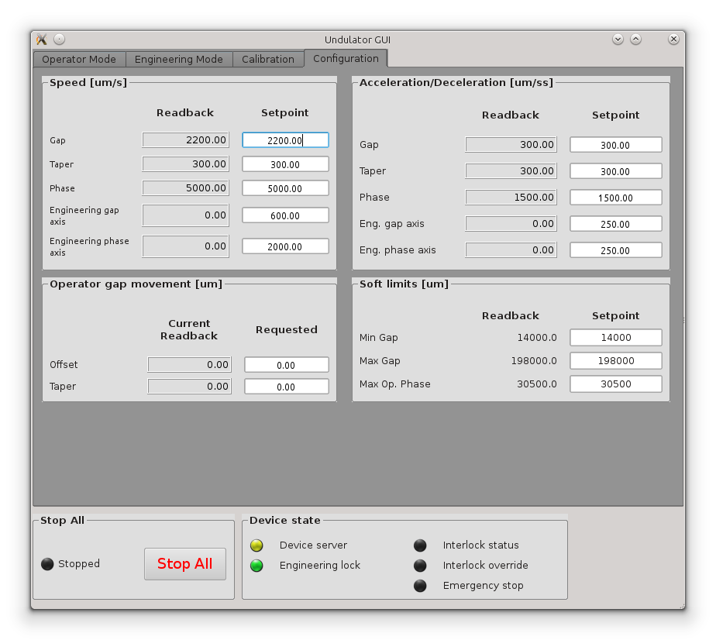
Figure 11: Configuration tab
Configuration tab is used for setting axes parameters, limits and gap behavior.

Speed Panel
Engineer can set up speeds for gap, taper and phase movement. This speeds only apply when operator issues gap or phase movement.
For engineering movements the two special fields are used which apply desired speed to all axes in a group (gap or phase). Readback for engineering speeds will have value only if all axes in a group have the same speed configured otherwise 0 will be displayed.

Acceleration/Deceleration Panel
It works the same as speed panel except here we are setting the acceleration and deceleration to the same value.

Operator Gap Movement Panel
A convenient method to introduce intentional gap center offset or taper for Operator mode screen movements is provided in the “Operator gap movement” panel. Both will be applied when the next gap movement is issued.

Soft Limits Panel
Minimal and maximal gap limit and maximal phase offset can be set here.
These values prevent the user to enter desired gap and phase offsets that are outside the machine operational range.

