* Powermerter driver

This is the Zigbee power meter driver. Because the Zigbee PowerMeter Driver communicates to PC with serial port, so this driver mainly accomplishes the basic function about operating serial port. So if you want to connect any other devices which are operated through serial port, you can use this driver. Using this driver’s example is Powermeter APP.

In *DriverPowerMeter.cs*, there are mainly four functions to operate serial port:

1. *public bool commOpen(string commName)*

In this function,you can set the basic configuration information about your serial port which communicates with your devices. Then open the serial port.

1. *public void CloseSerialPort()*

In this function, closing serial port is safe.

1. *public void WriteCom(String command)*

This function mainly accomplished commands are sent to serial port.

1. *private void comm_DataReceived(object sender, SerialDataReceivedEventArgs e)*

This function returns the message from serial port.

* Device Inforamtion

We use Billion Compact ZigBee Smart Power Meter SG3010 Series.

This compact smart power meter has a number of functions for electricity estimation and wireless transmission. If power meters want to communicate with PC, they must through USB dongle and serial port.

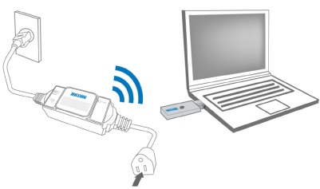

Notice: before running driver and app, please copy the content of Role.cs to the Common/Role.cs