Intelligent and Scalable Monitoring/Control Platform for Home Energy Management –

By Harbin Institute of Technology

Nowadays building energy consumption is the main part of the world energy consumption. So how to manage home energy better is concerned. This project’s plan is to realize “ IoT based home/building energy management”. The structure of it likes the following picture.

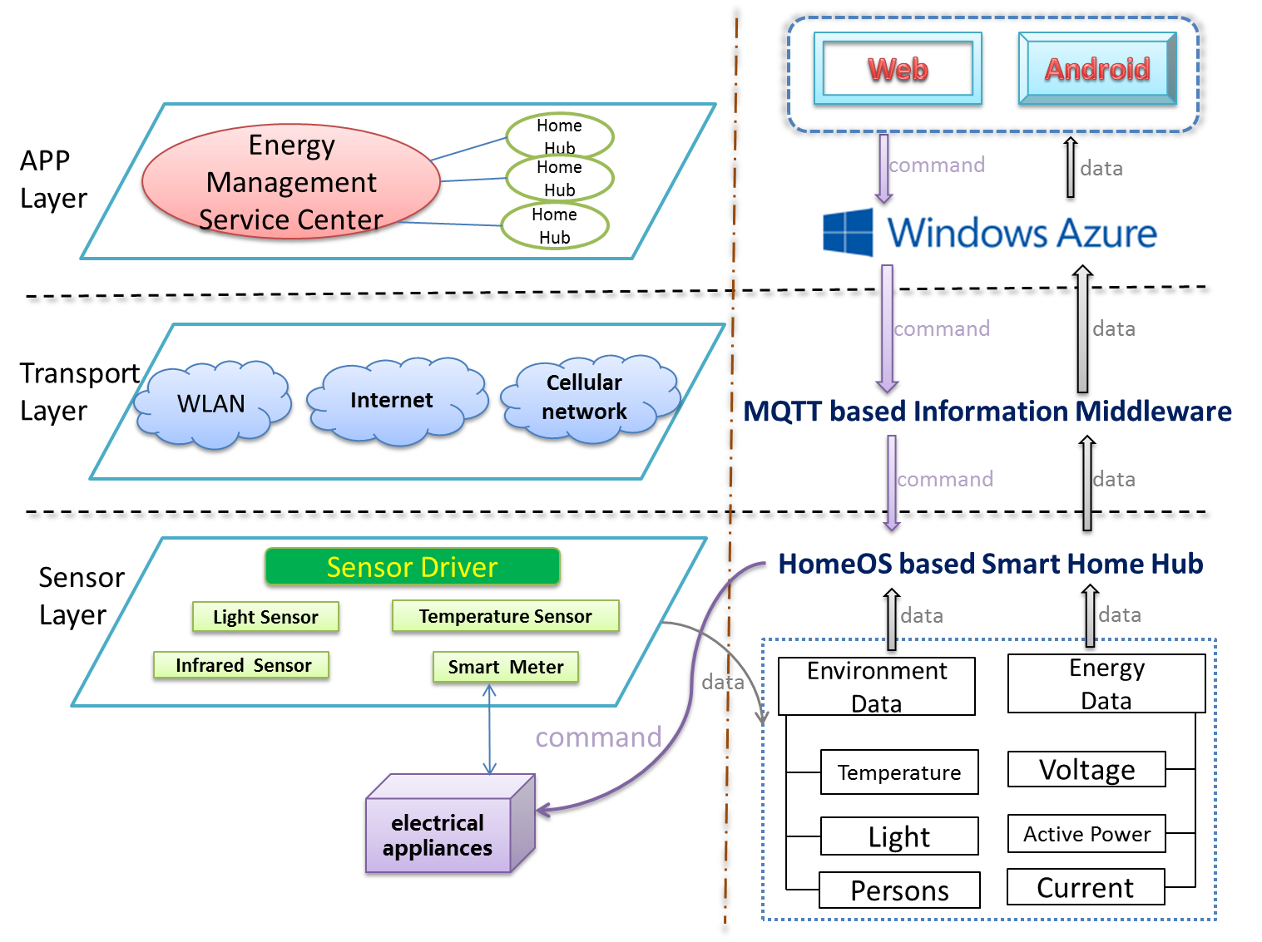

The energy consumption management system based on Internet of Things consists of three sub-systems: Single-family intelligent gateway subsystem based on HomeOS，Message reliable transmission subsystem based on MQTT middleware，Multi-family energy management cloud services subsystem based on Windows Azure.

**Single-family intelligent gateway subsystem based on HomeOS:**

Firstly, building a unified gateway for a typical home environment is needed, every home has a hub which heterogeneous devices/networks co-exist and sense/actuate. So HomeOS/LabofThings is used in this part. In Sensor Layer, this platform is used to collect Environment Data and Energy Data.

**Message reliable transmission subsystem based on MQTT middleware:**

Secondly, on top of many HomeOS-based gateways, a layer based on MQTT middleware which support reliable is set up, lightweight sensing/actuating message delivery. The message contains data and command. This layer is called “Transport Layer”.

**Multi-family energy management cloud services subsystem based on Windows Azure:**

Thirdly, both web-based and mobile UI will be developed to support domain functions. On the third layer, “cloud” is needed to achieve it. This cloud has basic following functions:

*  Monitoring – so you know the state of your deployment
* Relay - it enables the communication/routing from the internet to the hub
* Data logging – storing data for system and application to the cloud
* Update – it allows you to remotely update hubs with new configurations and binaries

So, Azure can help us. In Azure, we want to use Azure to manage many homes' energy data. It can achieve "Multi-Family Management" in cloud. The high level requirements of Multi-Family management like the following:

* Collect many homes' energy data liking HomeOS's data storage in Azure.
* In Azure we can analysis data which is collected from every home's power meters to guide

home owners make use of energy so that they can save energy.

* In Azure we can control electrical equipment (air condition, lamp, PC) remotely by transmitting commands(ON/OFF) to  electrical equipment in every home.

In summary, this platform contains the following functions and research topics:

* Closing the loop: not only capable of sensing the status and energy consumption of devices, but also actuating them such as turning off lights or HVAC through service on cloud.
* Fine-granularity energy auditing.
* Learning/mining energy usage modes and analyzing potential energy saving.
* Smart energy usage based on intelligent decision making.

**Single-family intelligent gateway subsystem based on HomeOS:**

* **A simple description of the module “AppNew”:**

Liking the following picture，we add the module ”AppNew” and its root files.

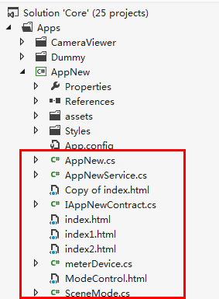

This module’s main function is to collect the energy data from all kinds of home electrical devices. Of course , these devices are binding power meters(BILLION). This module is finished like this:

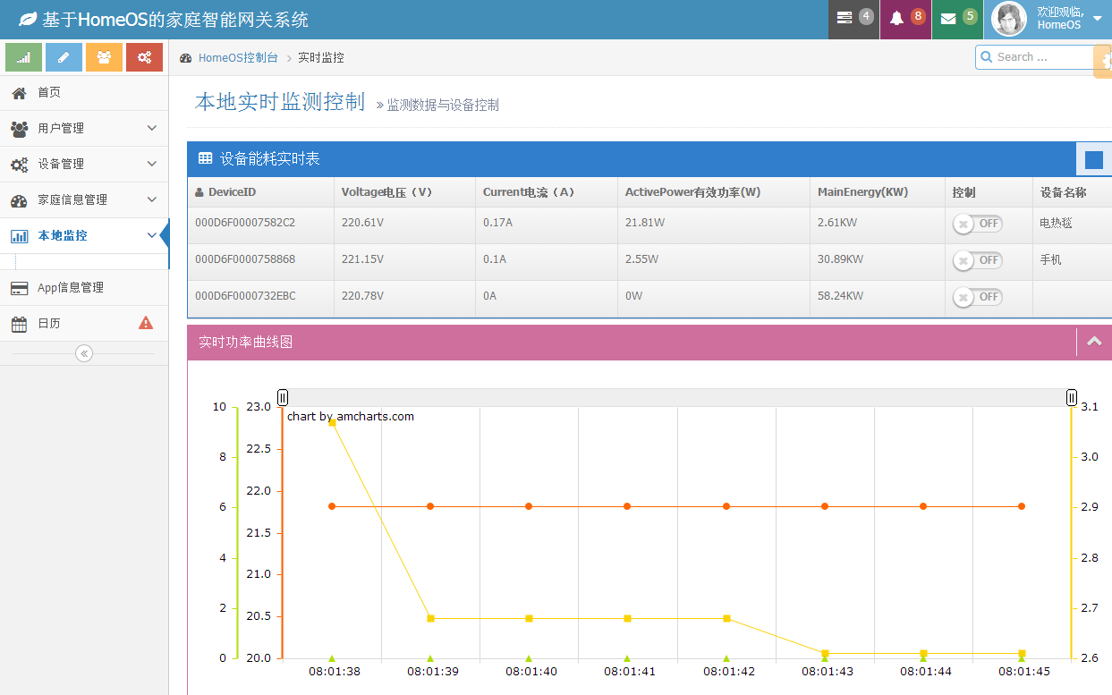

Switch of every device

devices’ realtime activepower dynamic curves

设备控制器，可控制相应设备

Table:devices’ realtime energy consumption

* **A simple description of the driver “PowerMeter”:**

Liking the following picture，we add the driver “PowerMeter” and its root files.

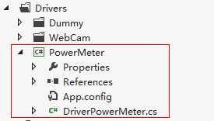

This driver’s main function is to realize the plug-and-play of the equipment.In this project we do experiment with power meters. This module is finished like this:

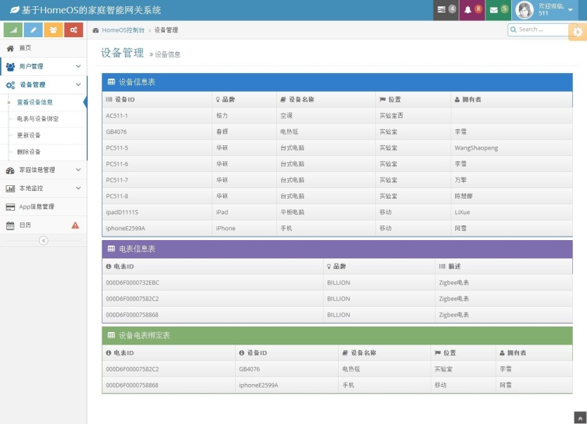

Find out power meters through driver

In addition to the above, we modify the source code of **platform. The detail information please check our source code.**

设备控制器，可控制相应设备

* **Quick steps to build the project**

First, Install “CDM 2.04.16.exe”, .

Second, you need one BILLION power meter dongle or other dongle and its subdevice,for example powermeters. Please plug it to the PC’s USB. We can see like following, maybe your PC’s COM is not COM3.

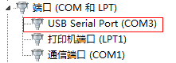

Third, you can refer to the document in the labofthings web, like “Getting_Start_with_lab_of_things.pdf” and so on.

If you do above steps ,this project can run successfully. The Index page like this:

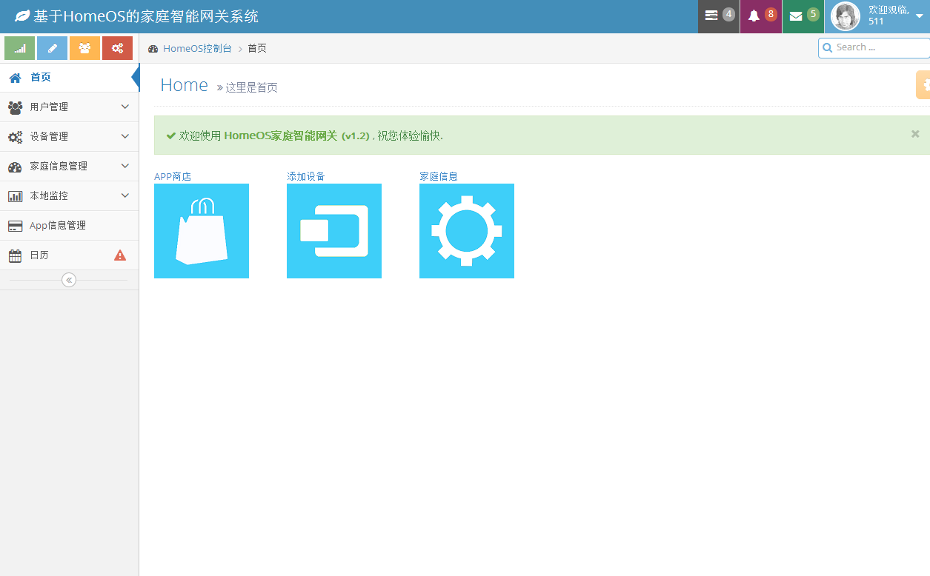

**Multi-family energy management cloud services subsystem based on Windows Azure:**

This project consists of the following files.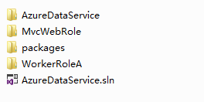

Refer to :

<http://azure.microsoft.com/en-us/documentation/articles/cloud-services-dotnet-get-started/>.

In this web , you can find the tutorials “Get Started with Azure Cloud Services and ASP.NET”.

Then you can run the “AzureDataService.sln” directly.

If you do above steps , this project can run successfully. The Index page like this：

