Persuasion
Sum values on the left side for the attempting Senator
and compare with values of the target on the right side. Chances are highest when difference is at least 9
12 – Persuasion failed
11 – Persuasion failed
10 – Persuasion failed
9 on 2D6
8 on 2D6
7 on 2D6
6 on 2D6
5 on 2D6
4 on 2D6
3 on 2D6
2 on 2D6
1 on 2D6
+ Loyalty
+ 7 if aligned
Special conditions
+ Counter-bribes from all factions

+ Oratory
+ Influnce
+ Talents from personal treasury

CHANCE

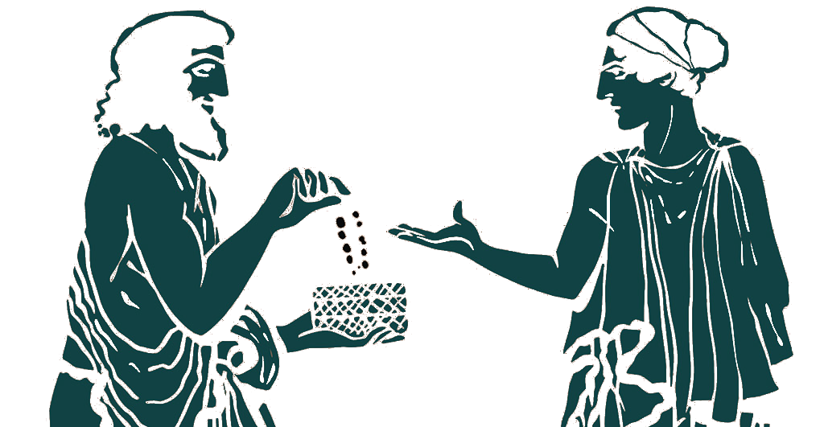
NO CHANCE
First sum up values, then go with bribes, then counter-bribes, and throw dices as the last step.
Bribes and counter-bribes stay on the card of the target Senator. Counter-bribes does not allow to take over the target by other factions.

