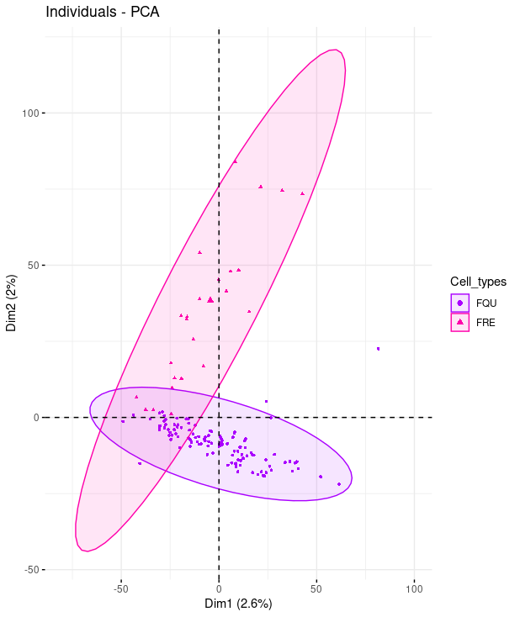
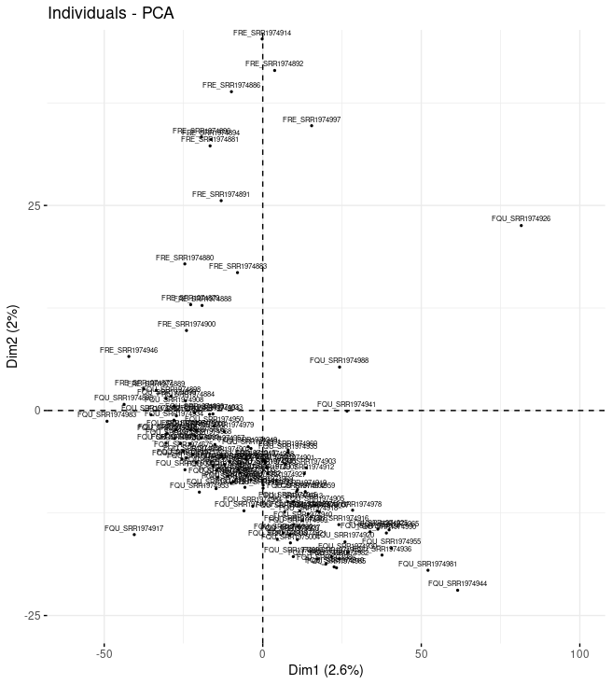

Figure X: PCA analysis plot of gene expression profiles of FQU and FRE. In the figure, the plots show the distribution of the cells in the first two principal components. The X- and Y- axes represent the two principal components obtained through PCA. Dimension 1 on the X-axis accounts for 2.6% of the total variance in the data, whereas dimension 2 on the Y-axis accounts for 2.0% of the total variance in the data. Each axis indicates how much variation of each of the datasets is represented by each of the dimensions. . Each point represents an individual cell, coloured according to its cell type, either FQU ( fibroblast/quiescent cell) in purple or FRE ( fibroblast/replicating cell) in pink. . Both plots show the same results on gene expression data, they differ in the way the data is presented with the right plot labelling the plot with its cell type rather than colour coordinating it.

