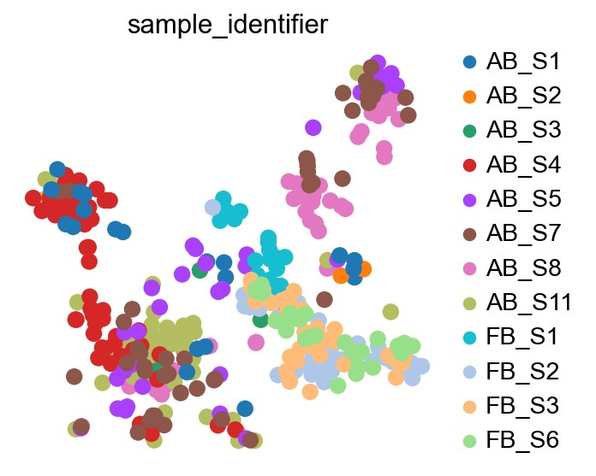
Figure X: t-SNE plot distinguishing between adult and fetal samples (individual samples) from the SraRunTable and single-cell RNA sequencing
data. This figure can be useful to identify the samples formed by Leiden clustering, distinguishing between each adult brain surgical sample and each fetal
brain surgical sample that are included in the study using the Leiden algorithm. Each sample is coloured by Leiden clustering. Adult brain surgical samples
are represented as AB_S1, AB_S2, AB_S3, AB_S4, AB_S5, AB_S7, AB_S8, and AB_S11. Fetal brain surgical samples are represented by FB_S1, FB_S2,
FB_S3, and FB_S6.
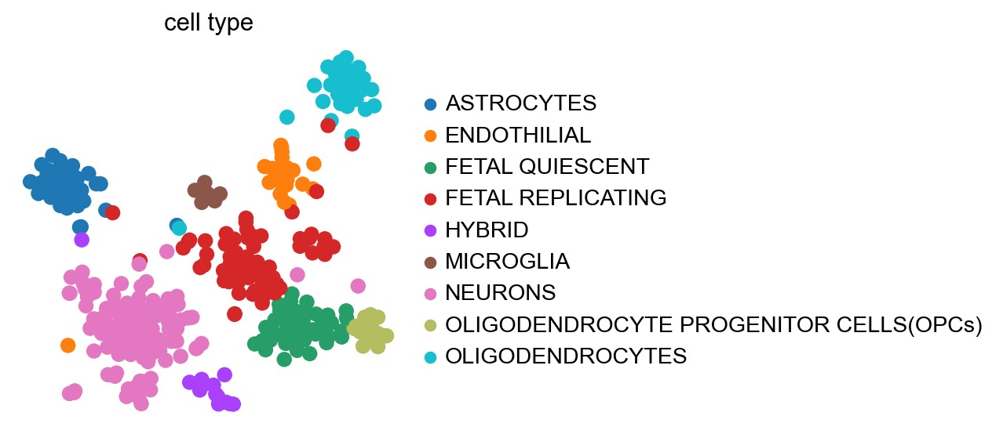
Figure X: t-SNE plot differentiating between all the cell types clusters. This figure represents each cell types that are distributed based on
their spacing. Cells types with distinguished gene markers were grouped together using the Leiden algorithm. Nine cell types are represented on
this plot. Each dot represents a cell.
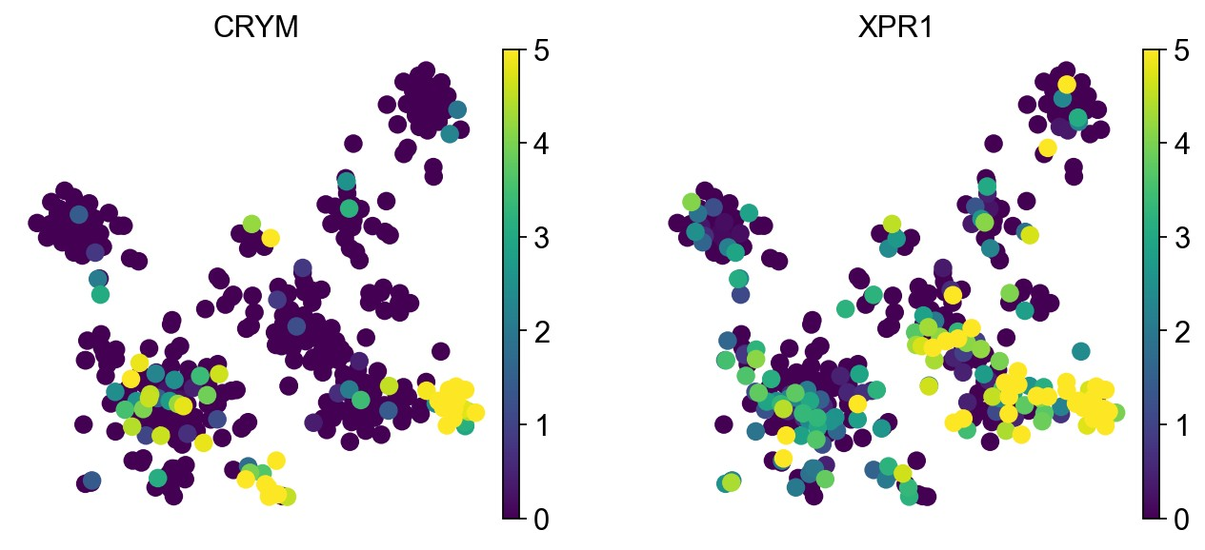
Figure X: t-SNE expression of genes CRYM and XPR1 in Neuron cell cluster. This figure represents the distribution of the marker
genes based on their expression levels. The dots are coloured based on their expression levels of the genes CRYM (on the left) and XPR1
(on the right). These expressions of genes are from the cell cluster. The scale describes the range of expression for both, from 0 to 5, with
yellow being the highest expression and purple the lowest.
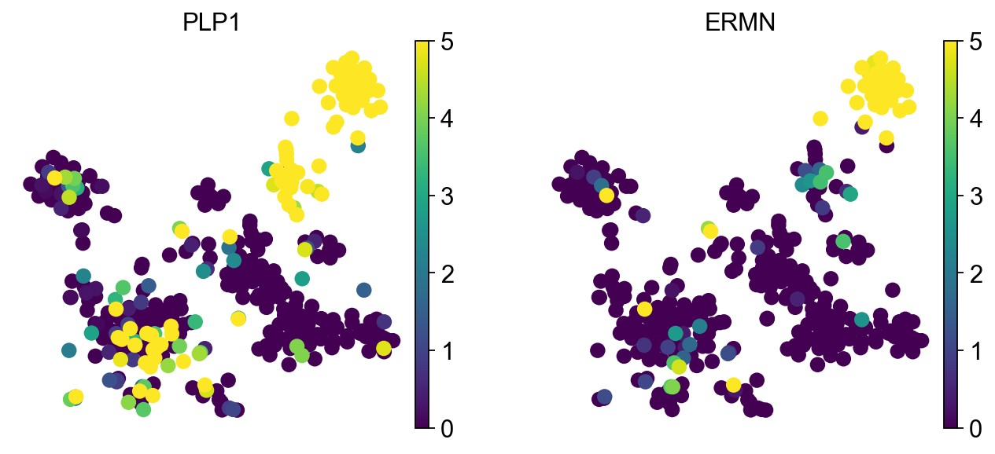
Figure X: t-SNE expression of genes PLP1 and ERMN in Oligodendrocytes cell cluster. This figure represents the distribution of the
marker genes based on their expression levels. The dots are coloured based on their expression levels of the genes PLP1 (on the left) and
ERMN (on the right). These expressions of genes are from the cell cluster. The scale describes the range of expression for both, from 0 to 5,
with yellow being the highest expression and purple the lowest.
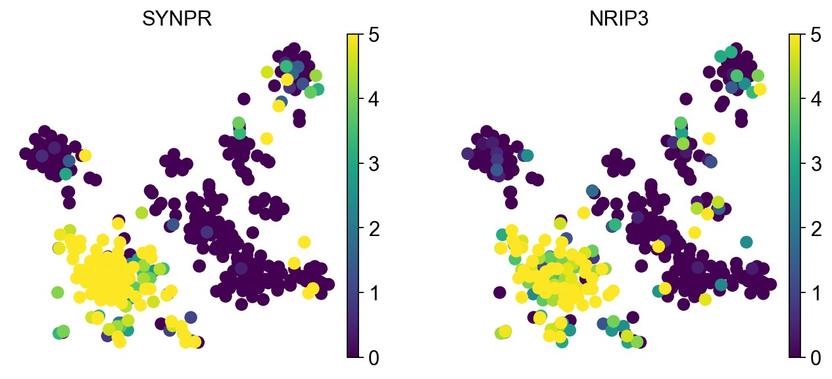
Figure X: t-SNE expression of genes SYNPR and NRIP3 in Neuron cell cluster. This figure represents the distribution of the marker genes
based on their expression levels. The dots are coloured based on their expression levels of the genes SYNPR (on the left) and NRIP3 (on the
right). These expressions of genes are from the neuron cell cluster. The scale describes the range of expression for both, from 0 to 5, with
yellow being the highest expression and purple the lowest.
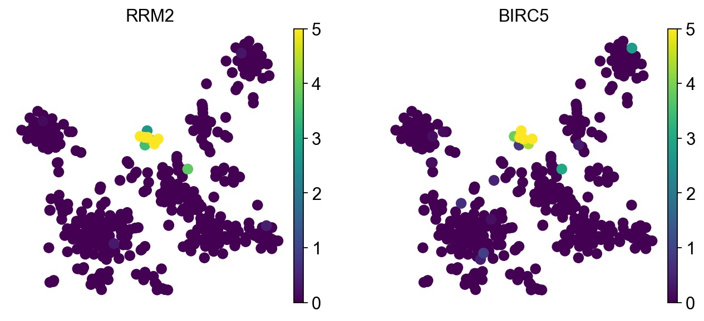
Figure X: t-SNE expression of genes RRM2 and BIRC5 in Microglia cell cluster. This figure represents the distribution of the marker
genes based on their expression levels. The dots are coloured based on their expression levels of the genes RRM2 (on the left) and BIRC5
(on the right). These expressions of genes are from the Microglia cell cluster. The scale describes the range of expression for both, from 0 to
5, with yellow being the highest expression and purple the lowest.
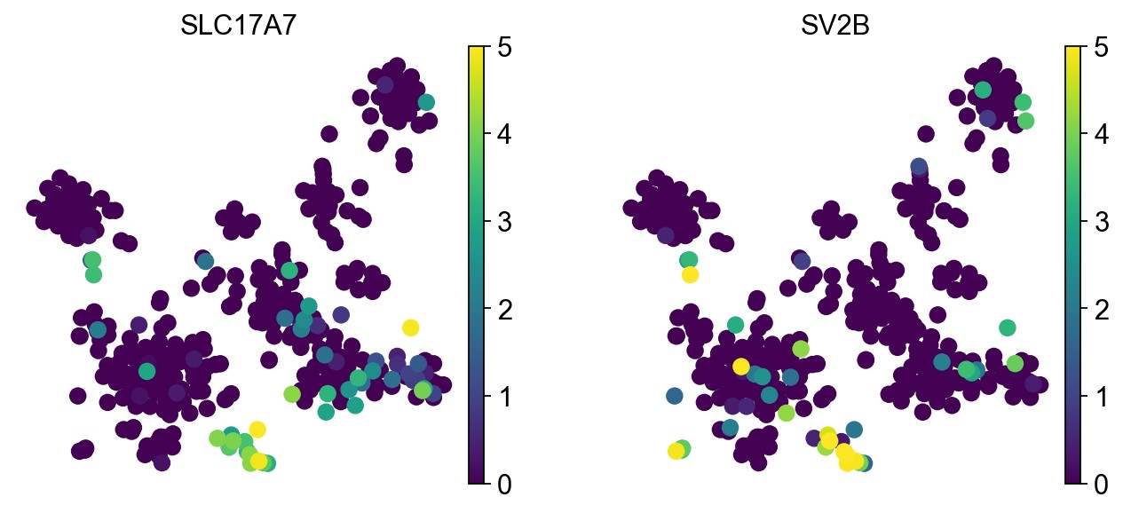
Figure X: t-SNE expression of genes SLC17A7 and SV2B in Hybrid cell cluster. This figure represents the distribution of the
marker genes based on their expression levels. The dots are coloured based on their expression levels of the genes SLC17A7 (on
the left) and SV2B (on the right). These expressions of genes are from the cell cluster. The scale describes the range of expression
for both, from 0 to 5, with yellow being the highest expression and purple the lowest.
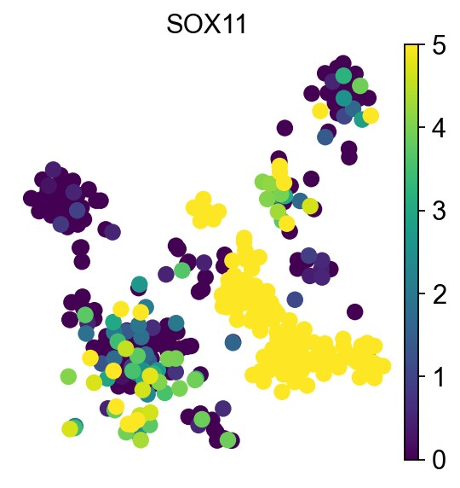
Figure X: t-SNE expression of SOX11 gene in Fetal replicating cluster. This figure represents the distribution of the marker gene
based on the expression level. The dots are coloured based on their expression levels of the gene SOX11. These expressions of genes
are from the fetal replicating cell cluster. The scale describes the range of expression, from 0 to 5, with yellow being the highest expression
and purple the lowest.
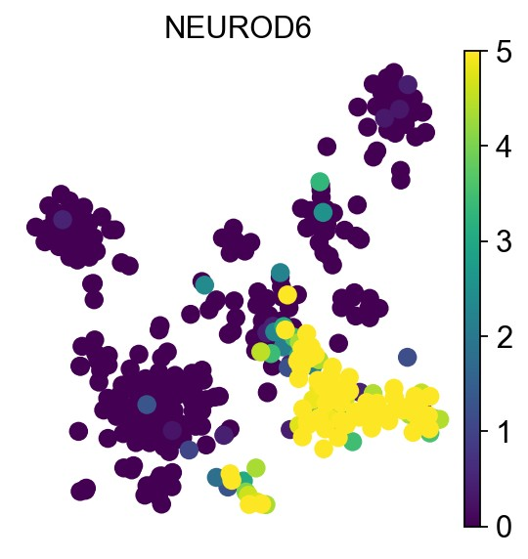
Figure X: t-SNE expression of NEUROD6 gene in Fetal quiescent cell cluster. This figure represents the distribution of
the marker gene based on the expression level. The dots are coloured based on their expression levels of the gene
NEUROD6. These expressions of genes are from the Fetal quiescent cell cluster. The scale describes the range of
expression, from 0 to 5, with yellow being the highest expression and purple the lowest.
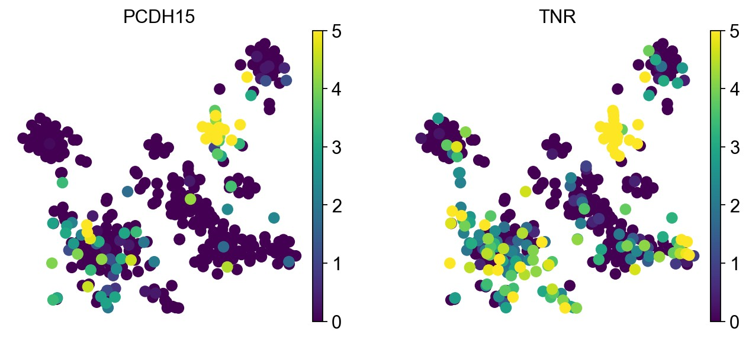
Figure X: t-SNE expression of genes PCDH15 and TNR in Endothelial cell cluster. This figure represents the distribution of the
marker genes based on their expression levels. The dots are coloured based on their expression levels of the genes PCDH15 (on the
left) and TNR (on the right). These expressions of genes are from the Endothelial cell cluster. The scale describes the range of
expression for both, from 0 to 5, with yellow being the highest expression and purple the lowest.
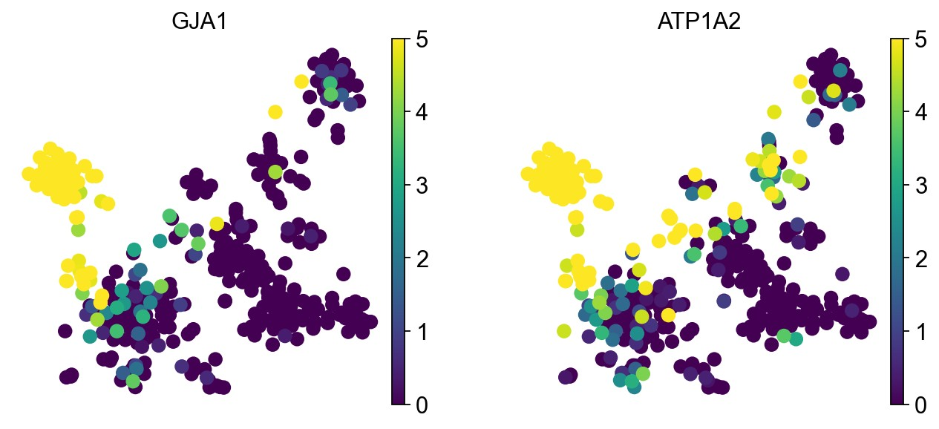
Figure X: t-SNE expression of genes GJA1 and ATP1A2 in Astrocytes cell cluster. This figure represents the distribution of the marker
genes based on their expression levels. The dots are coloured based on their expression levels of the genes GJA1 (on the left) and ATP1A2
(on the right). These expressions of genes are from the astrocyte cell cluster. The scale describes the range of expression for both, from 0 to
5, with yellow being the highest expression and purple the lowest.

