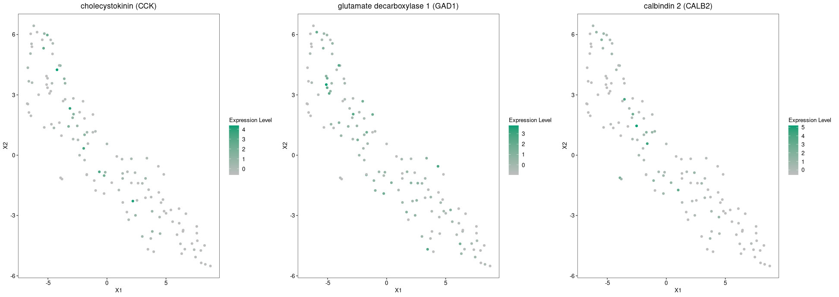
Highly enriched cell-type-defining genes for different cellular populations derived from the mouse brain using unbiased and focused approach.

Fig.x - Marked gene expression of cholecystokinin (CCK), glutamate decarboxylase 1 (GAD1) and calbindin 2(CALB2)

Expression of excitatory neuronal markers.

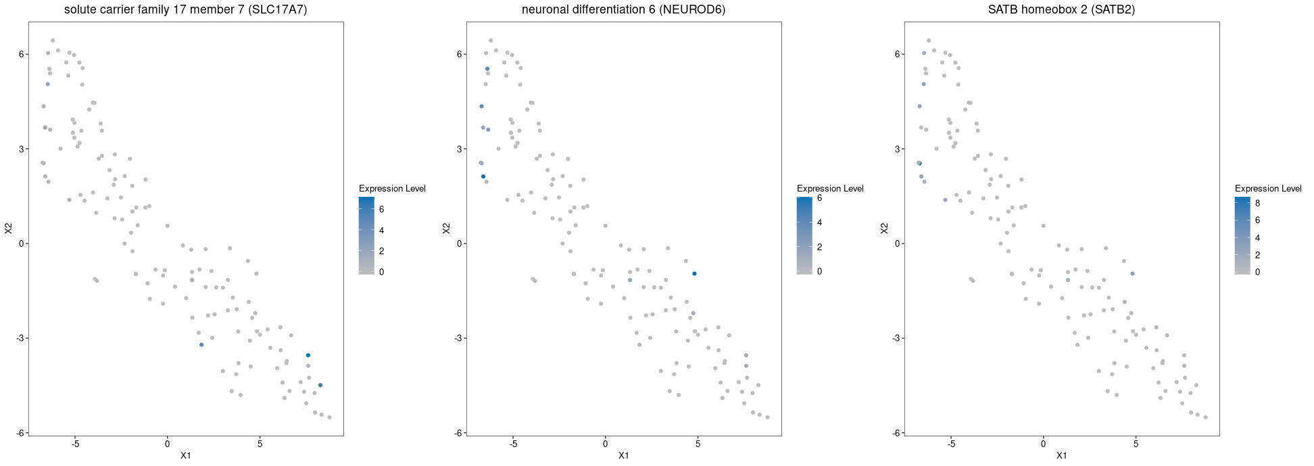
Fig.x – Excitatory communities expressing SLC17A7, NEUROD6 and SATB2 markers for excitatory neuronal cells in neurons four and seven.

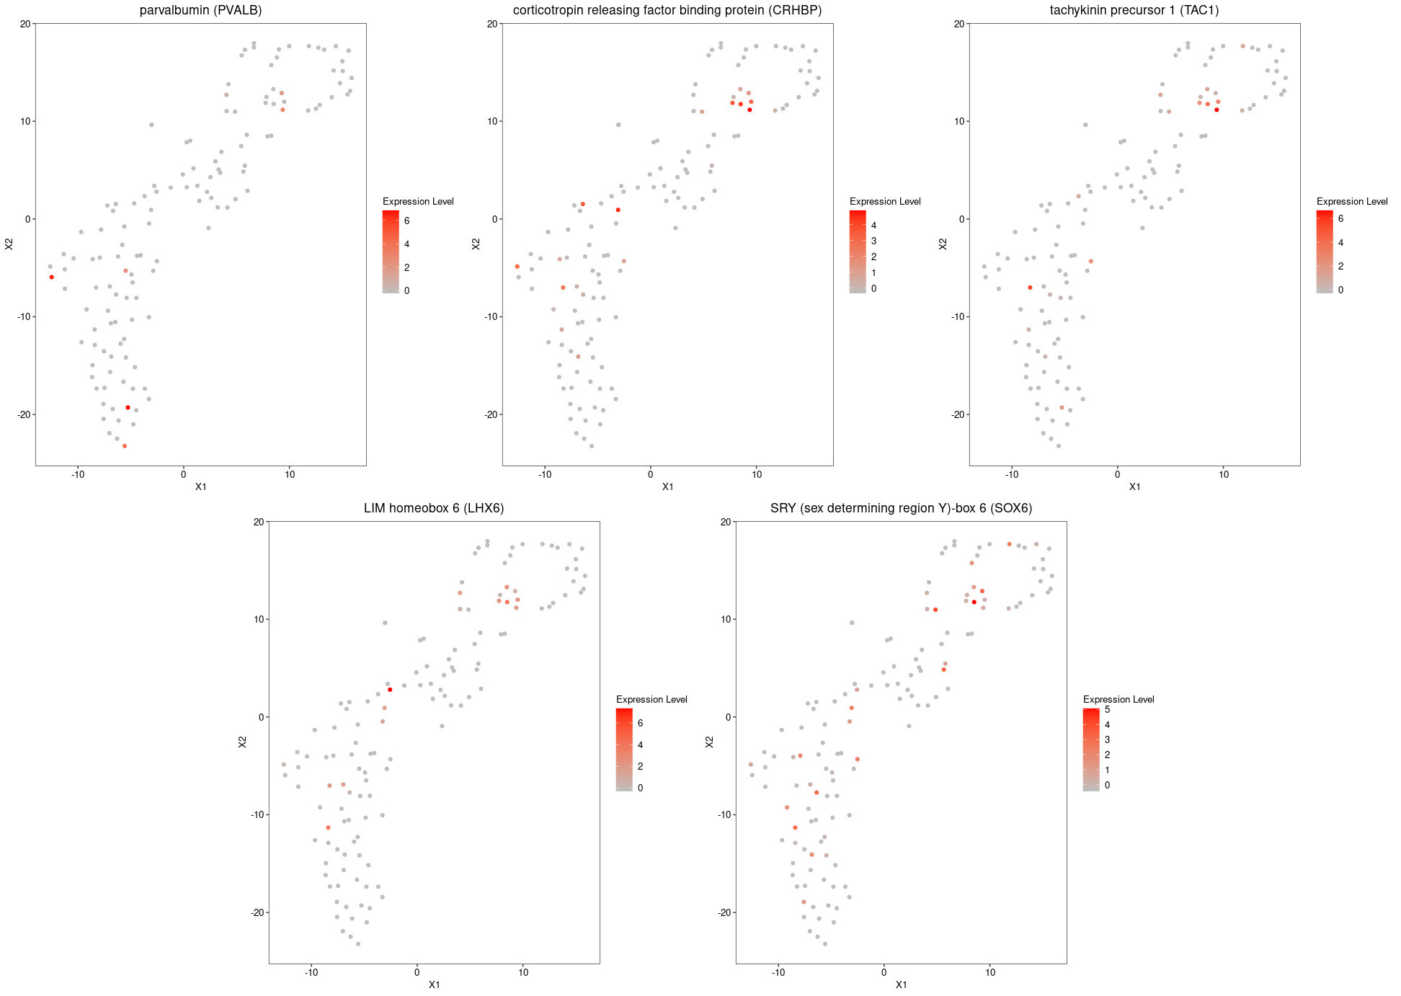
Enrichment genes expressing community of interneurons

Fig.x – Enrichment of genes TAC1, LHX6, CRHBP, SOX6 and PVALB expressing community of interneurons. Community five is enriched for the marker PVALB; tachykinin precursor 1 (TAC1) as well as the transcription factor LIM homeobox 6 (LHX6). LHX6 is closely related to the transcription factor, SRY (sex determining region Y)-box 6(SOX6).

