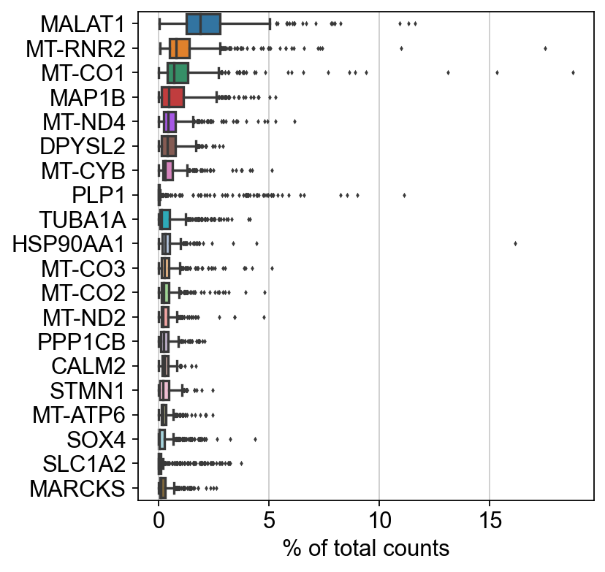

Figure X: Visualisation of the top 20 highest expressed genes with a set of boxplots. In this figure, the Y-axis shows the expression level of each gene in percent of total counts, while the X-axis ranks the genes from highest to lowest expression. Each boxplot reflects the expression value distribution for each gene across all cells in the dataset. The box reflects the expression values' interquartile range (IQR), with the horizontal line inside the box denoting the median expression value. The whiskers that extend from the box reflect the range of expression values that are within 1.5 times the IQR. Outliers are points that fall outside of this range and are represented as isolated dots.
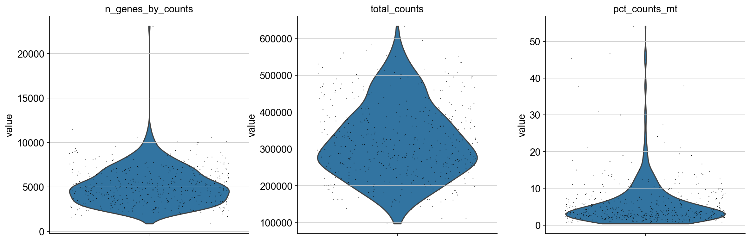

Figure X: Violin plot shows the distribution of single-cells gene expression. The multi-panel figure shows the each of the three violin plots side-by-side. Violin plots are used to visualize a summary of the distribution of numerical data. The violin plot on the left of the figure shows the number of genes expressed in each cell, the middle figure shows the total counts of RNA molecules detected in each cell and the right figure shows the percentage of counts of RNA molecules that are mitochondrial. The Y- axis of each shows the density or frequency of cells within each category. The width of each violin plot corresponds to the density of cells with that metric value. The violin's height represents the frequency of cells with the given expression value. The points across the plot indicate the individual cells' metric values.

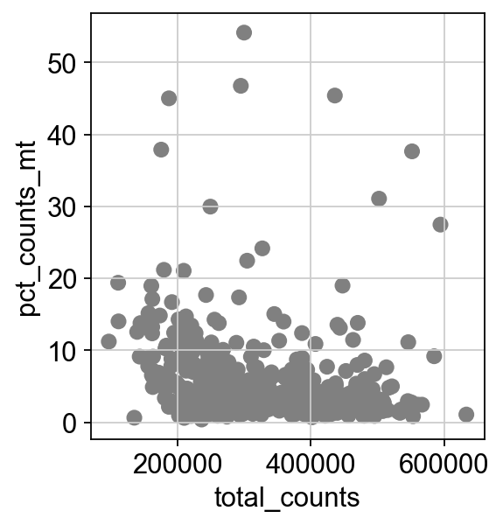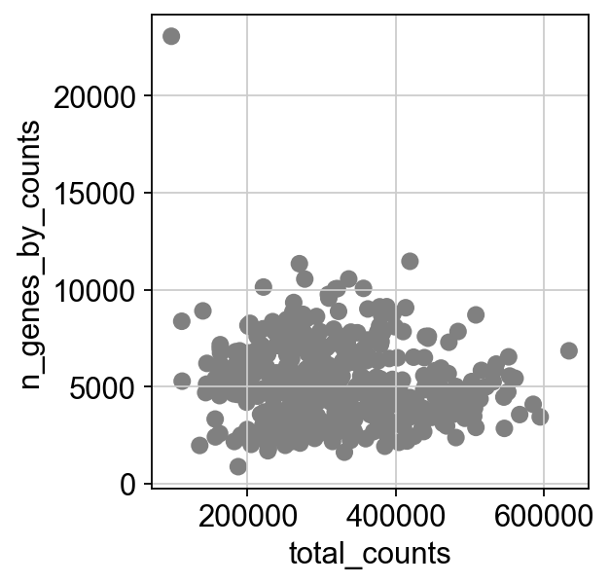

Figure X: Scatterplots showing the relationship between two variables in the single-cell RNA sequencing data. The scatterplot on the left shows the relationship between the total number of counts in each cell and the percentage of counts that come from mitochondrial genes. The X- axis represents the total number of counts. The Y- axis represents the percentage of counts that come from mitochondrial genes. The scatterplot on the right shows the relationship between the total number of counts in each cell and the number of genes expressed in each cell. This figure is useful for inspecting data quality and highlighting cells that should be filtered out due to low gene expression levels. The X- axis represents the total number of counts. The Y- axis represents the number of genes expressed. Each point on the scatterplot represents individual cells.

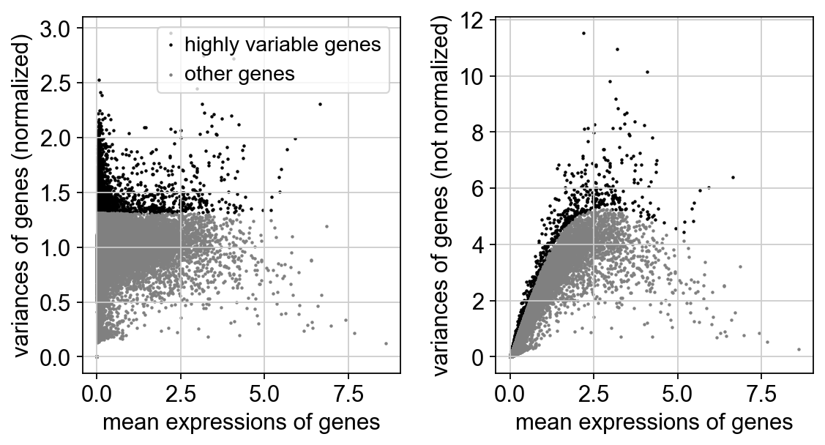

Figure X: The identification of highly variable genes and their distribution. After selecting the top 4000 genes with less than 10% mitochondrial count. The figure shows a plot with a normalised and not normalised gene expression dispersion (variance) plotted against mean expression. The highly variable genes are highlighted as black dots.

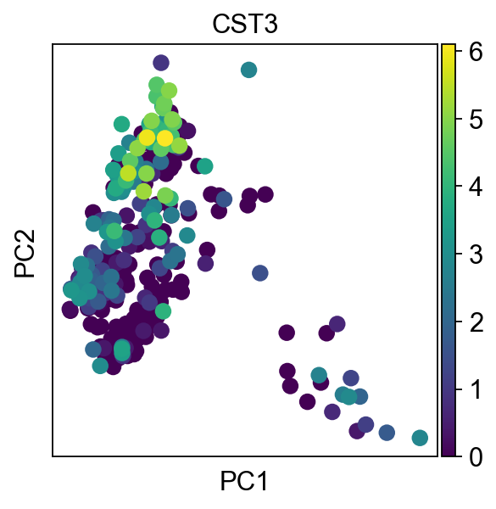

Figure X: Results of PCA on highly variable genes shown by a scatterplot. In the figure, each point in the scatter plot represents a cell with the colour of the data points representing the expression level of the gene Cystatin C (CST3) in that cell. The scale explains the expression levels of each ranging from 0 to 6, with the highest expression level represented by the colour yellow and the lowest the colour purple.

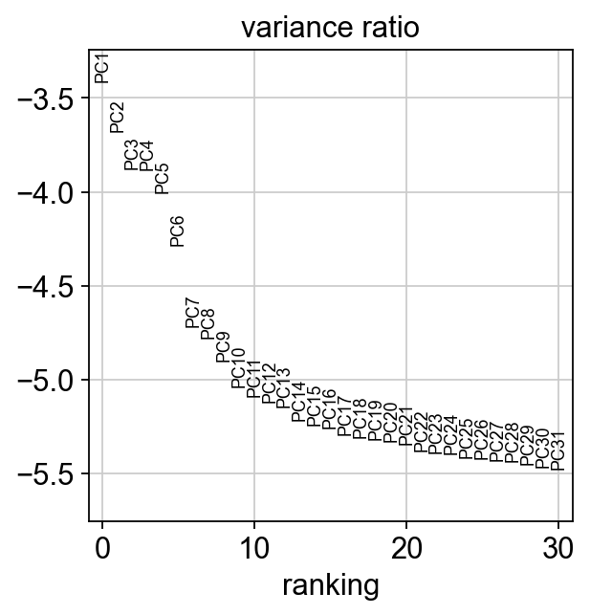

Figure X: The total variance in the data explained by each principal component in PCA. In this figure, the x-axis represents the number of principal components, whilst the y-axis represents the proportion of variance explained by each PC on a logarithmic scale. PC1, PC2, PC3, PC4, etc. refer to the principal components 1, 2, 3, 4, etc., respectively. Principal components are usually ordered from left to right in terms of their contribution to the total variance in the data. PC1 is the leftmost component and has the highest variance, where PC31 explains the least variance.

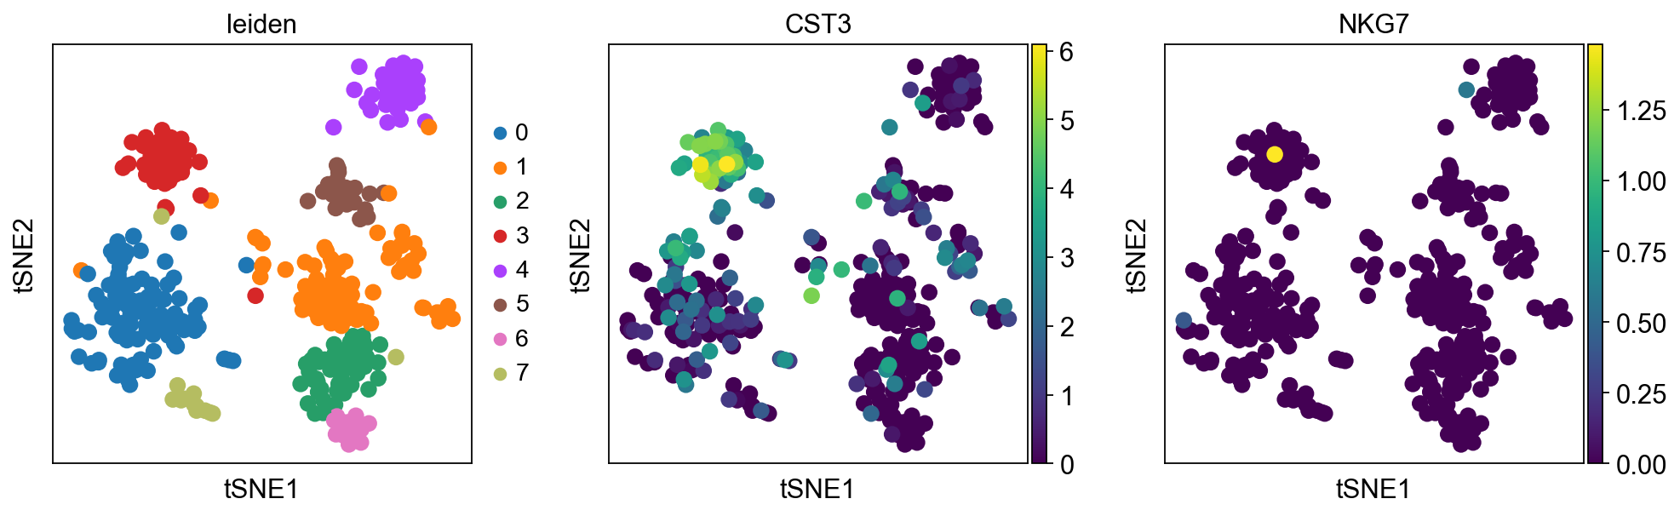

Figure X: t-SNE dimensionality reduction plot. In this figure, the t-SNE dimensionality reduction plot shows the distribution of cells in the reduced space based on the expression levels of the top 40 principal components. Each dot represents a cell. The dots are coloured according to the expression level of the genes CST3 (in the middle) and NKG7 (on the right). The scale explains the expression levels of each ranging from 0 to 6 and 0 to 1.25, with the highest expression level represented by the colour yellow and the lowest by the colour purple. The plot on the right shows a t-SNA plot coloured by the Leiden clustering results. The Leiden algorithm was used to cluster cells based on the similarity in their gene expression profiles. Each point in the figure on the right represents a cell, and their colours indicate its cluster assignment and 8 clusters were identified.

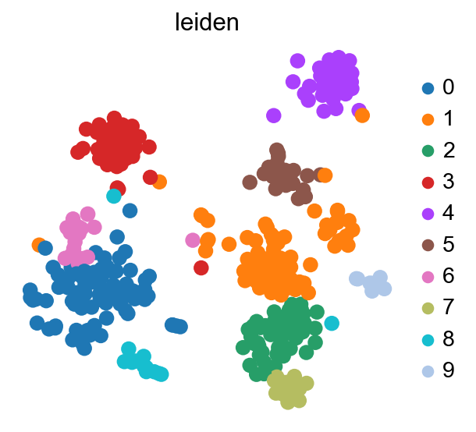

Figure X: Clustering results obtained from the Leiden algorithm. This figure is the result of performing clustering using the Leiden algorithm with a resolution value of 1.3. The clustering results are visualised in a two-dimensional t-SNE plot. Data points are represented as a dot, coloured according to the cluster assignment. 10 clusters were identified in total.

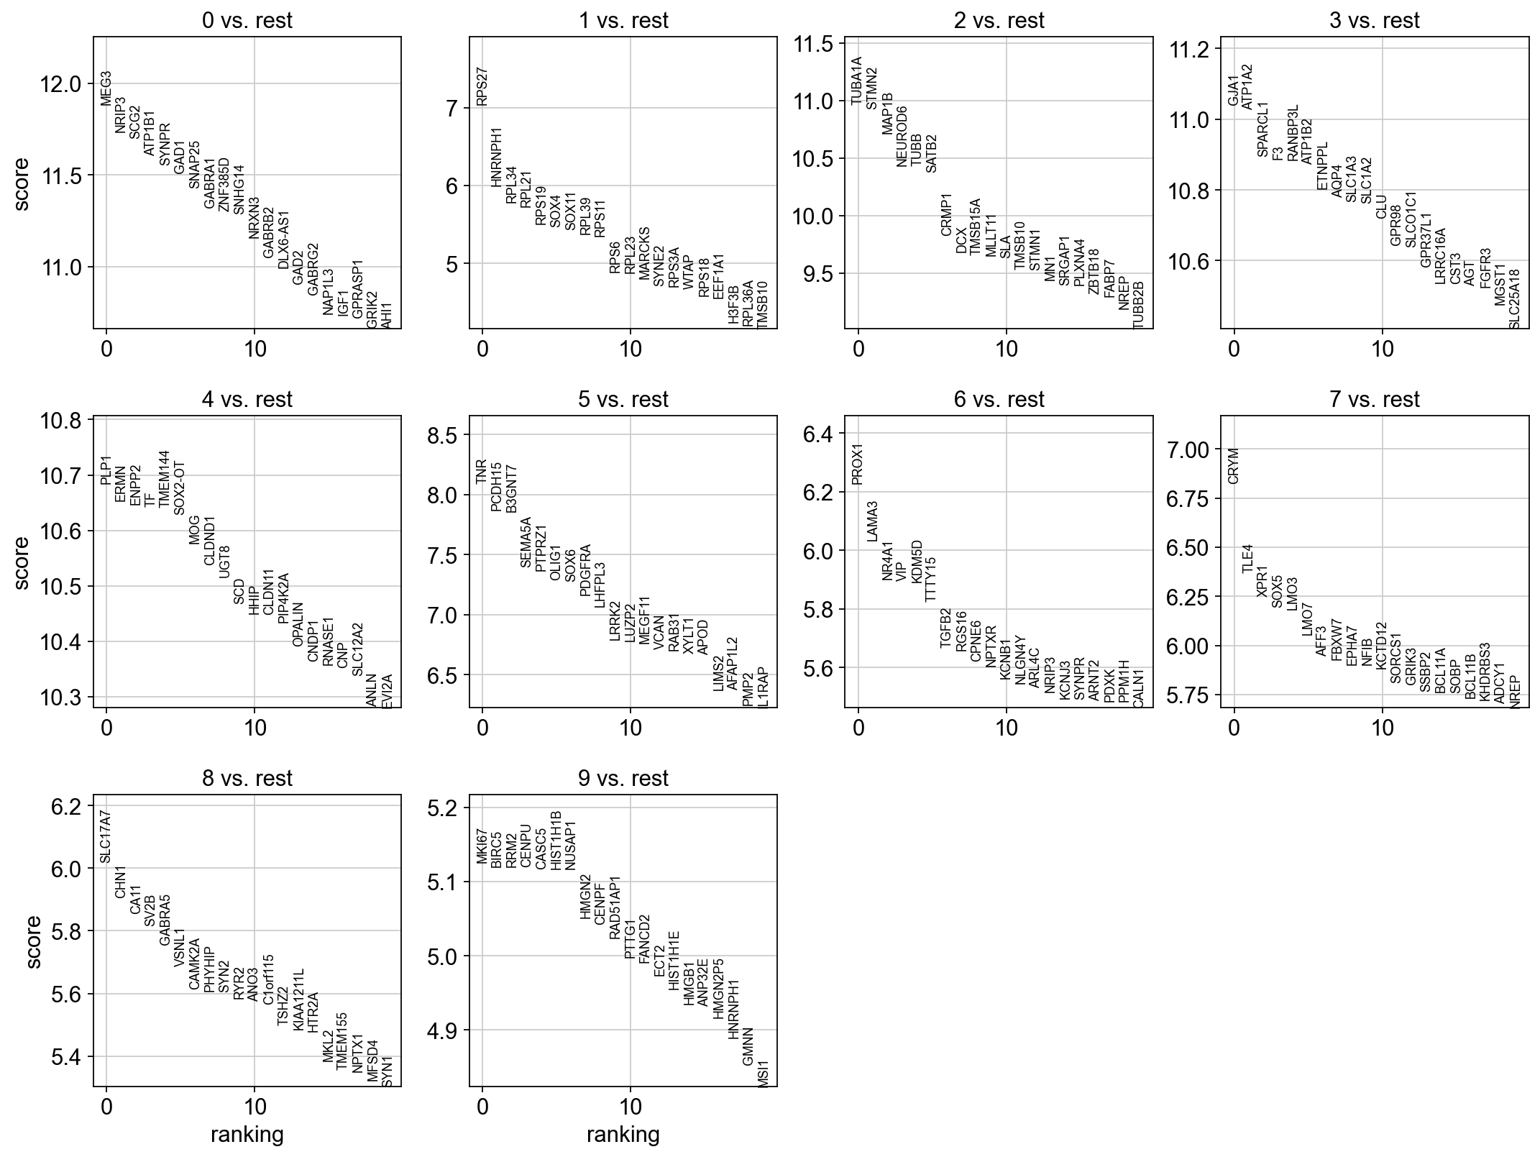
Figure X: The top 20 genes per cluster. A Wilcoxon rank-sum test was done to identify differentially expressed genes between the cluster. The plots show the top 20 differentially expressed genes between the clusters. The score calculated by the Wilcoxon rank-sum test to identify genes that are differentially expressed between different groups of cells are plotted against the Y- axis. Larger scores indicating more significant differences.
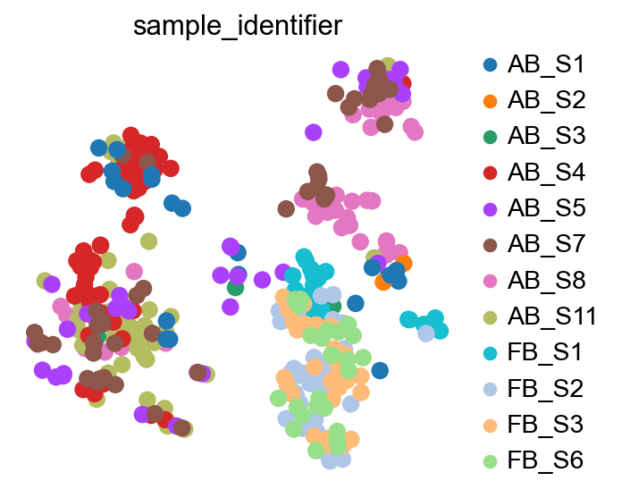

Figure X: Sample identification based on t-SNE plot. In this figure, each dot represents a cell and the color corresponds to the sample in the count matrix it was taken from. The plot was generated using the Scanpy Python library.
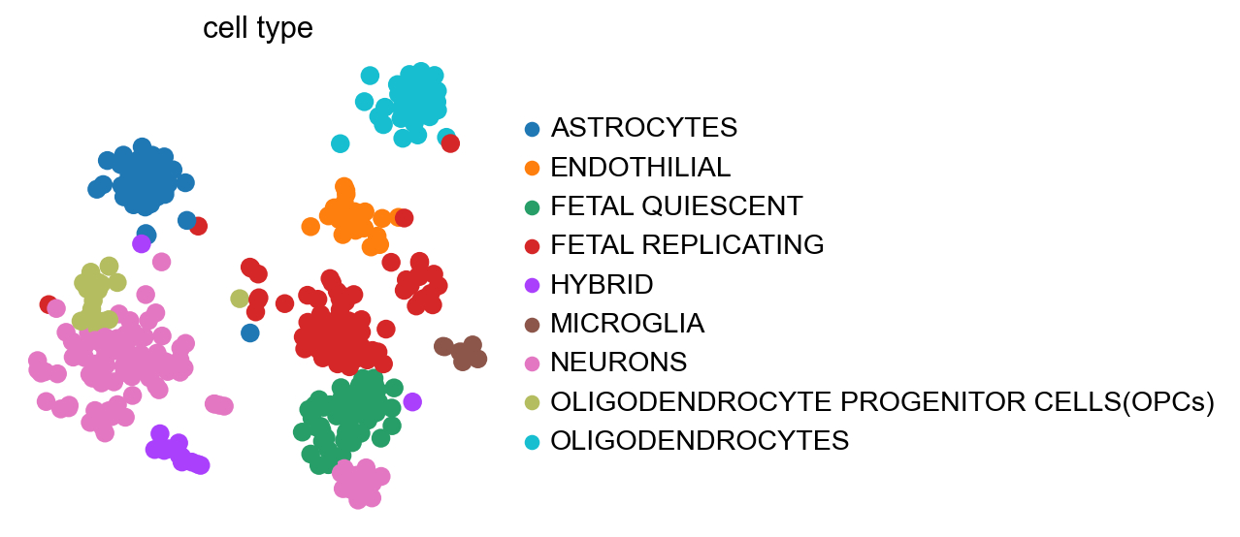

Figure X: t-SNE plot of sc-RNA seq data. In this figure, the plot shows the t-SNE results of sc-RNA seq analysis. Each dot represents a single cell coloured according to its assigned cell type, which is indicated by the key to the right of the plot

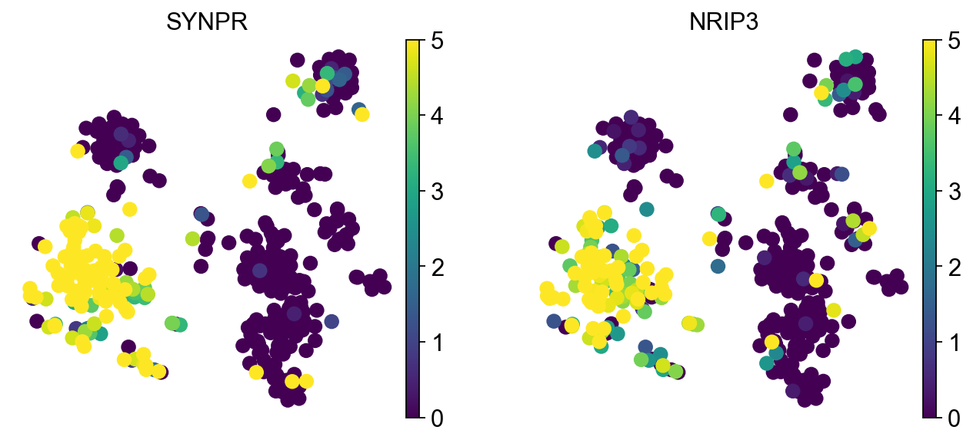
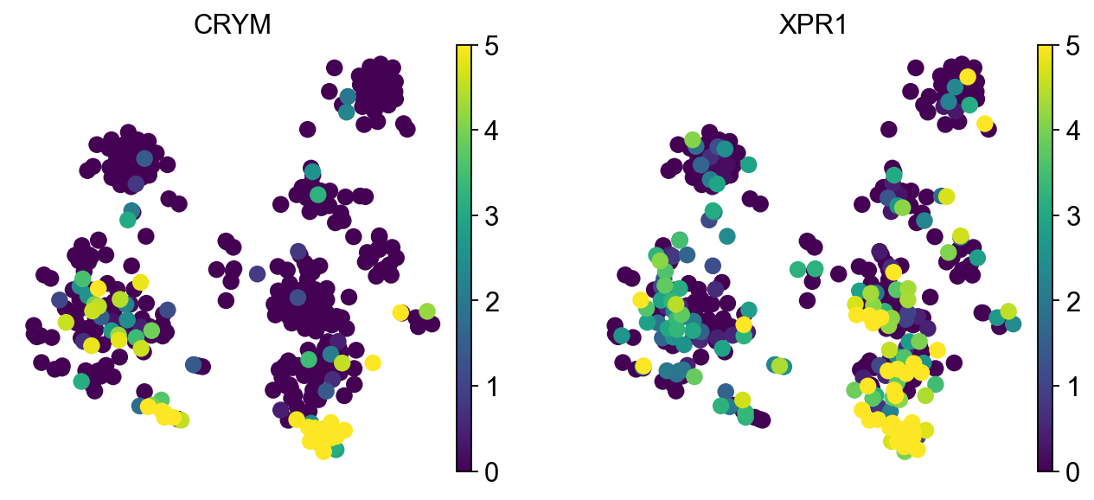
Figure X: t-SNE plot showing the expression of 16 genes. In the figure, each point in the scatter plot represents a cell with the colour of the data points representing the expression level of the genes CRYM (crystallin mu), XPR1 (xenotropic and polytropic retrovirus receptor 1), SV2B (synaptic vesicle glycoprotein 2B), SLC17A7 (solute carrier family 17 member 7), ATP1A2 (ATPase Na+/K+ transporting subunit alpha 2), GJA1 ( gap junction protein alpha 1), PCDH15 (protocadherin 15), TNR (tenascin R), RRM2 (ribonucleotide reductase regulatory subunit M2), BIRC5 (baculoviral IAP repeat containing 5), PLP1 (proteolipid protein 1), ERMN (ermin, ERM-like protein), NEUROD6 (neuronal differentiation 6) and SOX11 (SRY-box transcription factor 11). The vmax parameter is set to 5 and the colour scale represents the expression level, with the highest expression level represented by the colour yellow and the lowest the colour purple.

