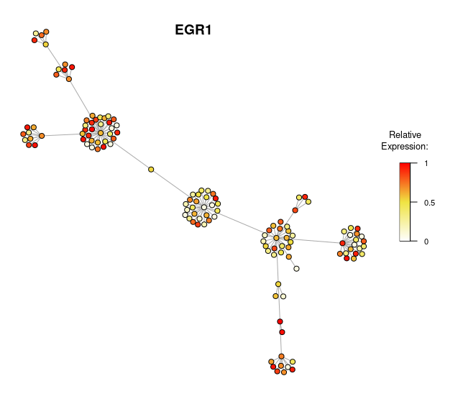
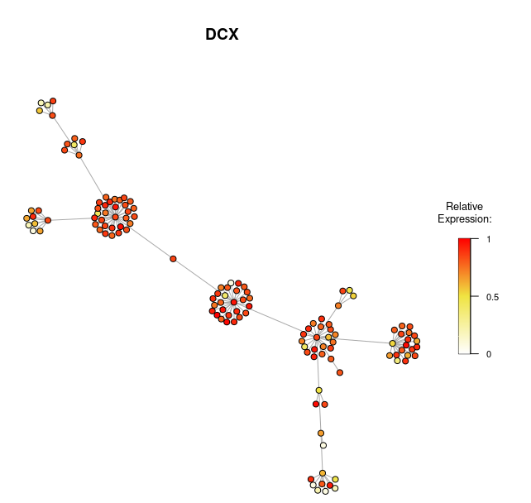
[A]
[B]
[C]
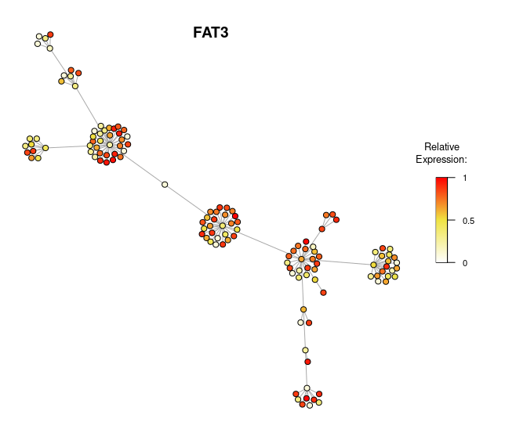

Figure X: Expression levels of DCX, FAT3 and ERG1 in fetal cells. After generating a minimum spanning tree from the pairwise distances between the fetal cells and [A] looking at the longest path across the tree, two genes identified with a high correlation coefficient being [A] doublecortin, [B] FAT atypical cadherin 3 (FAT3) and [C] early growth response 1 (EGR1). The key representing relative expression levels on the right correlates with the colour of the nodes. Each node is coloured according to its expression level relative to the other nodes in the plot. Nodes with a higher expression level are coloured red or orange, and those with medium expression levels are coloured yellow, and those with low expression levels are coloured white.

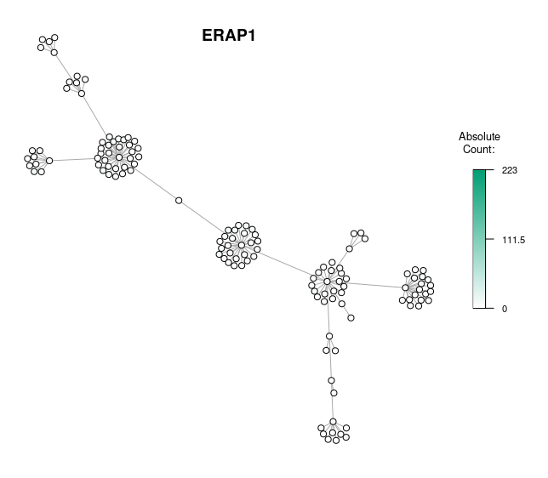

Figure X: Minimum spanning tree reflecting ERAP1’s expression levels. In this figure, the minimum spanning tree nodes are coloured according to their expression levels of the gene in fetal cells. The fetal cells were shown to lack the expression ERAP1, one of the 14 genes associated with MHCI. The absolute count represents the number of reads of the ERAP1 transcripts in the samples. The colour scale indicates and reflects the absolute count of ERAP1.
[B]
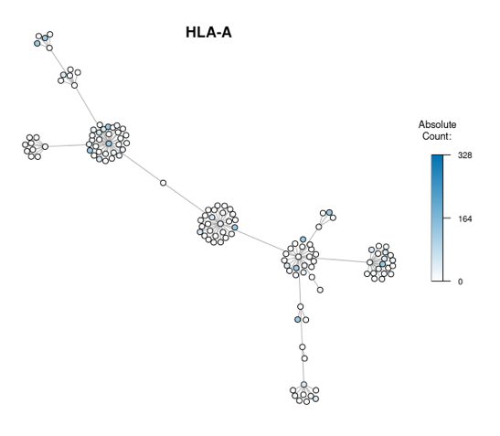
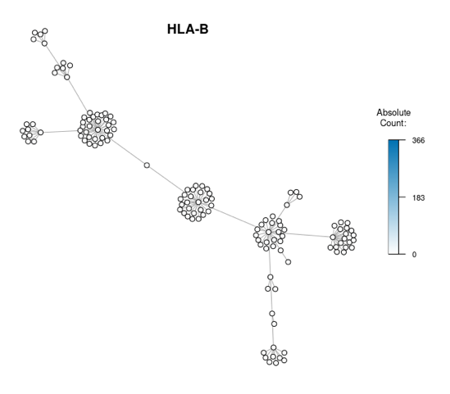
[C]
[A]
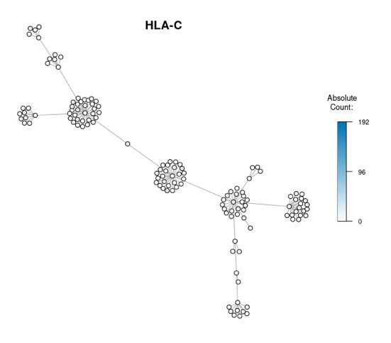
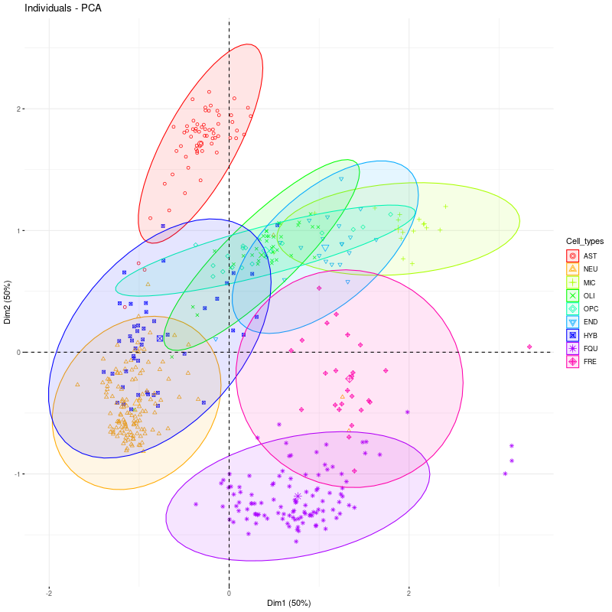

Figure X: Minimum spanning trees showing the fetal cells population’s relative expression of HLA-A, -B, and -C. The fetal cell populations showed a lack of expression of [A]HLA-A, [B] -B and [C] -C. The absolute count represents the number of reads of the genes in the samples. The colour scale indicates and reflects the absolute count, all of which showed none.

Figure X: Scatterplot showing the results of the PCA analysis. Multidimensional scaling (MDS) and Principal Component Analysis (PCA) are performed on the distance matrix. AST, NEU, MIC, OLI, OPC, END, HYB, FQU, and FRE are abbreviations for different cell types and are colour co-ordinated accordingly. They stand for astrocytes, neurons, microglia, oligodendrocytes, oligodendrocyte progenitor cells, endothelial cells, hybrid cells, fetal quiescent cells, and adult quiescent cells, respectively. In the plot, each dot represents a cell, and the colour of the dot indicates its cell type. Each axis indicates how much variation of each of the dataset is represented by each of the dimensions. Together, the two dimensions explain 50% of the total variation in the dataset. The astrocyte group indicates a unique gene expression pattern compared to the others, as it is located slightly away from the rest of the group. In the PCA space, AST is not seen to overlap the centroid point for the group.

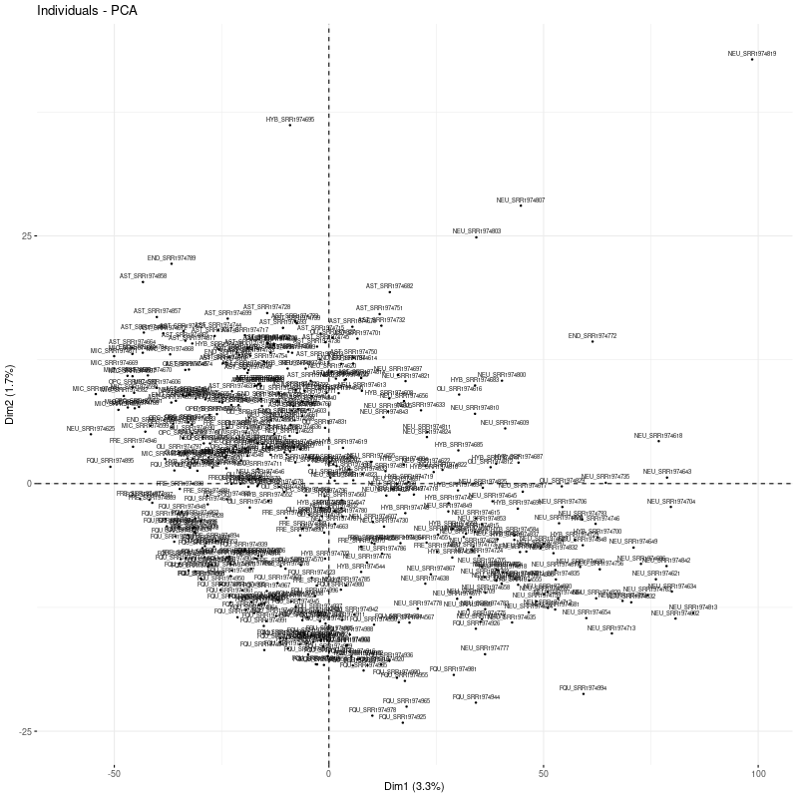
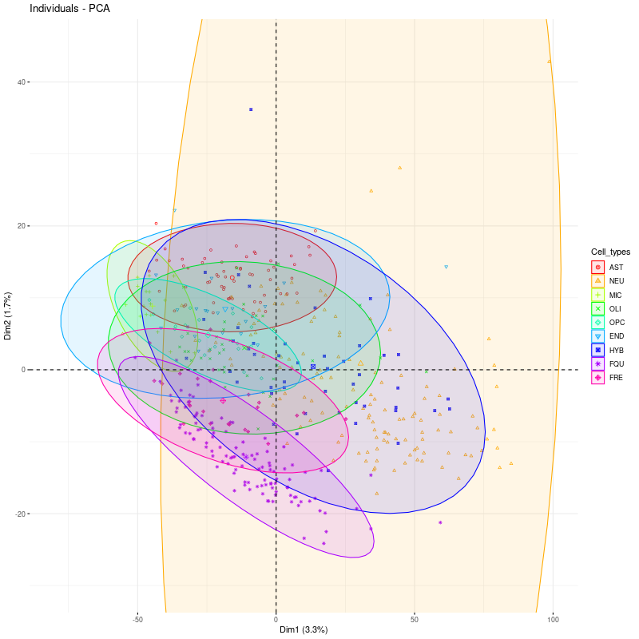
Figure X: PCA analysis plot of gene expression profiles from different cell types in the dataset. The X- and Y- axes represent the two principal components obtained through PCA. Dimension 1 on the X-axis accounts for 3.3% of the total variance in the data, whereas dimension 2 on the Y-axis accounts for 1.7% of the total variance in the data. Each axis indicates how much variation of each of the datasets is represented by each of the dimensions. Each of the different cell types is seen to overlap the centroid. The data was filtered to filter out genes with low expression in fewer than 5 cells. Each point represents an individual cell, coloured according to its cell type (AST: astrocyte, NEU: neuron, MIC: microglia, OLI: oligodendrocyte, OPC: oligodendrocyte precursor cell, END: endothelial cell, HYB: hybrid cell, FQU: fibroblast/quiescent cell, and FRE: fibroblast/replicating cell) as shown on the cell type key. Both plots show the same results on gene expression data, they differ in the way the data is presented with the right plot labelling the plot with its cell type rather than colour coordinating it. The plots show the distribution of the cells in the first two principal components.

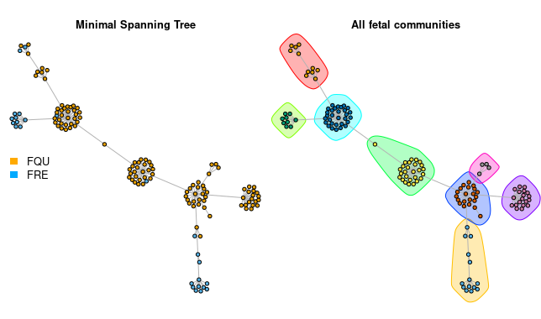

Figure X: Minimum spanning tree for all fetal cells. The left of the figure shows the minimum spanning trees generated for all the fetal cells. All fetal communities were identified in the multiple spanning trees based on ‘edge between-ness’. The `edge between-ness` function measures the number of shortest paths that pass a given edge, allowing the identification of edges that are likely to connect different groups of nodes. The different colours correspond to the different fetal communities that were identified using this algorithm.

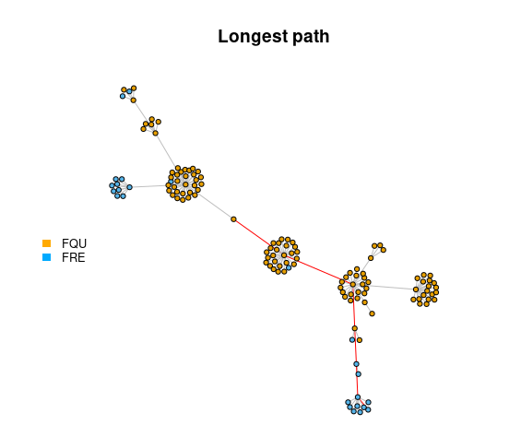

Figure X: Minimum spanning tree for all fetal cells with calculation of the longest path.

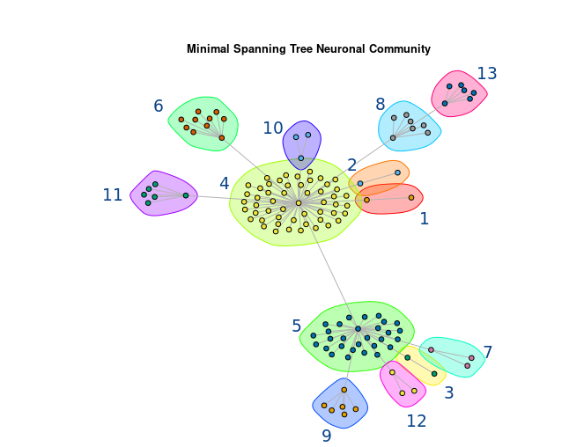

Figure X: Minimum spanning tree for all neuronal cells. Colours indicates the different neuronal communities identified by the minimum-spanning tree.

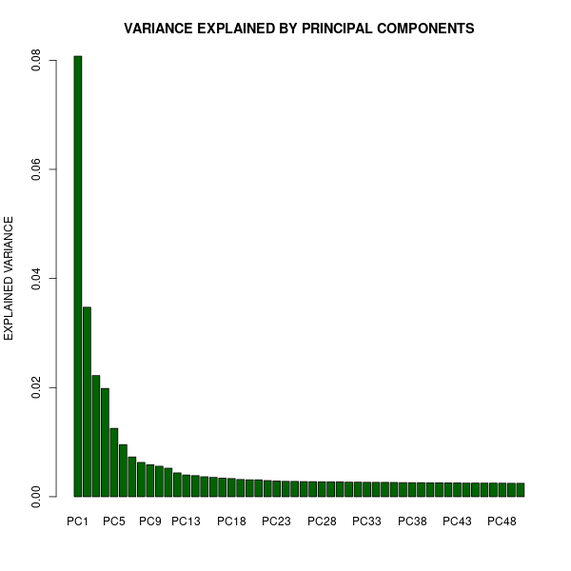

Figure X: Bar chart showing the explained variance of each principal component. After calculating the principal components and the explained variance of each principal component. This bar chart shows the variance of the first 50 principal components. The calculation identifies the optimal number of principal components to use for initial dimensional reduction for the t-SNE analysis. It is important to identify the correct number of principal components as not enough may see the loss of important data and too many may lead to overfitting. This bar chart helps identify the correct number of principle components needed for the analysis.

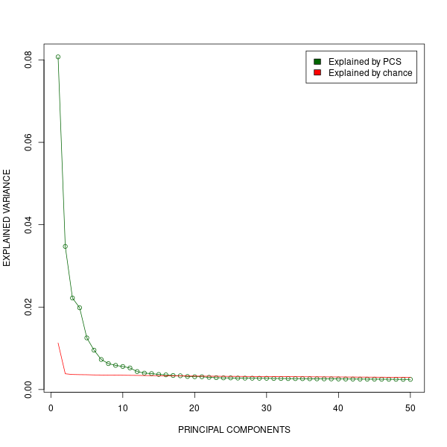

Figure X: Amount of variance explained by each principal component of a dataset using bootstrap analysis. This plot has variance explained by the first 50 principal components. The green line connects the points that represent the variance explained by each principal component, while the red line represents the average explained variance by chance obtained from bootstrapping. 5 permutations of the data were done to calculate the distribution of the variance explained by chance.
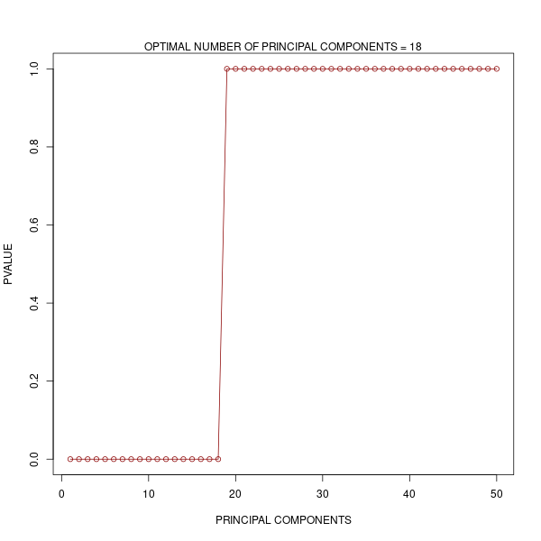

Figure X: Bootstrapping to determine the optimal number of principal components to use for dimensional reduction. The p-values of the principal components (Y-axis) from the bootstrapped data are plotted against the principal components (X-axis). The optimal number of principal components is based on a p-value with a set threshold of 0.05. The optimal number of components is identified to be 18.

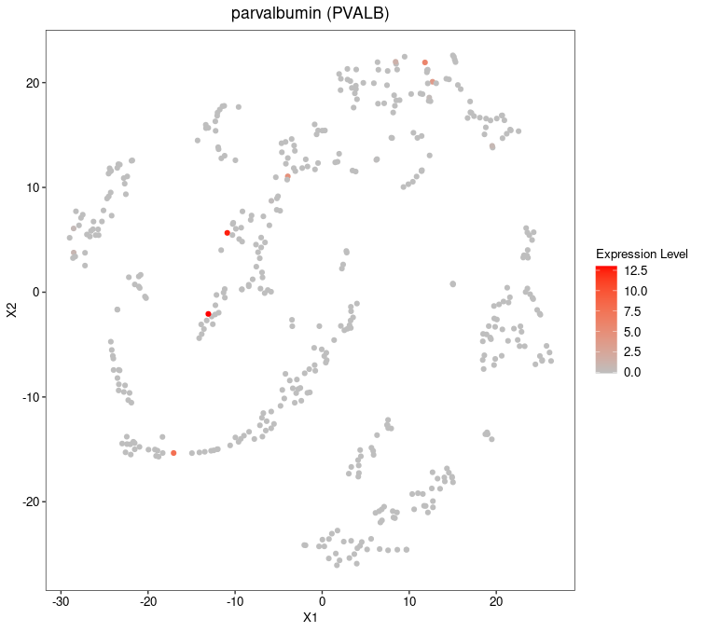

Figure X: t-SNE plot showing the expression levels of PVALB. The colour scale ranges from 0 to 12.5, with the highest expression level represented by the colour red and the lowest the colour grey. X1 and X2 on the X- and Y- axes of this t-SNE plot refer to the two dimensions of the reduced-dimensional space.
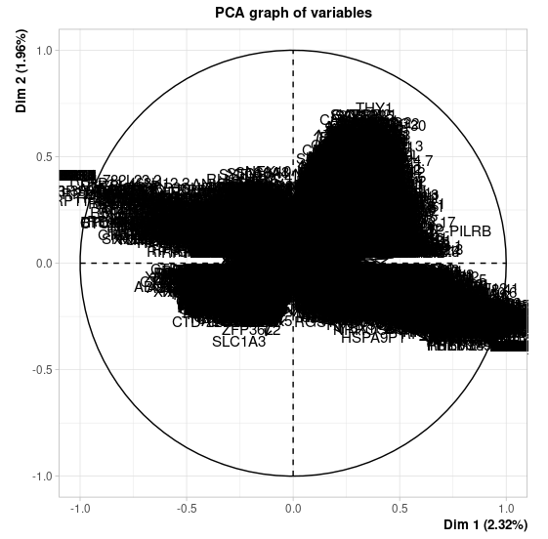

Figure X: PCA plot of variables. The plot shows the relationships between all variables. Dim1 on the X-axis represents principal component 1 and Dim2 on the Y-axis represents principal component 2 with their respective percentages. The graph of variables is very clouded with each cell layered on-top of each other.

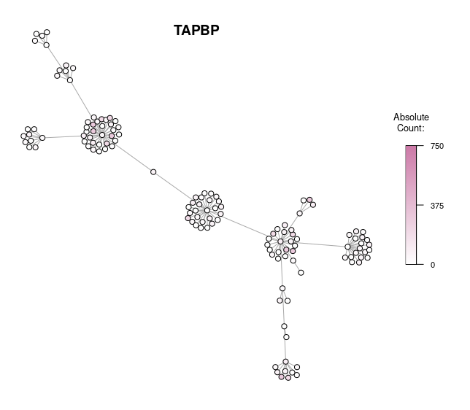

Figure X: Minimum spanning tree of TAPBP expression level in MCHI-associated genes. In this figure, is the expression level of TAPBP. Using the bar on the right, the colour gradient is shown to range from white to dark pink reflecting the expression levels, with dark pink being a high expression, the maximum count for TAPBP, and white being low expression levels. As seen in the figure, a few MHCI-associated genes have higher expression levels of TAPBP.

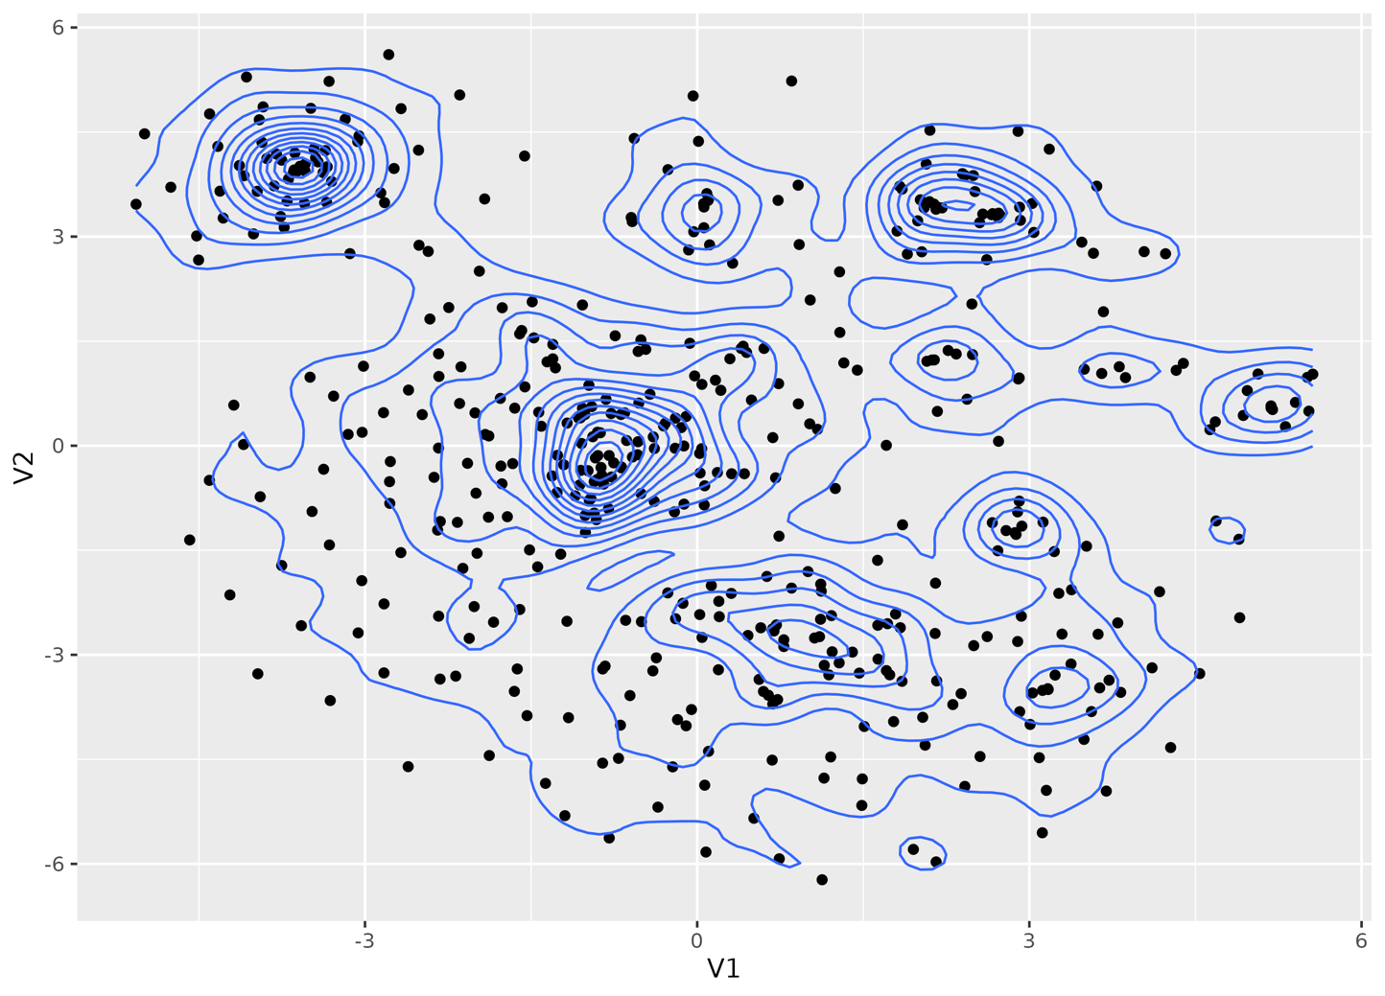

Figure X: Geometric density on the t-SNE results. A two-dimensional distribution t-SNE plot is shown in this figure, whereby the geometric density is overlaid on the plot of gene expression data using an unbiased error model. Each plot represents a gene and its expression profile, providing insight into the distribution of data points in the two-dimensional space. This plot highlights areas with higher density and potential clustering patterns. VI and V2 on the X- and Y-axes represent two-dimensional coordinates of each data point in the plot.

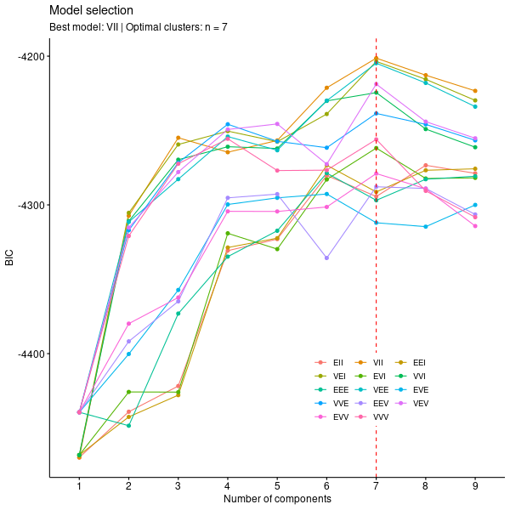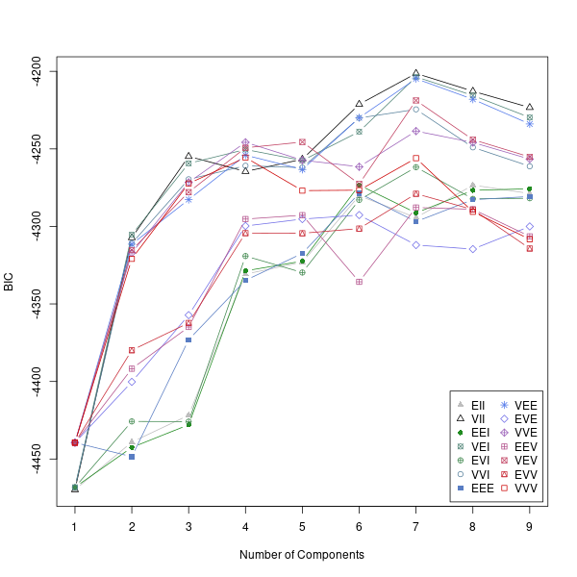

Figure X: BIC classification identifies an optimal number of 7 clusters with the best model being VII. The plots visually show the optimal number of clusters for the data based on the BIC score. The x-axis represents the number of components in the model, and the y-axis represents the BIC score. As the BIC value decrease, the number of components increase. Each coloured line corresponds to a different model type. The letter combinations E (equal variance), V(variable variance), and I (independence) specify a model type. EII corresponds to a spherical model with equal volume and equal shape, VII corresponds to a spherical model with variable volume and equal shape, EEI corresponds to a diagonal model with equal volume and equal shape, VEI corresponds to a diagonal model with variable volume and equal shape, EVI corresponds to a diagonal model with equal volume and variable shape, VVI corresponds to a diagonal model with variable volume and variable shape, EEE corresponds to an ellipsoidal model with equal volume and equal shape, EEV corresponds to an ellipsoidal model with equal volume and equal shape, VEV corresponds to an ellipsoidal model with variable volume and equal shape and VVV corresponds to an ellipsoidal model with variable volume and variable shape (Darmanis et al., 2015). The models are compared based on their BIC values, with lower BIC values indicating a better model. The best model has been identified to be VII. The vertical red dotted line indicates the optimal number of components based on the BIC criterion.
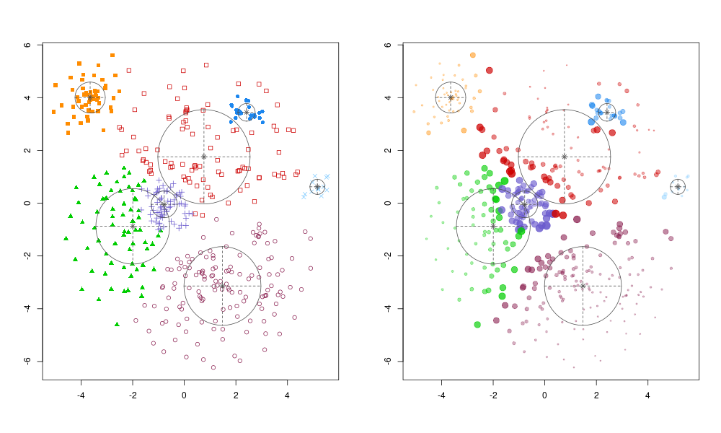

Figure X: The Mclust algorithm was run with the best model, Mclust VII as determined by BIC. Each of the points on the plot represents a cell and its colour represents the cluster it belongs to The X- and Y- axes represents the first and second principal components of the t-SNE results. The image on the left shows the classification plot obtained after clustering the t-SNE results using the Mclust algorithm showing which cluster has aligned well with the axes of the plot. The plot on the right of the figure shows the uncertainty plot to highlighting the parts of the data that is poorly aligned.
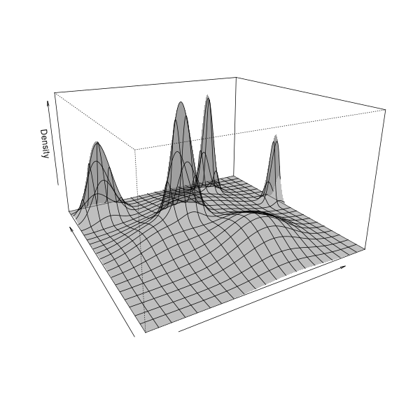

Figure X: Density perspective plot of the t-SNE results for the unbiased model. The figure is visualisation of the density distribution of the clusters of data points in a three-dimensional space. The z-axis represents the density of the data points in that region, whilst the X- and Y- axes are the two dimensions of the t-SNE space. Regions of high and low density are highlighted in this plot.
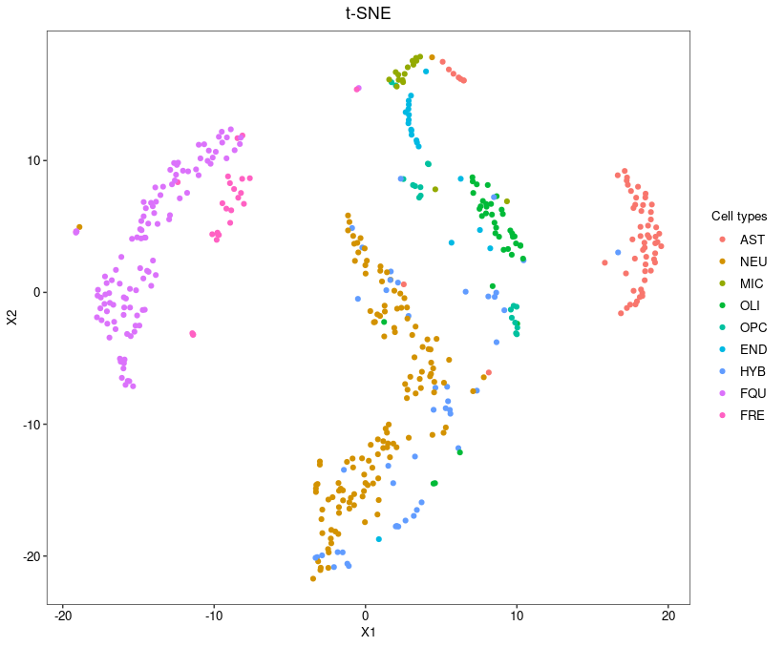

Figure X: t-SNE plot of single-cell RNA-seq data. t-SNE was performed to reduce dimensions. Each dot represents an individual cell which is colour coded according to its cell type which is shown on the key on the right-hand side of the figure.

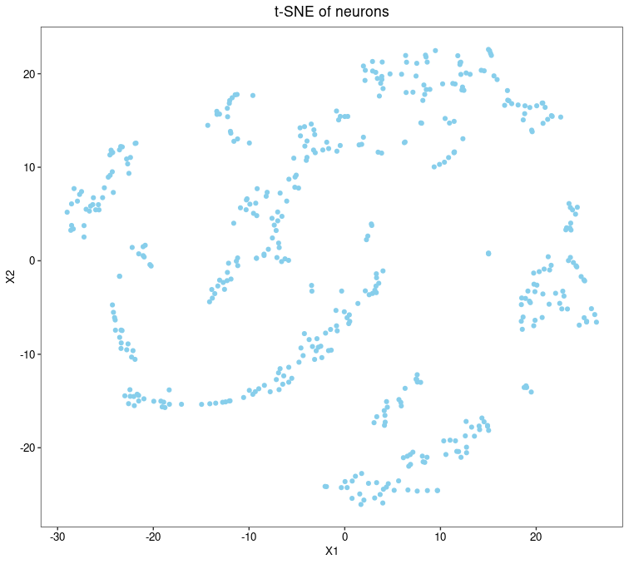

Figure X: Gene expression across the neurones, visualized by t-SNE. This figure displays a two-dimensional representation of high-dimensional single-cell gene expression data, with each point representing a single cell.

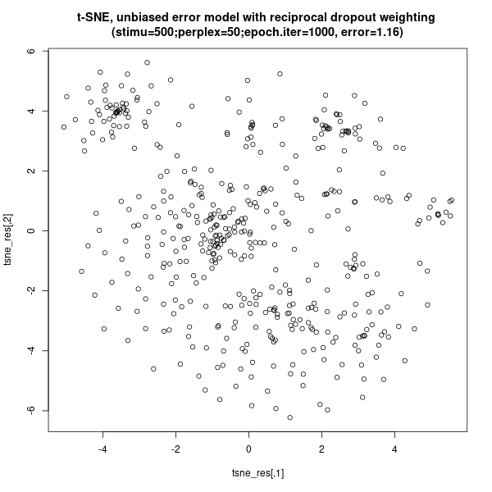

Figure X: Two-dimensional t-SNE plot. This figure shows the distribution of data points in a two-dimensional scatterplot. This dataset was created using an unbiased error model with reciprocal dropout weighting. The x and y-axes represent the two dimensions obtained from the t-SNE algorithm. The data was generated with a perplexity of 80 giving a relatively greater emphasis on global structure, with the t-SNE algorithm iterating over the dataset 1000 times. Each point represents a single observation with the density of the points increasing where there are more observations.

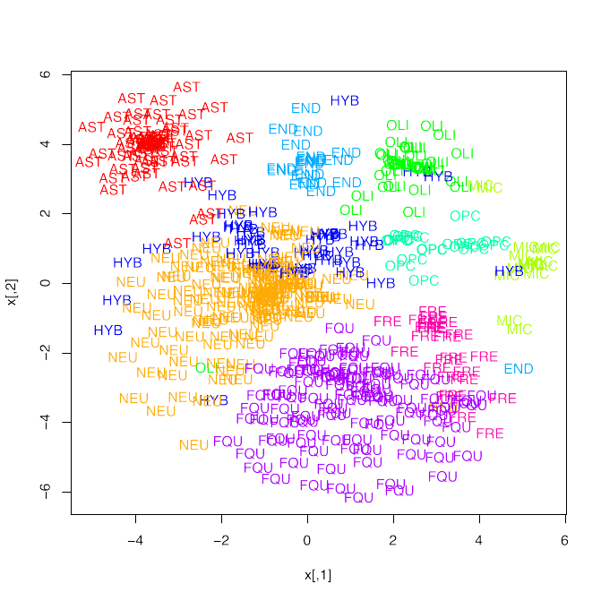

Figure X: t-SNE plot showing unbiased clustering of data points based on reciprocal dropout weighting. Each point in the figure represents the data point. Clustering was performed using an error model with reciprocal dropout weighting and a perplexity value of 80. The plots are the relative distances of data points, with more similar data points clustered together. The map is coloured according to the distinct groupings identified by the clustering study, with darker regions signifying higher densities.
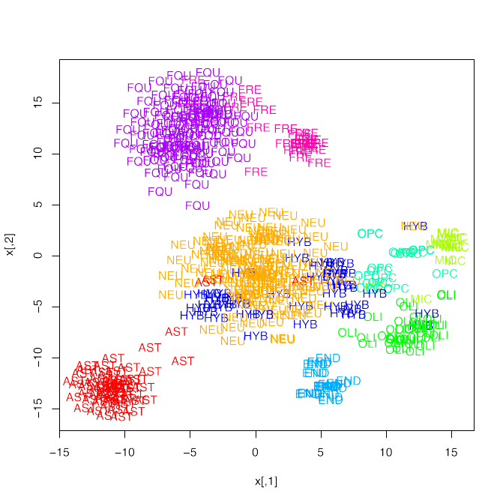

Figure X: t-SNE plot showing biased clustering from biased error model. The figure was created by applying t-SNE to biased gene expression profiles that only contained a selection of genes with high variance. Each data point is represented as a point on the two-dimensional t-SNE space in the figure. Points with similarities are grouped. The colour of the plot is determined by the cluster assignments produced using a model-based clustering approach.

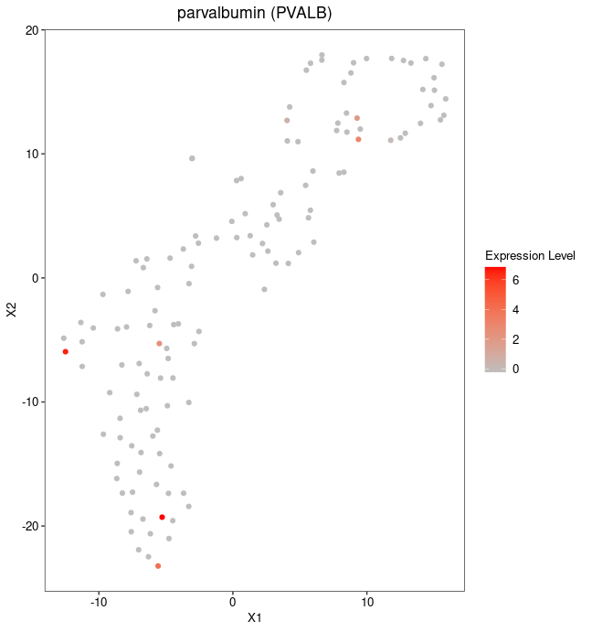
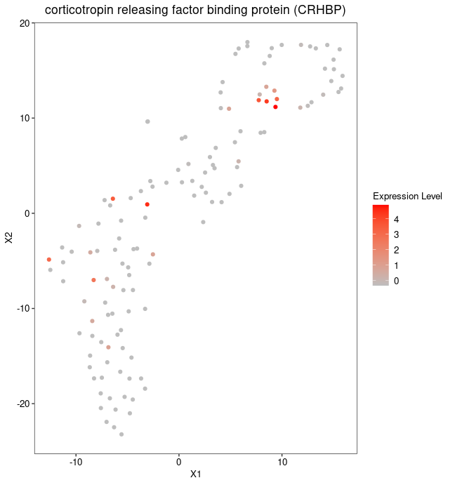
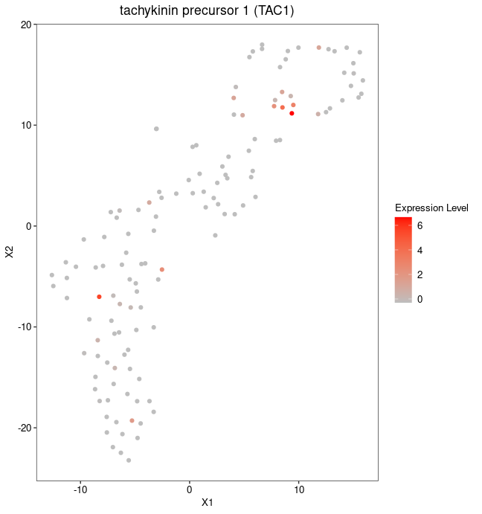
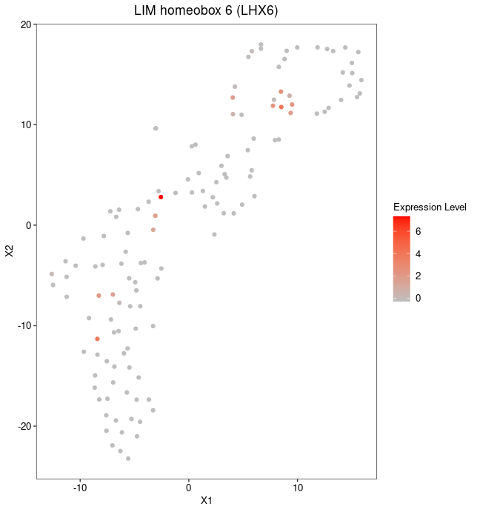
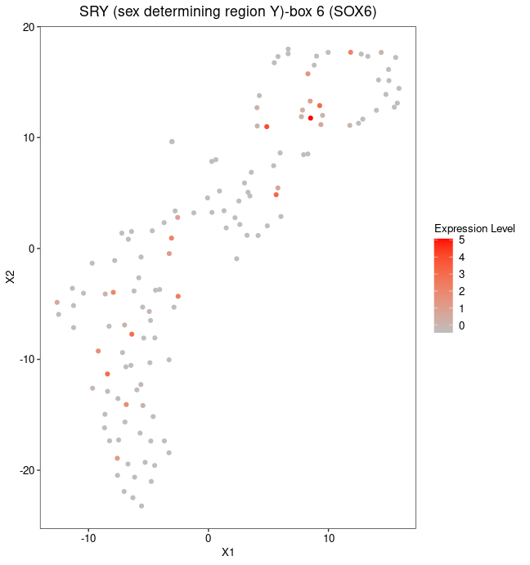

Figure X: t-SNE plot showing the expression levels of genes in in GABAergic neurons. The genes that have been selected for this figure are: "PVALB", "CRHBP", "TAC1", "LHX6", and "SOX6". The colour scale ranges from 0 to 6, with the highest expression level represented by the colour red and the lowest the colour grey. X1 and X2 on the X- and Y- axes of this t-SNE plot refer to the two dimensions of the reduced-dimensional space.

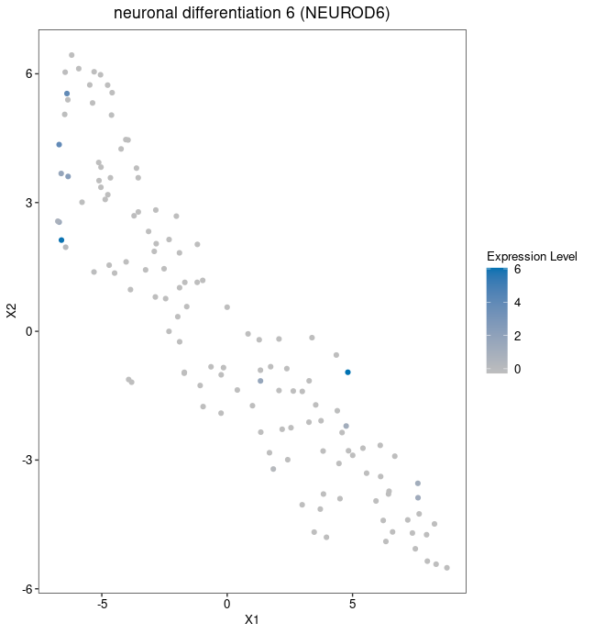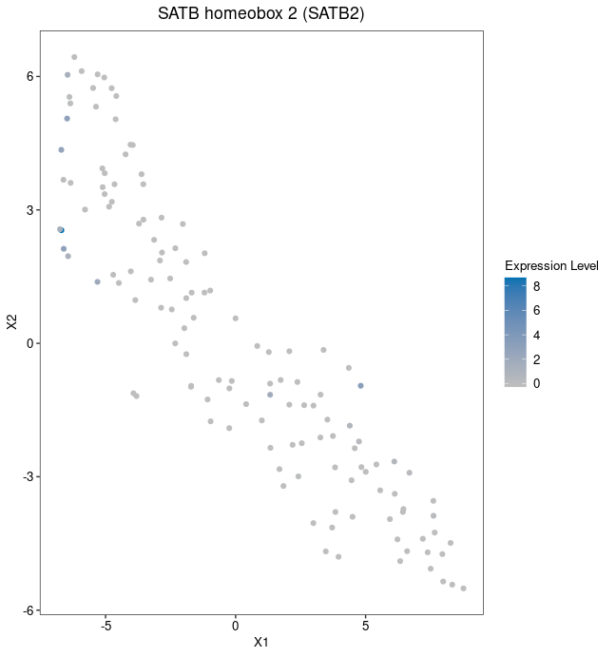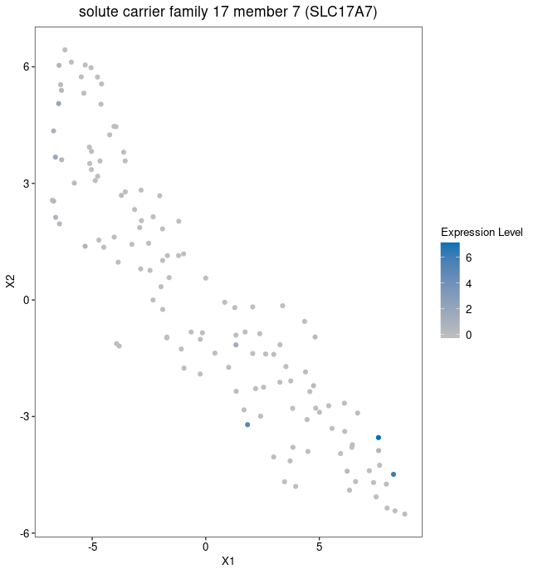

Figure X: t-SNE plot showing the expression levels of genes in distinct populations of excitatory communities. SLC17A7, NEUROD6, and SATB2 are the genes that have been selected for this figure, all of which are markers for excitatory neurons. Cells are coloured according to the expression levels of the genes NEUROD6, SATB2, and SLC17A7. The colour scale ranges from 0 to 6, with the highest expression level represented by the colour blue and the lowest the colour grey. X1 and X2 on the X- and Y- axes of this t-SNE plot refer to the two dimensions of the reduced-dimensional space.
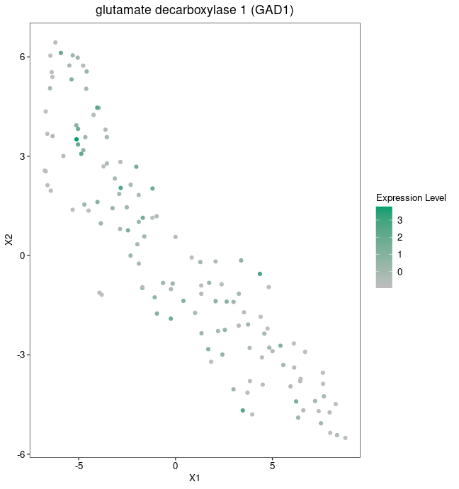
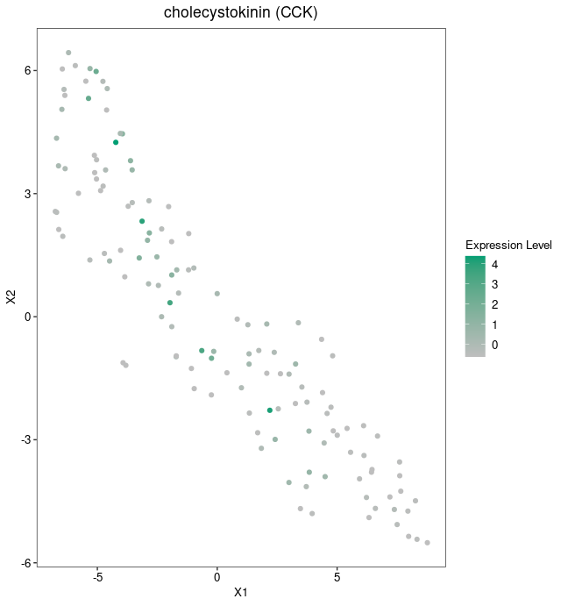
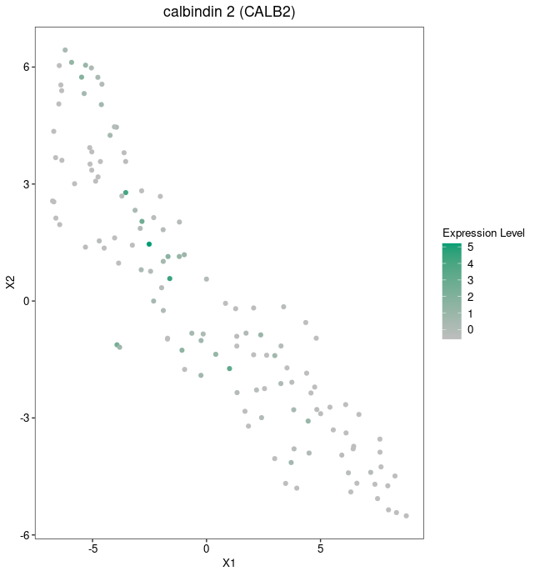

Figure X: t-SNE plot showing the expression levels of genes in distinct populations of cells. On the plot, cells are coloured according to the expression levels of three genes: GAD1, CCK, and CALB2, all of which are markers for inhibitory neurons. The colour scale explains the expression levels of each ranging from 0 to 5, with the highest expression level represented by the colour green and the lowest the colour grey. X1 and X2 on the X- and Y- axes of this t-SNE plot refer to the two dimensions of the reduced-dimensional space.

