To determine the participant’s walking speed for the experiment, participants will start walking on the treadmill at 0.6 m/s and the speed will increase by 0.05 m/s every 4 seconds until participants report that the speed is their typical walking speed. Participants will be instructed, “tell me when you reach your typical walking speed”. This process will be done 3 times, and the average of the 3 speeds will be used as the participant’s walking speed. The participant’s walking speed will need to be at least 0.6 m/s to continue with the experiment.
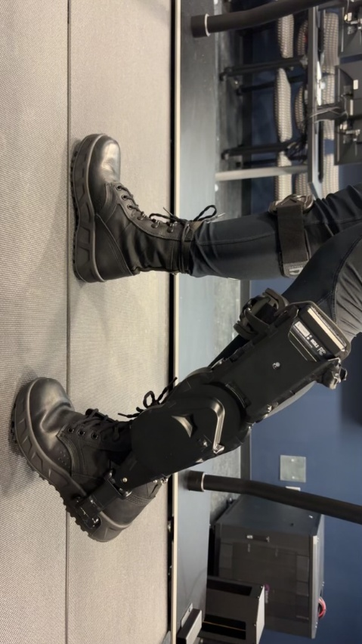
Participants will walk for 10 minutes at their walking speed to get familiar with the ExoBoot (see photo above), during which the torque will be set to 0.18Nm/kg (per kg of weight of the participant). This baseline value, derived from prior research, will remain constant during the initial familiarization to provide participants with a reference value before experimental variations are introduced.
After 2 minutes of rest, participants will begin the experimental task. Each trial consists of two walking conditions, presented in random order: a reference torque and a comparison torque. The reference torque is held constant throughout the experiment (0.18Nm/kg of participant body mass). The comparison torque will vary across trials. All torque values will be normalized to participant body weight. Each condition is presented for 5 strides (one stride is a left and right step together), resulting in 10 strides per trial. At the end of each trial, the participant will be asked: “Were the two torque profiles the same or different?” A subset of 25% of the trials will be catch trials, where both conditions are identical, to estimate false-alarm rates. These catch trials will be presented randomly.
For the comparison torque, an up-down method will be used to determine the following non-catch-trial comparisons: if a user answers ‘different’, the comparison torque in the next non-catch-trial will change by 0.005 Nm/kg closer to the reference torque, if a user answers ‘same’ the following non-catch-trial comparison will be 0.005 Nm/kg further from the reference torque. The initial comparison will be set to be 0.05 Nm/kg away from the reference torque.
Participants will be asked to complete 9 total sweeps. A sweep contains comparison value changes in two directions (greater and less than reference value). This will be done to approach the reference value from both more and less than the reference. There will be 9 tests conducted to approach the reference timing from above and 9 tests will be done to approach the reference timing from below for a total of 9 total sweeps. Participants will be notified when each condition starts and will have a 15-second break between trials to rest.
The duration of each sweep depends on the responses of the participant, because the comparison value is adapted based on the participant’s response. The number of individual comparisons making up a single sweep will vary with each participant’s responses of either “same” or “different”. As an estimate, based on prior research (Peng et al., 2022), each sweep is expected to be roughly 4-7 trials. With each trial lasting for a total of 10 strides (roughly 8 seconds) this gives an estimate for each sweep lasting roughly 2-3 minutes. With 9 sweeps total, we expect the total walking time to be approximately 20-30 minutes for the main task.
Participants will then complete another balance test.
After completing all trials, participants will complete a post-study questionnaire to assess comfort, fatigue, and perceived effort. Participants will then be debriefed on the purpose of the study and given an opportunity to ask any further questions.

