Data Technician
Week 2 Workbook
Power BI

Name:
Course Date:
Table of contents
Day 3: Task 1 3
Day 3: Task 2 3
Day 4: Task 1 4
Day 4: Task 2 (If completed other task early) 7
Course Notes 8
Additional Resources to learn and Practice 8

Day 3: Task 1
Please complete Tutorial: From Excel workbook to stunning report in Power BI Desktop - Power BI | Microsoft Learn.
Once complete, publish your report in Power BI service and paste a print screen below and in the collaboration board.

You can also watch this video how to publish and share power bi report.webm. and share with your trainer.

“Teaching is the best way to learn, so please listen out for support requests from the class and we’ll work through the challenges together”

Paste your completed lab here | 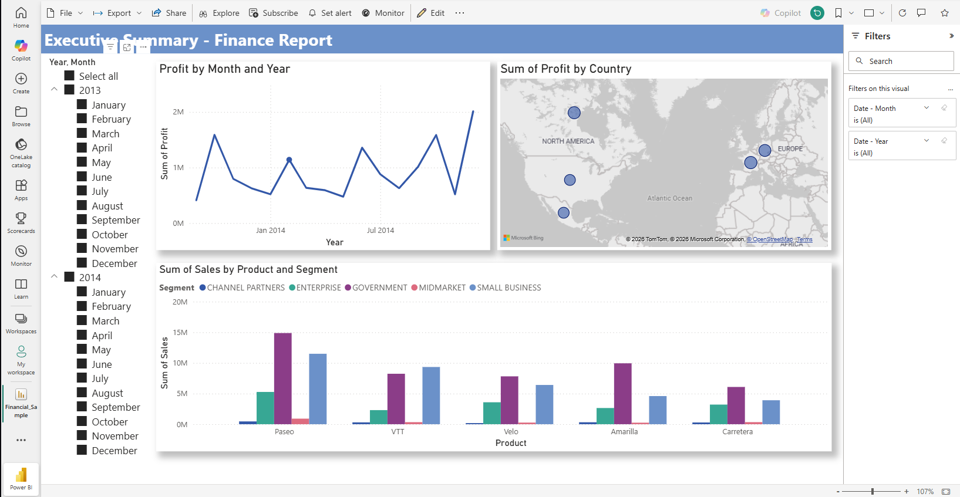

Day 3: Task 2

Please complete Tutorial: Combine data from Excel and an OData feed in Power BI Desktop - Power BI | Microsoft Learn.

Once complete, publish your report in Power BI service and paste a print screen below and share with your trainer.
You can also watch this video how to publish and share power bi report.webm.

Paste your completed lab here | 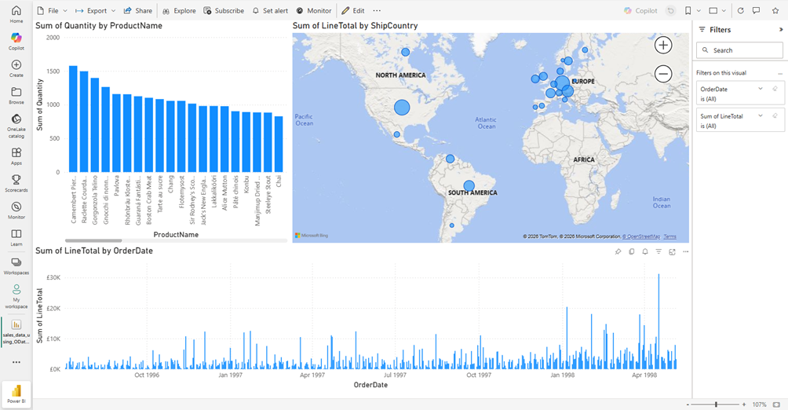

Day 4: Task 1

Please complete Exercise - Load Data in Power BI Desktop - Training | Microsoft Learn.
- Visit that page
- Select Sing in to launch Lab
- Sign in using Leep email
- Complete puzzle
- Start Lab

Once complete, publish your report in Power BI service and paste a print screen below and share with your trainer.
You can also watch this video how to publish and share power bi report.webm.

Paste your completed lab here | 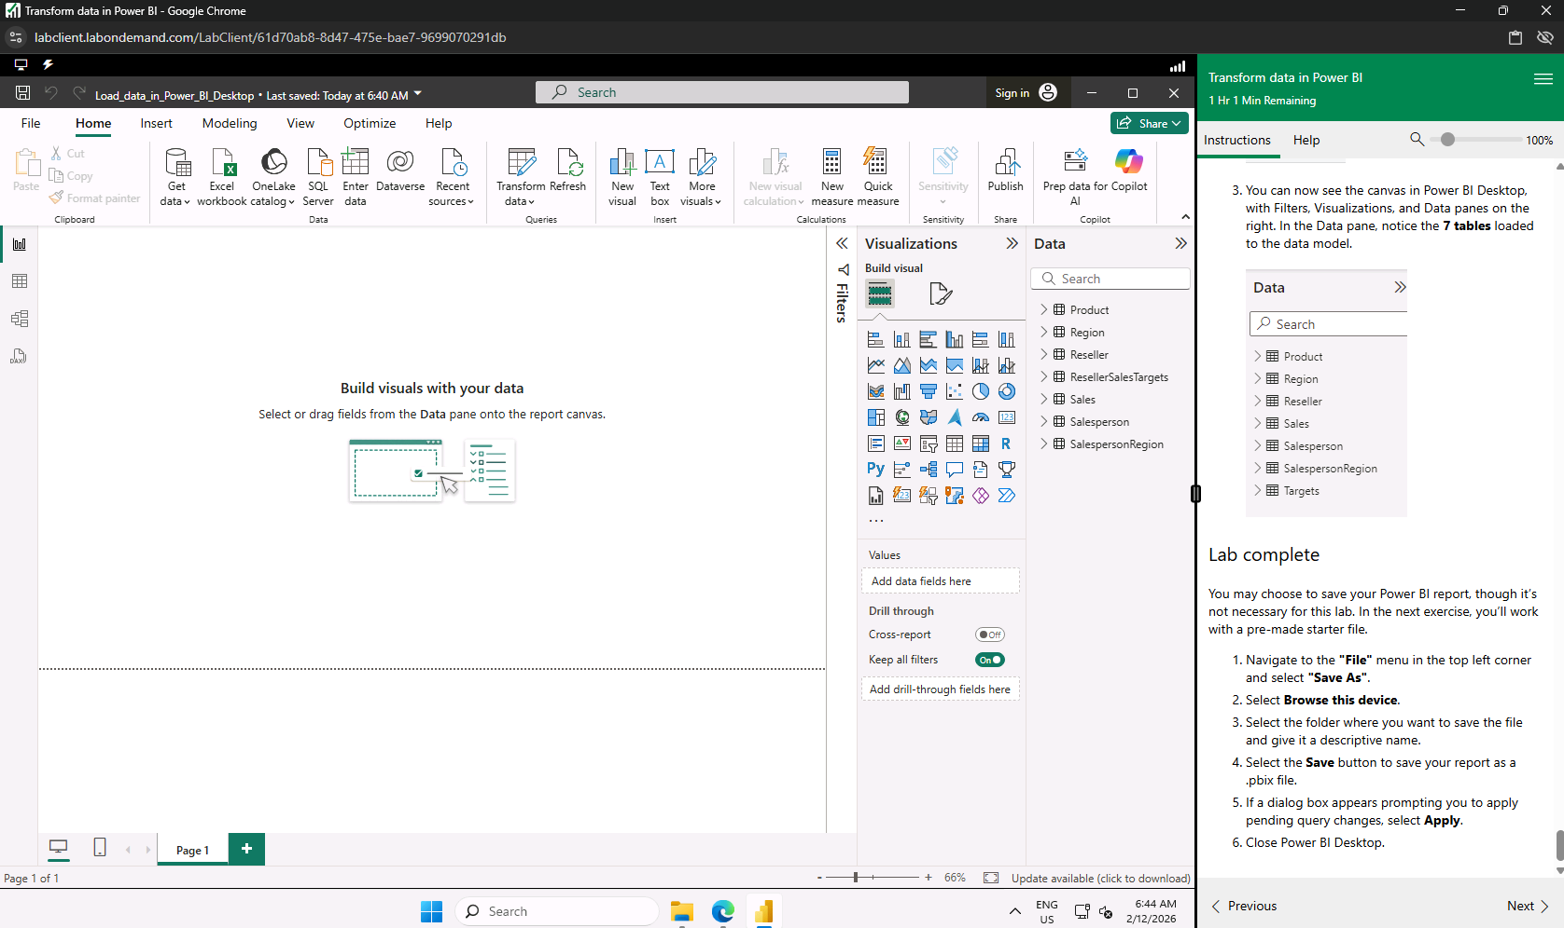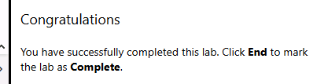  I was unable to share the file. Something a about restricted by admin.  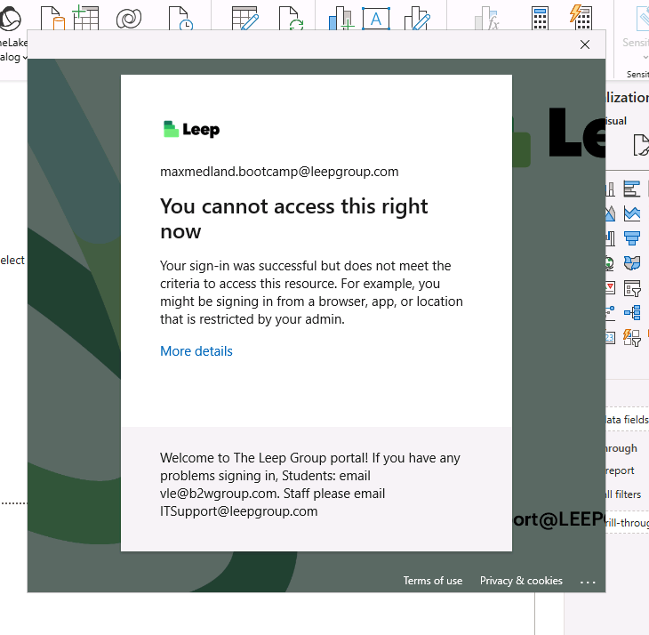

Day 4: Task 2 (If completed other task early)

Please complete Exercise - Design Power BI Reports - Training | Microsoft Learn.
- Visit that page
- Select Sing in to launch Lab
- Sign in using Leep email
- Complete puzzle
- Start Lab

Once complete, publish your report in Power BI service and paste a print screen below and share with your trainer.
You can also watch this video how to publish and share power bi report.webm.

Paste your completed lab here | 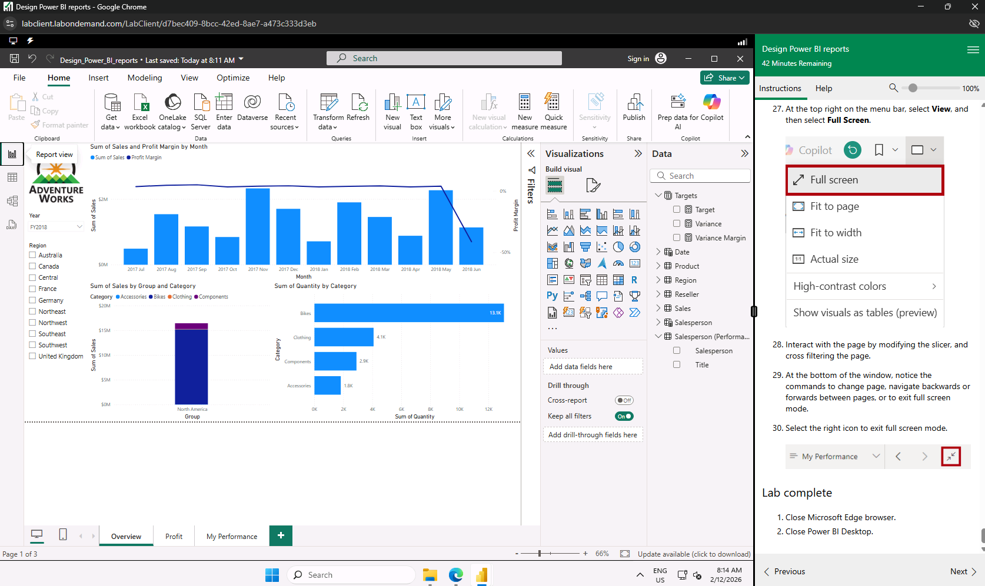Same file sharing issue as in the previous task

Course Notes

It is recommended to take notes from the course, use the space below to do so, or use the revision guide shared with the class:

Additional Resources to learn and Practice

- Full Beginner Project in Tableau | Tableau Tutorials for Beginners
- Learn Tableau Basic Calculations (Calculated Fields) in Tableau (with 10+ examples) | Part 1
- Tableau Hands-on Challenges Trailmix | Salesforce Trailhead
- Sample Data | Tableau Public
- How-To Videos | Tableau Public
- Power BI Embedded
- Power BI
- Exercise - Configure a semantic model in Power BI Desktop - Training | Microsoft Learn
  - Visit that page
  - Select Sing in to launch Lab
  - Sign in using Leep email
  - Complete puzzle
  - Start Lab
- Power BI Cheat Sheet | DataCamp

END OF WORKBOOK

Please check through your work thoroughly before submitting and update the table of contents if required.

Please send your completed work booklet to your trainer.

