Node.js Lab Notebook

This contains all the instructions for all the labs in this course. Feel free to print the notebook before class.

Asynchronous Programming Techniques

In this lab, you will familiarize yourself with various asynchronous programming techniques, a mainstay of Node development.

# Objectives

In this lab, you will learn to

* manage scope when using the this keyword in the presence of asynchronous callbacks, and
* see how to break up long-running tasks in order to improve Node's performance.

# Managing Scope in Callbacks

First off, let's have a look at how you might write a class to encapsulate a filename and a method to determine whether or not that file exists to see how the use of this might be problematic.

## Using this in callbacks

1. Open file scope-this.js in your IDE or text editor. Notice that we're using the function keyword to define a class called FileThing with a name property and a method called exists that asynchronously determines whether the file referred to by this.name exists.

In particular, have a look at how we're calling fs.open then inspecting the error given to us in the supplied onOpened callback. If we couldn't open the file, we ensure that it was because it didn't exist, log that fact, then inform our caller appropriately. Otherwise, we successfully opened the file, so we close it via fs.close (skipping a close callback) and invoke the supplied callback with no error and a true flag.

## Observing the loss of this

2. Now, use node to execute scope-this.js. You should see output similar to the following (highlighting added for emphasis).

$ node scope-this.js

Opening: thisFileDoesNotExist

/lesson-30-asynchronous-programming-techniques/lab/scope-this.js:13

console.log('Failed opening file: ' + this.name);

^

TypeError: Cannot read property 'name' of null

at onOpened (/lesson-30-asynchronous-programming-techniques/lab/scope-this.js:13:53)

at Object.oncomplete (fs.js:107:15)

Process finished with exit code 8

You should see that the file indeed does not exist, but notice the second line of output, where we log that the file wasn't found. It says "Failed opening file: undefined". This meant that the expression this.name returned the JavaScript literal undefined! Why?

The scope of this, at this location, is the enclosing function, onOpened. Since it doesn't define a property named name, JavaScript correctly returns undefined! Let's fix this (pun intended).

## Set a reference to the this we meant

3. Create a new file called scope-self.js and copy the contents of scope-this.js into it.

Remember that the scope of this in functions defined in a class is the class's members.

4. Since the this we meant in the onOpened function was FileThing's this, which is present in the function exists, create a new variable inside function exists called self and set it to the this that we meant (that was a mouthful).

5. Replace all uses of this in exists and in the onOpened callback with self.

6. Execute scope-self.js via node, and you should the following output, which properly echoes the filename in the "Failed opening file" message.

$ node scope-self.js

Opening: thisFileDoesNotExist

Failed opening file: thisFileDoesNotExist

file does NOT exist

When you see the output, you may move on to the next step.

# Breaking up long-running tasks

Remember that Node is single-threaded, meaning that it is possible for our code to cause Node to halt all work. This is obviously undesirable, so let's have a look at how we can refactor code to yield its processing, letting Node catch up on I/O that may have been queued while Node was processing our logic.

Note that the code for this lab is already completely written and serves instead as an example of yielding.

This example presents a brute-force means of calculating prime numbers up to a given exclusive limit, in order to provide a good example of long-running, compute-intensive code.

7. Open file prime-obnoxious.js, which contains the function computePrimes. Notice that the function takes a limit greater than or equal to one, handles some boundary conditions, then jumps into the main loop of calculating prime numbers. The loop starts with prime candidate 3 & factor 2 and increments each candidate once it's found to have an integral factor other than itself or all factors have been exhausted.

8. Run file prime-obnoxious.js via node. You should see output similar to the following. Your timing may vary depending on your hardware and current load.

$ node prime-obnoxious.js

9593 primes

3.033 secs

During the period that function computePrimes is running, Node can do nothing else. Other I/O-bound tasks, if present, would be queuing up and waiting for Node's event loop to finish executing computePrimes before they could be handled.

9. Now open file prime-polite.js. The first thing that you should notice is that we've introduced into computePrimes an inner function computePrimeBatch, also known as a JavaScript *closure*, that breaks up the task of computing primes into smaller chunks.

A JavaScript closure is roughly a function defined within another function that captures (or "closes around") and remembers all independent variables that are within scope at the time the closure is executed.

After each chunk has evaluated a certain number of prime candidates, it yields control to Node via the setImmediate function so that Node can allow other tasks to execute.

There are two ways of yielding control in Node: setImmediate and process.nextTick. setImmediate queues the given function behind whatever I/O event callbacks that are already in the event queue, ensuring I/O is not being starved. process.nextTick, however, queues the given function at the head of the event queue so that it executes immediately after the current function completes, which may starve I/O. In general, prefer setImmediate.

10. Run prime-polite.js via node. You should see output similar to the following. Again, your timing may vary depending on hardware & load.

$ node prime-polite.js

9593 primes

3.681 secs

Notice the time it took the polite version of the script to complete was about 20% slower than the obnoxious version. Why? Because we're yielding our algorithm's execution to Node so that Node can process any I/O-bound tasks that may be queued, which takes time.

While the performance of our algorithm suffers, the overall throughput of Node remains high because we're giving Node a chance to service any I/O-bound tasks that may have been waiting during our algorithm's processing.

This lab is now complete!

Modules

In this lab, you will create a Node module that performs simple calculations for various shapes.

# Objectives

In this lab, you will learn to

* create a Node module, and
* use the newly created module within a calling application.

We are going to create a directory module named ‘shapes’, which resides in the lab folder.  We must create the 'package.json' file to indicate the name and the JavaScript program.  Our module will export three additional modules for rectangle, triangle, and circle.

# Set things up

Let's start our setup by creating an appropriate place for the module we’re going to create.

## Create a shapes directory

1. Create a directory called shapes and create a package.json file within it. Remember a package.json needs keys name and main. Go ahead and use index.js for the main key and we will create it next.

Ok, we're now ready to start coding our module!

# Create the module

Since we want our shapes module to be flexible enough to handle multiple types of shapes, let’s create an index file and reference the individual supported shapes there.

## Create an index.js file

2. Create an index.js file in the shapes directory and add require statements for rectangle, circle, and triangle, which we are about to create.

## Export rectangle, circle, triangle

3. After the require statements, export each of them, making them available to users of our module.

A module can require the use of other modules internally but not necessarily export them. For example, a popular node module express requires cookie, a separate cookie parsing module internally.

## Create rectangle.js, circle.js, and triangle.js

4. Now that the index file is complete, let’s create implementation files for each shape. In case your geometry is rusty, here are some formulas you will include as functions in each shape.

Circle

* a = πr2
* c = 2πr

Rectangle

* a = wh
* p = 2(h + w)

Triangle

* a = **½**bh

You can export each function you create with the syntax:

exports.name = function(…) {…}

For objects with multiple functions, an alternative syntax is:

module.exports = {

someFunction: function(…) {…},

someOtherFunction: function(…) {…}

}

# Write the main program logic

It's time to write the application that will use our newly created module.

## Create geometry.js and require the shapes module

5. Create a geometry.js file and require the shapes module you created.

## Compute some interesting shape values!

6. All that is left now is to write some code using the functions that you exported from your module.

When you're seeing the messages that you expect, you have completed the lab!

Debugging

In this lab, you will debug a very simple JavaScript program to see one of the issues of debugging asynchronous applications.

# Objectives

In this lab, you will learn how essential breakpoints are when debugging in node.js.

# Open the file in your IDE and debug

1. Open debug.js in your IDE. Set a breakpoint on the first console.log() call in the file and then debug the file as a node.js application.

# Step through the code

2. Try stepping through the code one statement at a time. When you hit the setTimeout() call, you will find yourself deep in node.js code.

# Set a breakpoint

3. Kill the debugging session and set a breakpoint in the second console.log() call that is inside the callback for the setTimeout() call. Restart the debug session and now you can use "continue" to get past all of the node.js internals and into the body of the callback.

# Optional: Use the node.js debugging client

4. Open up a terminal and navigate to the folder with the debug.js file in it. Enter the command node debug debug.js. The debugger will show the top of the file. Enter help at the prompt for a list of available commands.

Testing

In this lab, you will familiarize yourself with the module Mocha, a popular unit test framework for Node.

# Objectives

You will learn to use the Test Driven Development (TDD) interface of Mocha by creating three simple unit tests.

# Install Mocha

The first thing we have to do is to use Node Package Manager, npm, to install the 'mocha' module. Do this by opening a command prompt in the lesson directory and issuing the command npm install -g mocha. The –g flag installs the module in the global node_modules and provides the mocha command line interface.

# Lab Steps

Now that Mocha is installed, we can begin the lab, whose goal is to create three unit tests for a simple Product class, which has been provided for you in product.js.

## Run the empty test suite

An empty test suite has been created for you in productTest.js. The Product class is instantiated and the Mocha suite definition is set up although it is currently empty.

1. Run the test suite by issuing the following on the command line: mocha productTest.js -u tdd. If everything is working correctly, you should see a message in the console indicating that there are 0 passing tests. This makes perfect sense because we do not yet have any tests created! Mocha defaults to Behavior Driven Development (BDD) syntax but for this lab, we will be using the TDD syntax, which we indicate by using the command line option “-u tdd”. The main differences in BDD and TDD are the syntax used to describe tests but functionally, the test cases should behave the same.

## Create the delete test case

2. Create the first unit test declaration with the signature test('deleteTest', function deleteTest() {…}). The first thing the unit test should do is add a product using the API. Use Node's assert module to make sure the product count is 1 by invoking assert.equal(). Then run the deleteAll API and again assert that the count is now 0.

3. Execute the unit test with the command line mocha productTest.js -u tdd and verify that there is one passing test.

## Create the add test case

4. Create another unit test declaration with the signature test('addTest', function addTest() {…}). Use the deleteAll API to reset the product list and then use the add API to create one. Use either assert.equal or assert.notEqual to test for the expected result and run your test suite again from the command line.

## Create the doAsync test case

Mocha allows you to test asynchronous code by adding a callback to the test function (usually named done). By adding the callback, Mocha knows that it should wait for completion. There is a 2 second timeout by default for a test case but this is configurable with a command line option: -t.

6. Create a unit test with the signature test('doAsyncTest', function doAsyncTest(done) {…}. The Product class contains a doAsync function which makes use of Node's setTimeout(callback, delay, args…) API. After waiting for 1.5 seconds, the value of true is returned. The test case should call the API with product.doAsync(function callback(value) {…} and assert that value is true. Then call the done() callback to indicate to Mocha that the test case is complete. If you modify the Product class to increase the timeout to a value greater than 2s, you can see that the test case fails because of Mocha's default timeout value.

Once you have created all three unit test cases and they are passing, you are complete with this lab!

The file productTest-bdd.js in the solutions folder is an example of tests done in Behavior-Driven Development (BDD) style.

A convenient mocha switch is “–w”: this will cause mocha to monitor the current working directory and rerun tests upon changes. Try it out!

Working with the File System

In this lab, you will learn to use Node’s File System module by watching a directory for file updates and file & directory creations and deletions.

# Objectives

In this lab, you will learn to

* use various functions from Node's File System module, and
* write asynchronous callback functions to handle events from the file system.

# Set things up

Let's start by setting up our script with a little bookkeeping.

## Require the File System module

1. Open the JavaScript file watch.js and declare a variable for Node’s File System module, by adding the line

var fs = require('fs');

## Declare a data structure to keep track of files & directories encountered

2. Declare a data structure that will hold our initial view of files and directories. You can use what you want, but an obvious choice would be map of lists:

var entries = { files : [], dirs : [] };

## Store the directory to watch as a variable

3. Declare a variable to hold the name of the directory that we'll be watching (due to the behavior of the file-related callbacks that we'll be using later on):

var dir = './dir';

Ok, we're now ready to start coding our directory watching logic!

# Initialize the data structure with files & directories

The first thing that we need to do is write logic to populate our data structure with the initial lists of files and directories in the directory that we're watching.

## Read the directory

4. Use the function fs.readdir to get all of the entries in the directory dir.

fs.readdir takes the directory you want to read and a callback of the form function(err, filenames), where filenames is an array of filenames relative to the directory being read.

It is a good idea to always name your callback functions, because when things go wrong, you can identify them more easily in stack traces. Also, remember that on success, err will be falsey, otherwise truey; if it's truey, make sure to throw it.

## Add file & directory names to the data structure

5. Use Array's forEach method to process each entry. forEach takes a callback of the form function(element, index array).

The fs.readdir function, when invoking your callback, returns filenames that are relative to the directory being read. For this particular use case, we'll only need to use the first argument (the array element), so your callback can take the form function(filename).

6. In your forEach callback, first prefix the given filename with the name of the directory being read.

7. Use fs.stat to find out if the given filename represents a file or directory.

fs.stat takes a callback of the form function(err, stats), where stats is an object of type fs.Stats, and has methods isDirectory() and isFile(). Use those methods to determine if the given filename represents a file or directory, and add it to the appropriate list (via Array's push method).

## Run what you've got so far

This is a good place to see whether things are working so far.

8. Sprinkle some console.log statements in with your forEach callback to see that your data structure is getting populated properly. If your data structure is a map called entries, you can just log the map itself with a call to console.log(entries).

9. Run your code either in your IDE or at the command line by invoking node watch.js in the directory containing the file watch.js.

Once you see that your code is populating your data structure ok, move on to the next step!

# Write the main program logic

It's time to write the meaty part of our application.

## Watch the target directory

10. Use the fs.watch function, which takes the target directory and a callback of the form function(event, filename). Write the call to fs.watch and include an empty callback for now; we'll complete the callback next.

fs.watch emits the rename event for all file & directory deletions, creations & renames. On some operating systems (like Mac OS X), a rename actually consists of a deletion and subsequent creation. Your mileage may vary.

## Complete the directory event callback function

11. Make the first line of your fs.watch callback function replace the contents of the filename variable with the filename prefixed with the target directory.

Just as the fs.readdir callback receives filenames relative to the directory it was given, so does the fs.watch callback.

The event given to your callback is actually a string with one of three values: 'error', 'change', or 'rename'.

12. Write skeleton code to handle each event value (hint: this is a good place to use a switch statement).

## Handle errors

13. Write code to handle the 'error' event. Simply throw an Error object with a message that indicates there was an error watching the target directory.

## Handle changes

14. Write code to handle the 'change' event that logs a message indicating which file changed and what its new size is. Use filename and the function fs.stat again to get the size of the file and echo the filename and its new size to the console (via console.log). Don't forget to add your break statement if you're using a switch!

15. Run your code again, then open and save a file in the directory you're watching. You should see messages indicating that file's changes.

Once that's working, move on to the next step!

## Handle file & directory deletions, creations & renames

16. Write code to handle the 'rename' event, using fs.exists to determine whether or not the given file exists. If it does, then you know that it's a creation.

fs.exists takes a filename and a callback of the form function(exists), where exists is a boolean indicating whether the file exists.

17. If fs.exists calls back with a true value, use fs.stat to determine whether it's a file or directory, and log a message to the console stating which type of entry (file or directory) that event is for, the name of the file or directory involved, and finally, how many files & directories are now being watched (information which can be gleaned from your data structure).

18. If event is for a file or directory that no longer exists, then you know that it was a deletion.

You can tell whether or not the file or directory existed by using your data structure; simply see if the file or directory name is present in your list of files or directories, respectively.

Remove the entry from the appropriate list (via Array's slice method), and then log to the console which type of entry event was for (file or directory), the file or directory's name, and the number of files and directories now being watched.

19. Run your application again. This time, trying adding then removing files or directories in the target directory and see what happens.

When you're seeing the messages that you expect, you have completed the lab!

Working with Streams & Buffers

In this lab, you will learn to use Node’s Stream & Buffer classes to read, compress & write data.

# Objectives

In this lab, you will learn to

* leverage Node's ability to stream & manipulate data via pipes.

# Compress a file via streams

In the first part of this lab, we're going to compress a file using streams.

## Write the main compression logic

1. Create a file called file.js and in it, require the modules fs and zlib.

## Create a file reading stream

2. Use fs's createReadStream function to create a stream.Readable that reads from our source file, file.js. Make sure to hold on to the reference returned.

## Create a duplex compression stream

3. Next, create a gzip compression stream via zlib's createGzip() function. Note that this is a Duplex stream, meaning it is both Readable and Writable.

## Create a file writing stream

4. One more stream that we'll need is a Writable stream for our output file. Use fs's createWriteStream function to create a writable file stream to a new file, file.js.gz.

## Pipe from the file to the output stream via the compression stream

5. With all of our streams now set up, we can pipe from the read stream to the compression stream, then on to the write stream. Write a chaining pipe expression that begins with our file reading stream, goes through our compression stream, and finishes with our writable stream and execute file.js via node.

## Confirm your results

6. Confirm your results by checking the newly created gzip file file.js.gz. If you have gzip in your path, a simple gzip -t file.js.gz will suffice; if it returns with no error, then the file is a valid gzip archive, otherwise it'll echo an error.

When you've confirmed that your archive is being created properly, move on to the next step.

# Compress URL stream

The next part of this lab is optional and requires Internet access. If you have it, continue on. If not, you're done with this lab!

## Add required modules

7. Open file net.js and require the following modules: fs, zlib, & https.

## Instantiate streams

8. Instantiate two streams: one for compression via zlib.createGzip(), and one for writing to a file (where we'll write the response we'll be getting from the URL).

## Invoke the URL

9. Use the https module's request function, whose first argument is an object with properties hostname, path & method (among others – check out the docs if you're curious), and whose second argument is a callback that takes a response object. Use 'www.google.com' for the hostname, and '/?q=node.js' for the path, and 'GET' for the method.

Capture the returned object and make sure to call its end() method so that the server knows that the request is complete and it should start responding. Alternatively, you could just call end() on the return value of https.request, without even storing the variable, since we're not going to use it after the end() call.

## Chain the response

10. In the event handler, take the response stream, pipe it to the compression stream, and then pipe that to the writable file stream.

## Run it & test

11. Now that you've got the code written, run net.js via node, extract the newly created google.gz file, and make sure that it's innards look like what Google would return in a query for node.js.

Once you see the results you expect, you're done with this lab!

**Error! Not a valid filename.**

Web Servers

In this lab, you will use most of the key components of the node.js http module.

# Objectives

In this lab, you will learn to

* create HTTP servers and make client requests,
* read and write data to and from the HTTP server.

# Start your webserver

1. Open webserver.js in your IDE. This essentially the same "Hello World" server as we saw in the introduction. Run this file from your IDE or from the command line. Navigate to <http://localhost:3000> with your browser and you should see "Hello World" in your browser.

# Add support for different clients

2. Shut down the server for now. We're going to add the ability to respond differently to different clients using the value of the "Accept" header. Add code to the requestListener() method to send "Hello World" back to the client in an H1 HTML element if the client accepts 'text/html.' You have access to all the headers on the request.headers property. Restart the server and you should now see an HTML version of "Hello World" in your browser.

You can also try to run curl http://localhost:3000, to see the example of plain response.

# Use parameters in the query string

## Add a supporting module

3. Shut down the server again. Include the url module by adding a requires statement and assigning it to a variable.

## Read the values in the query string

4. Go back to the requestListener() method and use the url.parse() method to parse the URL that is available on the request.url property. Use true for the second argument to the url.parse() method so that the query string will be available. Assign the return to a variable.

## Change the HTML tag using a query parameter

5. Change your code where you are writing out the HTML H1 element to use the value of a query parameter named style. If there is no value for the style parameter, use H1 as the default value.

## Test the query parameter

6. Navigate to <http://localhost:3000> to see "Hello World" still as an H1 element. Now add your query parameter to change it to a P, for example as in <http://localhost:3000>?style=p.

# Making a client request from node.js

Node.js also has nice support for initiating client requests to an HTTP server.

## Run the client

7. Open the file client.js in your IDE. This is essentially the same code as we saw in the lecture on client requests. With your web server code still running, run this file. You should see 'Hello World' print out in the console. There are no HTML tags since you added the branching based on the "Accept" header.

## Change the request method for the client

8. To make a POST request to the server, change the method option from GET to POST.

## Change the content type

9. Go to the request object and use request.setHeader() to set the value of the "Content-Type" header to "application/json."

## Write a JSON object to the request

10. After the header is set, use request.write() to write a JSON object to the request. The object should be an array of strings using the first names of the students around you.

# Handling POST requests on the server

## Add branching based on the request method in the request listener

11. Go back to the webserver.js file. In the createServer() function, replace the requestListener function with an inline function that will branch based on the value of the request.method property. If the value is 'GET,' call a function named handleGet(); if the value is 'POST,' call a function named handlePost(). Both functions should have the request and response as parameters.

## Create a function for handling GET requests

12. You've already implemented everything for handling GET requests in the requestListener() function. Just rename it to handleGet().

## Create a function for handling POST requests

13. Create a function name handlePost() that takes the request and response as parameters. Add the code to read the data that is in the request using the IncomingMessage interface and build a string object with it. Attach a listener for the 'data' and 'end' events.

## Write the response using the array that was posted to the server

14. When the 'end' event is fired, signaling that you have read all of the data from request, convert the JSON string into an array. Iterate over the contents of the array and build up a string of "Hello [value]" followed by a newline for every element of the array. Then write the string out to the response with a content type of "text/plain."

## Test the POST implementation

15. Restart your web server code and then go to the client request and run it with your new POST implementation. You should see "Hello [name]" printed on a new line for every name in the array.

Express

In this lab, you will create a simple “todo” application using the Express web application framework.

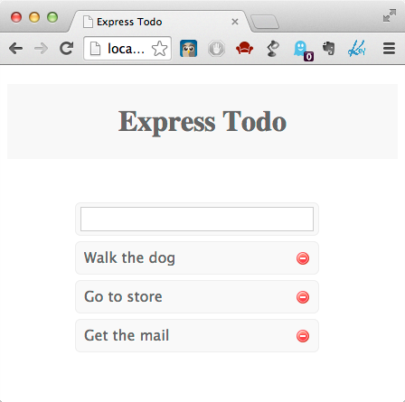

# Objectives

In this lab, you will learn to

* define CRUD routes in Express, and
* implement behavior for each route.

# Set things up

You have been provided a working Express application to start the lab but first we need to install the required modules.

## Install dependencies

1. Run npm install in the lab directory.

This will install the dependencies for our application from the package.json file. In this case, our only dependencies are express, an MVC web framework, and jade, a popular template engine that will render our views. The views and basic CSS styling have been provided for you in the views and public directories.

While not required, you probably want to install nodemon (npm –g nodemon). nodemon automatically restarts your application when a file system change is detected and will save time so you don’t have to manually restart Node to view your edits.

# Initialize the application

1. Open app.js in a text editor and take note of the fs.readFile invocation. Normally, a web application would use a database to store data, but working with a database is out of scope for this lab. Instead, we will be using a JSON file, todo_db.json, to load sample data into memory. After todo_db.json is parsed, we simply store its data in the app.locals.todos variable.

Express provides the variable app.locals to store app-level data that is available throughout the application.

## Specify the root route

1. Open routes/index.js in your editor and define a HTTP GET route for the root path (/) by using app.get.

The first argument to app.get is the URL path for the matching route, and the second argument is the callback function that will handle the request. In the spirit of a layered architecture, our controller layer concerning “todos” will be placed in module todo-controller.js located in the same directory.

The service layer will be placed in the services directory. You can see that as your application grows, this allows your routes/index.js to remain easy to read and keeps the controllers separate. Use todoController.findAll, which we'll write in the next step, as the second argument for your route.

## Create the controller function for the root route

1. Open routes/todo-controller.js and provide an implementation for the function findAll(req, res, next).

In your implementation, delegate to the service.findAll function, and pass to it a callback of the form function onFound(err, todos).

In the callback, use the res.render function to display the index.jade view that has already been created for you in the views directory.

As you can see, views/index.js expects a variable called todos to be passed containing all of the “todo” items, which is used to render edit & delete links for each todo in the browser. The value of todos will come from the service layer call.

Express is a model-view-controller framework. Controllers are functions (routes) that handle requests, delegate to services, produce models, and select views. Views render models. A model is simply a map of data whose entries are used by the view to get to the data. You can think of the model as the "data contract" between the controller and the view: the view expects certain data to be present in the view, and the controller must ensure that it provides that data.

## Implement findAll in the service layer

1. Open services/todo-service.js and provide an implementation for the function findAll(callback). In a normal application, this would be a database lookup, but in our case, we only need to return todos, which has already been passed into the service layer constructor. The implementation should simply be callback(null, todos).

## Start the application

1. Run node app.js (or nodemon app.js) and, if everything is working correctly, you should be able to navigate to <http://localhost:3000> and see three sample “todo” items already in your application!

You may notice that while our data renders correctly, the rest of the functionality to edit, create, and delete todos is broken because we need to define more routes.

## Create the ‘/create’ route & controller function

1. Open routes/index.js and define a HTTP POST route for path /create and corresponding function addTodo(req, res, next) in routes/todo-controller.js.

According to REST conventions, creation routes are typically defined with a HTTP POST, and our application is no different. The addTodo function in routes/todo-controller.js should call the service layer's addTodo function and pass req.body.content, along with a callback of the form function onAdded(err, todo). In the callback, we need to terminate the response, so add res.redirect(‘/’) to render the main index view after we've processed the business logic.

## Create the addTodo service function

1. Open services/todo-service.js and provide an implementation for the addTodo function.

If you examine the todo_db.json structure, you will see that we are storing only an id and content:

[{

"id":"f47b6329-e3db-4af2-e2a1-6fd818ab08ac",

"content":"Walk the dog"},

…

}]

1. In services/todo-service.js, a function to generate unique IDs, called uuid(), has been provided for you. Create a new todo inline object with property id equal to uuid() and property content equal to the content parameter.

Use the JavaScript push() method to add a new entry to todos, the array that represents our backing store, simulating database persistence.

Finally, call the callback function with parameters null, indicating no error, and the newly created todo object.

At this point, you should be able to verify that new items are correctly added in your application. Run your application again via node (or nodemon) and confirm everything is working ok.

## Create the ‘/edit’ route & controller function

In order to render our edit form, we need to define an edit route & corresponding controller function.

1. Open routes/index.js and define a HTTP GET route for /edit and corresponding controller function editTodo in routes/todo-controller.js.

The edit route should be in the form /edit/:id, which allows the id parameter to be accessed via request.params.id.

The edit view expects a model entry called todos, so the editTodo function needs to call service.findAll and render the edit view in the callback, passing the model map.

The view also expects a current model entry, which corresponds to the id of the “todo” item to be edited.

If everything works correctly, you should now be able to edit the selected “todo” item. Now, in order to save our changes, we need to define an update route.

## Create the ‘/update’ route & controller function

1. Open routes/index.js and define a HTTP POST route for /update and corresponding controller function in routes/todo-controller.js. Like the /edit route, /update should use a named parameter for the "todo" id.

The updateTodo function should call the service layer's updateTodo function and pass the updated todo's id and content for the "todo" item being changed, and a callback of the form function onUpdated(err).

In the callback, use res.redirect('/') to render the root view.

## Create the updateTodo service function

1. Open services/todo-service.js and provide an implementation for updateTodo.

Loop through all of the todos; if the id parameter matches the current “todo” item's id, update the current todo's content property with the content parameter, then call return callback() to break the loop & return immediately, indicating success.

If the id is not found, then our loop will exit; after the loop, then, invoke the callback with an error.

## Create the ‘/delete’ route & controller function

1. Open routes/index.js and define a HTTP GET route for /delete and corresponding controller function deleteTodo in routes/todo-controller.js.

Like the edit and update actions, we need to use a named parameter for the id corresponding to the specific “todo” item we wish to remove.

Call the service layer deleteTodo function and pass in the id of the item to be deleted, and a callback of the form function onDeleted(err). Then use res.redirect(‘/’) to render the root view in the callback.



The HTML specification, as implemented in browsers, does not support the DELETE verb in <form> elements, so make sure you use a GET instead. Express supports all HTTP verbs, including GET, POST, PUT and DELETE for RESTful clients.

## Create the deleteTodo service function

1. Open services/todo-service.js and provide implementation for deleteTodo.

First, initialize a temporary variable to keep track of an index into the todos array. Loop through the todos. if the given id matches the current element's id, use todos.splice(index, 1) to remove it, then invoke return callback() to break the loop and return immediately.

If the id is not found, we will exit the loop; at that point, invoke the callback with an error.

Once everything is working properly, this lab is now complete!

Express Middleware

In this lab, you will use several Express middleware components in the creation of a simple login form.

# Objectives

In this lab, you will learn to

* use several built in Express middleware components together, and
* implement custom middleware.

# Set things up

You have been provided a minimal Express application to start the lab but first we need to install the required modules.

## Install dependencies

1. Run npm install in the lab directory.

This will install the dependencies for our application from the package.json file. Our dependencies are connect, cookie-parser, cookies, and express-session.

While not required, you may want to install nodemon (npm –g nodemon). nodemon automatically restarts your application when a file system change is detected and will save time so you don’t have to manually restart Node to view your edits.

# Add a logger

Open app.js in a text editor and you can see that currently our application doesn't do anything aside from listen to port 3000. Let's begin with one of the most common middleware components you will encounter – logging.

## Add logger middleware

1. Add the logger middleware to the application with an app.use() statement.

Use the provided LOGGER variable to format the log messages by passing it as the argument to morgan(). It contains the default logging format plus a couple of additional arguments that we will use later to examine cookies.

## Test the logger middleware is working

1. Navigate to <http://localhost:3000> and verify that a logging statement appears in the console. The browser will contain an error because we have not yet defined any working routes so let's do that next!

# Create a login form

Creating a login form means that our application will need to handle POST form data so next we need to use the body-parser middleware.

## Add bodyParser middleware

1. Add the body-parser middleware after the logger. This will ensure that our application and correctly interpret application/x-www-form-urlencoded data used in the login form.

## Create login middleware

1. Add a custom middleware function called login after the bodyParser middleware declaration.

The first thing this middleware should do is check the req.method and if it is not GET, return next(). We will be creating middleware next to handle POST data and this middleware should only handle GET requests.

1. Create a login form by using res.setHeader to set the Content-Type to text/html and then use res.write to generate a HTML form that takes a user and password as inputs and then a submit button. Make sure the input types are text for the user and password for the password. End the response with res.end().

## Create middleware to handle POST data

1. Add a custom middleware function called checkAuth and make sure it is declared after the login form. The first thing this middleware should do is check the req.method and if it is not POST, return next().

We will create a middleware soon to handle DELETE data and this middleware should only handle POST requests. The bodyParser middleware allows POST values to be available on req.body. The user and password values should be available as req.body.user and req.body.password. Create a simple check by validating that req.body.user === 'admin' and req.body.password === 'password'. If true, use res.end to indicate they are logged in and otherwise display an invalid credentials message.

## Test the login form

1. Navigate to <http://localhost:3000> and make sure that your login form appears. You should be able to see a successful login message with the correct credentials or an error message. This login form isn't very interesting without a session so let's add that next.

# Add a session store

Connect supports backing session stores with MongoDB, Redis, and others. In this lab we will just be using the default memory store.

## Add session middleware

1. After the bodyParser middleware, add the cookieParser() middleware and then session() middleware. The session middleware requires a secret to be passed in the format app.use(session({ secret: 'super secret string' })).

## Add session regeneration in checkAuth function

1. In the checkAuth function, add req.session.regenerate(function createSession(err) {…}) if there is a successful login. Move the successful login message inside this callback.

A normal web application would redirect to some other location after a successful login but redirect functionality is not built into Connect. Express, a higher-level framework built on top of Connect, provides this functionality for more traditional web development.

# Add logout middleware

At this point, we can login successfully with the application and create a session but we don’t have a way yet to logout and destroy the session.

## Add methodOverride middleware

1. Add the methodOverride middleware to the application after the bodyParser. This middleware will allow us to send a form with a DELETE method and Connect will populate the req.method object.

## Add a logout form to the login middleware

1. Modify the login middleware by checking to see if req.session.user exists. If so, present a form to logout. Inside the form element use the action attribute to pass _method=DELETE as a query parameter. If req.session.user does not exist, present the login form as before.

## Add logout middleware

1. Create a custom middleware and place it last in the chain of middleware functions you have defined so far. Check that req.method is equal to DELETE and then use req.session.destroy(function logout(err) {…}) to destroy the session. Inside this callback, use res.end with a message indicating the user is logged out.

## Test the application

1. Navigate to <http://localhost:3000> and verify that the ability to log in and out of the session works properly.

Once everything is working properly, this lab is now complete!

RESTful APIs with Express

In this lab, you will build upon the "todo" application created in the previous lab and create a REST API alongside the web interface.

# Objectives

In this lab, you will learn to

* define RESTful routes in Express, and
* implement behavior for each route.

# Set things up

You have been provided a working Express application to start the lab but first we need to install the required modules.

## Install dependencies

X. Run npm install in the lab directory. This will install the dependencies for our application from the package.json file. In this case, our only dependency is express, an MVC web framework for Node.js.

While not required, you probably want to install nodemon (npm –g nodemon). nodemon automatically restarts your application when a file system change is detected and will save time so you don’t have to manually restart Node to view your edits.

## Specify the findAllJson route

X. Open routes/index.js in your editor and define a HTTP GET route for the REST path to get all todos, /api/todos, by using app.get. The first argument to app.get is the URL path for the matching route, and the second argument is the callback function that will handle the request. In the spirit of a layered architecture, our controller layer concerning todos will be placed in module todo-controller.js located in the same directory. The service layer will be placed in the services directory. You can see that as your application grows, this allows your routes/index.js to remain easy to read and keeps the controllers separate. Use todoController.findAllJson, which we'll write in the next step, as the second argument for your route.

Our REST API will be prefixed with /api so there is no confusion about which routes belong to the web layer and which belong to our API.

## Create the REST endpoint to get all todos

X. Open routes/todo-controller.js and provide an implementation for the function findAllJson(req, res, next). In your implementation, delegate to the service.findAll function, and pass to it a callback of the form function onFoundJson(err, todos). The service.findAll function has already been implemented from the previous lab. In the callback, use the res.json(todos) function to send a JSON response containing all todos. If there is an error, return it with res.json({message : err.message}).

response.json() is identical to response.send() when an object or array is passed. It may also be used for explicit JSON conversion of non-objects (null, undefined, etc.).

In the event of an error, be sure to always send a JSON response containing your error message and any other important information (stack trace, error code, etc) rather than sending a response code indicating failure like 500. Sending error information as a JSON response is a best practice to give consumers of your API as much help as possible to diagnose a problem.

## Start the application and test the REST endpoint to get all todos

X. Run node app.js (or nodemon app.js). Open a separate terminal window and issue the command curl -i http://localhost:3000/api/todos. If everything is working correctly, you should see a JSON response with three sample todo items.

If you are able to run Google Chrome on your lab machine and would prefer to use a graphical REST client, please refer to Appendix A.

## Create the REST endpoint to create a todo

X. Open routes/index.js and define a HTTP POST route for path /api/todos and function addTodoJson(req, res, next) in routes/todo-controller.js.

REST conventions dictate that the HTTP method GET is used for reading resources, POST for creating, PUT for updating, and DELETE for deleting.

The addTodoJson function in routes/todo-controller.js should call the service layer's addTodo function and pass req.body.content, along with a callback of the form function onAddedJson(err, todo). In the callback, use res.json(todo) to send a JSON response containing the newly added todo item. If there is an error, return it with res.json({message : err.message}).

## Test the creation endpoint

X. Test the addTodoJson route by issuing a command in the form curl -i -X POST -H "Content-Type: application/json" -d '{ "content" : "Get the milk" }' http://localhost:3000/api/todos. The new todo item should be returned in a JSON response. You can also invoke the REST endpoint GET '/api/todos' to see the entire list with your new item added.

## Create the REST endpoint to get a single todo by id

X. Open routes/index.js and define a HTTP GET route for /api/todos/:id and corresponding controller function findOneJson in routes/todo-controller.js. The token :id in the route is a named route parameter that allows the id parameter to be accessed via request.params.id. The findOneJson function should call the service layer's findOne and pass the todo's id and a callback of the form function onFoundJson(err, todo). The service layer function findOne has already been provided for you. In the callback, use res.json(todo) to send the JSON response. If there is an error, return it with res.json({message : err.message}).

## Test the REST endpoint to get a single todo

X. Test the findOneJson route by issuing a command in the form curl -i http://localhost:3000/api/todos/508d4a36-3c7c-7bb3-c5ee-1c4c3fb440f6. The todo item specified by the id should be returned.

## Create the REST endpoint to update a todo

X. Open routes/index.js and define a HTTP PUT route for /api/todos/:id and controller function updateTodoJson in routes/todo-controller.js. Like the findOneJson route, updateTodoJson should use a named route parameter for the todo id. The updateTodoJson function should call the service layer's updateTodo function and pass the updated todo's id and content for the item being changed, and a callback of the form function onUpdatedJson(err, todo). In the callback, use res.json() to return the updated todo's id. If there is an error, return it with res.json({message : err.message}).

## Test the REST endpoint to update a todo

X. Test the updateTodoJson route by updating the "Get the mail" todo to be "Pick up pizza" instead. Issue the command curl -i -X PUT -H "Content-Type: application/json" -d '{ "content" : "Pick up pizza" }' http://localhost:3000/api/todos/508d4a36-3c7c-7bb3-c5ee-1c4c3fb440f6. A JSON response of the updated todo's id should be returned.

## Create the REST endpoint to delete a todo

X. Open routes/index.js and define a HTTP DELETE route for /api/todos/:id and controller function deleteTodoJson in routes/todo-controller.js. Like the findOneJson and updateTodoJson routes, we need to use a named route parameter for the id corresponding to the specific todo item we wish to remove. Call the service layer deleteTodo function, pass in the id of the item to be deleted, and a callback of the form function onDeletedJson(err). If there is no error, use res.json() to return the id of the deleted item. If there is an error, return it with res.json({message : err.message}).

## Test the REST endpoint to delete a todo

X. Test the deleteTodoJson route by issuing a command in the form curl -i -X DELETE http://localhost:3000/api/todos/508d4a36-3c7c-7bb3-c5ee-1c4c3fb440f6. If the command is successful, the id of the deleted item should be returned.

Once everything is working properly, this lab is now complete!

# Appendix A

## Google Chrome

If your lab machine is equipped with Google Chrome, you may find it easier to work with a GUI based REST client rather than the curl command line utility. There are a number to choose from in the Chrome Web Store. One client that has worked well for the lab authors is Postman: <http://www.getpostman.com>.

Async.js

In this lab, you will familiarize yourself with the Node module Async.js, which assists in various ways to perform parallel & serial control flow as well as to iterate collections in both parallel & serial modes.

# Objectives

You will learn to use async.auto to more cleanly control program flow among interdependent functions.

# Install Async.js

The first thing we have to do is to use Node Package Manager, npm, to install the 'async' module. Do this by opening a command prompt in the lesson directory and issuing the command npm install async. This will download & install the latest version of the Async.js module into a directory called node_modules.

# Lab Steps

Now that Async.js is installed, we can begin the lab, whose goal is to use a simple (and admittedly buggy) minification algorithm to reduce the size of a JavaScript file.

## Add tasks

Since async.auto is a function that takes an object representing the tasks to be performed and a callback to be invoked when all tasks have been completed, we need to fill in the stubbed out tasks variable in auto.js with our initial requirements.

Notice that we've defined several functions: exists, read, create, write & close. These all deal with the JavaScript file we're reading from and the minified JavaScript file we're writing to. The functions' interdependencies are the following:

* read must be called only after exists is successfully called,
* write must be called only after read & create are successfully called, and
* close must be called only after write is successfully called.

Let's start slowly, and simply add our first function to the tasks object that calls exists.

1. Add a property named exists to variable tasks whose value is a reference to the exists function.

## Invoke async.auto

2. Now that we've got a minimal tasks object created, add the invocation of async.auto that takes the tasks object and a callback of the form function(err, results) that checks for the existence of an error and, if one exists, logs it to the console, otherwise simply logs a message that the file was minified ok.

3. Execute your tiny workflow consisting simply of the call to exists by executing node auto.js at a command prompt.

Once you see your 'minified ok' message, move on to the next step.

## Add the read task

The next thing to do is to add to the workflow the call to the read function, but only after the call to exists has completed successfully.

4. Update your tasks object to contain a property called read whose value is an array of a string containing the name of the key you used for the task that confirms file existence (exists) and a reference to the read function.

5. Execute your workflow again via node auto.js at the command prompt. This time, you should observe your exists function being invoked before the read function.

Once you see the order of invocations that you expect and your 'minified ok' message again, move on to the next step.

## Add the create task

Before we can write anything to the destination file, let's add a call to the create function, which ensures that the file is created and opened with a file descriptor. Note that create has no prerequisites because we're always creating & overwriting the destination file.

6. Update the tasks object with a property create whose value is a reference to the create function.

7. Execute your workflow again via node auto.js.

Once you see your create function being called and your 'minified ok' message, move on to the next step.

## Add the write and close tasks

We're now going to finish our minification workflow by adding two more tasks: one to write the contents of the source file and one to close the destination file after it's been written.

Notice that the buffer we're going to write to the file is set to null initially. Your job is to create a new Buffer whose contents are equal the array-ified string contents read from the read function. Where can you find that? Thanks to async.auto, we can find it in the results object that's given to the write function!

You see, async.auto tracks all values returned by tasks and stores them as properties on a results object that is given to any function that wants them (including the final completion callback given to async.auto itself).

8. Set the buffer to a new Buffer object whose value is simply results.read.join(' '), which is the result of the elements of the array returned by the read function (results.read) concatenated with a space (join(' ')).

9. Set the file descriptor fd to results.create, which is the file descriptor returned by the function create.

Lastly, we want to be good resource citizens and close the destination file.

10. Implement the close function by invoking fs.close using the same file descriptor used above.

11. Now, update the tasks object to include a write property that depends on read and create & invokes write, and a close property that depends on write & invokes close.

12. Execute node auto.js, which now has our complete workflow, and observe each function invocation happening only after each function's prerequisites have been satisfied.

Once you see the correct invocations and your 'minified ok' message, you have completed this lab!

Yeoman: Scaffolding Node Applications

In this lab, you will familiarize yourself with Yeoman, a suite of tools that enable quick scaffolding, in-browser dependency management, and mature builds.

# Objectives

You will learn to use the following tools:

* yo, a Node.js scaffolding plug-in framework,
* bower, a dependency management tool for the front-end, and
* grunt, a generic JavaScript task runner that is used to build Node applications.

# Install Tools

The first thing we have to do is to use Node Package Manager, npm, to install yo. Do this by opening a command prompt in the lesson directory and issuing the command npm install –g yo. This will download & globally install the latest version of yo. This will automatically install the tools bower & grunt. Last, install the yo generator for Angular.js with npm install -g generator-angular.

# Lab Steps

Now that the Yeoman tools are installed, we can begin the lab, whose goal is to scaffold an Angular web application, then add our own controller, view & route.

## Create the web application directory

1. Change to this lesson's lab directory and create a directory in it called todo with mkdir todo.

## Scaffold the initial web application

2. Change to the todo directory you just created and scaffold the initial Angular application with the command yo angular.

Choose **not** to use Compass, and then take the defaults for the remaining prompts.

At this point, you should have a directory structure that looks similar to this:

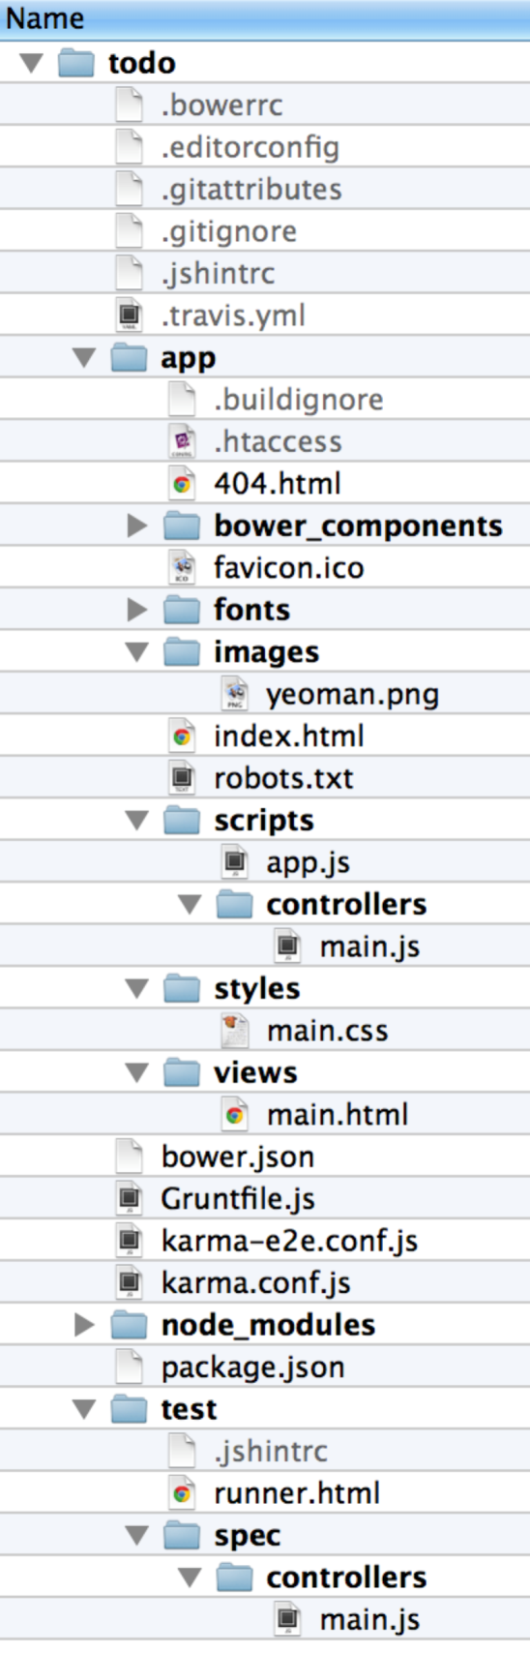

## Run the web app

3. Since yo integrates with bower & grunt, we can run the web app right out of the box. Do so with the command grunt serve.

As part of scaffolding the initial web app, yo defines a custom task called serve that builds & runs your application in a new browser window with LiveReload so that edits are immediately reflected in the browser.

You should see a new browser window pop up with the address http://127.0.0.1:9000/#/ with a view that looks like this:

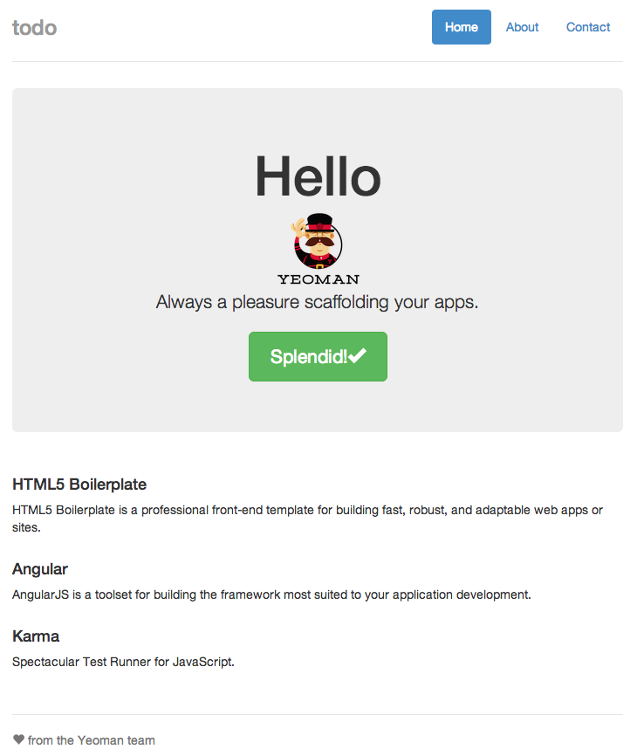

## Make a live edit

Now, let's see how editing is reflected immediately via LiveReload.

4. Open the file todo/app/views/main.html and change the text in it from <h1>'Allo, 'Allo!</h1> to <h1>Hello</h1>. You should see the new content in the browser without having to refresh the page:

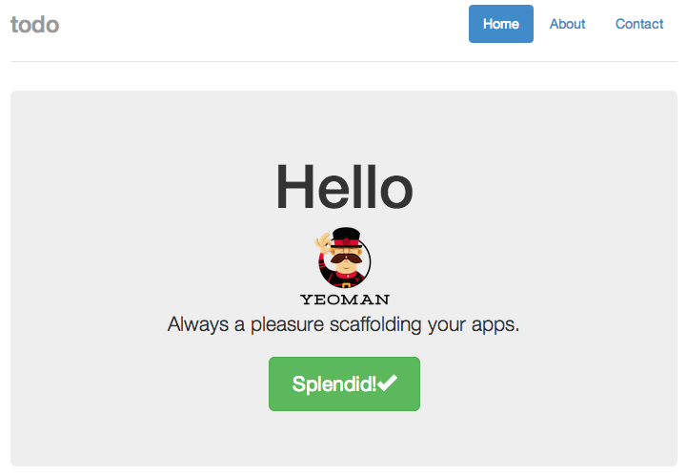

## Use model from controller in view

The page above is primarily statically rendered. Let's change this by using the model provided by the controller in the view.

5. Open the file todo/app/scripts/controllers/main.js and notice that the controller is populating the $scope with a property called awesomeThings with an array of three strings.

Angular routes requests to **controllers**, which produce **models**, which are then available to **views**. A controller places data to be rendered by a view by adding properties to the provided $scope service, given in a controller's constructor function.

For example, in app/app.js, you see the route for the root URL:

$routeProvider

.when('/', {

templateUrl: 'views/main.html',

controller: 'MainCtrl'

})

6. Update the view app/views/main.html to use the model that's produced by controller 'MainCtrl' by changing the content to nothing more than

<div class="container">

<h2>Awesome Things</h2>

<ul>

<li ng-repeat="thing in awesomeThings">{{thing}}</li>

</ul>

</div>

The view should be updated immediately to reflect the new view, which now dynamically renders the model placed in $scope by the controller. When you see this view, move on to the next step.

## Create a new single page application

7. Now, use the scaffolding offered by yo to create a new page ("single page application"), route, controller & view by opening a new terminal, changing to your todo directory, then issuing the command yo angular:route square. The artifacts created are listed below.

First, the route: app/app.js has been updated with the new route

.when('/square', {

templateUrl: 'views/square.html',

controller: 'SquareCtrl'

})

Next, the initial controller implementation in app/scripts/controllers/square.js simply returns some sample data (the same as controller 'MainCtrl'):

angular.module('todoApp')

.controller('SquareCtrl', function ($scope) {

$scope.awesomeThings = [

'HTML5 Boilerplate',

'AngularJS',

'Karma'

];

});

Last, the default view in app/views/square.html is simply

<p>This is the square view.</p>

If you now visit http://127.0.0.1:9000/#/square, you'll see the simple view.

## Update the controller and view to render squares of a few numbers

Now, we're going to update the controller and view so that it renders the squares of a few numbers, but first, we need to abide by good software development principles and ensure that we're testing our controller. Fortunately, grunt provides us with automatic unit and end-to-end testing capabilities.

### Install unit test modules

Before our tests will execute, make sure to install the test modules that we'll need and include them in our development environment's dependencies.

8. Kill the grunt process (via Ctrl-C), then execute npm install karma-jasmine --save-dev and npm install karma-chrome-launcher --save-dev. This will add these modules to the file todo/package.json.

9. Restart the server via grunt serve, then point the browser at http://127.0.0.1:9000/#/square. You should see the simple square view that you did before.

### Write a unit test for the controller

10. Open file todo/spec/controllers/square.js, the file that holds unit tests for the controller 'SquareCtrl', and update the test's it function to be the following:

it('should attach a list of squares of the form { val: n, squared: n*n } where n is from 1 to 6 to the scope', function () {

expect(scope.squares.length).toBe(6);

[1, 2, 3, 4, 5, 6].forEach(function (elem) {

var obj = scope.squares[elem - 1];

expect(obj).toEqual({

val : elem,

squared : elem * elem

});

});

});

This places the expectation on our controller to place the expected model into scope.

Once you save this file, you should see an error from grunt, stating something similar to the following:

Chrome 34.0.1847 (Mac OS X 10.9.2) Controller: SquareCtrl should attach a list of squares of the form { val: n, squared: n*n } where n is from 1 to 6 to the scope FAILED

Expected 0 to be 6.

…

You're seeing this error because our generated controller doesn't meet the specification that we just declared above.

You may need to touch the test file, todo/test/spec/controllers/square.js, in order to get grunt to rerun the tests.

11. Update the controller in app/scripts/controllers/square.js to place an array of objects with two properties each: val, containing a number, and squared, containing the square of the value. Since you're probably as lazy as the author of this lab is and writing code to do this is not the focus of the lab, here's the code.

angular.module('todoApp')

.controller('SquareCtrl', function ($scope) {

$scope.squares = [];

var vals = [1, 2, 3, 4, 5, 6];

vals.forEach(function onEach(it) {

$scope.squares.push({

val: it,

squared: it * it

});

});

});

Now, you should see a line similar to the following in your terminal, indicating successful testing (again, you may need to touch the test file again):

Chrome 34.0.1847 (Mac OS X 10.9.2): Executed 2 of 2 SUCCESS (0.027 secs / 0.025 secs)

12. Update the view app/views/square.html to render the values of the object at the key 'squares' in the model (which happens to be an array). Again, here's the code:

<p ng-repeat="sq in squares">{{sq.val}}<sup>2</sup> = {{sq.squared}}</p>

Now, view http://127.0.0.1:9000/#/square in a browser. You should see something similar to this:

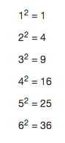

It is important to note that the model forms the contract between the controller and the view. The controller is responsible for populating the model, and the view must know the shape of the model so that it can render it properly. Any changes to the view that require new data to be added to the model must be accommodated by the controller so that the controller provides that data.

When you see the expected output, you have completed the lab!

Dust

In this lab, you will transform a static HTML page into a Dust template.

# Objectives

In this lab, you will

* extract a model from a static HTML page,
* use Dust logic helpers and section tags to navigate your model,
* transform a static HTML page into a Dust template.

# Run Dust with Node

For this lab, we will be running Dust from start to finish in Node. In your lab directory you will see a file named rundust.js. This application will compile your template, load it into Dust, and render an HTML page into a file.

1. Execute the following command in a shell:

node rundust quiz.dust

This will create a one-line html file, quiz.html. Rerun this command as needed as you are developing your template to see your results.

# Open your original, static HTML page

2. Open the file original-quiz.html in an editor. This is your starting point. Open it up in a browser also to see what it looks like rendered. This is a very simple page for gathering up students' answers to a set of assessment questions. Consider the pieces that should be taken out of this HTML so that the finished template can be used with any assessment.

# Open the template and model files

3. Open the file quiz.dust in an editor. This is where you will build your template

4. Open the file model.js in an editor. This is where you will build your model.

# Design your data model

5. Perhaps the easiest way to start is to just copy the contents of the static HTML page into your template. Then look at the information in the HTML and begin designing your data model. You should wind up with three major types: the assessment as a whole, a question, and an answer. Shell out the model in your model file.

# Populate the model

5. Extract the information from the HTML that belongs in the model and not the page. Replace any values you want with placeholder tags using the property names from your model.

# Create the template logic

5. There are a number of places where you will want to use the easy iteration of arrays built into Dust sections. There's also a lot of similarity between a set of radio button inputs and a checkbox input. Consider using a logic helper.

There is no "right" solution to this lab. There is a tremendous amount of flexibility in Dust. Have fun coming up with surprises!

When you're finished page matches the original, this lab is complete!

KrakenJS

In this lab, you will create a simple “todo” application using the Kraken web application framework.

# Objectives

In this lab, you will learn to

* create a model, view, and controller for "todo" items in Kraken,
* implement behavior for each route, and
* create an internationalized title.

# Install Tools

Before starting the lab, you will need a MongoDB server running on your lab machine for the database backend in our application. You will also need to install the generator-kraken module that will be used to generate a skeleton Kraken application.

## Install MongoDB

1. Go to the MongoDB homepage at http://www.mongodb.org and install the latest version for your operating system.
2. Once installed, start the server with the mongod command line utility.

## Install generator-kraken module

1. If you did not install Yeoman from the previous lab, you should do this now by opening a command prompt in the lesson directory and issuing the command npm install -g yo. This will download & globally install the latest version of yo.
2. Open a command prompt in the lesson directory and issue the command npm install -g yo generator-kraken. It may be necessary to prefix the npm command with sudo if you are using a Mac or Linux platform.

# Lab Steps

Now that the tools are installed, we can begin the lab.

## Scaffold a new web application with Kraken

1. Open a terminal in the lab directory, then issue the command yo kraken.
2. Enter todo for the app name, Todo Application for the description, and whatever you want for the author.
3. Take the defaults for the remaining prompts.

This will scaffold a web application that uses Express and Kraken in the directory todo.

## Start & view the web application

1. Change into the todo directory and issue the command npm start; this will start the server process.
2. Open http://localhost:8000 in a web browser. You should see something similar to the following:

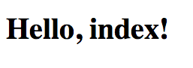

Once you see this, move on to the next step.

## Add MongoDB connectivity

1. Open package.json in your editor and add "mongoose": "3.8.12" to the dependencies section.
2. Copy the lib directory from the lab directory of this lesson into the todo directory, which contains your application.
3. Open index.js in your editor and add the following require statement at the top: var db = require('./lib/db');.
4. Add the line db.config(config.get('databaseConfig')); in the function at options.onconfig of index.js, right after the comment "any config setup/overrides here."

Make sure next(null); is the last statement in the function.

1. Open config/config.json and add the following section to this file immediately before the middleware property:

"databaseConfig": {  
 "host": "localhost",  
 "database": "test"  
 }

1. Stop the server and run npm install to install the mongoose dependency for MongoDB connectivity.
2. Start the server again with npm start and you should now see a message in the console that says "db connection open" indicating the MongoDB connection is working.

## Generate a controller and dependencies

1. Stop the server and run yo kraken:controller todos which will generate a model, view, controller, and I18N bundle in their respective places.

Accept the default at the prompt.

## Edit model

1. Open todo/models/todos.js and replace it with the contents of impl/model-todos.js. You can also just replace the file, but this will give you a chance to review the code.

This defines a very simple "todo" model with mongoose that only contains one String field.

## Edit controller

1. Open todo/controllers/todos/index.js and replace it with the contents of impl/controller-todos.js.

This controller defines typical create, read, update, delete routes using that should be familiar to most web developers.

### Copy CSS styles and graphics

1. Copy lab/css/app.less over the existing todo/public/css/app.less. This is a simple stylesheet and delete button similar to what was used in the Express lab.
2. Create the directory todo/public/png.
3. Copy lab/png/delete.png to todo/public/png/delete.png.

## Edit views

1. Open the file todo/public/templates/layouts/master.dust and add the following line as the last line in the head element:

<link rel="stylesheet" href="/css/app.css">

1. Open todo/public/templates/todos/index.dust and replace it with the contents of impl/todos.dust.

This Dust template first contains a form for creating new "todo" items. Then it checks for the existence of a todos object to render the list of all "todos". If the todos object does not exist, it checks for the update_todo object that is used to render the item to be updated. If neither exists, there are no "todo" items in the database yet.

## Run the web application

1. Start the web application again with npm start, return to the browser and view the URL http://localhost:8000/todos. You should see the following screen:

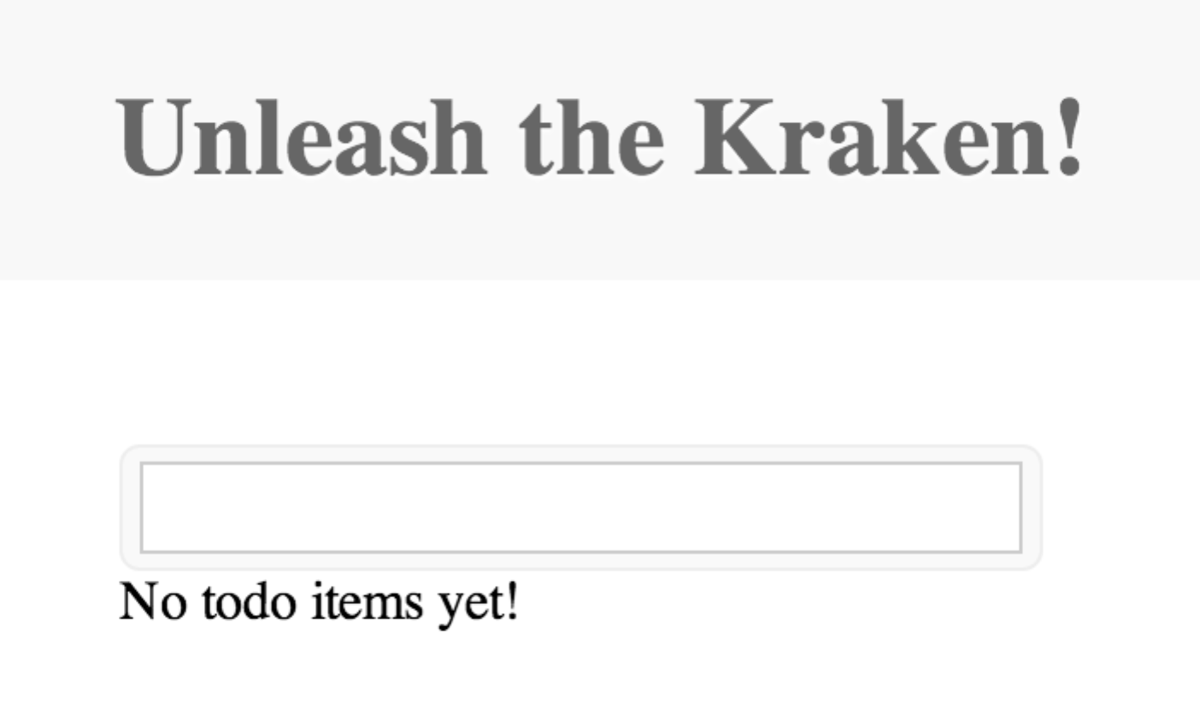

Verify that you are able to create, edit, and delete "todo" items and then move on to the next step.

# Internationalize the title

For the final part of the lab, we will take a brief look at how you can internationalize strings with Kraken.

## Create setLanguage controller

1. Create a file called controllers/setLanguage/index.js and paste the following implementation:

'use strict';  
  
module.exports = function (server) {  
 server.get('/setlanguage/:lang', function (req, res) {  
 res.cookie('language', req.param('lang'));  
 res.redirect('/todos');  
 });  
};

This route will set a cookie called language depending on the named parameter. We will add the language choices in the Dust template soon.

## Add language middleware

1. Open config/config.json .

"language": {  
 "priority": 95,  
 "enabled": true,  
 "module": {  
 "name": "path:./lib/language"  
 }  
},

Open todo/lib/language.js and examine what is happening. This middleware checks for the req.cookies.language cookie and if it exists, res.locals.context.locality is set with its value. This will cause Kraken to use the appropriate language bundle when rendering the template.

## Add a Spanish language bundle

1. Create locales/ES/es/todos/index.properties and paste the following key/value: greeting=Desata el Kraken!
2. Edit locales/US/en/todos/index.properties and change the greeting key to Unleash the Kraken!

## Modify template to switch languages

1. Open public/templates/todos/index.dust and make the following modification:

…  
{<body}  
 <p>Select language:</p>  
 <p><a href="/setLanguage/en-us" alt="English">English</a><br/>  
 <a href="/setLanguage/es-es" alt="Spanish">Spanish</a></p>  
 <h1 id="page-title">{@pre type="content" key="greeting"/}</h1>  
 <div id="list">  
…

This will create two links from which the setLanguage controller can be called and the appropriate cookie set. The title has been modified to use the greeting key from the message bundle instead of a hard coded greeting.

## Run the web application

1. Start the web application again with npm start, return to the browser and view the URL http://localhost:8000/todos. You should now see two links available and see something similar to the following if you select Spanish:

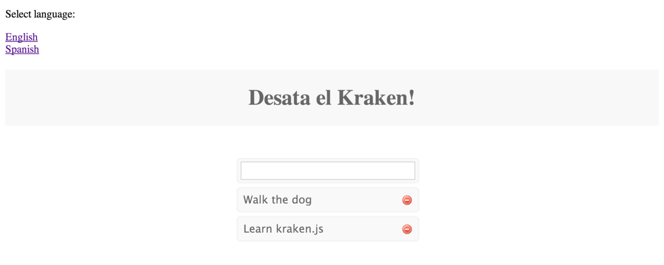

Once everything is working properly, this lab is now complete!

Security in Kraken with Lusca

In this lab, you will familiarize yourself with the security features in Kraken, offered by Lusca.

# Objectives

You will learn how to prevent

* cross-site request forgeries (CSRF/XSRF),
* cross-site scripting attacks (XSS),
* a browser from downloading unauthorized content via content security policies (CSP).

# Install Tools

The first thing we have to do is to use Node Package Manager, npm, to install generator-kraken. Do this by opening a command prompt in the lesson directory and issuing the command npm install –g generator-kraken.

# Lab Steps

Now that the tools are installed, we can begin the lab, whose goal is to scaffold a Kraken web application, then use Lusca to add our security features for CSRF & CSP.

## Scaffold a new web application with Kraken

1. Open a terminal in the lab directory, then issue the command yo kraken. Enter lusca-test for the app name, Lusca Test Application for the description, and whatever you want for the author. Take the defaults for the remaining prompts.

This will scaffold a web application that uses Express and Kraken in the directory lusca-test.

## Start & view the web application

2. Change into the lusca-test directory and issue the command npm start; this will start the server process.

3. Open http://localhost:8000 in a web browser. You should see something similar to the following:



Once you see this, move on to the next step.

## Protect the web application from cross-site request forgery

Out of the box, our web application is susceptible to cross-site request forgery (CSRF or XSRF). In order to prevent this, let's configure this protection now.

4. Open lusca-test/config/middlware.json and notice that property appsec is commented out. Uncomment it, remove the lines for p3p & xframe (since we're not addressing these in this lab), comment the csp property, which we'll be addressing in the next step, and ensure that the csrf property is set to true.

At this point, our web application is now no longer susceptible to CSRF attacks. Let's write some code now to prove it.

## Add a controller to test CSRF prevention

5. Kill the web server (Ctrl-C) and issue the command yo kraken:controller csrf. This will create a controller at lusca-test/controllers/csrf.js, a model at lusca-test/models/csrf.js, and a Dust.js view template at lusca-test/public/templates/csrf.dust.

## Update the view to demonstrate CSRF prevention

6. Open the Dust template at lusca-test/public/templates/csrf.dust and change its content to the following:

{>"layouts/master" /}

{<body}

<h1>{@pre type="content" key="greetings"/}</h1>

<h2>{@pre type="content" key="form"/}</h2>

<form method="post">

Name: <input type="text" name="name" value="{name}" size="100"/>

<br/>

CSRF Token: <input type="text" name="_csrf" value="{_csrf}" size="100"/>

<br/>

<input type="submit" value="Submit"/>

</form>

{/body}

Take a moment to look at this form. It renders a simple form that includes an input for a name and an input showing the current CSRF token that is used to prevent CSRF attacks.

Normally, this value is used in hidden form inputs, as it's not intended for human consumption.

## Update the i18n CSRF bundle

7. Notice the <h2> element in the template; it's expecting a message keys called greetings and form. Open lusca-test/locales/US/en/csrf.properties and replace its content with the following:

form=Enter name, then click submit. Change the CSRF token to force error.

greetings=Hello, {name}.

## Update the default CSRF model

8. Open the model file lusca-test/models/csrf.js and change it to return the literal JavaScript object { name: 'Dude' }, which will be the default model that our controller will have the view render.

## Update the CSRF controller

9. Open the controller in lusca-test/controllers/csrf.js and change its content to export a function that handles HTTP GETs & POSTs:

module.exports = function(app) {

var model = new CsrfModel();

app.get('/csrf', function(req, res) {

res.render('csrf', model);

});

app.post('/csrf', function(req, res) {

model.name = req.body.name || '(none)';

res.render('csrf', model);

});

As you can see, GETs will cause simply cause the form to be rendered will the default model, and POSTs will update the model with the name given in the name input from the HTML form, or (none) if one wasn't entered. So far, so good. Easy peasy!

## Run the web application

10. Start the web application again with npm start, return to the browser and view the URL http://localhost:8000/csrf. You should see the form looking similar to this:

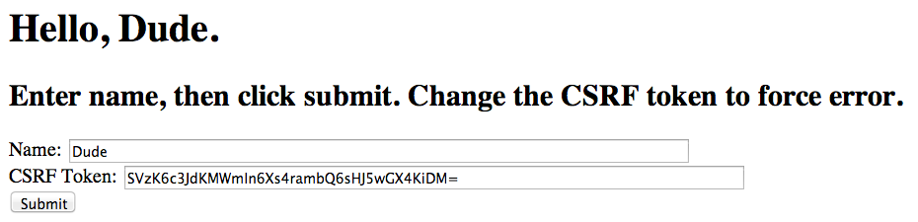

Notice the CSRF token. This changes on each request to ensure that only authorized requests are coming into this web application. Go ahead and refresh the form and notice that the CSRF token changes each time.

When you see the above form and the new tokens upon each GET request, move on to the next step.

## Change the name and view the result

11. Enter a new name in the name field and view the result. You should see something similar to the following:

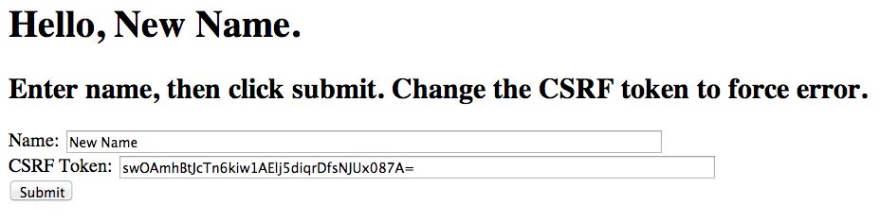

The site successfully handled the POST and rendered a new model. When the site is behaving properly, move on to the next step.

## Elicit a CSRF attack prevention

Now, we're going to simulate a CSRF attack. An attacker cannot know the CSRF token when attempting a request from a third party machine; the CSRF can only come from the origin web server, and is cryptographically secure.

12. Before the next form submittal, change the value of the CSRF token (or delete it), simulating an attack. The resultant page should look something like the following:

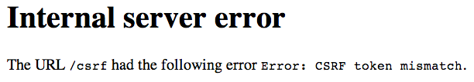

Our CSRF middleware component, configured in lusca-test/middleware.js, has detected the unauthorized request and denied it! Issue a new GET request to http://localhost:8000/csrf and resubmit the form without changing the CSRF token; you should see a successful result.

When you see the site behaving correctly, move on to the next step, knowing that the browser can now only respond to requests that originated from this server.

## Introduce a cross-site scripting (XSS) vulnerability

Next, we're going to see how a site can open a hole for an attacker to issue a cross-site scripting (XSS) attack.

12. Stop the web server and issue the command yo kraken:controller echo, which will generate a model, controller view, and i18n bundle in their respective places. As you might guess by the name, we're going to simply echo a string that the user submits via a web form.

## Implement the echo functionality

Now, let's implement the echo functionality.

13. First, let's modify the generated echo model, by replacing the content of lusca-test/models/echo.js with the following:

module.exports = function EchoModel() {

return {

message: 'Enter a message'

};

};

14. Next, update the controller to handle HTTP GET & POST requests by simply populating the model with the value of the message variable:

module.exports = function (app) {

var model = new EchoModel();

function handle(req, res) {

model.message = req.param('message') || model.message;

res.render('echo', model);

}

app.get('/echo', handle);

app.post('/echo', handle);

};

15. Now, update the Dust template lusca-test/public/templates/echo.dust that is the HTML form page to have the following content:

{>"layouts/master" /}

{<body}

<h1>{@pre type="content" key="greeting"/}</h1>

<form method="post">

Message: <input type="text" name="message" value="{message}" size="100"/>

<input type="hidden" name="_csrf" value="{_csrf}"/>

<input type="submit" value="Submit"/>

</form>

{/body}

As you can see, it's a simple form with an input that will be echoed in the <h1> element.

16. Update the i18n properties to introduce the XSS vulnerability by changing its content to the following:

greeting=You entered: {message|s}

Notice the trailing |s in the curly braces; this instructs Dust.js not to do any escaping of the content, instead rendering the content as given. *This, by the way, is the key to the XSS vulnerability.*

## Start the vulnerable site

17. Restart the website with npm start and test that the form is behaving properly; that is, that it is echoing the contents of the message form variable.

Now, it's time to put on our attacker hat. Try entering a message value that includes some HTML, like Boo <em>Hoo!</em> and notice what happens when its rendered. You should see something like the following:

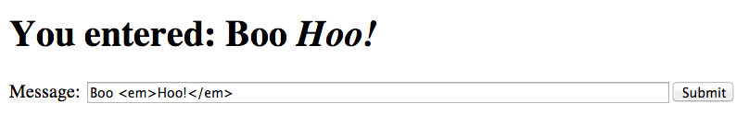

The browser is being given literal HTML from the Dust template, so it interprets the HTML verbatim! What do you suppose would happen if, instead of <em>, an attacker used <script> tags? Yes, you guessed it. They could get the browser to execute arbitrary JavaScript! Let's try it.

## Creating an HTML attack page

All our attacker needs to do now is to get a potential victim to click on a link that looks something like http://localhost:8000/echo?message=Hi&lt;script src=&#39;http://localhost:8000/js/evil.js&#39;&gt;&lt;/script&gt;. As you might expect, once the victim clicks on the link, the browser will see the <script> element, then load and execute the script.

18. Create a standalone HTML page at lusca-test/puppies.html, demonstrating a way an attacker might convince a victim to click on the link. Make its content the following:

<html>

<body>

<h2>Click <a href="http://localhost:8000/echo?message=Hi&lt;script src=&#39;http://localhost:8000/js/evil.js&#39;&gt;&lt;/script&gt;">here</a> if you LOVE PUPPIES!</h2>

</body>

</html>

While this example uses localhost:8000 for both the target of the attack and the attacker's JavaScript file, a real example would tell the browser to load the script from some other location, like http://evil.com/js/evil.js.

Any naïve victims who love puppies will certainly click the link.

Let's create an evil JavaScript page that will simply put up an alert indicating that the target site has been hacked.

19. Create the file lusca-test/public/js/evil.js and make its content the following:

alert("You've been duped!");

## View the attack result

20. Restart the web server, then open the file lusca-test/puppies.html in a browser. It should look like the following:



Go ahead & click the link, since you are clearly naïve and love puppies so much. You should see the results of our evil JavaScript file's execution:

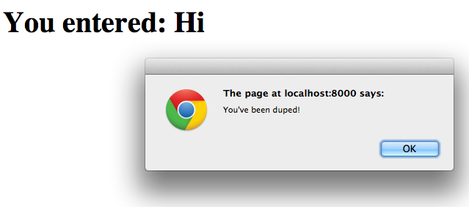

As you can see, the browser received literal HTML and simply executed it!

## Close the XSS hole

Now, let's fix our site to no longer be susceptible to the XSS vulnerability.

21. Change the file lusca-test/locales/US/en/echo.properties to force HTML escaping:

greeting=You entered: {message|h}

22. Restart the server, reopen lusca-test/puppies.html in a browser, and click on the link again. This time, we should see something similar to this:



Now, the browser is no longer executing the HTML, because our Dust template is ensuring that it is HTML encoding any characters in the message value that would be interpreted literally by the browser!

What's the moral of this story? *Make sure that you're escaping content that you don't want the browser to execute!*

## Add a controller to test content security policies (CSP)

Next, we're going to control from which sources our web site can download JavaScript files, fonts, styles, etc.

12. Stop the web server and issue the command yo kraken:controller csp, which will generate a model, controller, view, and i18n bundle in their respective places.

## Update the i18n CSP bundle

13. Open the i18n bundle lusca-test/locales/US/en/cap.properties and change its content to the following:

greeting=Hello, CSP!

## Update the CSP view

14. Open the Dust template lusca-test/public/templates/csp.dust to contain the following:

{>"layouts/master" /}

{<body}

<script type="text/javascript" src="https://ajax.googleapis.com/ajax/libs/jquery/1.11.0/jquery.min.js"></script>

<script type="text/javascript" src="js/csp-detect.js"></script>

{/body}

Notice that this template is including an external jQuery script and another script from the originating website, <http://localhost:8000/js/csp-detect.js>.

## Create the CSP detection script

15. Create a new file called lusca-test/public/js/csp-detect.js and set its contents to the following:

'use strict';

function detect() {

var not;

if (window.$) {

not = '';

} else {

not = 'NOT ';

}

document.write('<h1>External script ' + not + 'loaded!</h1>');

}

detect();

As you can see, this script will detect whether or not the jQuery script was loaded and render a message saying so.

## View default CSP behavior

If the appsec property's csp property evaluates to false, then there is no restriction on the sources that the browser is allowed to download from.

16. Restart the web application (npm start) and open the URL http://localhost:8000/csp, which will render the view that includes jQuery and our own csp-detect.js. You should see something similar to the following:



As you can see, the browser successfully loaded the external jQuery script as well as our own csp-detect.js script, which rendered the message above. When you see this message, move on to the next step.

## Restrict loading to the origin server

Now, we're going to instruct the browser that we only want it to load scripts from the originating website.

17. Update the csp entry of the appsec property to contain the following content:

{ "policy": { "default-src": "'self'" } }

This causes the Lusca middleware to include the following HTTP header in all responses:

Content-Security-Policy: default-src 'self';

This HTTP header instructs the browser to only allow scripts, styles, fonts, etc. to be loaded from the originating website. Let's see this in action.

## Elicit script downloading protection

18. Restart the web server now that you've made the change to CSP configuration and open http://localhost:8000/csp in the browser. You should see something similar to the following:



The inclusion of the HTTP Content-Security-Policy header caused the browser to skip loading jQuery from the external site!

When you see this response, you've completed this lab!