Dust

In this lab, you will work with a Dust template in an Express application using Makara and Adaro.

# Objectives

In this lab, you will

* extract a model from a static HTML page,
* use Dust logic helpers and section tags to navigate your model,
* transform a static HTML page into a Dust template.

# Enable Dust templates in an Express application

In your lab directory you will see a file named app.js. This program drives the bulk of processing in this application including Dust template rendering.

1. Open a shell, cd to the lab directory, and run npm install. This will install all of the necessary modules in the lab directory including Makara and Adaro.

# Open app.js and establish routing

1. Open the file app.js. After the lines commented with ‘To-do’, enter a line that will ‘require’ the index.js file in the routes folder.

# Open the index.js and controller.js files

1. In the routes folder, open the file index.js in an editor. Uncomment the lines in the router function and study how routing is established.
2. Open controller.js under the routes folder. Insert a line that will ‘require’ quiz.js under the model folder and assign it to var model. Notice that the model object returned is used in the following line to render our Dust template:  
   res.render('templates/quiz', model);
3. Examine your data model, model/quiz.js.

This defines a quiz with title, id, etc. Each quiz has multiple questions. Each question has text, type of question (single answer, multiple answers, input text) and answers. Each answer has an id and the answer text as shown below:

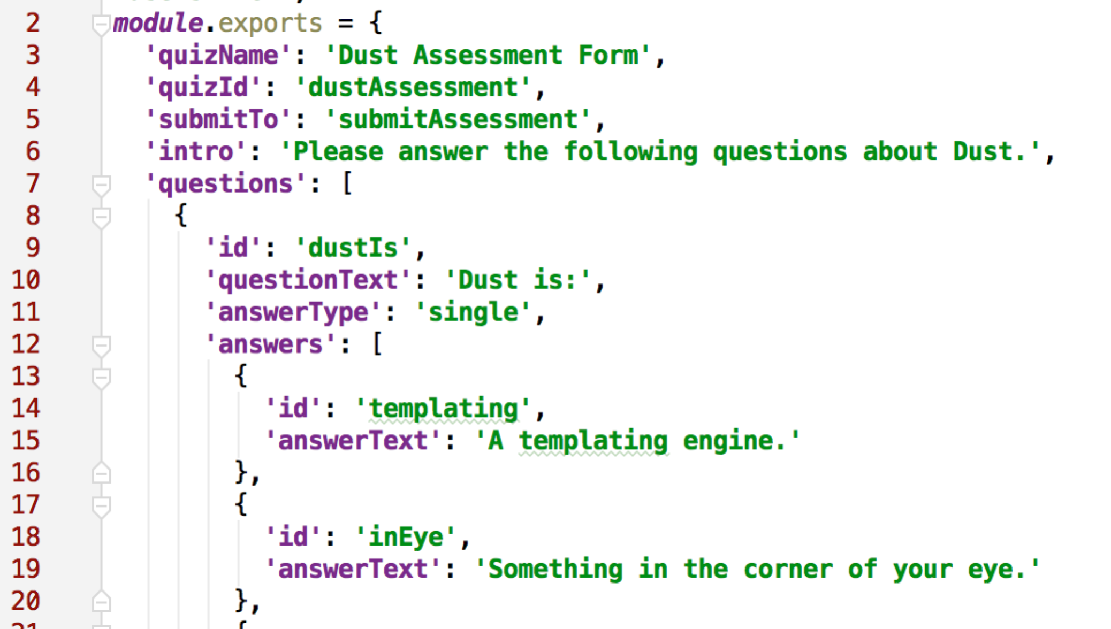

1. The following is a set of instructions for how to build the dust page.

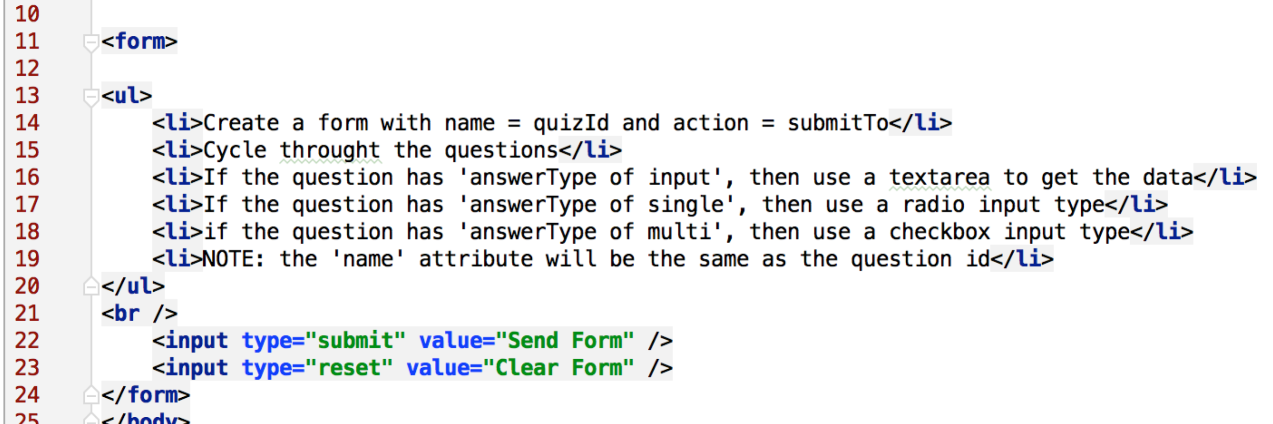

1. Using the data model above and the hints above, design a Dust page that generates similar HTML as the original_quiz.html.

# Create the template logic

1. There are a number of places where you will want to use the easy iteration of arrays built into Dust sections. There's also a lot of similarity between a set of radio button inputs and a checkbox input. Consider using a logic helper.

There is no "right" solution to this lab. There is a tremendous amount of flexibility in Dust. Have fun coming up with surprises!

When you're finished page matches the original, this lab is complete!