React – User Input

In this lab, you will refactor an existing app to use the three input methods.

# Objectives

In this lab, you will

* Use an existing React app named, ‘react-app’
* Change the Elements.js, Controlled.js, and Uncontrolled.js files
* Implement the embedded TODOs
* Run the app

# Run the React app to verify correctness

1. Change to the /solution/react-app folder and start the application:

yarn install

yarn start.

1. Open the browser to localhost:3000 and the page should look like this:

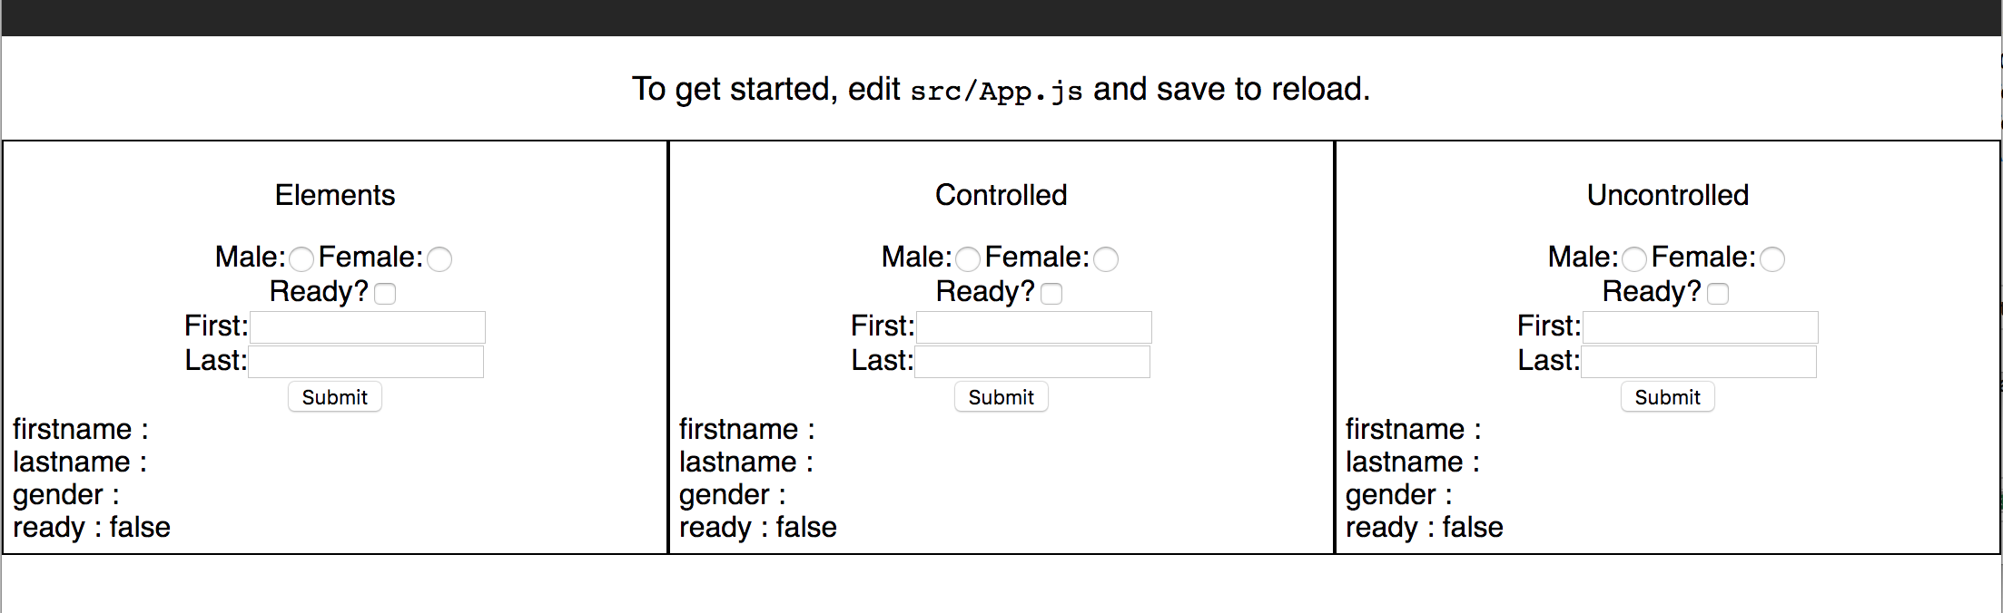

1. Enter data in all three sections. Notice how the Controlled inputs immediately update the state where the others require the SUBMIT button to be clicked.

# Lab Exercise

1. Stop the solution server.
2. Change to the lab/react-app/src/components folder. Start the application:

yarn install

yarn start.

1. Examine the Elements.js file as shown below:

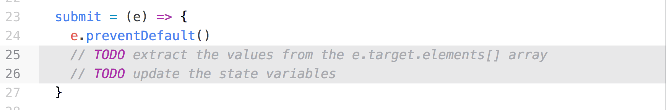

1. Using the slides, extract the input element values using the e.target.elements[] array. Set the state variables to the values.
2. Open the browser to localhost:3000 and verify the first section works correctly. Note, you must click on the Submit button to update the state variables.

# Controlled Inputs

1. Open the Controlled.js file as shown below:

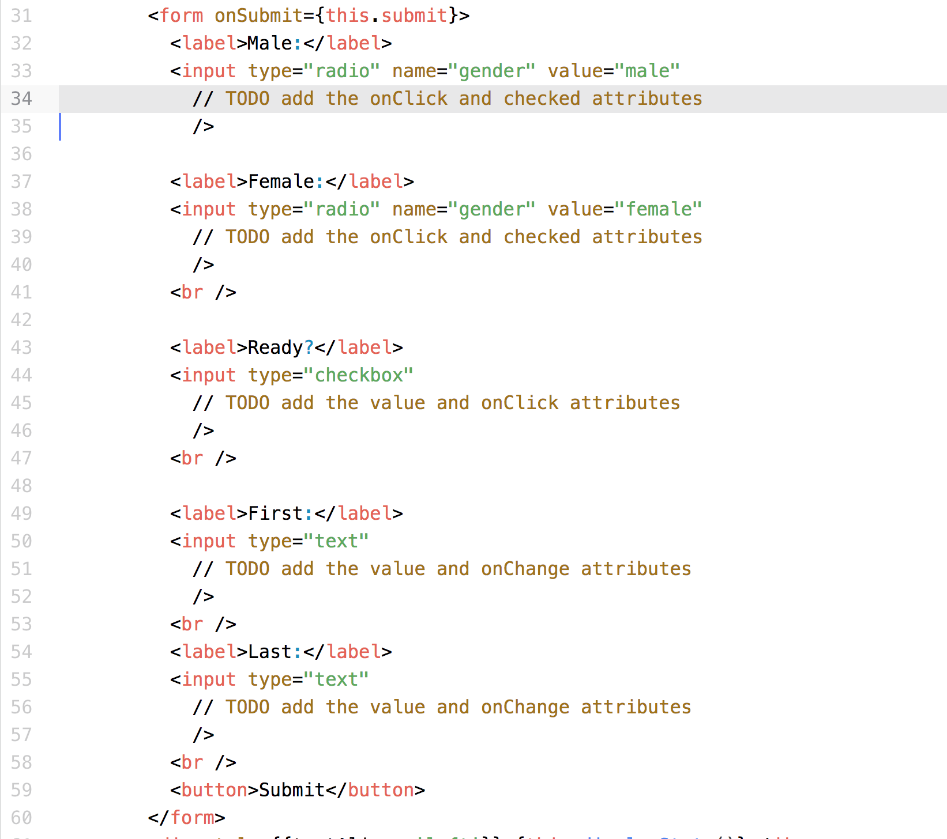

1. For each of the TODOs, add the appropriate attributes. NOTE: the radio buttons and checkbox require the checked attribute to render the correct state.
2. On the browser, verify the Controlled section works correctly. NOTE: the state updates immediately when the input changes.

# Un-Controlled Input

1. Examine the file, Uncontrolled.js as shown below:

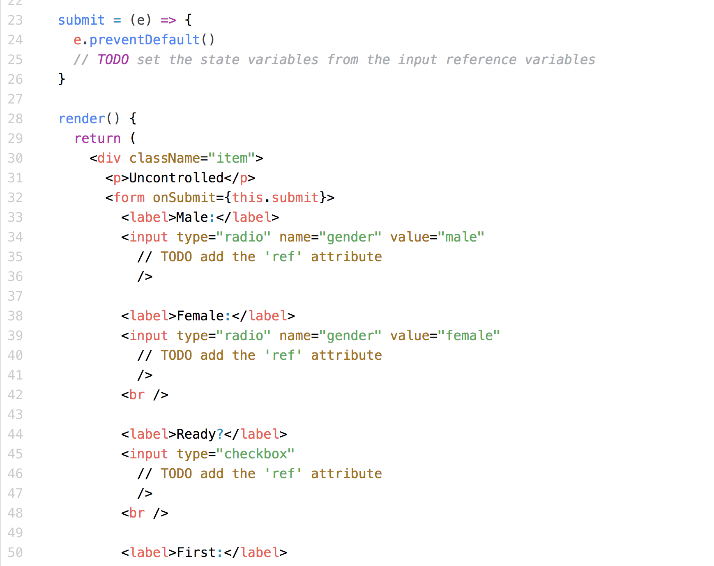

1. Create a ref attribute for each input. Define an instance variable for each input. NOTE: one convention for local, private variables is to have an initial ‘_’ prepended to the name.
2. Change the onSubmit() method to extract the value from each reference variable. Set the appropriate state variable with the results.
3. On the browser, verify the Uncontrolled section works correctly. NOTE: the application only updates the state variables when the user clicks on the SUBMIT button.

# Food for Thought

1. When is it useful to have partial input (like the Controlled input)?
2. Most people do NOT use the Elements method. Why?

Congratulations. You have completed this lab.