React – Best Practices

In this lab, you will refactor a TODO app to use Best Practices.

# Objectives

In this lab, you will

* Use an existing React app named, ‘react-app’
* Change the ‘TodoList.js’ to contain Presentation Components
* Create a ‘TodoContainer.js’
* Run the app

# Run the React app to verify correctness

1. Change to the /lab/react-app folder and start the application:

yarn install

yarn start.

1. Open the browser to localhost:3000 and the page should look like this:

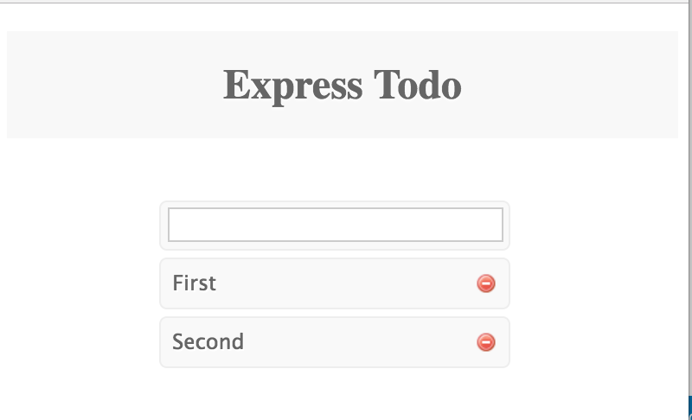

# Edit the TodoList.js to use Presentation Components

1. The current file, src/components/TodoList.js defines three components, TodoItem, TodoInput, and TodoList. These components have a mix of presentation logic and business logic. This lab separates the two concerns.
2. First, copy the file to TodoList.orig.js. We can steal the business logic later.
3. Edit the file, src/components/TodoList.js. Change all three components into presentation components. Define them as functions with one parameter, props. Examine the solution file if needed.

# Modify the Container

1. Modify the file, src/components/TodoContainer.js. Most of the code we need already exists in the original TodoList.js. Copy what you can.
2. Examine sections of the TodoContainer.js source file below:



1. In the above, copy the initial state of the todos array.



1. In the above, transfer the delete() and addTodo() functions to here. NOTE: use arrow functions when defining them. NOTE: remove the commas!!

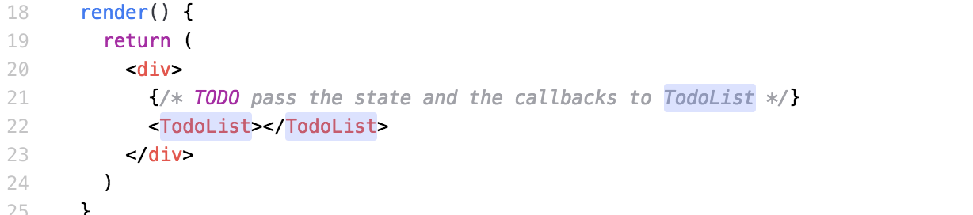

1. In the above, set the TodoList attributes.
2. In all three components, define the property types using:

PropTypes.string

PropTypes.func

PropTypes.array

Add an ‘isRequired’ to the types when needed. For example, the TodoList values would look like this:

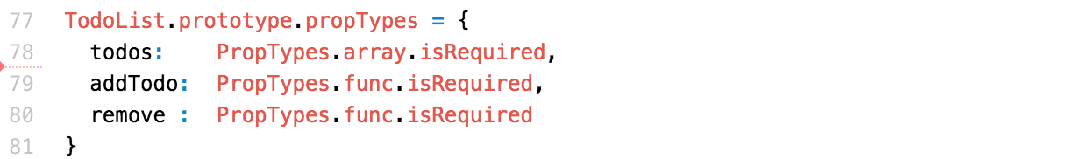

1. Save everything and watch it work.

# Food for Thought

1. Why is it useful to separate Components into View Components and Container Components?
2. Why use a pure function for the View Components?
3. Does the View Component connect directly to the Business Logic?

Congratulations. You have completed this lab.