**МІНІСТЕРСТВО ОСВІТИ І НАУКИ УКРАЇНИ**

**НАЦІОНАЛЬНИЙ УНІВЕРСИТЕТ «ЛЬВІВСЬКА ПОЛІТЕХНІКА»**

Інститут комп’ютерних технологій, автоматики та метрології

Кафедра ЕОМ



**Звіт**

Лабораторна робота №3

З дисципліни: “Моделювання комп’ютерних систем”

Тема: "Поведінковий опис цифрового автомата. Перевірка роботи автомата за допомогою стенда Elbert V2 – Spartan 3A FPGA"

**Виконав:**

ст. гр. КІ-24

Дроздовський М.Б

**Перевірив:**

Кузьо М. М.

ЛЬВІВ 2020

**Мета роботи:**

На базі стенда реалізувати цифровий автомат для обчислення

значення виразу.

**MUX.vhd**

library IEEE;

use IEEE.STD_LOGIC_1164.ALL;

entity MUX is

port(

InputA,InputB,InputC: in std_logic_vector(7 downto 0);

IN_SEL: in std_logic_vector(1 downto 0);

MuxOut: out std_logic_vector(7 downto 0)

);

end MUX;

architecture MUX of MUX is

begin

MUX_pr: process(InputA,InputB,InputC,IN_SEL)

begin

case IN_SEL is

when "00" =>

MuxOut<= InputA;

when "01" =>

MuxOut<= InputB;

when "10" =>

MuxOut<= InputC;

when others =>

MuxOut<="00000000";

end case;

end process MUX_pr;

end MUX;

**Симуляція MUX**

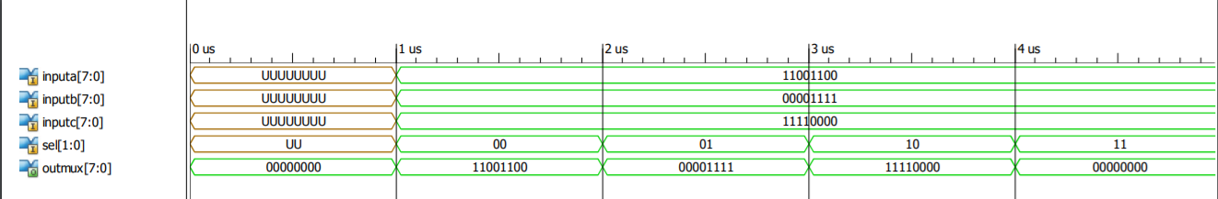

**ACC.vhd**

library IEEE;

use IEEE.STD_LOGIC_1164.ALL;

entity ACC is

port(

CLK: in std_logic;

WR,RST: in std_logic;

InData: in std_logic_vector(7 downto 0);

OutData: out std_logic_vector(7 downto 0)

);

end ACC;

architecture ACC of ACC is

signal tempData: std_logic_vector(7 downto 0):="00000000";

begin

ACC_proc : process(CLK, InData, WR, RST)

begin

if (rising_edge(CLK)) then

if (WR = '1') then

tempData <= InData;

OutData<=InData;

elsif(RST = '1') then

tempData <= "00000000";

OutData<="00000000";

end if;

end if;

end process ACC_proc;

end ACC;

**Симуляція ACC**

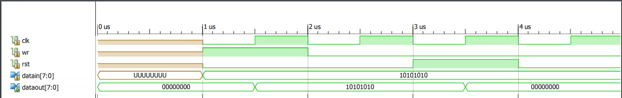

**ALU.vhd**

library IEEE;

use IEEE.STD_LOGIC_1164.ALL;

use IEEE.NUMERIC_STD.ALL;

entity ALU is

port(

A,B: in std_logic_vector(7 downto 0);

OP: in std_logic_vector(1 downto 0);

AluOut: out std_logic_vector(7 downto 0);

OverFlow: out std_logic

);

end ALU;

architecture ALU of ALU is

signal tempOverFlow: std_logic:='0';

begin

ALU_pr: process(OP,A,B)

variable intA,intB,intC: integer;

variable Result: std_logic_vector(9 downto 0);

begin

intA:= to_integer(unsigned(A));

intB:= to_integer(unsigned(B));

if(tempOverFlow = '1') then

intC:= 1;

else

intC:= 0;

end if;

Result:= "0000000000";

case OP is

when "00" =>

Result:= std_logic_vector(to_signed(intA+intB, 10));

tempOverFlow<=Result(8);

AluOut<= Result(7 downto 0);

when "01" =>

Result:= std_logic_vector(to_signed(intA-intB+(intC*256), 10));

tempOverFlow<=Result(8);

AluOut<= Result(7 downto 0);

when "10" =>

AluOut<= std_logic_vector(unsigned(A) sll intB);

when "11" =>

AluOut<=B;

when others =>

AluOut<="00000000";

tempOverFlow<='0';

end case;

end process ALU_pr;

OverFlow<=tempOverFlow;

end ALU;

**Симуляція ALU**

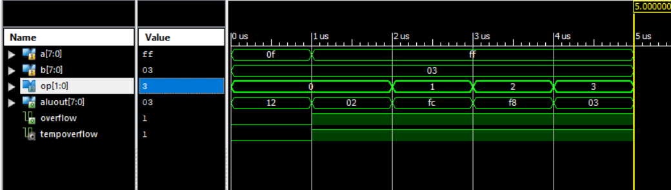

**RAM.vhd**

library IEEE;

use IEEE.STD_LOGIC_1164.ALL;

entity RAM is

port(

CLK: in std_logic;

InData: in std_logic_vector(7 downto 0);

ADDR, WR: in std_logic;

RamOut: out std_logic_vector(7 downto 0)

);

end RAM;

architecture RAM of RAM is

signal OP1,OP2: std_logic_vector(7 downto 0):= "00000000";

begin

RAM_pr: process(CLK,InData,ADDR,WR)

begin

if(rising_edge(CLK)) then

if(ADDR = '0') then

if(WR = '1') then

OP1<= InData;

RamOut<= InData;

else

RamOut<= OP1;

end if;

elsif(ADDR = '1') then

if(WR = '1') then

OP2<= InData;

RamOut<= InData;

else

RamOut<= OP2;

end if;

end if;

end if;

end process RAM_pr;

end RAM;

**Симуляція RAM**

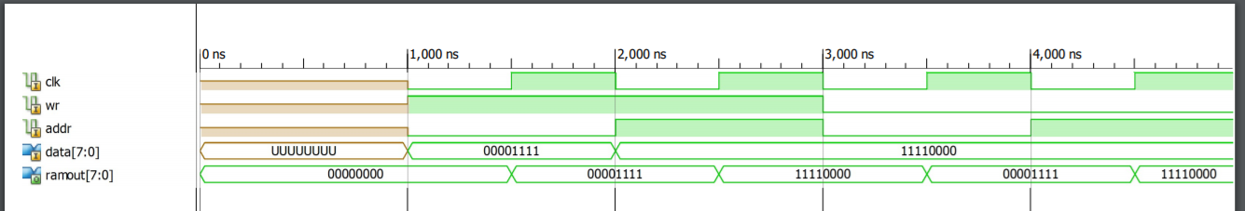

**CU.vhd**

library IEEE;

use IEEE.STD_LOGIC_1164.ALL;

use IEEE.NUMERIC_STD.ALL;

entity ALU is

port(

A,B: in std_logic_vector(7 downto 0);

OP: in std_logic_vector(1 downto 0);

AluOut: out std_logic_vector(7 downto 0);

OverFlow: out std_logic

);

end ALU;

architecture ALU of ALU is

signal tempOverFlow: std_logic:='0';

begin

ALU_pr: process(OP,A,B)

variable intA,intB,intC: integer;

variable Result: std_logic_vector(9 downto 0);

begin

intA:= to_integer(unsigned(A));

intB:= to_integer(unsigned(B));

if(tempOverFlow = '1') then

intC:= 1;

else

intC:= 0;

end if;

Result:= "0000000000";

case OP is

when "00" =>

Result:= std_logic_vector(to_signed(intA+intB, 10));

tempOverFlow<=Result(8);

AluOut<= Result(7 downto 0);

when "01" =>

Result:= std_logic_vector(to_signed(intA-intB+(intC*256), 10));

tempOverFlow<=Result(8);

AluOut<= Result(7 downto 0);

when "10" =>

AluOut<= std_logic_vector(unsigned(A) sll intB);

when "11" =>

AluOut<=B;

when others =>

AluOut<="00000000";

tempOverFlow<='0';

end case;

end process ALU_pr;

OverFlow<=tempOverFlow;

end ALU;

**Симуляція CU**

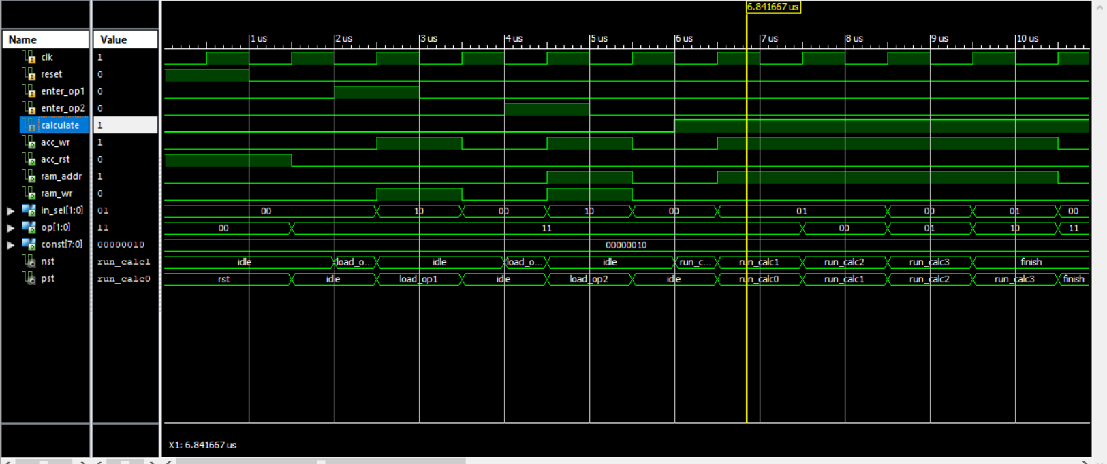

**SevenSegDecoder.vhd**

library IEEE;

use IEEE.STD_LOGIC_1164.ALL;

use IEEE.NUMERIC_STD.ALL;

use IEEE.STD_LOGIC_UNSIGNED.ALL;

entity SevenSegDecoder is

port(

InputData: in std_logic_vector(7 downto 0);

CLK: in std_logic;

Seg_A: out std_logic;

Seg_B: out std_logic;

Seg_C: out std_logic;

Seg_D: out std_logic;

Seg_E: out std_logic;

Seg_F: out std_logic;

Seg_G: out std_logic;

Seg_DP: out std_logic;

Com_Ones: out std_logic;

Com_Tens: out std_logic;

Com_Hundreds: out std_logic

);

end SevenSegDecoder;

architecture SevenSegDecoder of SevenSegDecoder is

signal ONES_BUS : STD_LOGIC_VECTOR(3 downto 0) := "0000";

signal DECS_BUS : STD_LOGIC_VECTOR(3 downto 0) := "0000";

signal HONDREDS_BUS : STD_LOGIC_VECTOR(3 downto 0) := "0000";

begin

BIN_TO_BCD : process (InputData)

variable hex_src : STD_LOGIC_VECTOR(7 downto 0) ;

variable bcd : STD_LOGIC_VECTOR(11 downto 0) ;

begin

bcd := (others => '0') ;

hex_src := InputData;

for i in hex_src'range loop

if bcd(3 downto 0) > "0100" then

bcd(3 downto 0) := bcd(3 downto 0) + "0011" ;

end if ;

if bcd(7 downto 4) > "0100" then

bcd(7 downto 4) := bcd(7 downto 4) + "0011" ;

end if ;

if bcd(11 downto 8) > "0100" then

bcd(11 downto 8) := bcd(11 downto 8) + "0011" ;

end if ;

bcd := bcd(10 downto 0) & hex_src(hex_src'left) ; -- shift bcd + 1 new entry

hex_src := hex_src(hex_src'left - 1 downto hex_src'right) & '0' ; -- shift src + pad with 0

end loop ;

HONDREDS_BUS <= bcd (11 downto 8);

DECS_BUS <= bcd (7 downto 4);

ONES_BUS <= bcd (3 downto 0);

end process BIN_TO_BCD;

INDICATE : process(CLK)

type DIGIT_TYPE is (ONES, DECS, HUNDREDS);

variable CUR_DIGIT : DIGIT_TYPE := ONES;

variable DIGIT_VAL : STD_LOGIC_VECTOR(3 downto 0) := "0000";

variable DIGIT_CTRL : STD_LOGIC_VECTOR(6 downto 0) := "0000000";

variable COMMONS_CTRL : STD_LOGIC_VECTOR(2 downto 0) := "000";

begin

if (rising_edge(CLK)) then

case CUR_DIGIT is

when ONES =>

DIGIT_VAL := ONES_BUS;

CUR_DIGIT := DECS;

COMMONS_CTRL := "001";

when DECS =>

DIGIT_VAL := DECS_BUS;

CUR_DIGIT := HUNDREDS;

COMMONS_CTRL := "010";

when HUNDREDS =>

DIGIT_VAL := HONDREDS_BUS;

CUR_DIGIT := ONES;

COMMONS_CTRL := "100";

when others =>

DIGIT_VAL := ONES_BUS;

CUR_DIGIT := ONES;

COMMONS_CTRL := "000";

end case;

case DIGIT_VAL is --abcdefg

when "0000" => DIGIT_CTRL := "1111110";

when "0001" => DIGIT_CTRL := "0110000";

when "0010" => DIGIT_CTRL := "1101101";

when "0011" => DIGIT_CTRL := "1111001";

when "0100" => DIGIT_CTRL := "0110011";

when "0101" => DIGIT_CTRL := "1011011";

when "0110" => DIGIT_CTRL := "1011111";

when "0111" => DIGIT_CTRL := "1110000";

when "1000" => DIGIT_CTRL := "1111111";

when "1001" => DIGIT_CTRL := "1111011";

when others => DIGIT_CTRL := "0000000";

end case;

COM_ONES <= COMMONS_CTRL(0);

COM_TENS <= COMMONS_CTRL(1);

COM_HUNDREDS <= COMMONS_CTRL(2);

SEG_A <= DIGIT_CTRL(6);

SEG_B <= DIGIT_CTRL(5);

SEG_C <= DIGIT_CTRL(4);

SEG_D <= DIGIT_CTRL(3);

SEG_E <= DIGIT_CTRL(2);

SEG_F <= DIGIT_CTRL(1);

SEG_G <= DIGIT_CTRL(0);

SEG_DP <= '0';

end if;

end process INDICATE;

end SevenSegDecoder;

**Симуляція SevenSegDecoder**

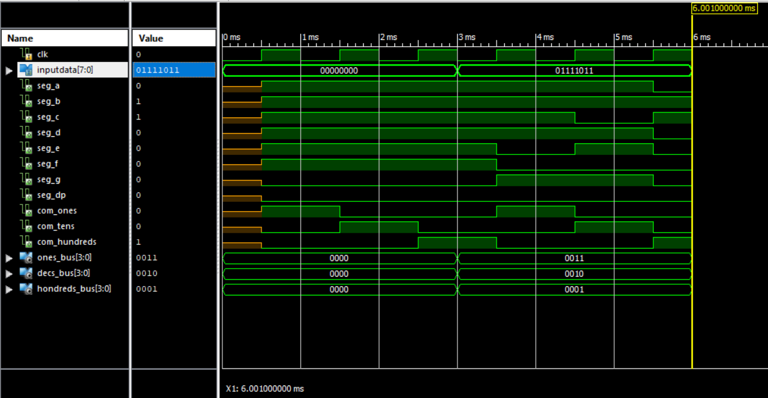

**ArithmeticUnit.sch**

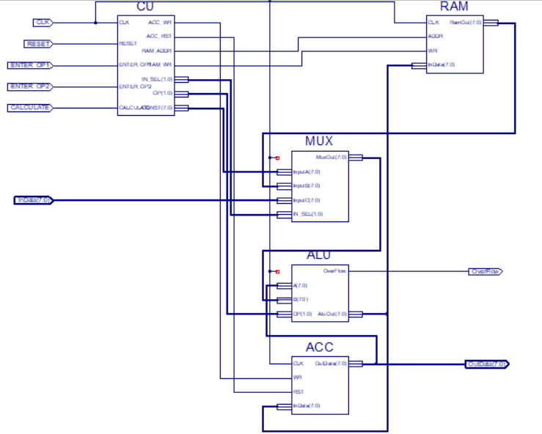

**Симуляція ArithmeticUnit**

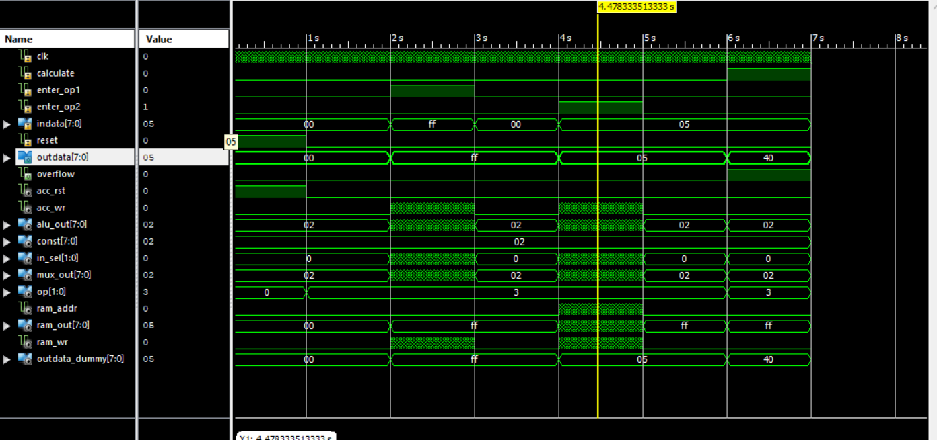

**TopLevel.sch**

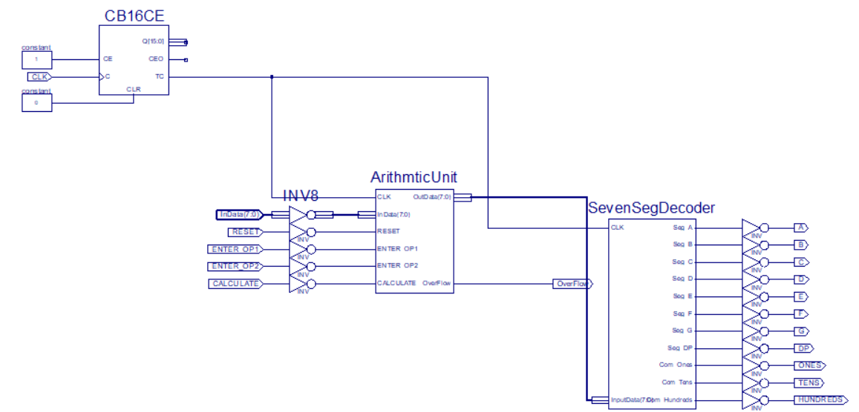

**Висновок:**

На лабораторній роботі я синтезував цифровий обчислювач та перевірив його роботу.