%spark

import org.apache.spark.sql.SparkSession

val spark = SparkSession.builder().master("local[*]").appName("PySpark_Tutorial").getOrCreate()

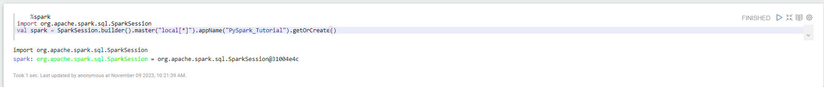

val df = spark.read.format("csv").option("header","true").load("/home/av/Downloads/stocks_price_final.csv")

df.show()

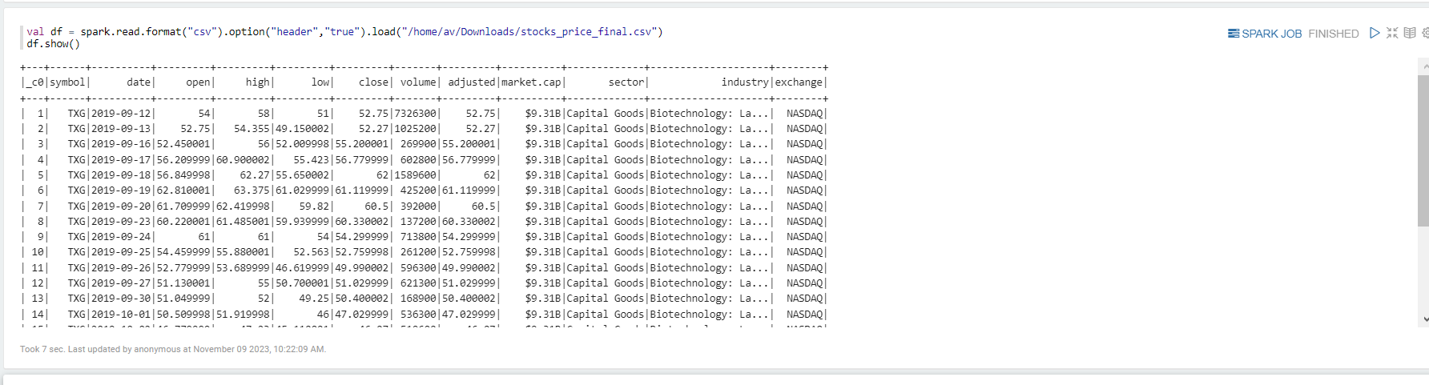

val df_old = spark.read.csv("/home/av/Downloads/stocks_price_final.csv")

df.show()

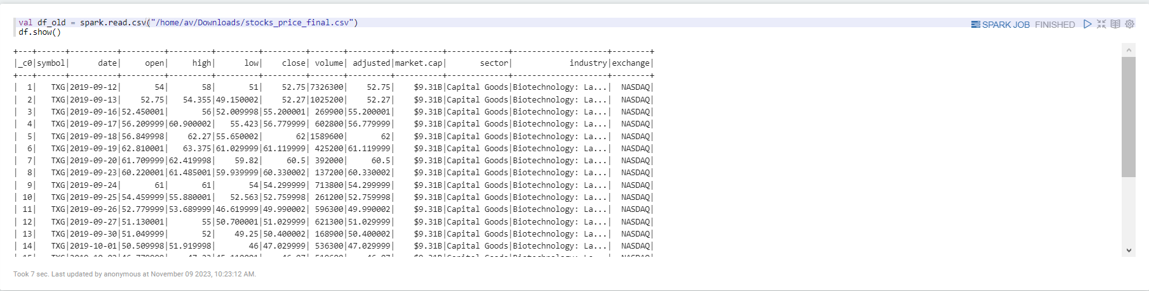

val data = df.limit(5)

data.show()

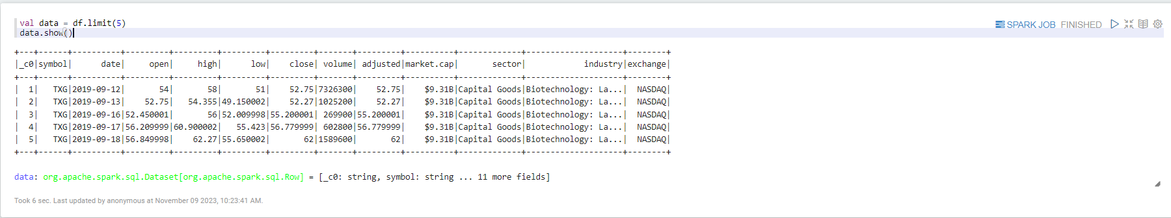

import org.apache.spark.sql.types._

val data_schema = Array(

StructField("_c0", IntegerType, true),

StructField("symbol", StringType, true),

StructField("data", DateType, true),

StructField("open", DoubleType, true),

StructField("high", DoubleType, true),

StructField("low", DoubleType, true),

StructField("close", DoubleType, true),

StructField("volume", IntegerType, true),

StructField("adjusted", DoubleType, true),

StructField("market_cap", StringType, true),

StructField("sector", StringType, true),

StructField("industry", StringType, true),

StructField("exchange", StringType, true)

)

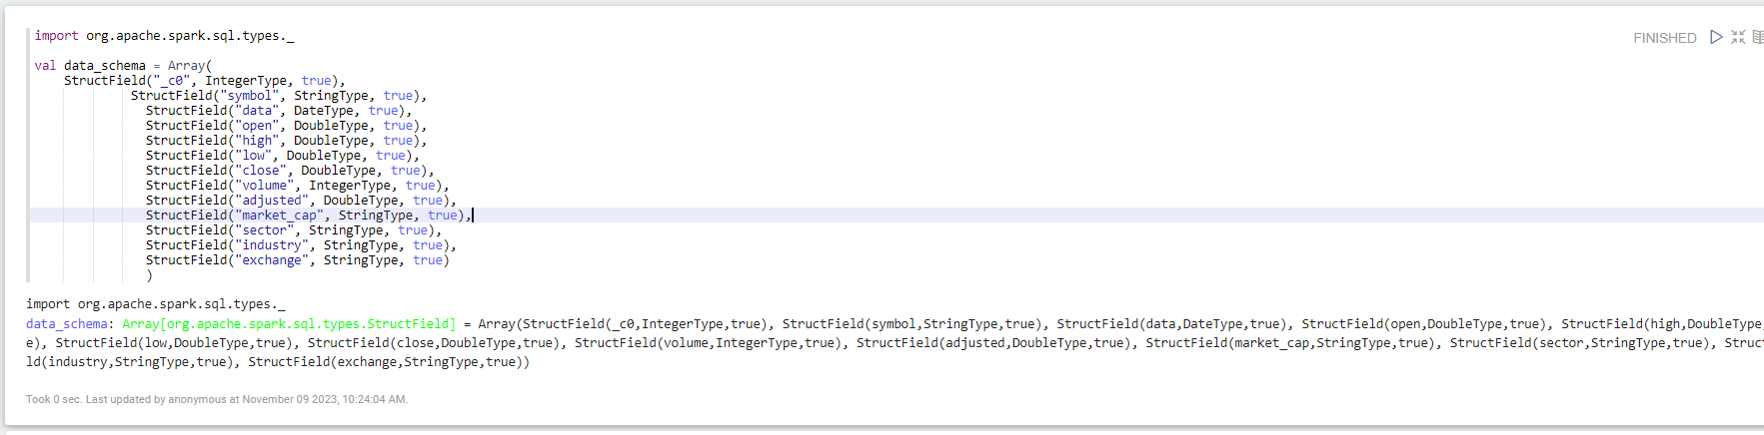

val final_struc = StructType(fields = data_schema)

val df = spark.read.format("csv").option("header","true").schema(final_struc).load("/home/av/Downloads/stocks_price_final.csv")

df.printSchema()

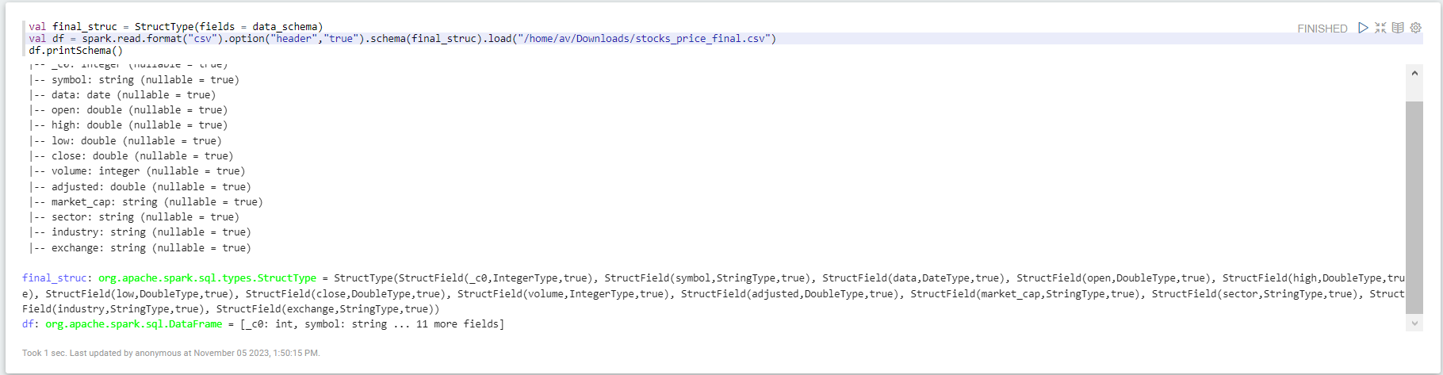

data.schema



data.dtypes



data.take(5)

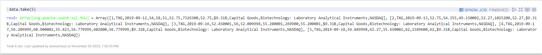



data.describe().show()

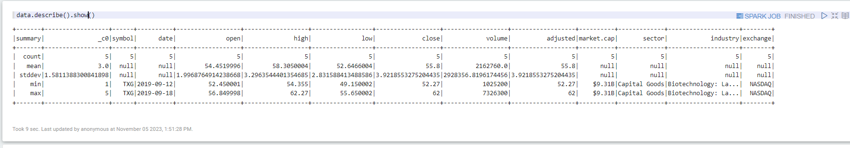

data.columns



data.count()



data.distinct().count()



data.distinct().show()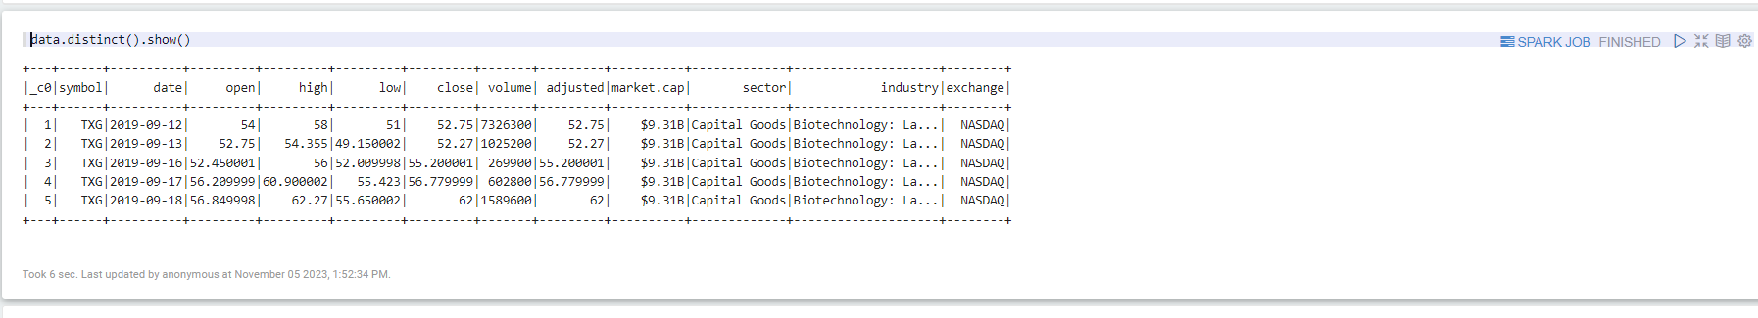

import org.apache.spark.sql.Row

import org.apache.spark.sql.functions.lit

val data_new = data.withColumn("test_new",lit("test"))

data_new.show(5)

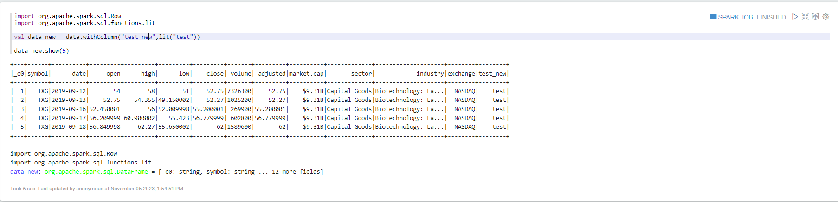

data_new.withColumnRenamed("test_new","test_new_1").show()

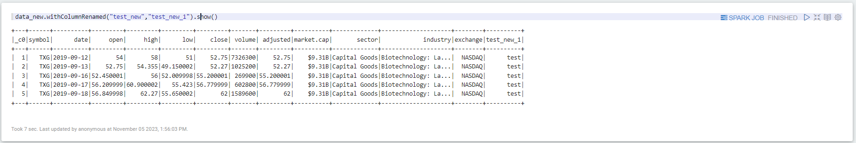

data_new.drop("test_new").show()

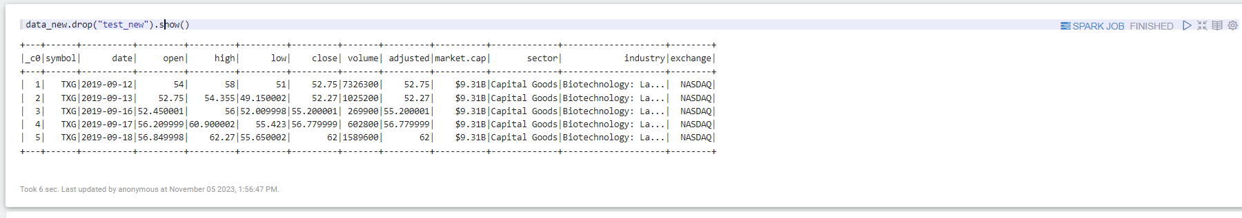

val data_null = data.withColumn("close",when(col("close")===62,null).otherwise(col("close")))



data_null.show()

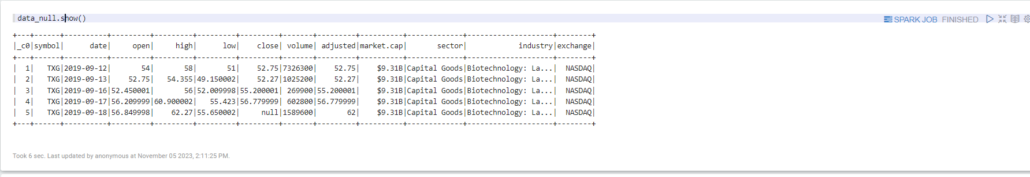

val data_null_new = data_null.withColumnRenamed("market.cap","market_cap")



data_null_new.na.drop().show()

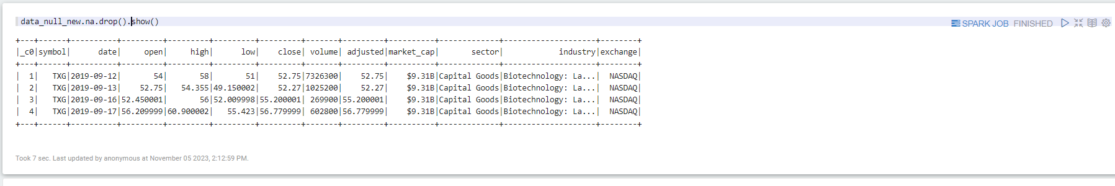

data.select("sector").show()

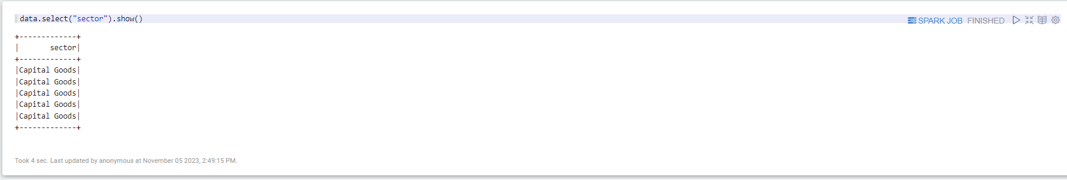

data.select("open","close","adjusted").show()

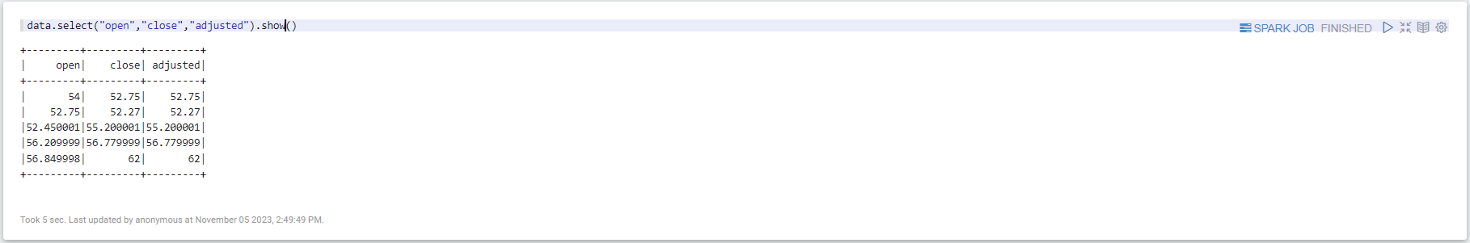

data.filter((col("open")>=54)).show()

