ELK-Network-Monitoring-Stack-Project-
A complete cloud monitoring system through the configuration of an ElastiSearch/Logstash/kibana stack server.

## 1. Automated ELK Stack Deployment

The milestones of this project were completed in the following steps:
- Creating a new Linux (Ubuntu 20x) VM to run ELK Stack dockerized container in the Previous creation of Virtual Cloud server Network in the Microsoft Azure Cloud Portal
- Provisioning ELK Stack container in Microsoft Azure Public Cloud in a different Azure Region and Availability Zone
- Provisioning ELK Stack with Ansible playbook (IaC - Infrastructure as Code)
- Provisioning Filebeat and Metricbeat with Ansible playbook in DVWA VMs

The files in this repository were used to configure the network depicted below.

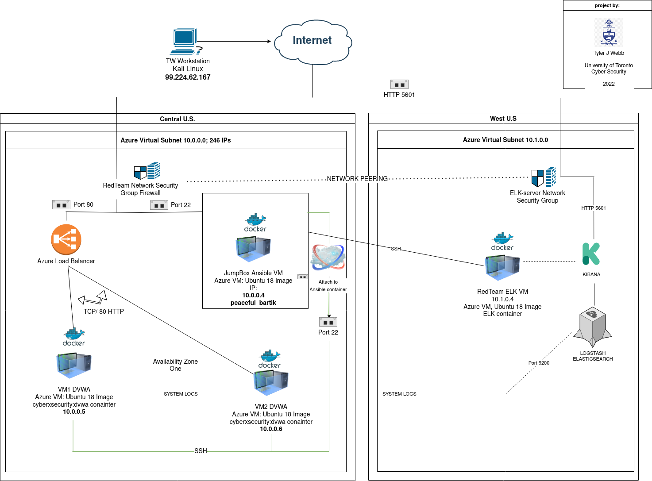

These files have been tested and used to generate a live ELK deployment on Azure. They can be used to either recreate the entire deployment pictured above. Alternatively, select portions of the playbook file may be used to install only certain pieces of it, such as Filebeat.

This document contains the following details:
- Description of the Topology
- Access Policies
- ELK Configuration
- Beats in Use
- Machines Being Monitored
- How to Use the Ansible Build

### 2. Description of the Topology

The main purpose of this network is to expose a load-balanced and monitored instance of DVWA, the Damn-Vulnerable Web Application. Within the diagram is also server that acts as a software defined Data center hosted in a private cloud in order to ensure Security, Reliability, Scalability, and availability.

- Security is achieved through the Network Security Group, Access Lists, Apache2 + MySQL containerized applications, JumpBox provisioners
- Reliability is achieved through the Microsoft Azure Environment
- Scalability is achieved through Ansible containers (IaC) and the Azure environment
- Availability is managed through Multiple ‘Availability Zone’ In the Central US and West US and Through a load balancer

- Load balancing ensures that the application will be highly available while still restricting unauthorized access to the network.
- Load Balancing also ensures that a server and a session can still operate even if a particular host fails (in this case, a VM in the network). Rules can be made to distribute traffic evenly across all hosts in a network, or to prioritize traffic through a tiered-system of preferred VMs.
- The advantage of a jump box provisioner is that it creates an secure environment that restricts access to the rest of the servers and can prevent additional attacks from malicious actors.

Integrating an ELK server allows users to easily monitor the vulnerable VMs for changes to the configurations and system logs.

- Filebeat is used to monitor inbound traffic, error messages, privileged escalations and log files and uses port 9200 to forward to Elastisearch and logstash for indexing and further analysis
- Metricbeat focuses on capturing statistics and metrics from system services and also forwards them to elasticsearch and logstash

The configuration details of each machine may be found below.

Name | Function | IP | OS
Host Machine | Sysdmin | Public IP | Kali Linux
Jump-box-Provisioner | Gateway | 10.0.0.4 : Dynamic IP | Linux
Web-1 | DVWA Web Server | 10.0.0.5 : Public IP | Linux
Web-2 | DVWA Web Server | 10.0.0.6 : Public IP | Linux
ELKStack | Monitoring Service (ELK) | 10.1.0.4 : Dynamic IP | Linux
Load Balancer

### Access Policies

The machines on the internal network are not exposed to the public Internet.

- Only the ELKstack machine can accept connections from the Internet.
- Access to this machine is only allowed from the following IP addresses:
  - Host Linux machine(Public IP Address): HTTP through TCP port 5601

Machines within the network can only be accessed by the host linux machine through the Jump Box-Provisioner. .
- JumpBoxProvisioner IP:10.0.0.4/24 via port 22 (SSH)
- Host Linux machine(Public IP Address): HTTP through TCP port 5601

A summary of the access policies in place can be found in the table below.

Name | Public Access | Allowed Source Address | Source:Port
JumpBox Provisioner | Various | Public Host IP | 22, 3389
Web-2 | no | 10.0.0.0/24 | 22
Web-2 | no | 10.0.0.0/24 | 22
ELKServer | various | 10.1.0.0/24 | 22, 5601
Load Balancer | no | Public Host IP | 80

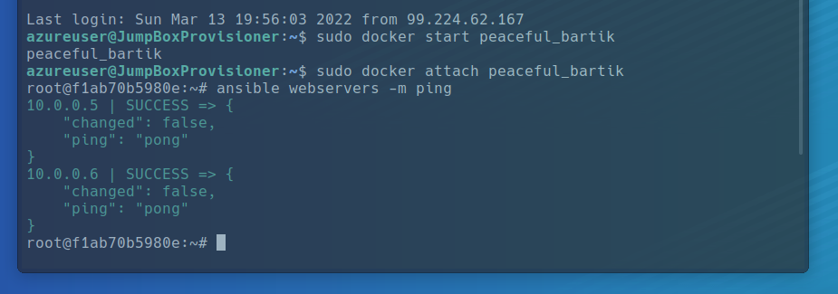

### Elk Configuration

Ansible was used to automate configuration of the ELK machine. Ansible is an automated tool that can provision software and manages configurations of IaC (infrastructure as code) application deployments. In this setup, there were no configurations performed manually. Automation in the context is advantageous because its ability o configure hundreds of machines quicker and more efficiently than a physical system. Ansible also saves time by using playbook scripts that automate the completing of multiple configuration tasks by combining them into one script or “play”. This is especially handy when creating new VM environments, patching servers or updating containers.

The playbook implements the following tasks:
- _TODO: In 3-5 bullets, explain the steps of the ELK installation play. E.g., install Docker; download
Installs Docker on Elk server machine
- Installs the following services:
  - docker.io
  - python3-pip
- Optimizing system memory
- Optimizing virtual memory
- Downloads the Elk container

The following screenshot displays the result of running `docker ps` after successfully configuring the ELK instance.
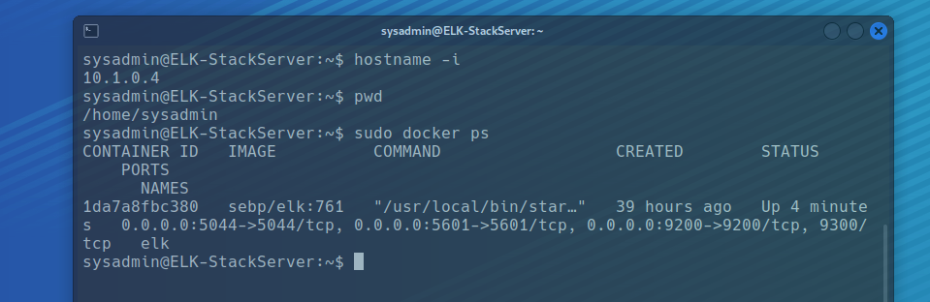



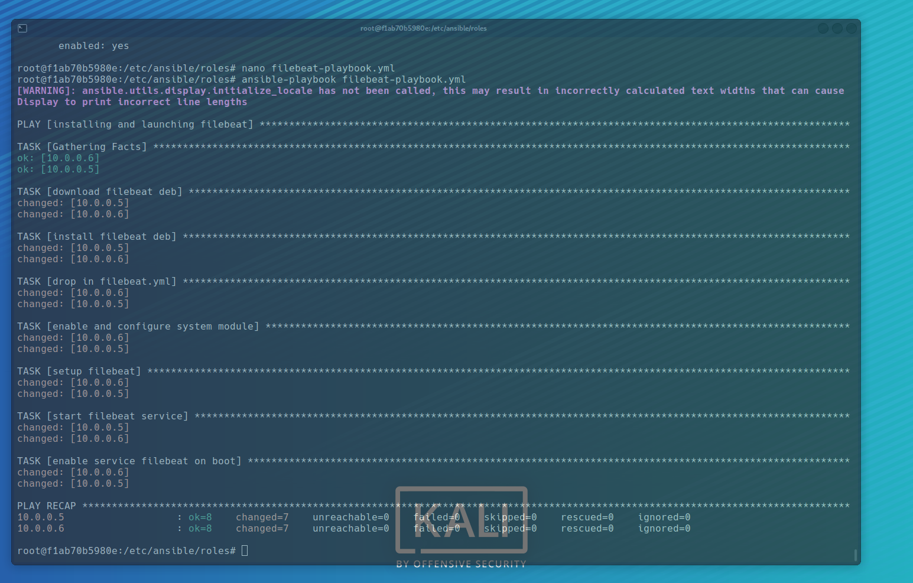

### Target Machines & Beats
This ELK server is configured to monitor the following machines:
Vms | Private IP
Web-1 (DVWA) | 10.0.0.5
Web-2 ( | 10.0.0.6
ELKServer^^^^ | 10.1.0.4

We have installed the following Beats on these machines:
- Filebeat
- Metricbeat

These Beats allow us to collect various types data at end points of a connection between Vms or virtual networks. Filebeat can collect activity logs and audit logs while metric beats focuses on the more technical activities such as system metrics and statistics. The beats are just 2 tools within the Beat Family, the other being Packetbeat, Winlogbeat, Auditbeat and Heartbeat.

Kibana Main Page

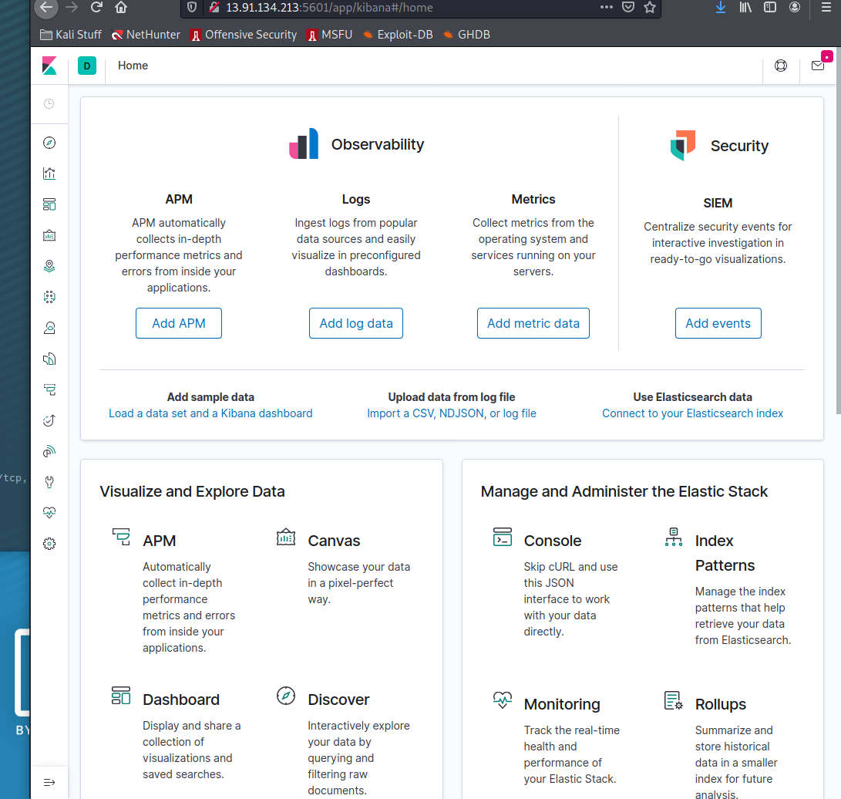

Filebeat Screenshot:

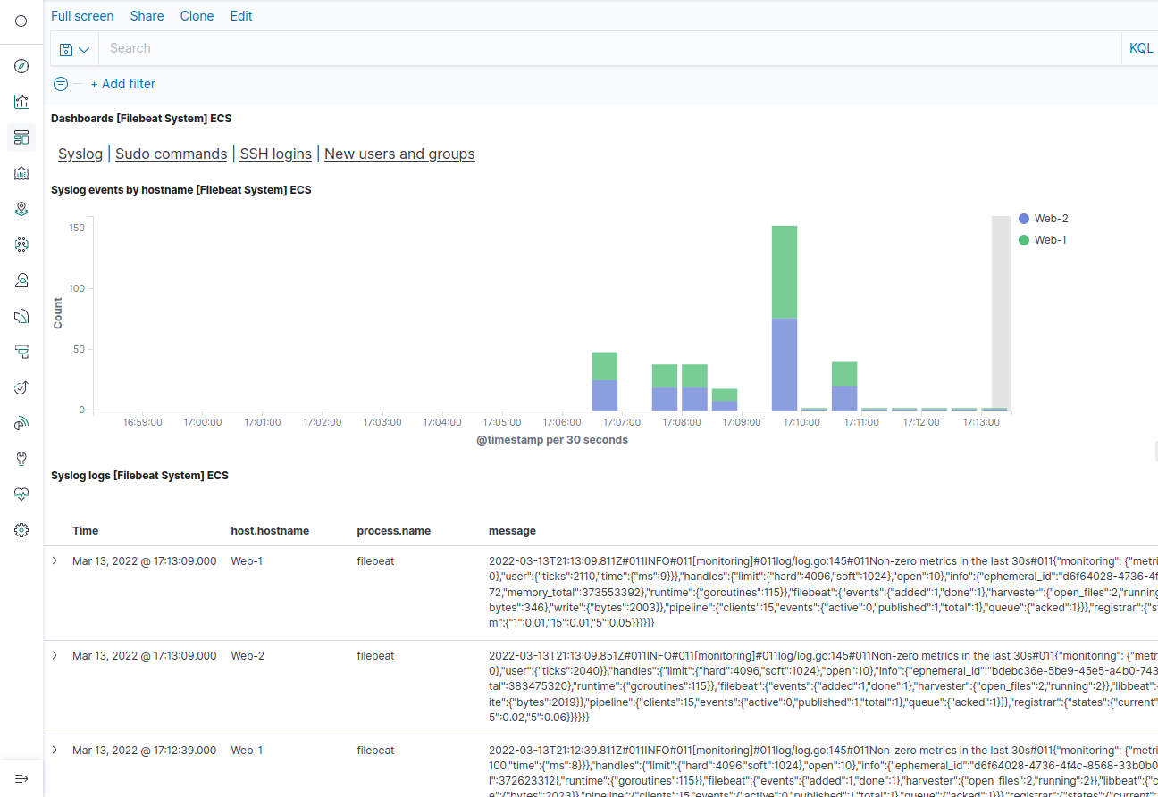

Metricbeat Screenshot:

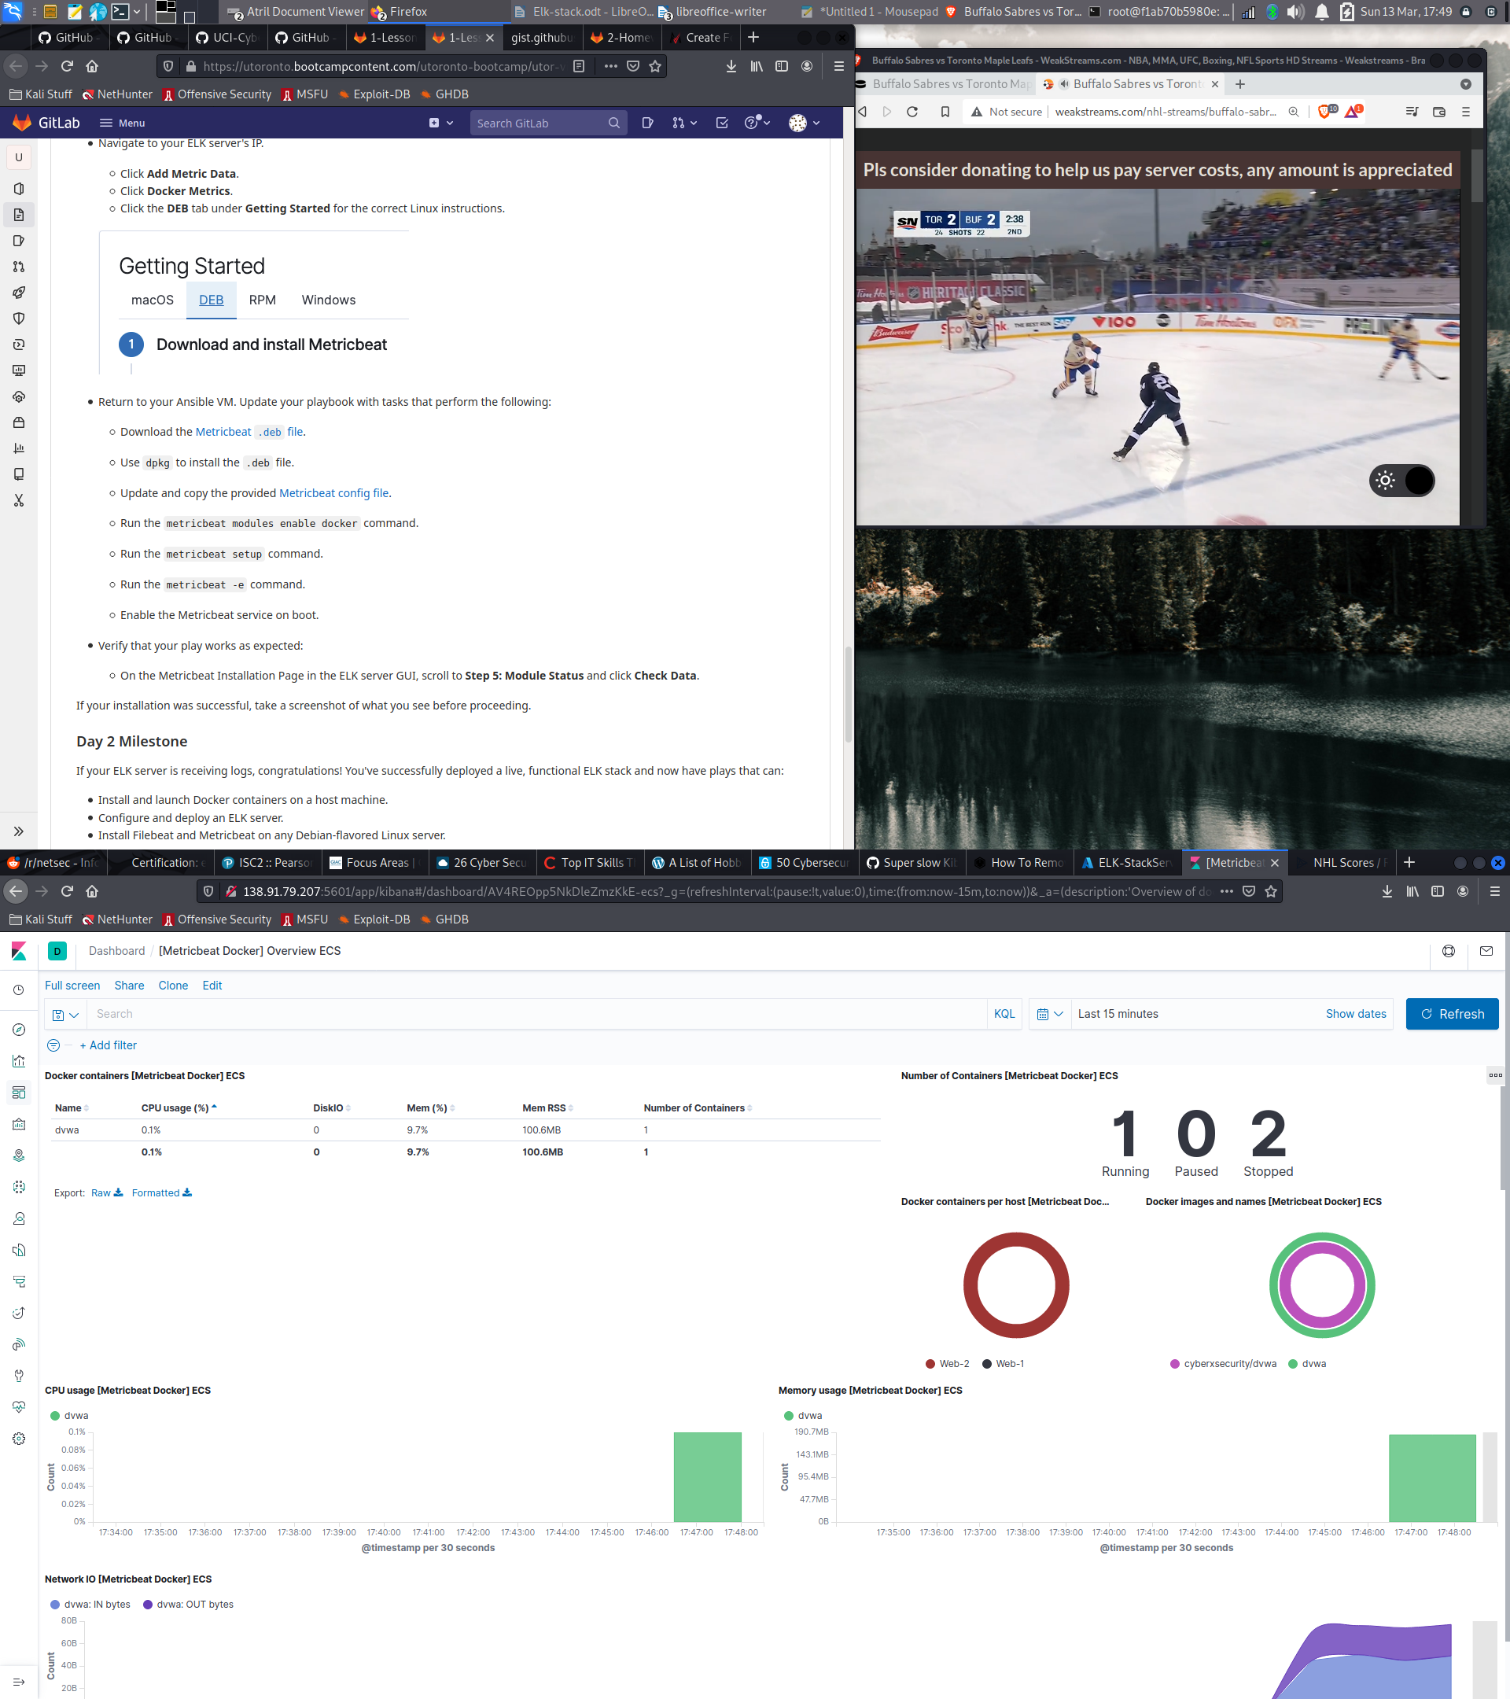

### Using the Playbook

In order to use the playbook, you will need to have an Ansible control node already configured. Assuming you have such a control node provisioned:

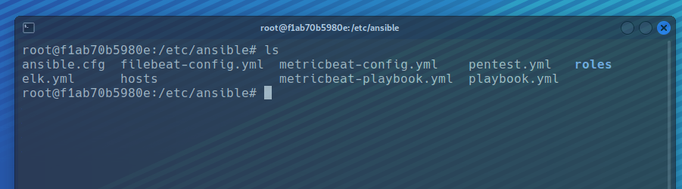

SSH into the control node and follow the steps below:
- Copy the elk.yml file to /etc/ansible.
- Pic?

- Update the Host file in /etc/ansible to include the VM IP
  - in this case, ‘10.1.0.4’ as well as ‘ansible_python_interpreter=/usr/bin/python3’ that will add the correct python interpreter
- Run the playbook to set up:
  - ansible-playbook elk.yml

- navigate to the "Kibana local host > module status > Check Data” to check that the installation worked as expected.

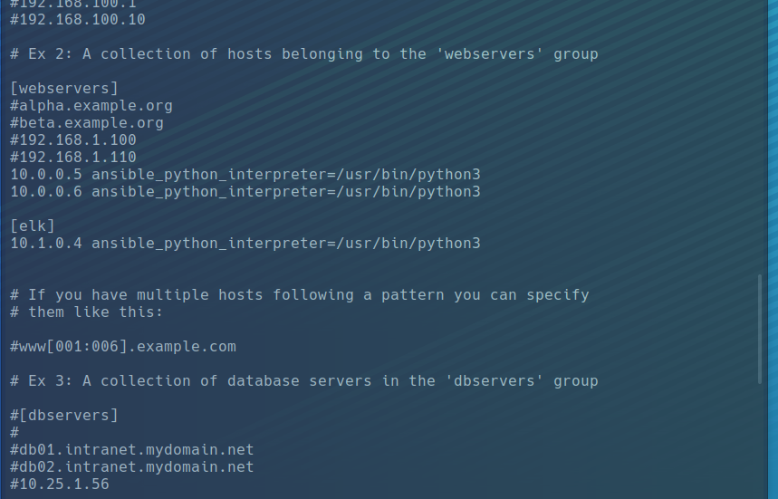

Commands | Actions
sudo apt install docker.io | Installs Docker service
sudo service docker start | Starts docker if not already started
docker container list -a | Lists and verfies active containers
docker start elk | Starts ELK container
dpkg -i | .deb file installation
Ansible -m ping all | Checks connectivity of webservers connected to ansible container
sudo docker exec -i -t ansible /bin/bash | Access docker container with root access
ssh-keygen | SSH public key generation
Sudo docker pull | Verify successful deployment of machine

Activity File: Exploring Kibana
- You are a DevOps professional and have set up monitoring for one of your web servers. You are collecting all sorts of web log data and it is your job to review the data regularly to make sure everything is running smoothly.
- Today, you notice something strange in the logs and you want to take a closer look.
- Your task: Explore the web server logs to see if there's anything unusual. Specifically, you will:
Heads Up: These sample logs are specific to the time you view them. As such, your answers will be different from the answers provided in the solution file.

Instructions
- Add the sample web log data to Kibana.
- Answer the following questions:
  - In the last 7 days, how many unique visitors were located in India?
237
  - In the last 24 hours, of the visitors from China, how many were using Mac OSX?
65
  - In the last 2 days, what percentage of visitors received 404 errors? How about 503 errors?
404 = 0%
503 = 20%
  - In the last 7 days, what country produced the majority of the traffic on the website?
    - China 20.4%
  - Of the traffic that's coming from that country, what time of day had the highest amount of activity?
    - 11 AM
  - List all the types of downloaded files that have been identified for the last 7 days, along with a short description of each file type (use Google if you aren't sure about a particular file type).
    - Css - Cascaded Style Sheet used for web page theme and decoration
    - gz - Compressed file
    - zip - Compressed archive
    - deb - Compressed linux software package for debian-based distributions
    - rpm - Compressed linux software package introduced by RedHat
- Now that you have a feel for the data, Let's dive a bit deeper. Look at the chart that shows Unique Visitors Vs. Average Bytes.
  - Locate the time frame in the last 7 days with the most amount of bytes (activity).
    - 15709 Avg Bytes at
    - Unique Visitors: 21
  - In your own words, is there anything that seems potentially strange about this activity?

During this time an increase in unique users combined with higher byte size can be potential dangerous and indicative of a traffic escalation to preempt a DDoS or multiple login attempts from malicious actors. Further analysis is recommended to rule out findings of false positives

- Filter the data by this event.
  - What is the timestamp for this event? 22;55 March 13th
  - What kind of file was downloaded? RPM files
  - From what country did this activity originate? USA
  - What HTTP response codes were encountered by this visitor? 200
- Switch to the Kibana Discover page to see more details about this activity.

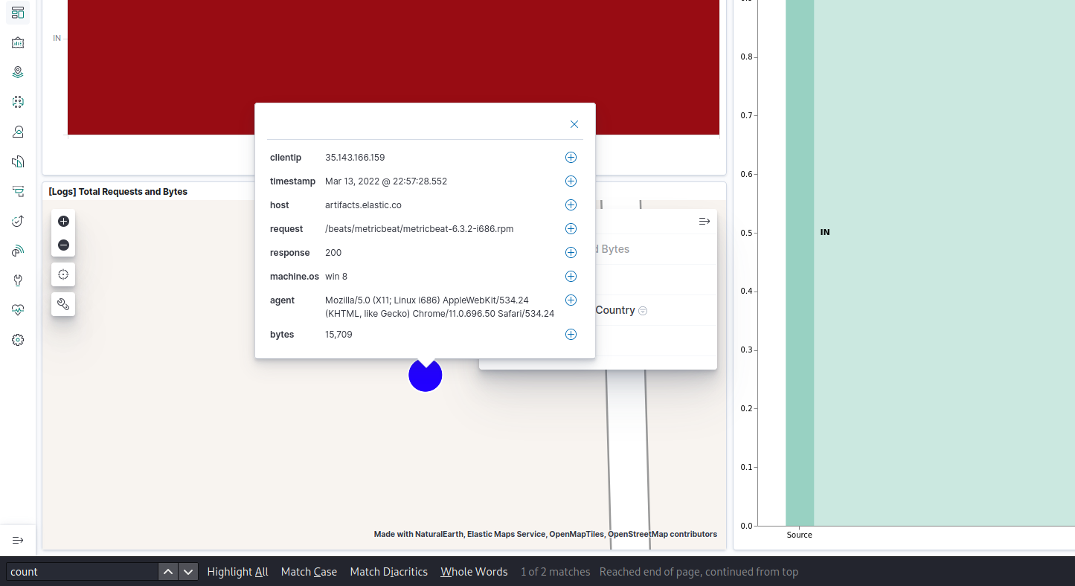

  - What is the source IP address of this activity? 35.143.166.159
  - What are the geo coordinates of this activity?
  - What OS was the source machine running?
  - What is the full URL that was accessed?
    - artifacts.elastic.co
  - From what website did the visitor's traffic originate?

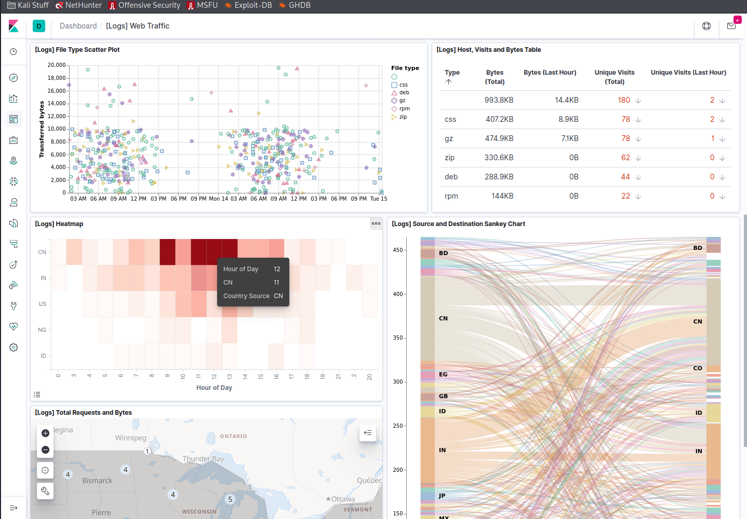

- Finish your investigation with a short overview of your insights.
  - What do you think the user was doing?
    - The user seems to be downloading the metric-beat collector from elastic.co site,
  - Was the file they downloaded malicious? If not, whats the file used for?
    - The user seems to want to use the metric-beat as a
  - Is there anything that seems suspicious about this activity?
    - Unless the file has been corrupted or overwritten with malicious intend it is difficult to tell without actually viewing the file.
  - Is any of the traffic you inspected potentially outside of compliance guidelines?
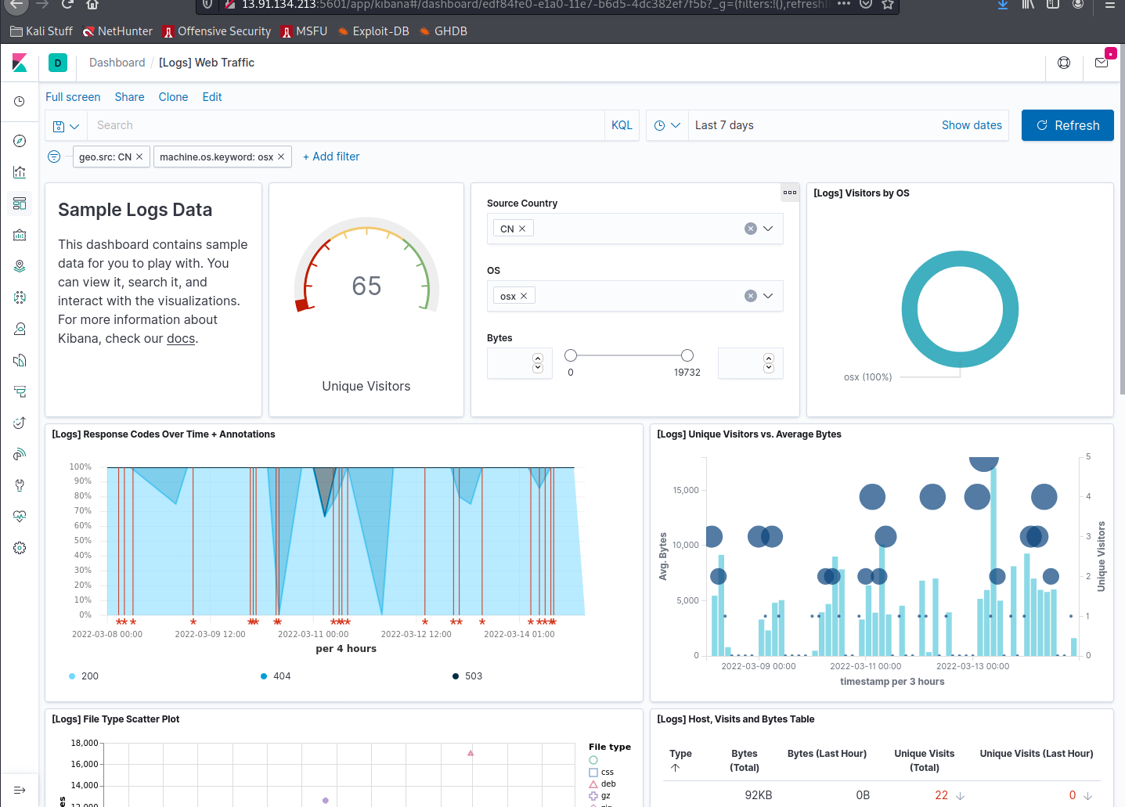
    - The behavior appears to be normal during file download, unless there is some sort of bandwidth or data limit or policy violation.

