Table of Contents

# Example Stock report

## Example stock in ICES Division 4

### Catch data

Table 9.6.1: Estimated catch at age.

| **1** | **2** | **3** | **4** | **5** | **6** | **7** | **8** | **9** | **10** | **total** |
| --- | --- | --- | --- | --- | --- | --- | --- | --- | --- | --- |
| 0 | 2002 | 4239 | 858 | 1731 | 200.0 | 207.0 | 50.0 | 10.00 | 0.10 | **9297** |
| 0 | 4728 | 4027 | 2574 | 513 | 876.0 | 171.0 | 131.0 | 61.00 | 0.00 | **13081** |
| 0 | 3093 | 2686 | 1331 | 1066 | 232.0 | 372.0 | 78.0 | 29.00 | 0.00 | **8887** |
| 0 | 4424 | 2500 | 1255 | 855 | 481.0 | 93.0 | 94.0 | 22.00 | 0.00 | **9724** |
| 0 | 4110 | 3958 | 1280 | 662 | 284.0 | 204.0 | 48.0 | 30.00 | 0.00 | **10576** |
| 0 | 2033 | 3021 | 2300 | 630 | 350.0 | 158.0 | 79.0 | 41.00 | 0.00 | **8612** |
| 0 | 852 | 3230 | 2564 | 1416 | 363.0 | 155.0 | 48.0 | 63.00 | 0.00 | **8691** |
| 0 | 1337 | 970 | 2080 | 1339 | 606.0 | 197.0 | 104.0 | 33.00 | 0.00 | **6666** |
| 0 | 1609 | 2690 | 860 | 1706 | 847.0 | 309.0 | 64.0 | 27.00 | 0.00 | **8112** |
| 0 | 1529 | 3322 | 2663 | 945 | 1226.0 | 452.0 | 105.0 | 11.00 | 0.00 | **10253** |
| 0 | 878 | 3106 | 3300 | 1538 | 477.0 | 713.0 | 203.0 | 92.00 | 0.00 | **10307** |
| 0 | 402 | 1163 | 2172 | 1685 | 752.0 | 244.0 | 300.0 | 44.00 | 0.00 | **6762** |
| 0 | 328 | 757 | 821 | 1287 | 1451.0 | 510.0 | 114.0 | 179.00 | 0.00 | **5447** |
| 0 | 875 | 1176 | 810 | 596 | 1021.0 | 596.0 | 154.0 | 25.00 | 0.00 | **5253** |
| 0 | 723 | 3124 | 1590 | 707 | 384.0 | 312.0 | 227.0 | 120.00 | 97.00 | **7284** |
| 0 | 2161 | 1266 | 1811 | 934 | 563.0 | 452.0 | 149.0 | 141.00 | 91.00 | **7568** |
| 0 | 2584 | 5689 | 2157 | 2211 | 813.0 | 295.0 | 190.0 | 118.00 | 150.00 | **14207** |
| 0 | 1497 | 4158 | 3799 | 1380 | 1427.0 | 617.0 | 273.0 | 120.00 | 186.00 | **13457** |
| 0 | 425 | 3282 | 6844 | 3718 | 788.0 | 1160.0 | 239.0 | 134.00 | 9.00 | **16599** |
| 0 | 555 | 1219 | 2643 | 3216 | 1041.0 | 268.0 | 201.0 | 66.00 | 56.00 | **9265** |
| 0 | 575 | 1732 | 1673 | 1601 | 1906.0 | 493.0 | 134.0 | 87.00 | 38.00 | **8239** |
| 0 | 1129 | 2263 | 1461 | 895 | 807.0 | 832.0 | 339.0 | 42.00 | 18.00 | **7786** |
| 0 | 646 | 4137 | 1981 | 947 | 582.0 | 487.0 | 527.0 | 123.00 | 55.00 | **9485** |
| 0 | 1139 | 1965 | 3073 | 1286 | 471.0 | 314.0 | 169.0 | 254.00 | 122.00 | **8793** |
| 0 | 2149 | 5771 | 2760 | 2746 | 1204.0 | 510.0 | 157.0 | 104.00 | 102.00 | **15503** |
| 0 | 4396 | 5234 | 3487 | 1461 | 912.0 | 314.0 | 82.0 | 34.00 | 66.00 | **15986** |
| 0 | 998 | 9484 | 3795 | 1669 | 770.0 | 872.0 | 309.0 | 65.00 | 80.00 | **18042** |
| 0 | 210 | 3586 | 8462 | 2373 | 907.0 | 236.0 | 147.0 | 47.00 | 38.00 | **16006** |
| 0 | 257 | 1362 | 2611 | 3083 | 812.0 | 224.0 | 68.0 | 69.00 | 26.00 | **8512** |
| 0 | 509 | 2122 | 1945 | 1484 | 2178.0 | 492.0 | 168.0 | 33.00 | 25.00 | **8956** |
| 0 | 2237 | 2151 | 2187 | 1121 | 1026.0 | 997.0 | 220.0 | 61.00 | 9.00 | **10009** |
| 0 | 247 | 2892 | 1504 | 865 | 410.0 | 298.0 | 295.0 | 51.00 | 26.00 | **6588** |
| 0 | 192 | 451 | 2152 | 622 | 303.0 | 142.0 | 93.0 | 53.00 | 24.00 | **4032** |
| 0 | 205 | 455 | 466 | 911 | 293.0 | 132.0 | 53.0 | 30.00 | 34.00 | **2579** |
| 0 | 120 | 802 | 603 | 222 | 329.0 | 96.0 | 33.0 | 22.00 | 25.00 | **2252** |
| 0 | 573 | 788 | 1062 | 532 | 125.0 | 176.0 | 39.0 | 23.00 | 16.00 | **3334** |
| 0 | 2615 | 2716 | 2008 | 1012 | 465.0 | 118.0 | 175.0 | 44.00 | 49.00 | **9202** |
| 0 | 351 | 5164 | 4608 | 1542 | 1526.0 | 596.0 | 147.0 | 347.00 | 47.00 | **14328** |
| 0 | 200 | 1278 | 6710 | 3731 | 657.0 | 639.0 | 170.0 | 51.00 | 120.00 | **13556** |
| 0 | 455 | 745 | 1558 | 5140 | 1529.0 | 159.0 | 118.0 | 28.00 | 25.00 | **9757** |
| 0 | 1246 | 1044 | 840 | 1164 | 2339.0 | 461.0 | 62.0 | 18.00 | 8.00 | **7182** |
| 0 | 2170 | 2737 | 811 | 443 | 700.0 | 840.0 | 108.0 | 8.00 | 1.00 | **7818** |
| 0 | 3967 | 3812 | 2130 | 373 | 372.0 | 728.0 | 443.0 | 36.00 | 6.00 | **11867** |
| 0 | 2099 | 7354 | 3405 | 1688 | 474.0 | 538.0 | 417.0 | 293.00 | 7.00 | **16275** |
| 0 | 697 | 2186 | 4696 | 1979 | 657.0 | 182.0 | 94.0 | 118.00 | 21.00 | **10630** |
| 0 | 98 | 673 | 1230 | 2051 | 717.0 | 234.0 | 63.0 | 41.00 | 36.00 | **5143** |
| 0 | 504 | 604 | 896 | 1146 | 841.0 | 208.0 | 41.0 | 19.00 | 31.00 | **4290** |
| 0 | 1110 | 1097 | 469 | 663 | 801.0 | 333.0 | 76.0 | 10.00 | 3.00 | **4562** |
| 0 | 506 | 1226 | 723 | 315 | 289.0 | 255.0 | 85.0 | 20.00 | 3.00 | **3422** |
| 0 | 287 | 761 | 783 | 430 | 187.0 | 157.0 | 156.0 | 57.00 | 19.00 | **2837** |
| 0 | 873 | 2262 | 861 | 618 | 296.0 | 85.0 | 55.0 | 43.00 | 17.00 | **5110** |
| 0 | 2114 | 2034 | 861 | 468 | 481.0 | 178.0 | 58.0 | 33.00 | 38.00 | **6265** |
| 0 | 328 | 2344 | 1234 | 365 | 188.0 | 126.0 | 50.0 | 19.00 | 2.00 | **4656** |
| 0 | 49 | 517 | 1347 | 555 | 200.0 | 99.0 | 69.0 | 25.00 | 22.00 | **2883** |
| 0 | 55 | 173 | 333 | 587 | 175.0 | 39.0 | 25.0 | 15.00 | 5.00 | **1407** |
| 0 | 387 | 517 | 286 | 499 | 350.0 | 86.0 | 14.0 | 9.00 | 1.00 | **2149** |
| 0 | 154 | 1026 | 517 | 208 | 280.0 | 219.0 | 46.0 | 23.00 | 7.00 | **2480** |
| 0 | 175 | 374 | 702 | 214 | 146.0 | 143.0 | 67.0 | 18.00 | 2.00 | **1841** |
| 0 | 112 | 280 | 333 | 438 | 151.0 | 75.0 | 41.0 | 24.00 | 8.00 | **1462** |
| 0 | 929 | 1026 | 717 | 541 | 476.0 | 94.0 | 60.0 | 36.00 | 4.00 | **3883** |
| 0 | 574 | 2163 | 1403 | 1238 | 925.0 | 238.0 | 36.0 | 23.00 | 9.00 | **6609** |
| 0 | 27 | 1634 | 1220 | 478 | 324.0 | 184.0 | 44.0 | 9.00 | 1.00 | **3921** |
| 0 | 41 | 386 | 754 | 314 | 118.0 | 55.0 | 20.0 | 7.00 | 1.00 | **1696** |
| 0 | 55 | 158 | 276 | 369 | 136.0 | 37.0 | 20.0 | 8.00 | 4.00 | **1063** |
| **0** | **1155** | **2298** | **1948** | **1227** | **672.1** | **331.3** | **131.9** | **60.09** | **27.97** | **7851** |

### Retrospective

The mohns rho value for F is -0.352. The plot of the retrospective is plotted in Figure 9.6.1

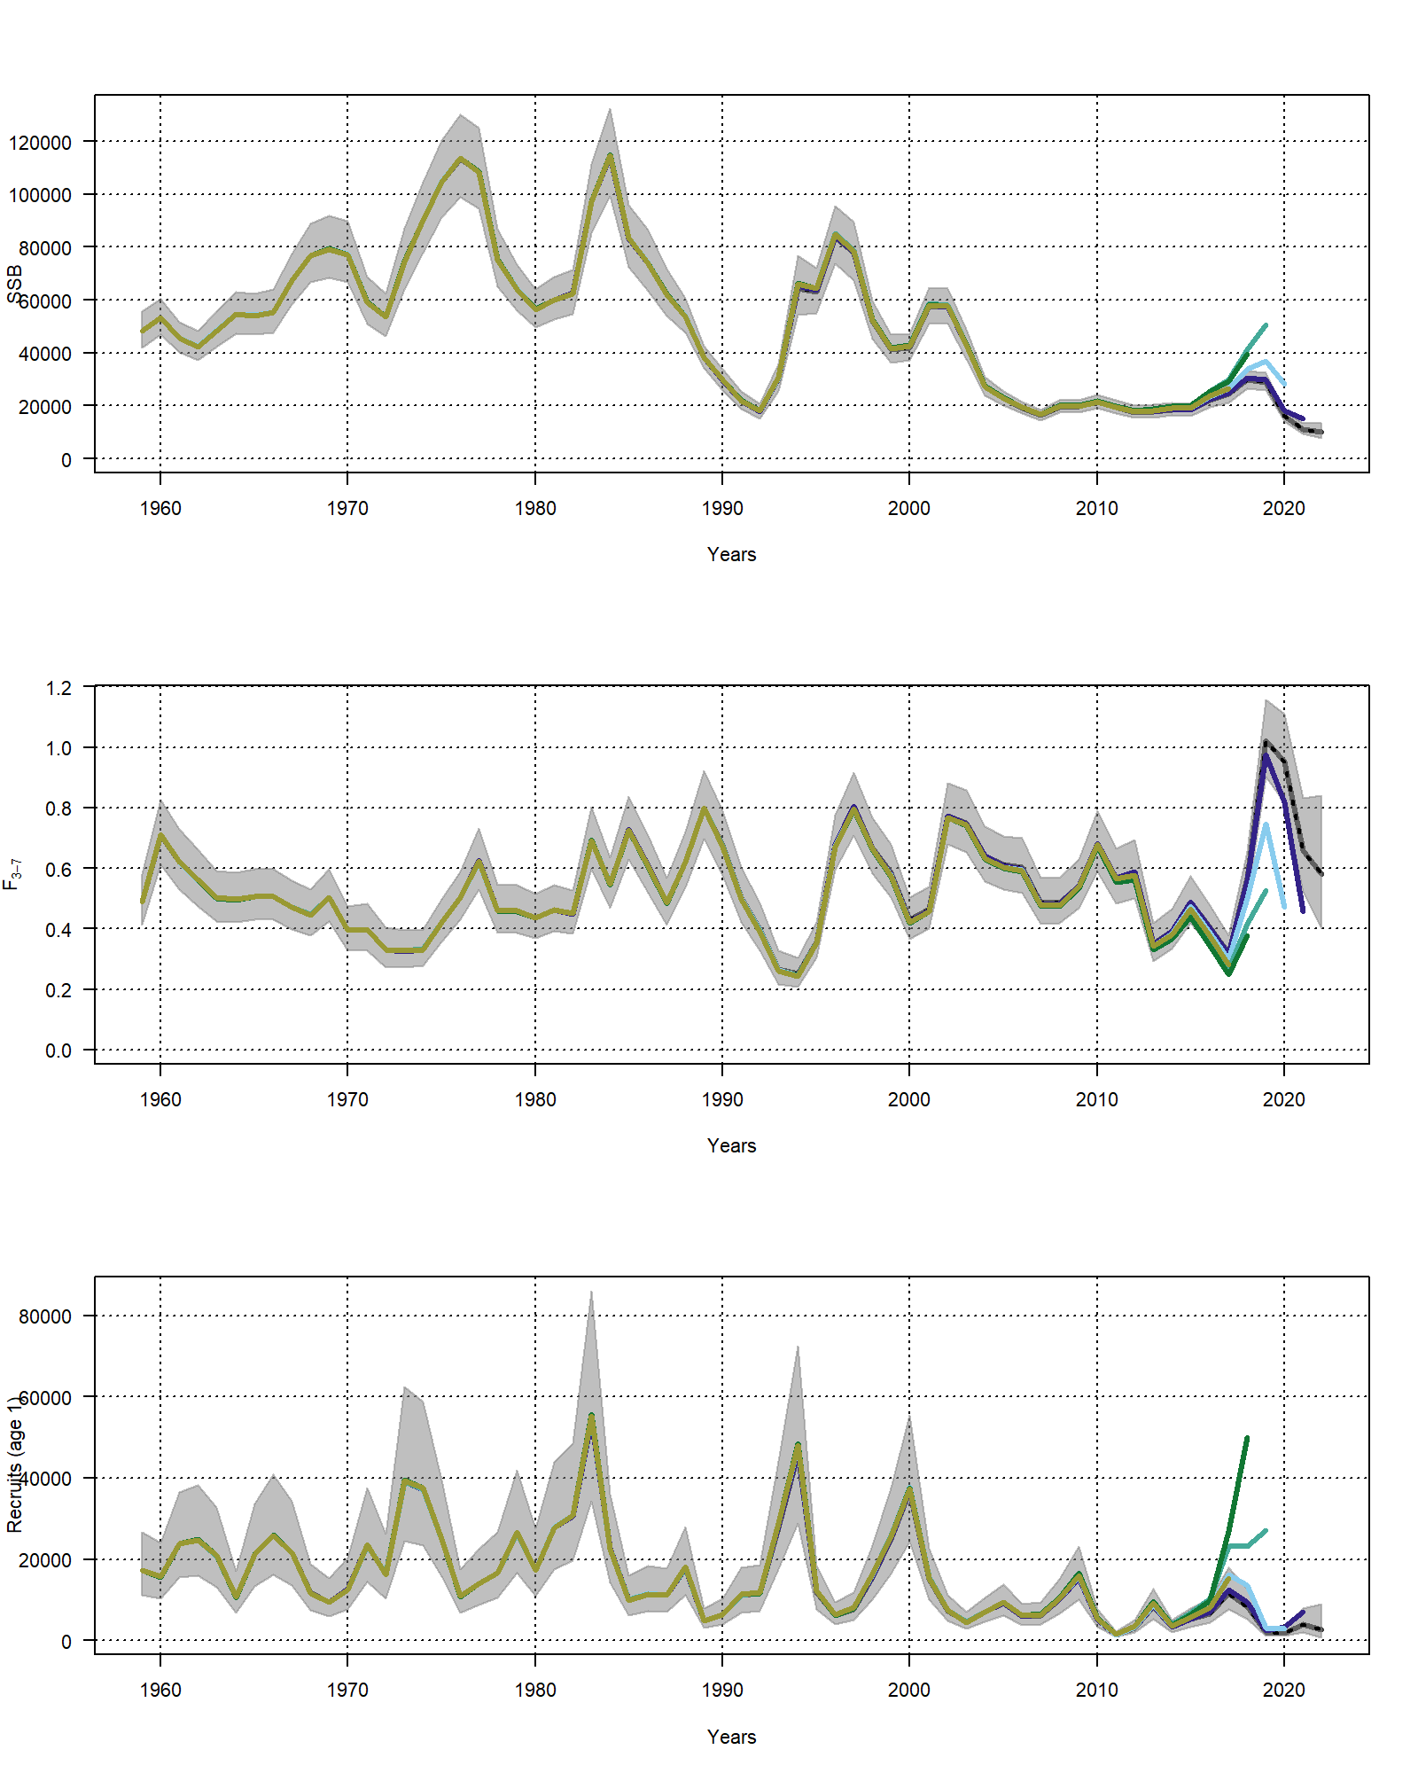

Figure 9.6.1: Retrospective of SSB, F and Recruitment (age 0).

### F at age estimate

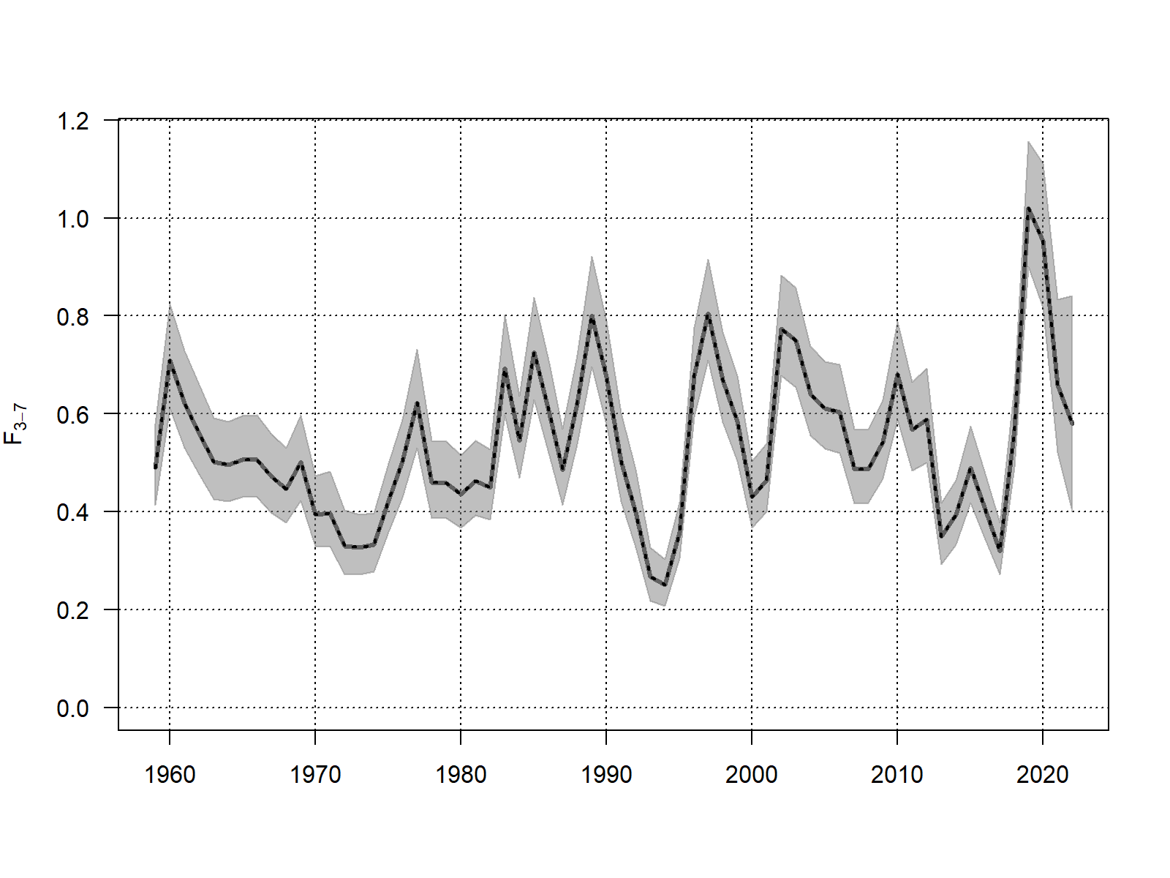

Figure 9.6.2: Plot of F bar (3-5) from the final assessment run.

# References

“ICES TAF Word Template for Report Automation.” 2019.

“SAM Configuration File for ...” 2023.

“SAM Input Data for ...” 2023.