Football Team Strength Models

Mathieu Tischer & Maximilian Prinz
Universität des Saarlandes
Data Science and Artificial Intelligence
Chair for Sports Analytics
04.08.2025

Abstract Summary
Hier fehlt nurnoch project schnell beschreiben: ziel, methoden, key findings und conclusion -ca. 250 wörter

Table of Contents
Abstract Summary 2
Introduction 2
Methodology 3
Data 3
Code 3
Implementation 3
ELO model 3
Data generation 3
Feature extraction 4
ML models 4
Results 4
ELO model results 4
ML classifiers results 5
Discussion 5
Result interpretation 5
Limitations 5
Conclusion 6
References 6
Appendix 6

Introduction
In the sport of Football, there are a lot of betting websites that state odds for match pairings, which then resemble the predicted outcome of a match. But how are these odds generated? And more importantly, which models hide behind the predictions made for given matches and how do they work? In this project we dive deep into the prediction making task to try and find the best possible models to predict future football match outcomes ourselves.
For that, we use two main approaches which we will see differ a lot in terms of method and results.

Methodology

Data
The data we used to train and test our models is pulled from the free event dataset from Statsbomb. It consists of event data for every match where every event is a detailed description of what is happening with the ball during that moment of the game, as well as who is handling it, what type of shot it is, etc… We trained and evaluated everything using the data from the 2015/2016 Bundesliga season.

Code
The main programming language and version we used was Python 3.11.2 and we used Jupyter Notebook to execute files, functions, blocks of code, etc... The machine learning models we used are all part of the Scikit-learn python library and we used libraries like pandas for handling data frames, Statsbomb’s own library for handling the data itself, and Matplotlib to visualize our findings.

Implementation

ELO model
Our first approach to the task was to apply the ELO rating system known from chess to the data and to use the brier score as a metric to quantify how good our predictions are. The brier score computes a value between 0 and 2 to quantify how well our ELO model predicts the match. The lower the score, the better. It uses a probability vector of in this case 3 dimensions and compares it to the actual outcome of the match. We do this for every match and average out per matchday and season.
Since we have a lot of parameters to tune, we used a parameter grid search technique to find the best combination.

Data generation
One problem we encountered while working with the dataset is that while it was very detailed, it was unfortunately very little to work with since we only had one season, so it was going to be hard to properly train our models.
To solve that issue, we resulted in a method that generates match data we could train our model on based on the data that we already had. We essentially created fake pairings for one match week and used the actual outcome of that pairing in the 2015/2016 season as a label for that data point (visualization seen below). We could then tune the number of weeks we wanted to simulate and chose 510 since that would correspond to having data from the 2000/2001 season onwards.
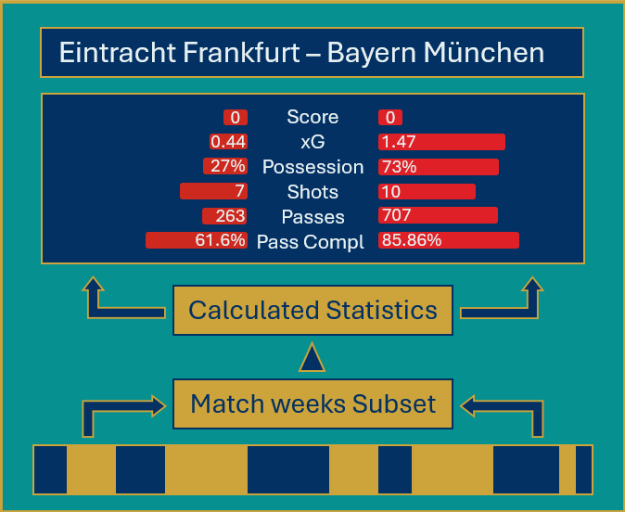

Feature extraction
To find predictors for our ML models we had to extract features like average ball possession, xG, average shots on target, etc. from the dataset based on the events in each match. That way, we were able to create tables filled with each Team’s statistics for the given season later used to train and evaluate the classifiers.

ML models
Now that we had everything set up for training and testing, we could easily choose and implement some well-known classifiers using the imported libraries, and evaluate their performance again using the brier score.

Results

ELO model results
The best combination of parameters for the ELO model yielded us a brier score of around 0.58. The plot below shows the evolution of the brier score across the season.

ML classifiers results
The results for the ML models were, again, found by using a parameter grid search implementation and evaluated using the brier score. In general, most of the models outperformed the ELO approach – some of them gave poor results while others excelled in expectations. The best Classifier we could find was the Gradient Boosting Classifier. The plot below shows some of the best (and worst) performing models.

Discussion

Result interpretation
The ELO model only uses match outcome labels to quantify team strength and suffers a lot under the events of surprising wins and draws - and the probability vectors it puts out are not tweakable in a way that addresses these problems. That is why its’ brier score took a rather disappointing value of 0.58 (for reference: random guessing would yield a score of 0.66).
In contrast to that, the Gradient boosting classifier uses useful predictors to make predictions, plus it updates the weights of the predictors after every matchday which helps represent certain teams’ win/loss streaks throughout the season. This is why it was ultimately able to yield a brier score of 0.113.

Limitations
While it was nice to extract predictors from the data, unfortunately some of them shared a higher correlation than we would have wished for, but we had to keep them since it was not possible to get some of the most important predictors like Starting XI because of how the data is structured. This predictor for example is one that betting websites must heavily consider when calculating odds because of how large the impact of even the substitution of only one player is.
As we addressed before, the data we had was very little to work with, so we had to rely on our data generation to train the models, which was fine for the purpose of this project but made our models a little more biased. To generalize better, we would have needed the data from at least the season before so that we could get more accurate starting values.

Conclusion
All in all, we can say that we achieved our goal on this project - while we had to work with some limitations, we were able to build a decent model for making predictions in football. The problems and limitations we encountered along the way are common when working with ML, and we were able to take away a few things which could help us in future projects.
For a future improved implementation of our project, we would consider using noise to make the models generalize a bit better so that surprising wins, for example, don’t affect the performance too much. We would like to work on our data generation, i.e. finding better/more creative ways to make data generation more robust.

References
- Hudl Statsbomb – The World’s Most Advanced Football Data. (2025). https://www.hudl.com/en_gb/products/statsbomb
- GitHub - statsbomb/open-data: Free football data from StatsBomb. (2025). https://github.com/statsbomb/open-data

Appendix
The entire project code is found in the folder this report was submitted in.

