Министерство науки и высшего образования РФ
Пензенский государственный университет
Кафедра «Вычислительная техника»

ОТЧЕТ
по лабораторной работе №6
по дисциплине «Программирование на языке Java»
на тему «Сетевое взаимодействие в Java»

Выполнили: студенты группы 22ВВП1
Беляев Д. И.
Демин М. С.

Приняли:
Юрова О. В.
Карамышева Н. С.

Пенза 2025
Название
Сетевое взаимодействие в Java
Цель работы
Научиться создавать клиент-серверные приложения c использованием стандартных классов Java
Задание
Модифицировать приложение из предыдущей лабораторной работы, реализовав клиент-серверную архитектуру, обеспечивающую распределенное вычисление определенного интеграла на нескольких вычислительных узлах (клиентах) при этом каждый узел использует несколько нитей, как в предыдущей работе. Сервер не занимается вычислениями, а лишь реализует взаимодействие с пользователем и агрегацию результатов вычислений от клиентов. Нечетные варианты используют протокол UDP, а четные TCP. Оформление лабораторной работы должно быть выполнено в соответствии с требованиями, приведенными в Приложении 2.
Ход работы
- Сделали проект, который отвечает за классы, которые передаются между клиентом и сервером
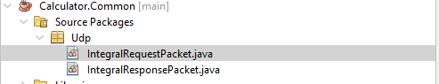
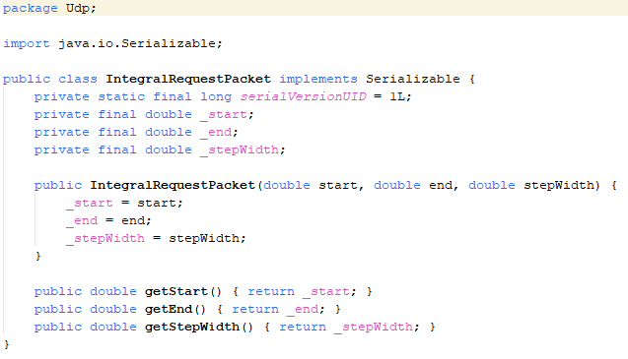
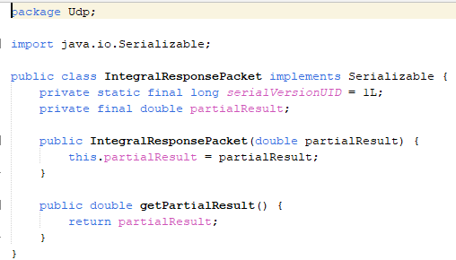
- Разделили проект на клиент и сервер
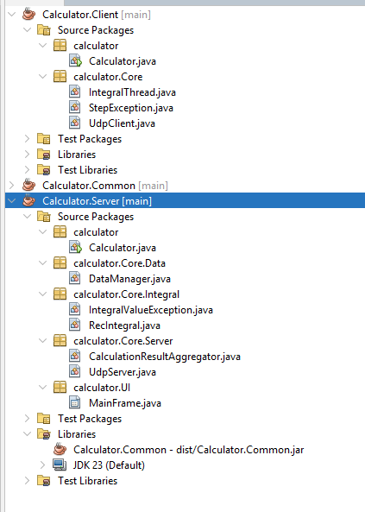
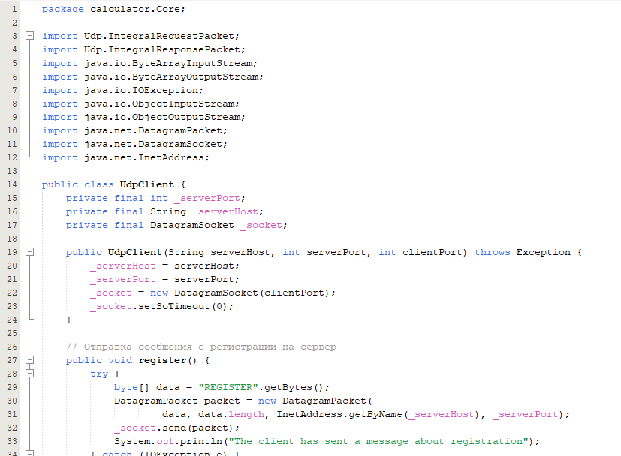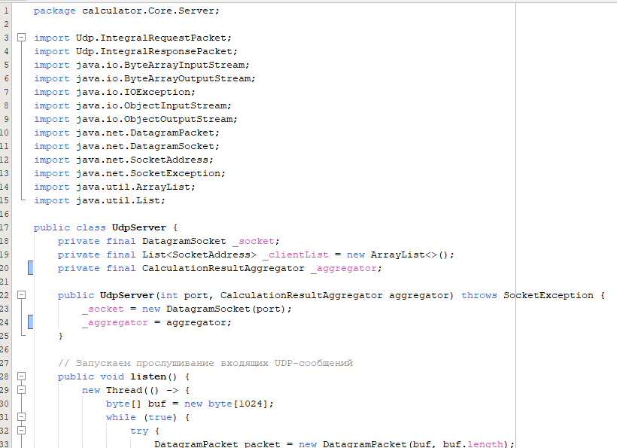
Листинг
package calculator;

import calculator.Core.UdpClient;

public class Calculator {
public static void main(String[] args) {
try {
String serverHost = "localhost";
int serverPort = 5000;
int clientPort = 0; // уникальный порт для этого клиента
UdpClient client = new UdpClient(serverHost, serverPort, clientPort);
client.register();
client.listenForRequests();
} catch (Exception e) {
e.printStackTrace();
}
}
}
package calculator.Core;

public class IntegralThread extends Thread {
private final double _start;
private final double _end;
private final double _stepWidth;
private double _partialResult = 0.0;

public IntegralThread(double start, double end, double stepWidth) {
_start = start;
_end = end;
_stepWidth = stepWidth;
}

public double getPartialResult() {
return _partialResult;
}

@Override
public void run() {
System.out.println("Start calculate: [" +
_start + ", " +
_end + ", " +
_stepWidth + "]...");
for (double x = _start; x < _end; x += _stepWidth) {
double nextX = Math.min(x + _stepWidth, _end);
double area = (nextX - x) * (Math.exp(-x) + Math.exp(-nextX)) / 2.0;
_partialResult += area;
}
System.out.println("End calculate: [" +
_start + ", " +
_end + ", " +
_stepWidth + "]");
}
}
package calculator.Core;

public class StepException extends Exception {
public StepException(double step, double lowerBound, double upperBound){
String message = String.format(
"Step exception (Step is bigger than borders): step - %f, lower bound - %f, upper bound - %f",
step, lowerBound, upperBound);
super(message);
}

public String getExceptionName(){
return "StepException";
}
}
package calculator.Core;

import Udp.IntegralRequestPacket;
import Udp.IntegralResponsePacket;
import java.io.ByteArrayInputStream;
import java.io.ByteArrayOutputStream;
import java.io.IOException;
import java.io.ObjectInputStream;
import java.io.ObjectOutputStream;
import java.net.DatagramPacket;
import java.net.DatagramSocket;
import java.net.InetAddress;

public class UdpClient {
private final int _serverPort;
private final String _serverHost;
private final DatagramSocket _socket;

public UdpClient(String serverHost, int serverPort, int clientPort) throws Exception {
_serverHost = serverHost;
_serverPort = serverPort;
_socket = new DatagramSocket(clientPort);
_socket.setSoTimeout(0);
}

// Отправка сообщения о регистрации на сервер
public void register() {
try {
byte[] data = "REGISTER".getBytes();
DatagramPacket packet = new DatagramPacket(
data, data.length, InetAddress.getByName(_serverHost), _serverPort);
_socket.send(packet);
System.out.println("The client has sent a message about registration");
} catch (IOException e) {
e.printStackTrace();
}
}

public void close() {
if (_socket != null && !_socket.isClosed()) {
_socket.close();
}
}

// Прослушивание входящих UDP-запросов
public void listenForRequests() {
new Thread(() -> {
byte[] buf = new byte[1024];
while (true) {
try {
DatagramPacket packet = new DatagramPacket(buf, buf.length);
_socket.receive(packet);
IntegralRequestPacket request = deserializeRequest(packet);
System.out.println("Request received: [" +
request.getStart() + ", " +
request.getEnd() + ", " +
request.getStepWidth() + "]");
double partialResult = processRequest(request);
sendResponse(packet.getAddress(), packet.getPort(), partialResult);
System.out.println("The result has been sent: " + partialResult);
} catch (Exception e) {
e.printStackTrace();
}
}
}).start();
}

// Преобразование UDP-пакета в объект запроса
private IntegralRequestPacket deserializeRequest(DatagramPacket packet) throws Exception {
ByteArrayInputStream bais = new ByteArrayInputStream(packet.getData(), 0, packet.getLength());
ObjectInputStream ois = new ObjectInputStream(bais);
return (IntegralRequestPacket) ois.readObject();
}

// Обработка запроса с использованием вычислительного класса
private double processRequest(IntegralRequestPacket request) throws StepException {
final int THREAD_COUNT = 5;
double start = request.getStart();
double end = request.getEnd();
double stepWidth = request.getStepWidth();
double sign = 1.0;

if (start > end) {
double tmp = start;
start = end;
end = tmp;
sign = -1.0;
}
if (stepWidth > (end - start)) {
throw new StepException(stepWidth, start, end);
}

double totalInterval = end - start;
double subIntervalLength = totalInterval / THREAD_COUNT;
IntegralThread[] threads = new IntegralThread[THREAD_COUNT];

for (int i = 0; i < THREAD_COUNT; i++) {
double subStart = start + i * subIntervalLength;
double subEnd = (i == THREAD_COUNT - 1) ? end : subStart + subIntervalLength;
threads[i] = new IntegralThread(subStart, subEnd, stepWidth);
threads[i].start();
}

double sum = 0.0;
for (int i = 0; i < THREAD_COUNT; i++) {
try {
threads[i].join();
sum += threads[i].getPartialResult();
} catch (InterruptedException e) {
e.printStackTrace();
}
}

return sign * sum;
}

// Отправка результата вычисления обратно серверу
private void sendResponse(InetAddress address, int port, double partialResult) throws Exception {
IntegralResponsePacket response = new IntegralResponsePacket(partialResult);
ByteArrayOutputStream baos = new ByteArrayOutputStream();
ObjectOutputStream oos = new ObjectOutputStream(baos);
oos.writeObject(response);
oos.flush();
byte[] responseData = baos.toByteArray();
DatagramPacket responsePacket = new DatagramPacket(responseData, responseData.length, address, port);
_socket.send(responsePacket);
}
}
package Udp;

import java.io.Serializable;

public class IntegralRequestPacket implements Serializable {
private static final long serialVersionUID = 1L;
private final double _start;
private final double _end;
private final double _stepWidth;

public IntegralRequestPacket(double start, double end, double stepWidth) {
_start = start;
_end = end;
_stepWidth = stepWidth;
}

public double getStart() { return _start; }
public double getEnd() { return _end; }
public double getStepWidth() { return _stepWidth; }
}
package Udp;

import java.io.Serializable;

public class IntegralResponsePacket implements Serializable {
private static final long serialVersionUID = 1L;
private final double partialResult;

public IntegralResponsePacket(double partialResult) {
this.partialResult = partialResult;
}

public double getPartialResult() {
return partialResult;
}
}
package calculator;

import calculator.Core.Server.CalculationResultAggregator;
import calculator.Core.Server.UdpServer;
import calculator.UI.MainFrame;
import java.net.SocketException;
import javax.swing.SwingUtilities;

public class Calculator {
public static void main(String[] args) {
try {
CalculationResultAggregator aggregator = new CalculationResultAggregator();
UdpServer udpServer = new UdpServer(5000, aggregator);
udpServer.listen();
System.out.println("The UDP server is running on port 5000...");

SwingUtilities.invokeLater(() -> {
MainFrame frame = new MainFrame(udpServer, aggregator);
frame.setVisible(true);
});
} catch (SocketException e) {
e.printStackTrace();
}
}
}
package calculator.Core.Data;

import calculator.Core.Integral.RecIntegral;
import java.io.BufferedReader;
import java.io.BufferedWriter;
import java.io.File;
import java.io.FileInputStream;
import java.io.FileOutputStream;
import java.io.FileReader;
import java.io.FileWriter;
import java.io.IOException;
import java.io.ObjectInputStream;
import java.io.ObjectOutputStream;
import java.util.ArrayList;
import java.util.List;

public class DataManager {
// Save data as text
public static void saveDataAsText(File file, List<RecIntegral> integrals) throws IOException {
try (BufferedWriter writer = new BufferedWriter(new FileWriter(file))) {
for (RecIntegral integral : integrals) {
writer.write(integral.getTopBorder() + ";"
+ integral.getBottomBorder() + ";"
+ integral.getStepWidth() + ";"
+ integral.getResult());
writer.newLine();
}
}
}

// Load data from text
public static ArrayList<RecIntegral> loadDataFromText(File file) throws IOException {
ArrayList<RecIntegral> integrals = new ArrayList<>();
try (BufferedReader reader = new BufferedReader(new FileReader(file))) {
String line;
while ((line = reader.readLine()) != null) {
String[] parts = line.split(";");
if (parts.length < 4) {
continue;
}
double top = Double.parseDouble(parts[0]);
double bottom = Double.parseDouble(parts[1]);
double step = Double.parseDouble(parts[2]);
double result = Double.parseDouble(parts[3]);
RecIntegral integral = new RecIntegral(top, bottom, step, result);
integrals.add(integral);

}
} catch (Exception e) {
throw new IOException("Error when load data: " + e.getMessage());
}
return integrals;
}

// Save data as binary
public static void saveDataAsBinary(File file, List<RecIntegral> integrals) throws IOException {
try (ObjectOutputStream oos = new ObjectOutputStream(new FileOutputStream(file))) {
oos.writeObject(integrals);
}
}

// Load data from binary
public static ArrayList<RecIntegral> loadDataFromBinary(File file) throws IOException, ClassNotFoundException {
try (ObjectInputStream ois = new ObjectInputStream(new FileInputStream(file))) {
return (ArrayList<RecIntegral>) ois.readObject();
}
}
}
package calculator.Core.Integral;

public class IntegralValueException extends Exception {
public IntegralValueException(double lowerBound, double upperBound){
String message = String.format(
"Value exception: lower bound - %f, upper bound - %f",
lowerBound, upperBound);
super(message);
}

public String getExceptionName(){
return "IntegralValueException";
}
}

package calculator.Core.Integral;

import java.io.Serializable;

public class RecIntegral implements Serializable {
private static final long serialVersionUID = 1L;
private static final double MINIMAL_DOUBLE_VALUE = 0.000001;
private static final double MAXIMUM_DOUBLE_VALUE = 1000000;

private double _topBorder = 0.0;
private double _bottomBorder = 0.0;
private double _stepWidth = 0.0;
private double _result = 0.0;

public RecIntegral(double topBorder, double bottomBorder, double stepWidth) throws IntegralValueException {
this(topBorder, bottomBorder, stepWidth, Double.NaN);
}

public RecIntegral(
double topBorder,
double bottomBorder,
double stepWidth,
double previewResult)
throws IntegralValueException {
_topBorder = topBorder;
_bottomBorder = bottomBorder;
// Проверка значений на допустимый диапазон
if (bottomBorder < MINIMAL_DOUBLE_VALUE || bottomBorder > MAXIMUM_DOUBLE_VALUE ||
topBorder < MINIMAL_DOUBLE_VALUE || topBorder > MAXIMUM_DOUBLE_VALUE ||
stepWidth < MINIMAL_DOUBLE_VALUE || stepWidth > MAXIMUM_DOUBLE_VALUE) {
throw new IntegralValueException(
MINIMAL_DOUBLE_VALUE, MAXIMUM_DOUBLE_VALUE);
}
_stepWidth = stepWidth;
_result = previewResult;
}

public double getTopBorder() { return _topBorder; }
public double getBottomBorder() { return _bottomBorder; }
public double getStepWidth() { return _stepWidth; }
public double getResult() { return _result; }

public void setResult(double result) { _result = result; }
}
package calculator.Core.Server;

import java.beans.PropertyChangeListener;
import java.beans.PropertyChangeSupport;

public class CalculationResultAggregator {
private double _totalResult;
private int _expectedResponses;
private int _receivedResponses;
private final PropertyChangeSupport pcs = new PropertyChangeSupport(this);

public synchronized void reset(int expectedResponses) {
_totalResult = 0.0;
_receivedResponses = 0;
_expectedResponses = expectedResponses;
}

public synchronized void addPartialResult(double partial) {
double oldResult = _totalResult;
_totalResult += partial;
_receivedResponses++;
pcs.firePropertyChange("partialResult", oldResult, _totalResult);
if (_receivedResponses == _expectedResponses) {
// Все ответы получены – уведомляем об окончательном результате
pcs.firePropertyChange("finalResult", null, _totalResult);
}
}

public void addPropertyChangeListener(PropertyChangeListener listener) {
pcs.addPropertyChangeListener(listener);
}
}
package calculator.Core.Server;

import Udp.IntegralRequestPacket;
import Udp.IntegralResponsePacket;
import java.io.ByteArrayInputStream;
import java.io.ByteArrayOutputStream;
import java.io.IOException;
import java.io.ObjectInputStream;
import java.io.ObjectOutputStream;
import java.net.DatagramPacket;
import java.net.DatagramSocket;
import java.net.SocketAddress;
import java.net.SocketException;
import java.util.ArrayList;
import java.util.List;

public class UdpServer {
private final DatagramSocket _socket;
private final List<SocketAddress> _clientList = new ArrayList<>();
private final CalculationResultAggregator _aggregator;

public UdpServer(int port, CalculationResultAggregator aggregator) throws SocketException {
_socket = new DatagramSocket(port);
_aggregator = aggregator;
}

// Запускаем прослушивание входящих UDP-сообщений
public void listen() {
new Thread(() -> {
byte[] buf = new byte[1024];
while (true) {
try {
DatagramPacket packet = new DatagramPacket(buf, buf.length);
_socket.receive(packet);
String msg = new String(packet.getData(), 0, packet.getLength());

// Если сообщение – регистрация, добавляем клиента
if ("REGISTER".equalsIgnoreCase(msg.trim())) {
if (!_clientList.contains(packet.getSocketAddress())) {
_clientList.add(packet.getSocketAddress());
System.out.println("The client is registered: " + packet.getSocketAddress());
}
} else {
// Иначе десериализуем ответ с частичным результатом
ByteArrayInputStream bais = new ByteArrayInputStream(packet.getData(), 0, packet.getLength());
ObjectInputStream ois = new ObjectInputStream(bais);
IntegralResponsePacket response = (IntegralResponsePacket) ois.readObject();
System.out.println("Received a response from " + packet.getSocketAddress() +
" - Partial result: " + response.getPartialResult());
_aggregator.addPartialResult(response.getPartialResult());
}
} catch (IOException | ClassNotFoundException e) {
e.printStackTrace();
}
}
}).start();
}

// Отправка запроса конкретному клиенту
public void sendRequest(SocketAddress clientAddress, IntegralRequestPacket request) {
try {
ByteArrayOutputStream baos = new ByteArrayOutputStream();
ObjectOutputStream oos = new ObjectOutputStream(baos);
oos.writeObject(request);
oos.flush();
byte[] data = baos.toByteArray();
DatagramPacket packet = new DatagramPacket(data, data.length, clientAddress);
_socket.send(packet);
System.out.println("A request has been sent to the client " + clientAddress + ": ["
+ request.getStart() + ", " + request.getEnd() + "]");
} catch (IOException e) {
e.printStackTrace();
}
}

// Разделение общего интервала на части и отправка запросов всем клиентам
public void distributeIntegralCalculation(double bottomBorder, double topBorder, double stepWidth) {
int clientCount = _clientList.size();
if (clientCount == 0) {
System.out.println("There are no registered clients for calculations!");
return;
}

_aggregator.reset(clientCount);
double totalInterval = topBorder - bottomBorder;
double subIntervalLength = totalInterval / clientCount;
for (int i = 0; i < clientCount; i++) {
double subStart = bottomBorder + i * subIntervalLength;
double subEnd = (i == clientCount - 1) ? topBorder : subStart + subIntervalLength;
IntegralRequestPacket request = new IntegralRequestPacket(subStart, subEnd, stepWidth);
sendRequest(_clientList.get(i), request);
}
}

public List<SocketAddress> getClientList() {
return _clientList;
}

public void close() {
if (_socket != null && !_socket.isClosed()) {
_socket.close();
}
}
}
package calculator.UI;

import calculator.Core.Data.DataManager;
import calculator.Core.Integral.IntegralValueException;
import calculator.Core.Integral.RecIntegral;
import calculator.Core.Server.CalculationResultAggregator;
import calculator.Core.Server.UdpServer;
import java.io.File;
import java.io.IOException;
import java.util.ArrayList;
import javax.swing.JFileChooser;
import javax.swing.JOptionPane;
import javax.swing.JTable;
import javax.swing.filechooser.FileNameExtensionFilter;
import javax.swing.table.DefaultTableModel;

public class MainFrame extends javax.swing.JFrame {
// Shadow column
private static final int SHADOW_COLUMN_NUMBER = 4;
private static final String SHADOW_COLUMN_TITLE = "ShadowColumn";
// Load/Save files
private static final String TEXT_EXTENSION = ".txt";
private static final String BINARY_EXTENSION = ".calcbin";
private static final String TEXT_FILTER_DESCRIPTION = "Text Files (*" + TEXT_EXTENSION + ")";
private static final String BINARY_FILTER_DESCRIPTION = "Calc Binary Files (*" + BINARY_EXTENSION + ")";
private static final String SAVE_ERROR_MESSAGE = "Save error: ";
private static final String LOAD_ERROR_MESSAGE = "Load error: ";

private ArrayList<RecIntegral> _integrals;
private final UdpServer _udpServer;
private int _currentCalculationRow = -1;

public MainFrame(UdpServer udpServer, CalculationResultAggregator aggregator) {
initComponents();

_integrals = new ArrayList<>();
_udpServer = udpServer;

DataTable.removeColumn(DataTable.getColumn(SHADOW_COLUMN_TITLE));
FileSaveMenuAsTextItem.addActionListener(e -> saveAsText());
FileSaveMenuAsBinaryItem.addActionListener(e -> saveAsBinary());
FileLoadMenuFromTextItem.addActionListener(e -> loadFromText());
FileLoadMenuFromBinaryItem.addActionListener(e -> loadFromBinary());

aggregator.addPropertyChangeListener(evt -> {
if ("finalResult".equals(evt.getPropertyName())) {
double finalResult = (double) evt.getNewValue();
javax.swing.SwingUtilities.invokeLater(() -> {
CalculateButton.setEnabled(true);
DefaultTableModel model = (DefaultTableModel) DataTable.getModel();
if (_currentCalculationRow >= 0) {
model.setValueAt(finalResult, _currentCalculationRow, 3);
}
});
}
});
}

@SuppressWarnings("unchecked")
// <editor-fold defaultstate="collapsed" desc="Generated Code">
private void initComponents() {

jMenuItem1 = new javax.swing.JMenuItem();
DataTableScrollPanel = new javax.swing.JScrollPane();
DataTable = new javax.swing.JTable();
TopBorderLabel = new javax.swing.JLabel();
BottomBorderLabel = new javax.swing.JLabel();
StepWidthLabel = new javax.swing.JLabel();
TopBorderTextField = new javax.swing.JTextField();
BottomBorderTextField = new javax.swing.JTextField();
StepWidthTextField = new javax.swing.JTextField();
AddButton = new javax.swing.JButton();
DeleteButton = new javax.swing.JButton();
CalculateButton = new javax.swing.JButton();
ClearTableButton = new javax.swing.JButton();
FillTableButton = new javax.swing.JButton();
MenuBar = new javax.swing.JMenuBar();
FileMenu = new javax.swing.JMenu();
FileSaveMenu = new javax.swing.JMenu();
FileSaveMenuAsTextItem = new javax.swing.JMenuItem();
FileSaveMenuAsBinaryItem = new javax.swing.JMenuItem();
FileLoadMenu = new javax.swing.JMenu();
FileLoadMenuFromTextItem = new javax.swing.JMenuItem();
FileLoadMenuFromBinaryItem = new javax.swing.JMenuItem();

jMenuItem1.setText("jMenuItem1");

setDefaultCloseOperation(javax.swing.WindowConstants.EXIT_ON_CLOSE);

DataTable.setModel(new javax.swing.table.DefaultTableModel(
new Object [][] {

},
new String [] {
"Верхняя граница", "Нижняя граница", "Ширина шага", "Результат", "ShadowColumn"
}
) {
boolean[] canEdit = new boolean [] {
false, false, false, false, false
};

public boolean isCellEditable(int rowIndex, int columnIndex) {
return canEdit [columnIndex];
}
});
DataTableScrollPanel.setViewportView(DataTable);

TopBorderLabel.setFont(new java.awt.Font("Segoe UI", 0, 14)); // NOI18N
TopBorderLabel.setText("Верхняя граница");
TopBorderLabel.setName(""); // NOI18N

BottomBorderLabel.setFont(new java.awt.Font("Segoe UI", 0, 14)); // NOI18N
BottomBorderLabel.setText("Ширина шага");

StepWidthLabel.setFont(new java.awt.Font("Segoe UI", 0, 14)); // NOI18N
StepWidthLabel.setText("Нижняя границы");

TopBorderTextField.setFont(new java.awt.Font("Segoe UI", 0, 14)); // NOI18N

BottomBorderTextField.setFont(new java.awt.Font("Segoe UI", 0, 14)); // NOI18N

StepWidthTextField.setFont(new java.awt.Font("Segoe UI", 0, 14)); // NOI18N

AddButton.setFont(new java.awt.Font("Segoe UI", 0, 14)); // NOI18N
AddButton.setText("Добавить");
AddButton.addMouseListener(new java.awt.event.MouseAdapter() {
public void mouseClicked(java.awt.event.MouseEvent evt) {
AddButtonMouseClicked(evt);
}
});

DeleteButton.setFont(new java.awt.Font("Segoe UI", 0, 14)); // NOI18N
DeleteButton.setText("Удалить");
DeleteButton.addMouseListener(new java.awt.event.MouseAdapter() {
public void mouseClicked(java.awt.event.MouseEvent evt) {
DeleteButtonMouseClicked(evt);
}
});

CalculateButton.setFont(new java.awt.Font("Segoe UI", 0, 14)); // NOI18N
CalculateButton.setText("Вычислить");
CalculateButton.addMouseListener(new java.awt.event.MouseAdapter() {
public void mouseClicked(java.awt.event.MouseEvent evt) {
CalculateButtonMouseClicked(evt);
}
});

ClearTableButton.setText("Очистить");
ClearTableButton.addMouseListener(new java.awt.event.MouseAdapter() {
public void mouseClicked(java.awt.event.MouseEvent evt) {
ClearTableButtonMouseClicked(evt);
}
});

FillTableButton.setText("Восстановить");
FillTableButton.addMouseListener(new java.awt.event.MouseAdapter() {
public void mouseClicked(java.awt.event.MouseEvent evt) {
FillTableButtonMouseClicked(evt);
}
});

FileMenu.setText("File");

FileSaveMenu.setText("Save...");

FileSaveMenuAsTextItem.setText("As txt");
FileSaveMenu.add(FileSaveMenuAsTextItem);

FileSaveMenuAsBinaryItem.setText("As binary");
FileSaveMenu.add(FileSaveMenuAsBinaryItem);

FileMenu.add(FileSaveMenu);

FileLoadMenu.setText("Load...");

FileLoadMenuFromTextItem.setText("From txt");
FileLoadMenu.add(FileLoadMenuFromTextItem);

FileLoadMenuFromBinaryItem.setText("From binary");
FileLoadMenu.add(FileLoadMenuFromBinaryItem);

FileMenu.add(FileLoadMenu);

MenuBar.add(FileMenu);

setJMenuBar(MenuBar);

javax.swing.GroupLayout layout = new javax.swing.GroupLayout(getContentPane());
getContentPane().setLayout(layout);
layout.setHorizontalGroup(
layout.createParallelGroup(javax.swing.GroupLayout.Alignment.LEADING)
.addGroup(javax.swing.GroupLayout.Alignment.TRAILING, layout.createSequentialGroup()
.addGap(48, 48, 48)
.addGroup(layout.createParallelGroup(javax.swing.GroupLayout.Alignment.LEADING, false)
.addComponent(TopBorderLabel, javax.swing.GroupLayout.DEFAULT_SIZE, javax.swing.GroupLayout.DEFAULT_SIZE, Short.MAX_VALUE)
.addComponent(StepWidthLabel, javax.swing.GroupLayout.DEFAULT_SIZE, javax.swing.GroupLayout.DEFAULT_SIZE, Short.MAX_VALUE)
.addComponent(BottomBorderLabel, javax.swing.GroupLayout.DEFAULT_SIZE, javax.swing.GroupLayout.DEFAULT_SIZE, Short.MAX_VALUE))
.addGroup(layout.createParallelGroup(javax.swing.GroupLayout.Alignment.LEADING)
.addGroup(layout.createSequentialGroup()
.addGap(18, 18, 18)
.addGroup(layout.createParallelGroup(javax.swing.GroupLayout.Alignment.LEADING)
.addComponent(StepWidthTextField, javax.swing.GroupLayout.DEFAULT_SIZE, 314, Short.MAX_VALUE)
.addComponent(BottomBorderTextField)))
.addGroup(layout.createSequentialGroup()
.addGap(16, 16, 16)
.addComponent(TopBorderTextField)))
.addGap(18, 18, 18)
.addGroup(layout.createParallelGroup(javax.swing.GroupLayout.Alignment.LEADING, false)
.addComponent(CalculateButton, javax.swing.GroupLayout.Alignment.TRAILING, javax.swing.GroupLayout.DEFAULT_SIZE, javax.swing.GroupLayout.DEFAULT_SIZE, Short.MAX_VALUE)
.addComponent(DeleteButton, javax.swing.GroupLayout.Alignment.TRAILING, javax.swing.GroupLayout.DEFAULT_SIZE, javax.swing.GroupLayout.DEFAULT_SIZE, Short.MAX_VALUE)
.addComponent(AddButton, javax.swing.GroupLayout.Alignment.TRAILING, javax.swing.GroupLayout.DEFAULT_SIZE, javax.swing.GroupLayout.DEFAULT_SIZE, Short.MAX_VALUE))
.addGap(48, 48, 48))
.addGroup(layout.createSequentialGroup()
.addContainerGap()
.addComponent(DataTableScrollPanel)
.addContainerGap())
.addGroup(javax.swing.GroupLayout.Alignment.TRAILING, layout.createSequentialGroup()
.addContainerGap()
.addComponent(ClearTableButton, javax.swing.GroupLayout.DEFAULT_SIZE, javax.swing.GroupLayout.DEFAULT_SIZE, Short.MAX_VALUE)
.addPreferredGap(javax.swing.LayoutStyle.ComponentPlacement.RELATED)
.addComponent(FillTableButton, javax.swing.GroupLayout.PREFERRED_SIZE, 317, javax.swing.GroupLayout.PREFERRED_SIZE)
.addContainerGap())
);
layout.setVerticalGroup(
layout.createParallelGroup(javax.swing.GroupLayout.Alignment.LEADING)
.addGroup(javax.swing.GroupLayout.Alignment.TRAILING, layout.createSequentialGroup()
.addGap(15, 15, 15)
.addGroup(layout.createParallelGroup(javax.swing.GroupLayout.Alignment.BASELINE)
.addComponent(TopBorderLabel)
.addComponent(TopBorderTextField, javax.swing.GroupLayout.PREFERRED_SIZE, javax.swing.GroupLayout.DEFAULT_SIZE, javax.swing.GroupLayout.PREFERRED_SIZE)
.addComponent(AddButton))
.addGap(18, 18, 18)
.addGroup(layout.createParallelGroup(javax.swing.GroupLayout.Alignment.LEADING)
.addComponent(DeleteButton, javax.swing.GroupLayout.Alignment.TRAILING, javax.swing.GroupLayout.PREFERRED_SIZE, 27, javax.swing.GroupLayout.PREFERRED_SIZE)
.addGroup(layout.createParallelGroup(javax.swing.GroupLayout.Alignment.BASELINE)
.addComponent(StepWidthLabel)
.addComponent(BottomBorderTextField, javax.swing.GroupLayout.PREFERRED_SIZE, javax.swing.GroupLayout.DEFAULT_SIZE, javax.swing.GroupLayout.PREFERRED_SIZE)))
.addGap(18, 18, 18)
.addGroup(layout.createParallelGroup(javax.swing.GroupLayout.Alignment.BASELINE)
.addComponent(BottomBorderLabel)
.addComponent(StepWidthTextField, javax.swing.GroupLayout.PREFERRED_SIZE, javax.swing.GroupLayout.DEFAULT_SIZE, javax.swing.GroupLayout.PREFERRED_SIZE)
.addComponent(CalculateButton))
.addGap(18, 18, 18)
.addComponent(DataTableScrollPanel, javax.swing.GroupLayout.PREFERRED_SIZE, 122, javax.swing.GroupLayout.PREFERRED_SIZE)
.addPreferredGap(javax.swing.LayoutStyle.ComponentPlacement.RELATED)
.addGroup(layout.createParallelGroup(javax.swing.GroupLayout.Alignment.BASELINE)
.addComponent(ClearTableButton)
.addComponent(FillTableButton))
.addContainerGap(javax.swing.GroupLayout.DEFAULT_SIZE, Short.MAX_VALUE))
);

pack();
}// </editor-fold>

private void AddButtonMouseClicked(java.awt.event.MouseEvent evt) {
// Check if all fields field
String topBorderFieldText = TopBorderTextField.getText();
String bottomBordeFieldText = BottomBorderTextField.getText();
String stepWidthFieldText = StepWidthTextField.getText();
if (stringIsNullOrEmpty(topBorderFieldText) ||
stringIsNullOrEmpty(bottomBordeFieldText) ||
stringIsNullOrEmpty(stepWidthFieldText)) {
return;
}
// Try to convert
double topBorder;
double bottomBorder;
double stepWidth;
try {
topBorder = Double.parseDouble(topBorderFieldText);
bottomBorder = Double.parseDouble(bottomBordeFieldText);
stepWidth = Double.parseDouble(stepWidthFieldText);
} catch (NumberFormatException e) {
return;
}
// Step must be greater then zero
if (stepWidth <= 0) {
return;
}
// Add data to table
RecIntegral integral;
try {
integral = new RecIntegral(topBorder, bottomBorder, stepWidth);
} catch(IntegralValueException ex){
JOptionPane.showMessageDialog(
this,
ex.getMessage(),
ex.getExceptionName(),
JOptionPane.ERROR_MESSAGE);
return;
}
_integrals.add(integral);
AddIntegralToTable(DataTable, integral);
}

private void DeleteButtonMouseClicked(java.awt.event.MouseEvent evt) {
// Check if row selected
int selectedRow = DataTable.getSelectedRow();
if (selectedRow < 0) {
return;
}
// Remove row
DefaultTableModel model = (DefaultTableModel)DataTable.getModel();
_integrals.remove(
(RecIntegral)model.getValueAt(selectedRow, SHADOW_COLUMN_NUMBER));
model.removeRow(selectedRow);
}

private void CalculateButtonMouseClicked(java.awt.event.MouseEvent evt) {
int selectedRow = DataTable.getSelectedRow();
if (selectedRow < 0) {
return;
}
_currentCalculationRow = selectedRow;
DefaultTableModel model = (DefaultTableModel) DataTable.getModel();
RecIntegral integral = (RecIntegral)model.getValueAt(selectedRow, SHADOW_COLUMN_NUMBER);
CalculateButton.setEnabled(false);
_udpServer.distributeIntegralCalculation(
integral.getBottomBorder(), integral.getTopBorder(), integral.getStepWidth());
System.out.println("A distributed integral calculation is requested.");
}

private void ClearTableButtonMouseClicked(java.awt.event.MouseEvent evt) {
((DefaultTableModel) DataTable.getModel()).setRowCount(0);
}

private void FillTableButtonMouseClicked(java.awt.event.MouseEvent evt) {
DefaultTableModel model = (DefaultTableModel) DataTable.getModel();
model.setRowCount(0);
for (RecIntegral integral : _integrals) {
AddIntegralToTable(DataTable, integral);
}
}

private void saveAsText() {
JFileChooser chooser = new JFileChooser();
FileNameExtensionFilter textFilter =
new FileNameExtensionFilter(
"Text Files (*" + TEXT_EXTENSION + ")",
TEXT_EXTENSION.replace(".", ""));
chooser.setFileFilter(textFilter);
if (chooser.showSaveDialog(this) == JFileChooser.APPROVE_OPTION) {
File file = chooser.getSelectedFile();
// Append the .txt extension if it is missing.
if (!file.getName().toLowerCase().endsWith(TEXT_EXTENSION)) {
file = new File(file.getAbsolutePath() + TEXT_EXTENSION);
}
try {
DataManager.saveDataAsText(file, _integrals);
} catch (IOException e) {
JOptionPane.showMessageDialog(this, SAVE_ERROR_MESSAGE + e.getMessage());
}
}
}

private void saveAsBinary() {
JFileChooser chooser = new JFileChooser();
FileNameExtensionFilter binFilter = new FileNameExtensionFilter(
BINARY_FILTER_DESCRIPTION,
BINARY_EXTENSION.replace(".", ""));
chooser.setFileFilter(binFilter);
if (chooser.showSaveDialog(this) == JFileChooser.APPROVE_OPTION) {
File file = chooser.getSelectedFile();
// Append the .calcbin extension if it is missing.
if (!file.getName().toLowerCase().endsWith(BINARY_EXTENSION)) {
file = new File(file.getAbsolutePath() + BINARY_EXTENSION);
}
try {
DataManager.saveDataAsBinary(file, _integrals);
} catch (IOException e) {
JOptionPane.showMessageDialog(this, SAVE_ERROR_MESSAGE + e.getMessage());
}
}
}

private void loadFromText() {
JFileChooser chooser = new JFileChooser();
FileNameExtensionFilter textFilter = new FileNameExtensionFilter(
TEXT_FILTER_DESCRIPTION,
TEXT_EXTENSION.replace(".", ""));
chooser.setFileFilter(textFilter);
if (chooser.showOpenDialog(this) == JFileChooser.APPROVE_OPTION) {
File file = chooser.getSelectedFile();
// Validate the file extension.
if (!file.getName().toLowerCase().endsWith(TEXT_EXTENSION)) {
JOptionPane.showMessageDialog(this,
"Please select a file with " + TEXT_EXTENSION + " extension");
return;
}
try {
_integrals = DataManager.loadDataFromText(file);
for (RecIntegral integral : _integrals) {
AddIntegralToTable(DataTable, integral);
}
} catch (IOException e) {
JOptionPane.showMessageDialog(this, LOAD_ERROR_MESSAGE + e.getMessage());
}
}
}

private void loadFromBinary() {
JFileChooser chooser = new JFileChooser();
FileNameExtensionFilter binFilter = new FileNameExtensionFilter(
BINARY_FILTER_DESCRIPTION,
BINARY_EXTENSION.replace(".", ""));
chooser.setFileFilter(binFilter);
if (chooser.showOpenDialog(this) == JFileChooser.APPROVE_OPTION) {
File file = chooser.getSelectedFile();
// Validate the file extension.
if (!file.getName().toLowerCase().endsWith(BINARY_EXTENSION)) {
JOptionPane.showMessageDialog(this,
"Please select a file with " + BINARY_EXTENSION + " extension");
return;
}
try {
_integrals = DataManager.loadDataFromBinary(file);
for (RecIntegral integral : _integrals) {
AddIntegralToTable(DataTable, integral);
}
} catch (IOException e) {
JOptionPane.showMessageDialog(this, LOAD_ERROR_MESSAGE + e.getMessage());
} catch (ClassNotFoundException e) {
JOptionPane.showMessageDialog(this, e.getMessage());
}
}
}

private void AddIntegralToTable(JTable table, RecIntegral integral) {
double result = integral.getResult();
((DefaultTableModel)table.getModel()).addRow(
new Object[]{
integral.getTopBorder(),
integral.getBottomBorder(),
integral.getStepWidth(),
result == Double.NaN ? "" : result,
integral});
}

private boolean stringIsNullOrEmpty(String str) {
return str == null || str.trim().isEmpty();
}

// Variables declaration - do not modify
private javax.swing.JButton AddButton;
private javax.swing.JLabel BottomBorderLabel;
private javax.swing.JTextField BottomBorderTextField;
private javax.swing.JButton CalculateButton;
private javax.swing.JButton ClearTableButton;
private javax.swing.JTable DataTable;
private javax.swing.JScrollPane DataTableScrollPanel;
private javax.swing.JButton DeleteButton;
private javax.swing.JMenu FileLoadMenu;
private javax.swing.JMenuItem FileLoadMenuFromBinaryItem;
private javax.swing.JMenuItem FileLoadMenuFromTextItem;
private javax.swing.JMenu FileMenu;
private javax.swing.JMenu FileSaveMenu;
private javax.swing.JMenuItem FileSaveMenuAsBinaryItem;
private javax.swing.JMenuItem FileSaveMenuAsTextItem;
private javax.swing.JButton FillTableButton;
private javax.swing.JMenuBar MenuBar;
private javax.swing.JLabel StepWidthLabel;
private javax.swing.JTextField StepWidthTextField;
private javax.swing.JLabel TopBorderLabel;
private javax.swing.JTextField TopBorderTextField;
private javax.swing.JMenuItem jMenuItem1;
// End of variables declaration
}
Результат выполнения программы
Подключение клиентов
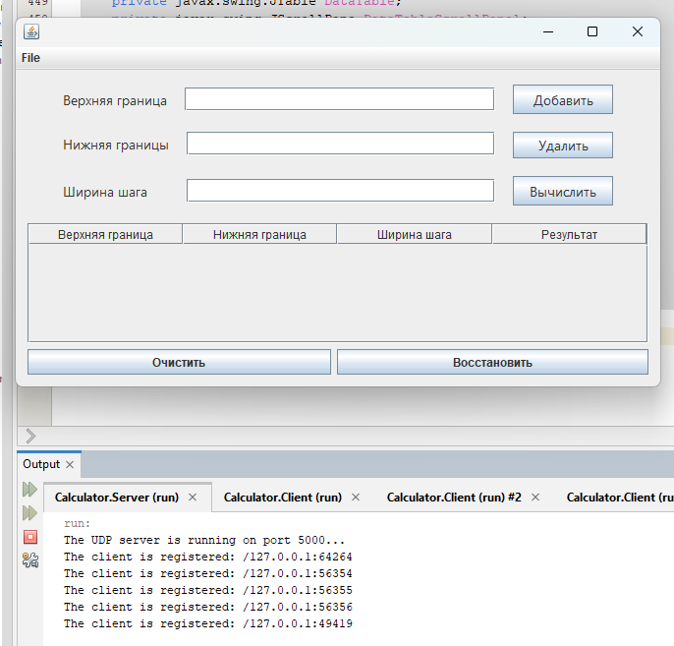
Разветвленное вычисление
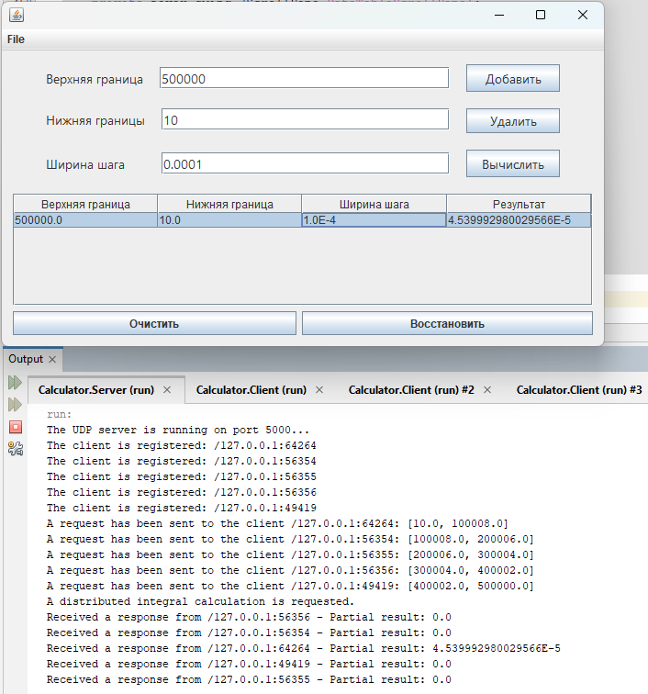
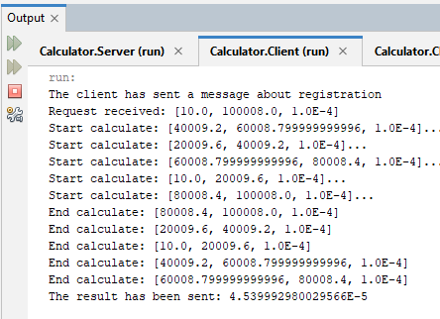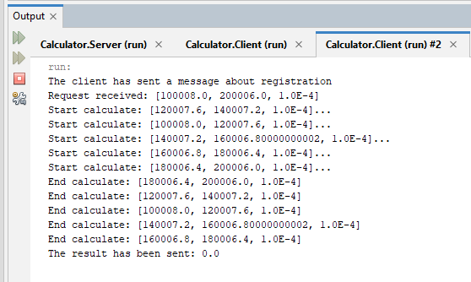
Вывод
Научились создавать клиент-серверные приложения c использованием стандартных классов Java

