Max Nguyen and Quang Nguyen

MMScheduling

1. Excel Files
   1. General Note
      1. When name is entered with extra space before and after, the program will ignore the space. However, to keep everything simple, ensure that name does not have leading or trailing space.
      2. Some cells/columns/rows will not be read. I will try to note those with blue background.
      3. Otherwise stated, input file names is not used.
   2. Department File

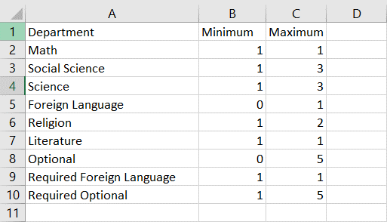



* The purpose of department is a way to group subjects. For each department, the number of minimum and maximum class also implies whether the registered subject for the department is required or not.
* First Column: Name of each department.
* Second Column: Minimum Class: Number of subjects need to be taken to meet requirements.
* Third Column: Maximum Class: Number of subjects that can be taken for each department in one year
* First Row: This row is not read, so labels do not matter. “Minimum” can be changed to “Minimum Class” or any other fancy name as long as it makes sense to the school
* Side note: If students’ registrations do not contain a department, it implies that students do not need to fulfill the minimum requirement for that department.
* Required Optional includes classes like Computer Science, Computer Applications, Speech, College planning 11 and 12, PE I.
* Required Foreign Language includes Spanish I and II, and French I and II. This category can be used to make sure that students can receive Honors Spanish III and IV or Honors III and IV.
  1. Subject Lists

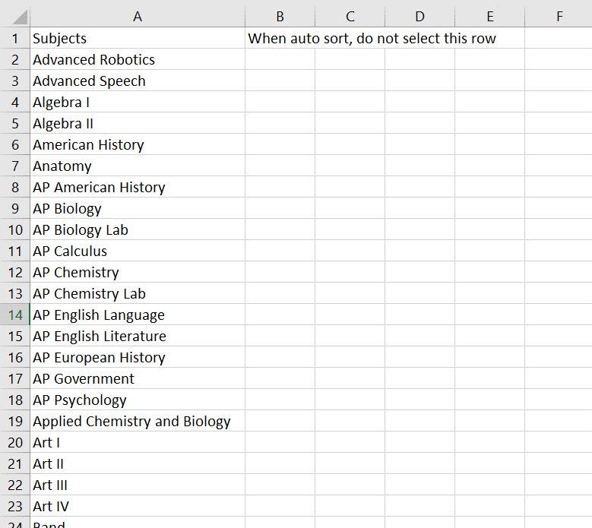



* This excel file lists all subjects in one year of MM. The name here must match with what appears on Master Schedule.
* The first row is not read.
* When auto-sort, only select from cell A2 to the end.
  1. Room

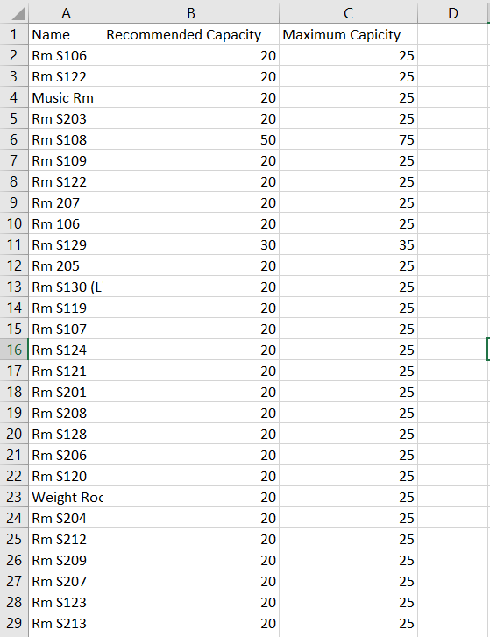



* Purpose: List all the rooms available at Mount Michael with recommended capacity and maximum capacity.
* First Column: Name: name of all rooms. Those names should match with what goes on Master Schedule including the “Rm” and the “S”.
* Second Column: Recommended Capacity: in general, this is the suggested classroom size.
* Third Column: Maximum Capacity: this is the highest number of students that can be in this classroom at a period for a subject.
* Side note: besides study hall room, all other subjects have sizes from 20 to 25.
  1. Credit

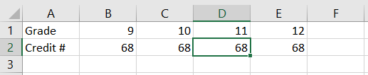



* Purpose: List number of required credits for each year
  1. Master Schedule (Main Part)

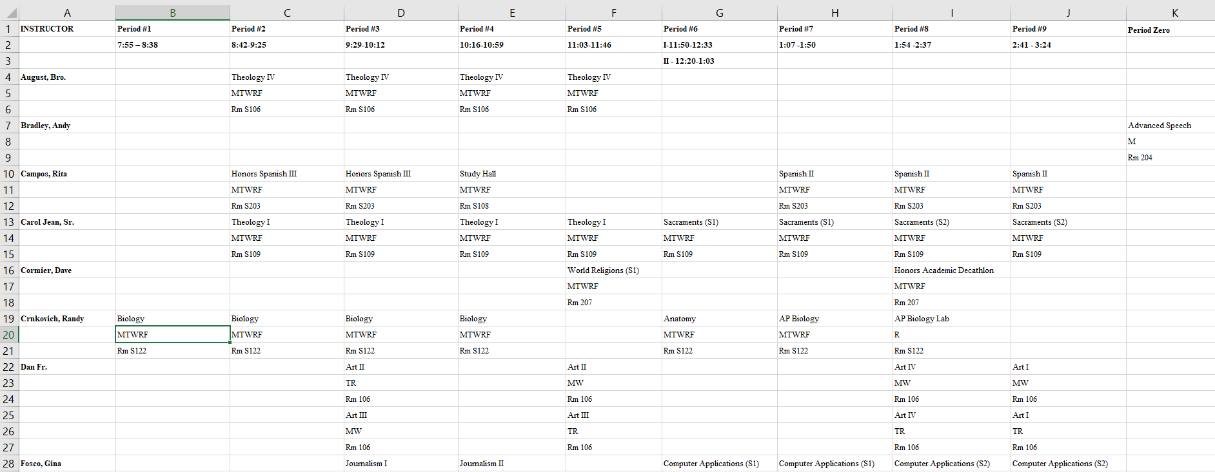



* First Column: List of all instructors. Each instructor takes up the number of rows that are multiple of 3. (explanation comes later).
  + Examples: Brother August takes up 3 rows (4, 5, 6)
  + Fr. Dan takes up 6 rows (22 to 27).
* Second Column to Eleventh Column: List classes during the period.
* First Row: Instructor and Period #. This row is not read.
* Second and Third Row: Time for each period. These rows are not read.
* Definite of a class: in this program, a class is defined as a subject taught by a faculty member during a period in a specified classroom for a set number of days during the week. In short, the following image ↓.
  + Each class will have four parts:
    - Faculty name: used from 1st column
    - Class name: 1st row of the class
    - Day taught: 2nd row of the class
    - Room used: 3rd row of the class
  + Note:
    - Class name must match with name appeared in “Subject List” Excel with the exception of “S1” and “S2”.
    - Only 5 characters can be used for “day taught”: M, T, W, R, F. Must be capitalized.
    - Room name must match with name appeared in “Room” Excel.
  + Because each class is read with three rows, each faculty will take up a multiple of three rows.
  + If a faculty has multiple classes in the same period but different semester or day, simply add new class below previous class like in the case of Fr. Dan.
  + If class name contains “S1” or “S2”, the program will recognize that this is a one semester class and categorize it respectively.

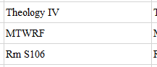

* 1. Conflict (Acceptable Conflict)

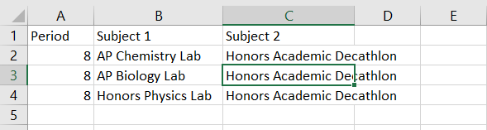



* Purpose: This excel allows the flexibility to declare some classes that can be taken simultaneously like Science Lab and Honors Academic Decathlon.
* First Column: Period of those classes
* Second Column: First subject
* Third Column: Second subject
* First Row: will not be read
* Note:
  + Whichever class has fewer days in one week will be Subject 1.
  + Class name must match with name appeared in “Subject List” Excel.
  1. Pair Relation (Classes go together)

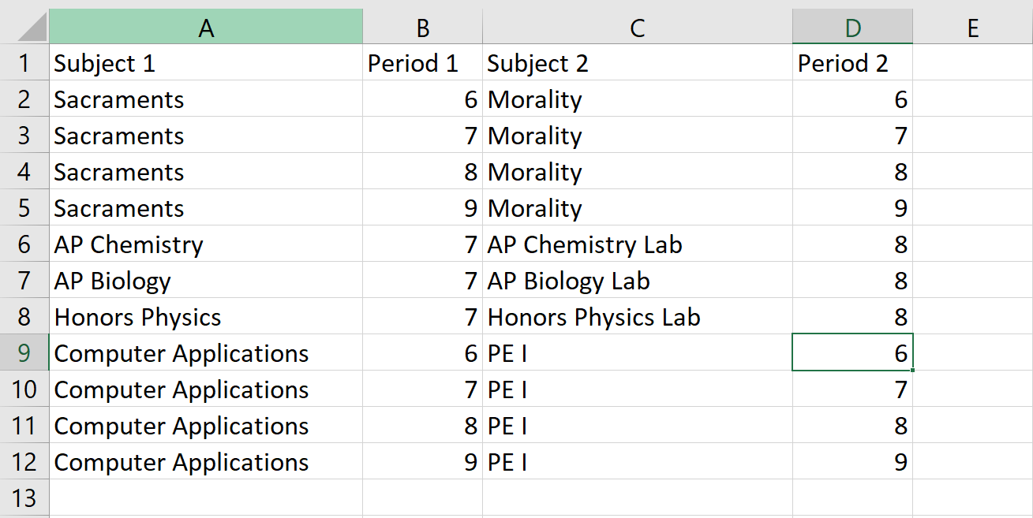



* Purpose: List classes that must go together. This can be in case of semester 1 and 2 or Science Lab.
* First Column: subject 1 name
* Second Column: period of subject 1
* Third Column: subject 2 name
* Fourth Column: period of subject 2
* Note:
  + Class name must match with name appeared in “Subject List” Excel.
  + Order of appearance does not matter.
  1. Registration Format

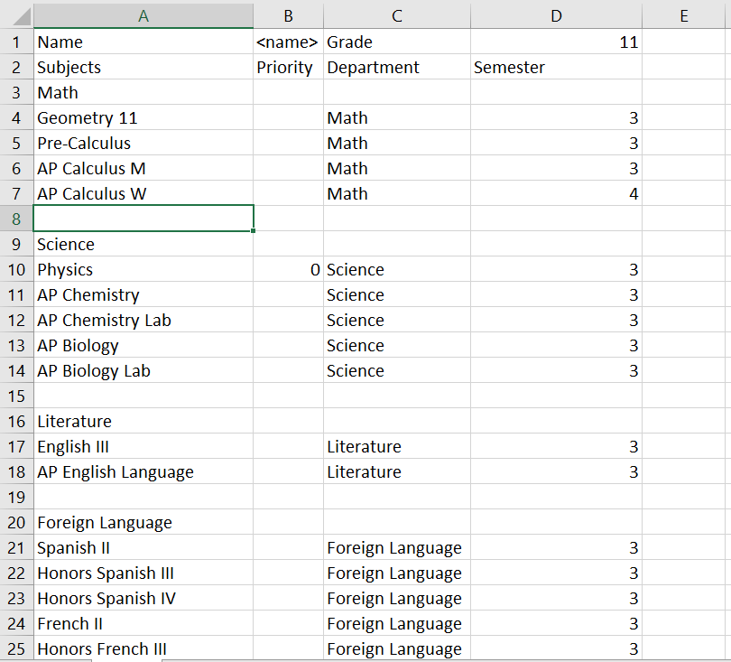



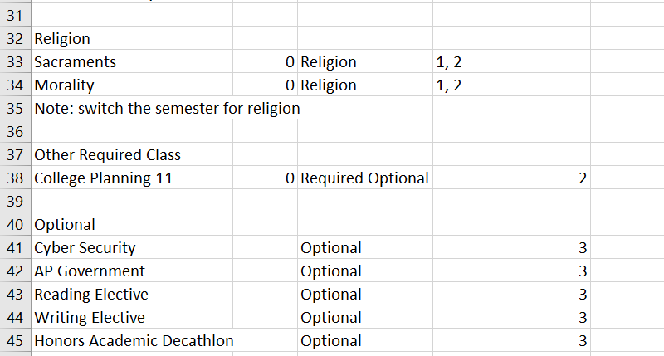

* Purpose: List students’ registrations
* First Column: Class registered
* Second Column: Priority
  + “0” indicates the subject is required
  + Any other numbers note importance. 1 then 2 then 3.
  + For classes that goes together like Science and Lab, give them the same priority
* Third Column: Department
  + Department does not mean that AP Biology must be science and cannot be Optional.
  + In the program, the department concept is used to group subjects to ensure students take all required classes. Therefore, if a student has already had a science, AP Science can be moved to Optional or kept as Science. The only difference will come down to priority when scheduling.
* Fourth Column: Semester desired (only for single semester class). Otherwise: both semester = 3
  + For some classes like Theology III (Sacraments and Morality), adjust the semester respectively.
  + Tips: for the first half of the class, give them Sacraments 1, Morality 2. Then switch around for the other half.
* First Row:
  + B1: name of student. This name will be used for output files.
  + D1: grade of students.
  + A1 and C1 are not read.
* Definite of a registration: in the program, a registration is defined as a row having all four information (class name, priority, department, and semester filled up).
  + Therefore, if a row is missing one or more columns, the row will be ignored.
  + A format can be created like such to speed up the inputting process.
* Inputting: using the format, only the priority needs to be filled out to validate a registration. Adjust semester as needed.
  + For classes like History or English, avoid using “0”. Use “1” for the class that student registered and put “2” for the other.
  1. Sample Output

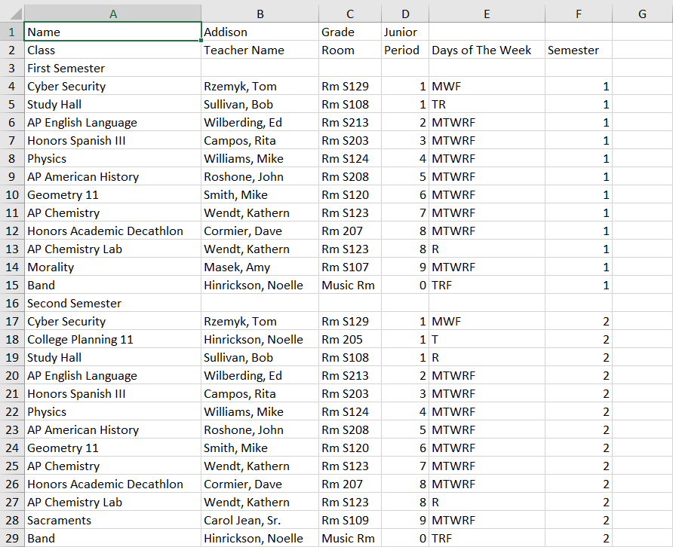

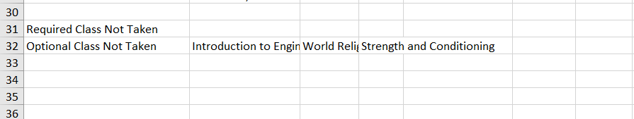

* Look exactly like students’ actual schedule.
* In the end, there is a list of required and optional classes that cannot be scheduled.
  1. Students’ Registration Error File.

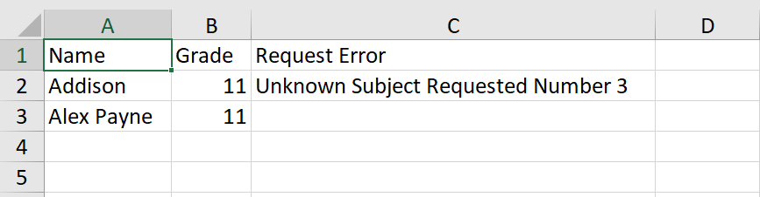

* Purpose: since finding subject name errors can be frustrated, this program has a feature to help finding those errors. Details will come in the program section
* First Column: Name of all students that are checked
* Second Column: Grade of students that are checked
* Request Error:
  + Four types of errors: subject, department, grade, and semester.
  + Regarding “Requested Number #”, the number will be the placement of the subject registration for the students. Since not all lines are read in the students’ registration input, only count fully registered classes.
  1. Master Schedule error File

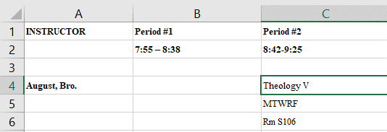

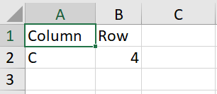

* Purpose: check for subject, room, and day of the week errors for Master Schedule.
* In the example, “Theology V” should be “Theology IV”. The program will indicate there is an error at cell C4. The address/cell reference is exactly where the error is on Master Schedule.

1. Program User Interface and How to Use

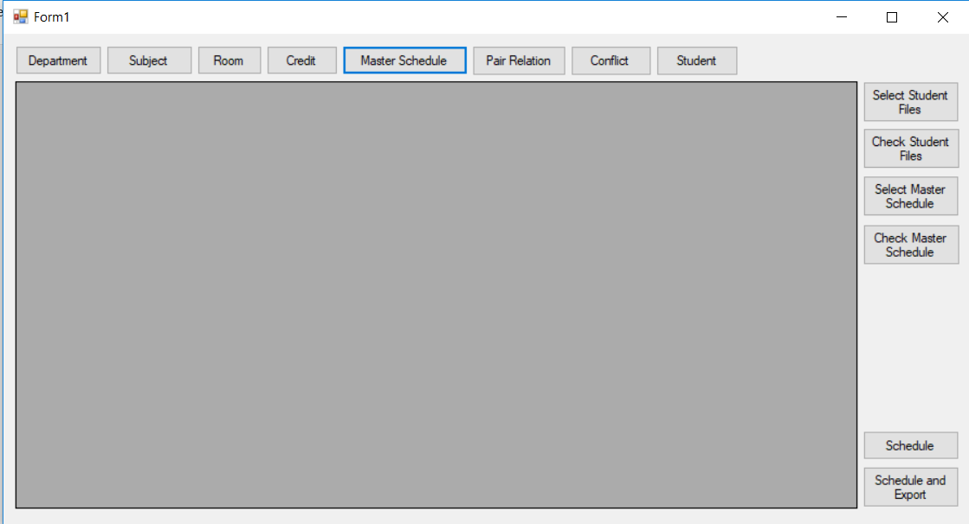



Explanations of all buttons

* 1. Main button
     1. Department button: Input “department” excel
     2. Subject button: Input “subject list” excel
     3. Room button: Input “room” excel
     4. Master Schedule button: Input “Master schedule” excel
     5. Pair Relation button: Input “pair-relation” excel, the one that pairs two classes together
     6. Conflict button: Input “conflict” excel
     7. Student button: Input “students’ registrations” excels. More than 1 registrations can be input at a time.
     8. Schedule button: Schedule all input registrations without exporting to excel (mainly use for testing).
     9. Schedule and Export button: schedule and export all registrations.
  2. Checking Excel button
     1. Students File Checker: check for subject and department name error, and grade
        1. First, need to input “subject-list” and “department” excel using the two main buttons
        2. Select Student Files button: select students files that users wish to check for typo.
        3. Check Students Files button: check and output the “Error” excel that indicates which students’ registrations, if any, contain typo
     2. Master Schedule Checker: Check for subject name error, room name error, days taught error.
        1. First, need to input “subject-list” and “room” excel using the two main buttons
        2. Select Master Schedule button: select Master Schedule files that users wish to check for type
        3. Check Master Schedule button: check and output the “Error” excel that indicates the locations of typos, if any, in the input Master Schedule
  3. Other notes
     1. The excels should be inputted from left to right.
     2. For checker feature: input the excels needed using the main button before selecting files that users wish to check.
     3. Unless otherwise noted, when a button is reused, the older data will be erased. For example, a “Department ver 1” excel is inputted. Later, a “Department ver 2” excel is added. The data from “Department ver 1” excel is erased from the program.
  4. **IMPORTANT**
     1. To minimize running time, I divide four classes into three groups: freshman, sophomore, and junior + senior group. Since freshmen have a fixed set of courses with little flexibility, it will be wiser to arrange them as a class to significantly cut down running time. Same thing goes for sophomore. However, because junior and senior tend to share many AP classes, I opt to arrange them together.
     2. In general, the steps are
        1. Update registrations format. Check it like a student registration by putting a priority “-1” next to every class.
        2. Check that the Master Schedules and Students’ registrations are free of errors.
        3. Input all main excel files.
        4. Select freshmen registrations
        5. Schedule and export freshmen schedules to a folder
        6. Repeat step 1, 2, 3 for sophomore
        7. Repeat step 1, 2, 3 for junior + senior together.

1. Tips for organizing data

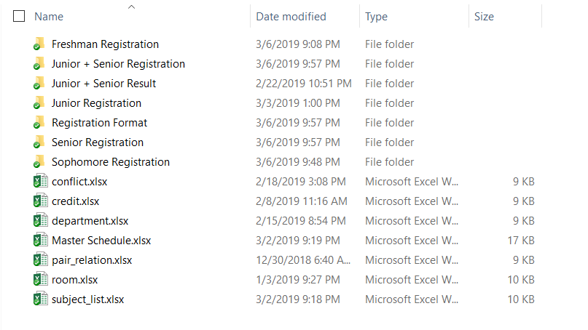

* I create a folder and name it “2019-2020 Files”
* In this folder, I have all the major excels outside.
* Then I create subfolders for each class registration. After entering all registrations, I create another folder for junior + senior registrations since those registrations need to go in the program as a group
* When entering registrations especially freshman and sophomore’s since students have alternating classes, users should make sure that those classes have the semester changed. An easy way to do this, for the first half of the freshman class, have them take computer applications first semester and PE second semester.
* Use the “Registration format” to speed up the process. How I do it
  + Open registration format
  + Ctrl + N, then Ctrl + S: this will create a new excel and save it. Then name the excel and save it to the registration folder.
  + When finish input all the priority, Ctrl + W: this will close the excel.
  + Repeat. This way will cut time finding the mouse and navigating.