Original Game Studios



**Design Document for:**

# Patient Zero

**Brains are delish.**

“Taking the ‘O’ out of original and throwing it out the window”™

Group#: 1

Date/Time: Monday, December 04, 2017

Student Name: Max Sazhaev  Student ID: 300830601

Student Name: Manpreet Matharu   Student ID: 300838888

Student Name: Kyle Puno  Student ID: 300629575

Student Name: Igor Brovchenko  Student ID: 300829961

All work Copyright ©1999 by Original Game Studios

Written by Max, Manpreet, Kyle, Igor

Version # 1.00

Table of Contents

Original Game Studios 1

Patient Zero 1

Design History 4

Version 0.01 4

Version 1.10 4

Version 2.00 4

Game Overview 5

Philosophy 5

Philosophical point #1 5

Common Questions 5

What is the game? 5

Why create this game? 5

Where does the game take place? 5

What do I control? 5

How many characters do I control? 5

What is the main focus? 5

What’s different? 5

Feature Set 6

General Features 6

Multiplayer Features 6

Editor 6

Gameplay 6

The Game World 7

Overview 7

World Feature #1 7

World Feature #2 7

The Physical World 7

Overview 7

Key Locations 7

Travel 7

Scale 7

Objects 7

Weather 7

Day and Night 7

Time 8

Rendering System 8

Overview 8

2D/3D Rendering 8

Camera 9

Overview 9

Camera Detail #1 9

Camera Detail #2 9

Game Engine 10

Overview 10

Game Engine Detail #1 10

Water 10

Collision Detection 10

Lighting Models 10

Overview 10

Lighting Model Detail 10

Game Characters 11

Overview 11

Creating a Character 11

Enemies and Monsters 11

User Interface 12

Overview 12

User Interface Detail #1 12

User Interface Detail #2 12

Musical Scores and Sound Effects 13

Overview 13

Red Book Audio 13

3D Sound 13

Sound Design 13

Single-Player Game 14

Overview 14

Single Player Game Detail #1 14

Single Player Game Detail #2 14

Story 14

Hours of Gameplay 14

Victory Conditions 14

Multiplayer Game 15

Overview 15

Max Players 15

Servers 15

Customization 15

Internet 15

Gaming Sites 15

Persistence 15

Saving and Loading 15

# Design History

This is a brief explanation of the history of this document.

In this paragraph describe to the reader what you are trying to achieve with the design history. It is possible that they don’t know what this is for and you need to explain it to them.

## Version 0.01

Version 0.01 includes Preliminary Design History fragment. Here is what we changed.

1. Created high concept document stating the high concept statement, features, and overview of the game. This includes player motivation, genre, license, target audience, competition, unique selling point, target hardware, and design goals for the game
2. Used design document template and changed the document to contain the company name, logo, name of the game, one liner, and a joke, as well as a group number, date, and each members’ student id and names.
3. Filled up the preliminary design history fragment, philosophy, as well as answering common questions in the document, such as, what is the game, why create this game, and so on.

## Version 0.02

Version 0.02 contains the fleshed out feature set in the document, information about the game world including the overview, world features, physical world, location, travel, scale, weather, rendering system, camera, game engine, and lighting model. Gameplay is defined and core mechanics are described.

## Version 2.00

Version 2.10 has several small changes over that of version 2.00. The key areas are in many of the appendixes.

Included in the changes are:

1. Minor revisions throughout entire document.
2. Added “User Interface Appendix”.
3. Added “Game Object Properties Appendix”.
4. Added concept sketch for world.

# Game Overview

## Philosophy

### Philosophical point #1

Who ever said that the earth belongs to humans? The game is trying to show you that it’s not always black and white with who’s the hero, sometimes the world is grey, with a lot of red.

## Common Questions

### What is the game?

Zombie action/ tactics game. Player takes control over Patient 0, first zombie, who has special powers and can command other zombies. He evolves and develops his zombie horde to take over the world!

### Why create this game?

Usually when you’re thinking about a zombie game you’ll find yourself surviving against them rather than hoping for their victory. Zombie games don’t usually involve building your own army of zombies, and fighting against the humans to conquer all. If you’re playing as patient zero with powers, it will make the player feel as if they were in a world where their life had so much more meaning.

### Where does the game take place?

Los Angeles. Picture it, a very dense city with multiple hospitals, schools, and prisons. Plenty of gruesome possibilities, and strategic advantages.

### What do I control?

You will not only control patient zero, but other zombies which you will infect or humans you will recruit. Use armies of zombies to infect even more people, growing the size of your army, eventually taking over the world.

### How many characters do I control?

The camera follows only patient zero, but you can command anybody you infect, as well as some humans which are complicit.

### What is the main focus?

The main focus of the game is to conquer the world. This can be achieved by either converting all humans, or enslaving them until the sun explodes and everyone dies.

### What’s different?

It’s a zombie game that reverses the roles of the main player, but also adds an element of strategy, similar to a Real Time Strategy game.

# Feature Set

## General Features

3 Maps

3D graphics

32-bit color

Zombie model

Human model

## Multiplayer Features

Up to 2 players

Easy to find a game

Easy to find your teammate

## Gameplay

Start off as 1 zombie with a zombie friend by your side

Hit the humans trying to defend themselves from you to turn them into zombie allies

Control the zombies you and your friend create and make them attack other humans

Player zombie has special abilities such as jumping and fast movement, can also command other zombies

Win by being the only species standing

## Core Mechanics

Create the player by spawning him in a specific location and giving the player control. From there the player will run up to humans and as they are grabbed, the box colliders trigger and the human will transform into a zombie. Then using ray casting you can select the zombie and order him to move to a certain location. When you turn all the humans into zombies the win condition gets triggered and you move on to the next stage or win.

# The Game World

## Overview

It was just a few weeks since the break out of zombie virus. Humans are running in panic without even trying to fight. Recently dominant species is hiding away from big cities, such as small towns and insane asylums. In game you will visit different sights to witness and speed up the end of human race.

**Insane Asylum**

This is inside an insane asylum. The hallways looks very gloomy and the structure is maze-like. Perfect for hunting humans. You have to jump over a pit which could kill the zombie

## Town

Just a small town outside the city, it contains some rocks, houses, and a well, and some cars.

## Bridge

Some areas in the city have been destroyed, ground has collapsed and the humans needed a bridge to cross it, but so do you.

## The Physical World

### Overview

The physical world will contain 3 levels, an insane asylum, and a small town outside the city, and a bridge in the middle of the destroyed city.

### Key Locations

Inside an insane asylum.

Outside at a small town.

At a bridge in the middle of the city.

### Travel

Player moves with WASD, shift to sprint, space to jump, and mouse to look around. They control other zombies by selecting one with left click and telling it to go somewhere with right click.

### Scale

The scale is real world size. The world will be closed off to a specific area though.

### Objects

Gas can you can collect to prevent humans from using it to leave town

Rocks

Houses

Cars

Door

Bridge/ladder

See the “Objects Appendix” for a list of all the objects found in the world.

### Weather

No weather.

### Day and Night

Day time on all the levels.

### Time

Real time.

## Rendering System

### Overview

Use unity for all rendering

### 2D/3D Rendering

Use unity for all rendering. Use the build function in unity to create a working build of the project. Exe file and data that goes with it.

## Camera

### Overview

First person point of view.

### Camera Detail #1

As the mouse moves the camera and player moves with it.

### Camera Detail #2

Camera wobbles as the player moves.

## Game Engine

### 

### Overview

Use unity game engine for everything in the game

### Game Engine Detail #1

Game engine will track lives and score in the game, it will also track how many humans you have converted and how many are needed to win the game. It will also track how much time has gone by.

### Water

Water will be a texture at the end of the insane asylum to show the place is run down and flooding.

### Collision Detection

Unity uses the box collider to see if the zombie makes contact with the enemy, or the player collides with a specific surface.

## Lighting Models

### Overview

Use basic lighting built into unity to light our game.

# Game Characters

## Overview

Player - original zombie, called Patient Zero, hunts humans and convert them into zombies. Can control other zombies.

## Creating a Character

There's no character customization.

## Enemies and Monsters

Humans - enemies, run away from player and other zombies. Not able to protect themselves but can run and hide.

Zombies - allies controlled by player. Can convert humans into zombies.

# User Interface

## Overview

* Player’s Score in the top left corner
* Play Time in the top middle of the screen
* Player’s Life in upper right corner
* Counter of the humans remaining on the level in lover left corner

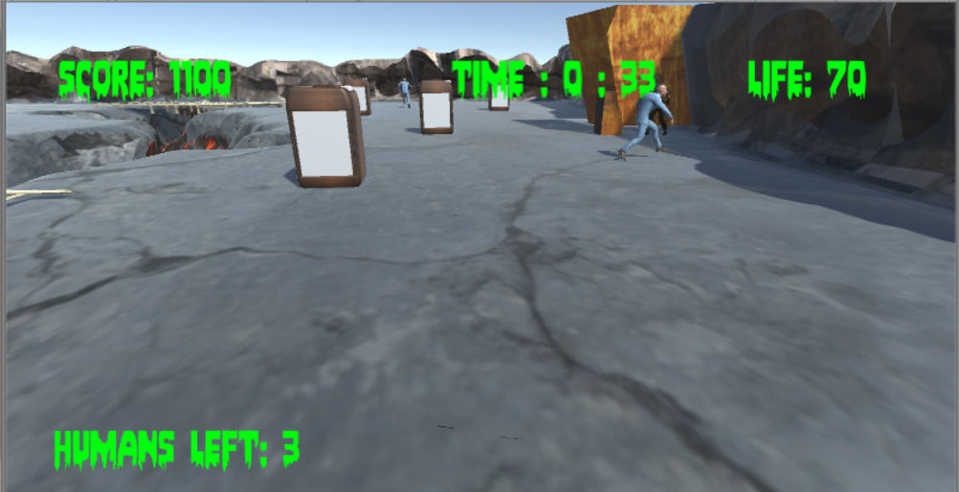

# Musical Scores and Sound Effects

## Overview

Music theme was chosen in order to maintain dark atmosphere of the game .

## 3D Sound

Used standard unity sound tools.

## Sound Design

Sound consist of the main theme music and sound effects on item pick-ups, human conversions and game over.

# Single-Player Game

## Overview

Player is a Patient Zero hunts humans in various locations and turns them into zombies he controls.

## Story

Zombie apocalypse from zombie master point of view. After secret experiments on internal life main character turns into the zombie overlord. He doesn't have any memories of his previous life and only thing he knows is that he has to bring vengeance on all of the man kind. Main character takes name of Patient Zero and develops ability to command zombies.

## Hours of Gameplay

Single player campaign takes approximately 1 hour to complete.

## Victory Conditions

Player wins when turns all the people into zombies on the mission map.

# Multiplayer Game

## Overview

Coop multiplayer makes taking down human race even more fun.

## Max Players

Maximum 2 players.

## Servers

One of the players is a host, second player connects to his game using ip address.

## Gaming Sites

Multiplayer is available only for LAN network.

## Saving and Loading

There's no saving in the game to make game more challenging.